**Lab Task_01**

**Implement the 3-to-8 decoder**

**VHDL Code:**

**library** IEEE**;**

**use** IEEE**.**STD_LOGIC_1164**.ALL;**

**entity** dec3to8 **is**

**port** **(**

input **:** **in** std_logic_vector**(**2 **downto** 0**);**

output **:** **out** std_logic_vector**(**7 **downto** 0**)**

**);**

**end** dec3to8**;**

**architecture** Behavioral **of** dec3to8 **is**

**begin**

output **<=** "00000001" **when** **(**input **=** "000"**)** **else**

"00000010" **when** **(**input **=** "001"**)** **else**

"00000100" **when** **(**input **=** "010"**)** **else**

"00001000" **when** **(**input **=** "011"**)** **else**

"00010000" **when** **(**input **=** "100"**)** **else**

"00100000" **when** **(**input **=** "101"**)** **else**

"01000000" **when** **(**input **=** "110"**)** **else**

"10000000"**;**

**end** Behavioral**;**

**Simulation:**

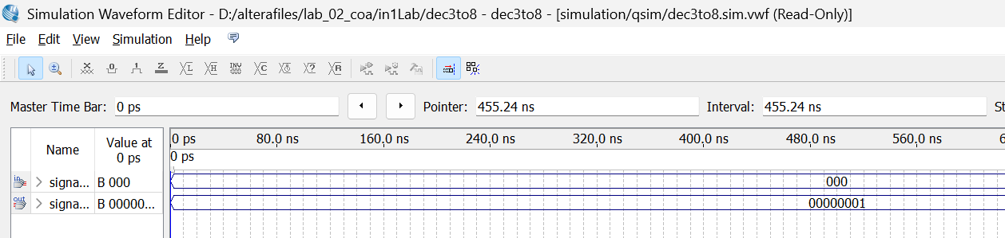

**Simulation 1:** Input is 000, so the respective output is 00000001

**Implementation FPGA Board:**

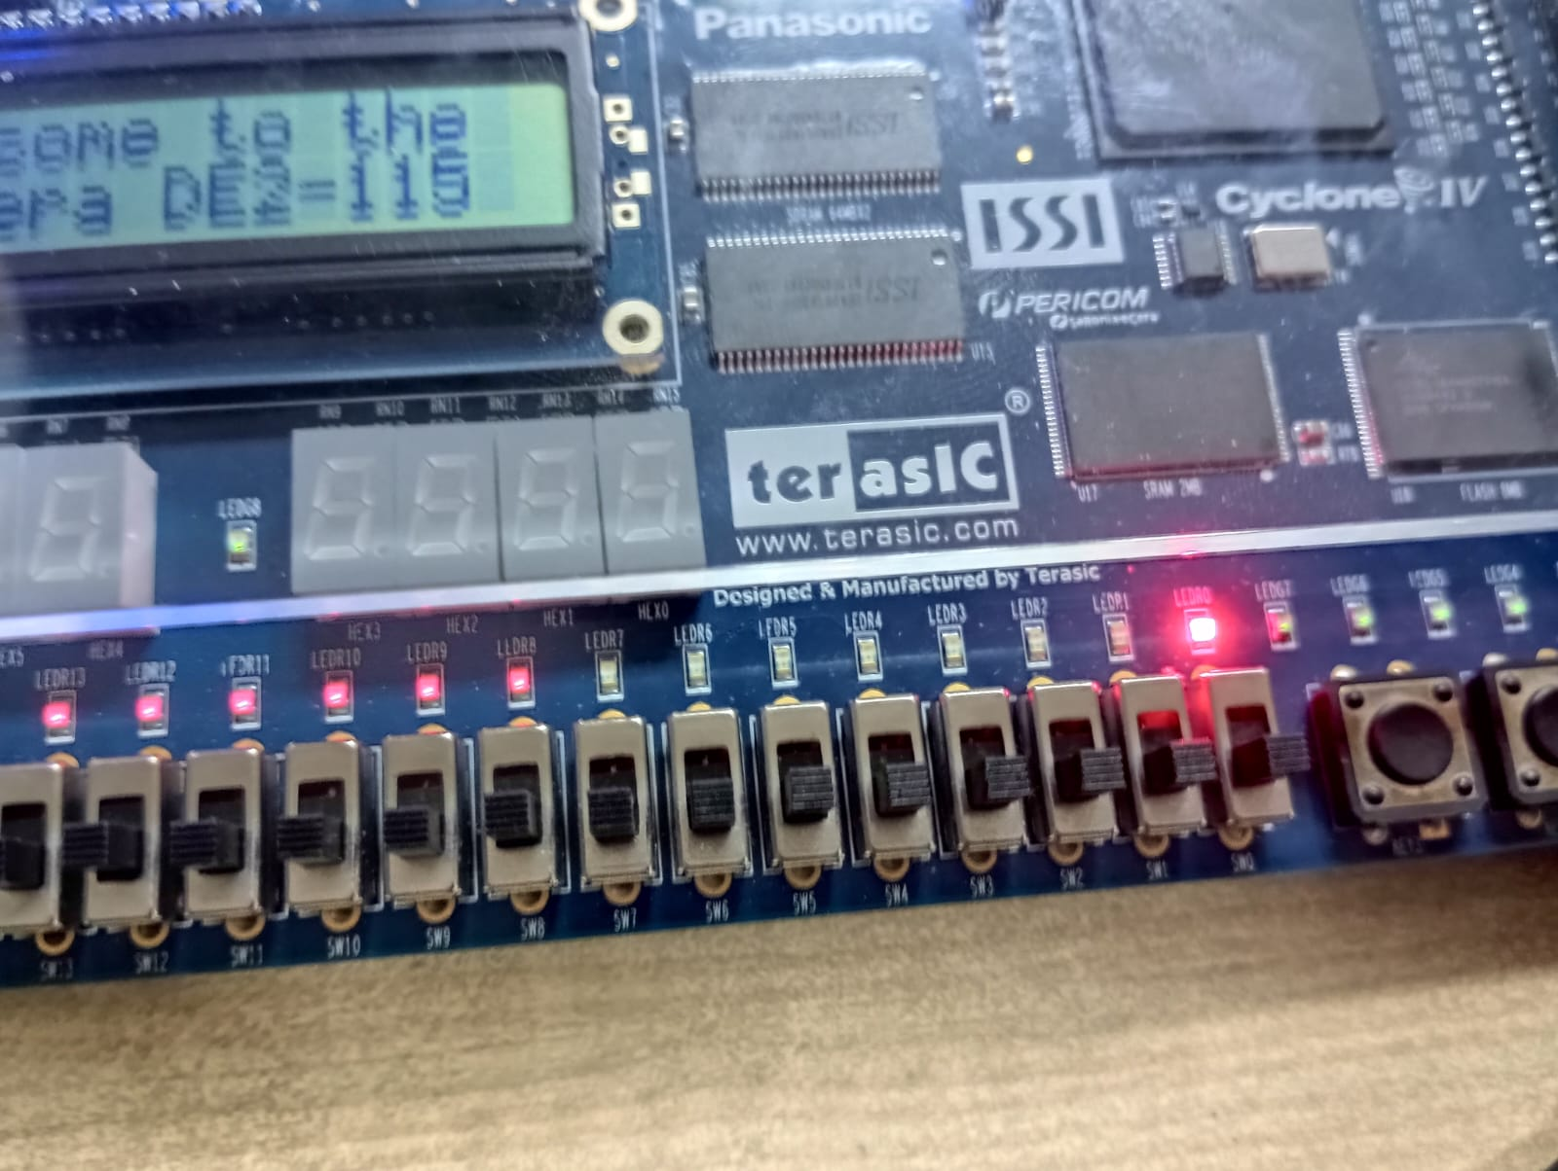

**FPGA Hardware 1:** All the three inputs are off (0) so only the first output Led is on (1)

**Lab Task_02**

**Seven Segment Display (SSD)**

**VHDL Code:**

**LIBRARY** IEEE**;**

**USE** IEEE**.**STD_LOGIC_1164**.ALL;**

**ENTITY** seven_seg **IS**

**PORT(**

bininput **:** **IN** std_logic_vector**(**3 **DOWNTO** 0**);**

cathodes **:** **OUT** std_logic_vector**(**6 **DOWNTO** 0**)**

**);**

**END** seven_seg**;**

**architecture** dataflow **of** seven_seg **is**

**begin**

cathodes **<=** "1000000" **when(**bininput **=** "0000"**)** **else**

"1111001" **when** **(**bininput **=** "0001"**)** **else**

"0100100" **when** **(**bininput **=** "0010"**)** **else**

"0110000" **when** **(**bininput **=** "0011"**)** **else**

"0011001" **when** **(**bininput **=** "0100"**)** **else**

"0010010" **when** **(**bininput **=** "0101"**)** **else**

"0000010" **when** **(**bininput **=** "0110"**)** **else**

"1111000" **when** **(**bininput **=** "0111"**)** **else**

"0000000" **when** **(**bininput **=** "1000"**)** **else**

"0010000" **when** **(**bininput **=** "1001"**)** **else**

"0001000" **when** **(**bininput **=** "1010"**)** **else**

"0000011" **when** **(**bininput **=** "1011"**)** **else**

"1000110" **when** **(**bininput **=** "1100"**)** **else**

"0100001" **when** **(**bininput **=** "1101"**)** **else**

"0000110" **when** **(**bininput **=** "1110"**)** **else**

"0001110" **when** **(**bininput **=** "1111"**)** **else**

"1111111"**;**

**end** dataflow**;**

**Simulation:**

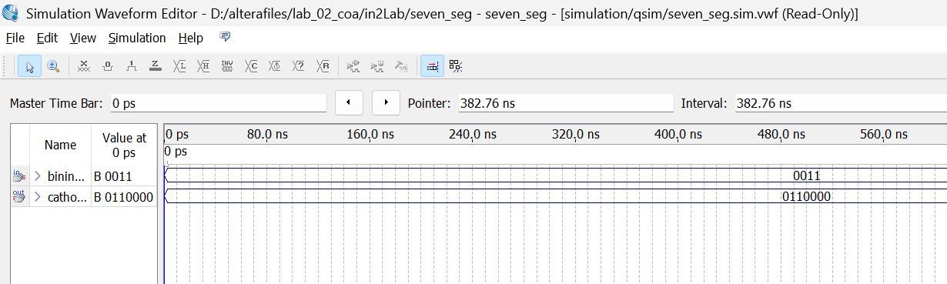

**Simulation 2:** Input is 0011, so the respective output is 0110000 which display 3 on seven segment

**Implementation FPGA Board:**

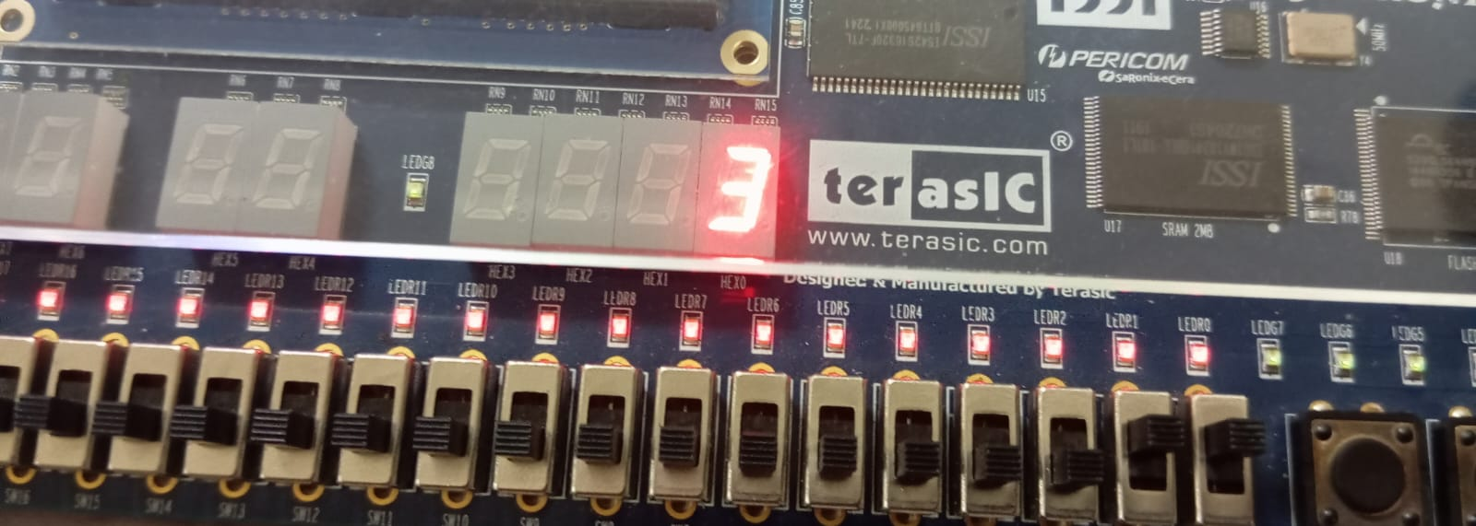

**FPGA Hardware 2****:**First two input pins are on, so input is 0011, which corresponds to 3 at seven segment display

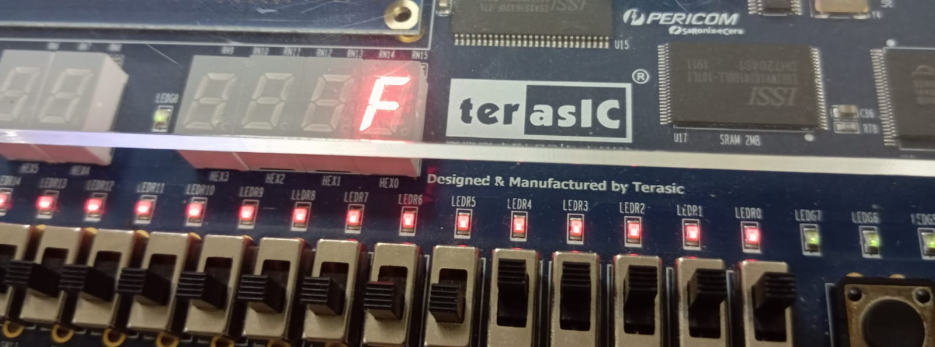

**FPGA Hardware 3: :**First four input pins are on, so input is 1111, which corresponds to F at seven segment display