**Lab Task_01**

**ALU implementation using your own library components**

**ENTITIES:**

**1:OR gate**

**library** IEEE**;**

**use** IEEE**.**STD_LOGIC_1164**.ALL;**

**entity** Orgate **is**

**port(**

or_in1**,** or_in2 **:** **in** STD_LOGIC**;**

or_out **:** **out** STD_LOGIC

**);**

**end** Orgate**;**

**architecture** bhv **of** Orgate **is**

**begin**

or_out **<=** or_in1 **OR** or_in2**;**

**end** bhv**;**

**1:AND gate**

**library** IEEE**;**

**use** IEEE**.**STD_LOGIC_1164**.ALL;**

**entity** Andgate **is**

**port(**

and_in1**,** and_in2 **:** **in** STD_LOGIC**;**

and_out **:** **out** STD_LOGIC

**);**

**end** Andgate**;**

**architecture** bhv **of** Andgate **is**

**begin**

and_out **<=** and_in1 **AND** and_in2**;**

**end** bhv**;**

**2:NAND gate**

**library** IEEE**;**

**use** IEEE**.**STD_LOGIC_1164**.ALL;**

**entity** Nandgate **is**

**port(**

nand_in1**,** nand_in2 **:** **in** STD_LOGIC**;**

nand_out **:** **out** STD_LOGIC

**);**

**end** Nandgate**;**

**architecture** bhv **of** Nandgate **is**

**begin**

nand_out **<=** **NOT** **(**nand_in1 **AND** nand_in2**);**

**end** bhv**;**

**3:Full Adder**

**library** IEEE**;**

**use** IEEE**.**STD_LOGIC_1164**.ALL;**

**entity** Fulladder **is**

**port(**

adder_inA**,** adder_inB**,** adder_inC **:** **in** STD_LOGIC**;**

adder_outS**,** adder_outC **:** **out** STD_LOGIC

**);**

**end** Fulladder**;**

**architecture** bhv **of** Fulladder **is**

**begin**

adder_outS **<=** **(**adder_inA **XOR** adder_inB**)** **XOR** adder_inC**;**

adder_outC **<=** **(**adder_inA **AND** adder_inB**)** **OR** **(**adder_inC **AND** **(**adder_inA **XOR** adder_inB**));**

**end** bhv**;**

**4:MUX**

**library** IEEE**;**

**use** IEEE**.**STD_LOGIC_1164**.ALL;**

**entity** Mux **is**

**port** **(** mux_inI0**,** mux_inI1**,** mux_inI2**,** mux_inI3 **:** **in** STD_LOGIC**;**

mux_Sel **:** **in** STD_LOGIC_VECTOR**(**1 **downto** 0**);**

mux_outY **:** **out** STD_LOGIC**);**

**end** Mux**;**

**architecture** bhv **of** Mux **is**

**begin**

**process** **(**mux_Sel**,** mux_inI0**,** mux_inI1**,** mux_inI2**,** mux_inI3**)**

**begin**

**case** mux_Sel **is**

**when** "00" **=>** mux_outY **<=** mux_inI0**;**

**when** "01" **=>** mux_outY **<=** mux_inI1**;**

**when** "10" **=>** mux_outY **<=** mux_inI2**;**

**when** "11" **=>** mux_outY **<=** mux_inI3**;**

**when** **others** **=>** mux_outY **<=** '0'**;**

**end** **case;**

**end** **process;**

**end** bhv**;**

**PACKAGE:**

**library** IEEE**;**

**use** IEEE**.**STD_LOGIC_1164**.ALL;**

**package** alu_components **is**

**component** Orgate

**port** **(** or_in1**,** or_in2 **:** **in** STD_LOGIC**;**

or_out **:** **out** STD_LOGIC**);**

**end** **component;**

**component** Andgate

**port** **(** and_in1**,** and_in2 **:** **in** STD_LOGIC**;**

and_out **:** **out** STD_LOGIC**);**

**end** **component;**

**component** Nandgate

**port** **(** nand_in1**,** nand_in2 **:** **in** STD_LOGIC**;**

nand_out **:** **out** STD_LOGIC**);**

**end** **component;**

**component** Fulladder

**port** **(** adder_inA**,** adder_inB**,** adder_inC **:** **in** STD_LOGIC**;**

adder_outS**,** adder_outC **:** **out** STD_LOGIC**);**

**end** **component;**

**component** Mux

**port** **(** mux_inI0**,** mux_inI1**,** mux_inI2**,** mux_inI3 **:** **in** STD_LOGIC**;**

mux_Sel **:** **in** STD_LOGIC_VECTOR**(**1 **downto** 0**);**

mux_outY **:** **out** STD_LOGIC**);**

**end** **component;**

**end** alu_components**;**

**TOP-ENTITY(Wrapper File)**

**library** IEEE**;**

**use** IEEE**.**STD_LOGIC_1164**.ALL;**

**use** work**.**alu_components**.ALL**

**entity** ALU **is**

**port** **(**

a**,** b**,** Cin **:** **in** STD_LOGIC**;**

Sel **:** **in** STD_LOGIC_VECTOR**(**1 **downto** 0**);**

Result**,** Cout **:** **out** STD_LOGIC

**);**

**end** ALU**;**

**architecture** struct **of** ALU **is**

**signal** and_out**,** or_out**,** nand_out**,** sum_out**,** carry_out**:** STD_LOGIC**;**

**begin**

U1**:** Andgate **port** **map(**and_in1 **=>** a**,** and_in2 **=>** b**,** and_out **=>** and_out**);**

U2**:** Orgate **port** **map(**or_in1 **=>** a**,** or_in2 **=>** b**,** or_out **=>** or_out**);**

U3**:** Nandgate **port** **map(**nand_in1 **=>** a**,** nand_in2 **=>** b**,** nand_out **=>** nand_out**);**

U4**:** Fulladder **port** **map(**adder_inA **=>** a**,** adder_inB **=>** b**,** adder_inC **=>** Cin**,** adder_outS **=>** sum_out**,** adder_outC **=>** carry_out**);**

U5**:** Mux **port** **map(**

mux_inI0 **=>** and_out**,**

mux_inI1 **=>** or_out**,**

mux_inI2 **=>** nand_out**,**

mux_inI3 **=>** sum_out**,**

mux_Sel **=>** Sel**,**

mux_outY **=>** Result

**);**

Cout **<=** carry_out**;**

**end** struct**;**

**Simulation:**

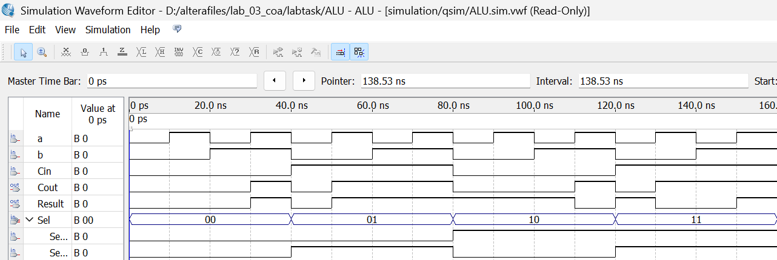

Simulation : All four components (AND,OR,NAND,SUM) are working on their respective selections.

**Control Signal to Operation Mapping:**

|  |  |
| --- | --- |
| **SELECTION** | **OPERATION** |
| 00 | AND GATE |
| 01 | OR GATE |
| 10 | NAND GATE |
| 11 | ADDITION |

Table : Operation corresponding to selection lines.