**Lab_01:**

**-- task-00**

**use** ahmad_db

**create** **table** studentRecord**(**

Name varchar**(**50**),**

regNo int **primary** **key,**

Courses varchar**(**50**),**

courseCode int**,**

offeredBy varchar**(**50**)**

**);**

**-- task-01**

--single record with default sequence

**insert** **into** studentRecord

**values** **(**'Ali' **,**01 **,**'DIP' **,**1001 **,**'Mr. A'**)**

--multiple record with default sequence

**insert** **into** studentRecord

**values** **(**'Basit'**,** 02 **,**'DBMS'**,** 1002**,** 'Mr. X'**),**

**(**'Akram'**,** 03 **,**'OS' **,** 1003**,** 'Mr. Y'**),**

**(**'Asad' **,**04 **,**'DBMS'**,** 1002 **,**'Mr. X'**),**

**(**'Zeeshan'**,** 05 **,**'DIP'**,** 1001**,** 'Mr. A'**),**

**(**'Muneer'**,** 06**,** 'OS'**,** 1003 **,**'Mr. Y'**),**

**(**'Shafqat'**,** 07 **,**'NM'**,** 1004 **,**'Mr. H'**),**

**(**'Ahsan' **,**08**,** 'OS'**,** 1003**,** 'Mr. Y' **),**

**(**'Ikram'**,** 09 **,**'DIP' **,** **null,null)**

z

-- single record with customized sequence

**insert** **into** studentRecord**(**Name**,**regNo**)**

**values** **(**'Hassan'**,** 10**)**

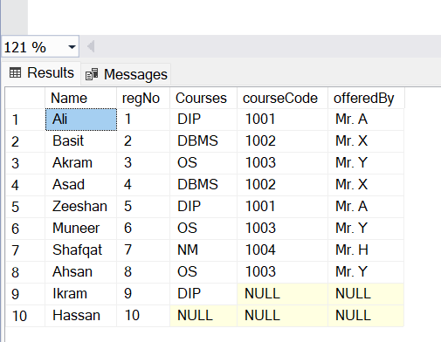

**-- task-02**

-- update apna record

-- set (nmae='newnaem', ...)

-- where id is x

**update** studentRecord

**set** Courses **=** 'DIP'**,**courseCode **=** 1001**,** offeredBy **=** 'Mr. A'

**where** name **=** 'Ikram'**;**

**update** studentRecord

**set** Courses **=** 'DSP'**,**courseCode **=** 1005**,**offeredBy **=** 'Mr. Z'

**where** name **=** 'Hassan'**;**

**-- task-03**

**delete** **from** studentRecord

**where** Name **in** **(**'Akram'**,** 'Ahsan'**);**

**delete** **from** studentRecord

**WHERE** courseCode **=** 1001**;**

**-- task-04**

**SELECT** **DISTINCT** Courses**,**courseCode**,**offeredBy **FROM** studentRecord

**-- task-05**

**SELECT** **\*** **FROM** studentRecord **ORDER**

**BY** Name **DESC**

**select** **\*** **from** studentRecord