**Labtask_1**

% Program to understand the use of script file

% 𝑓(𝑡) = 𝑡𝑐𝑜𝑠(2𝜋𝑡), -5 ≤ 𝑡 ≤ 5

t=-5:0.1:5;

f=t.*cos(2*pi*t);

plot(t,f)

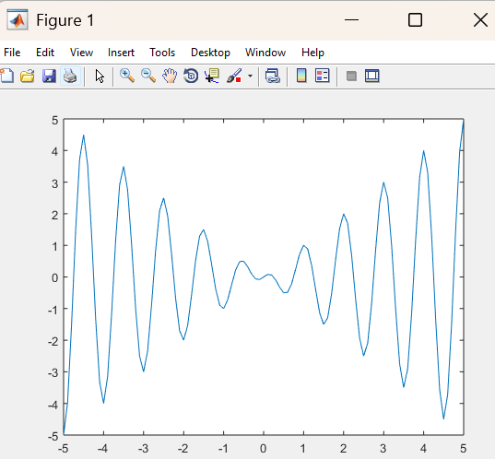

**Labtask_2**

function [sm,pro]=opertions(A,B)

sm=A+B;

pro=A*B;

end

**Labtask_3**

x = -2:0.1:2;

y = x.^2;

plot(x, y, 'b', 'LineWidth', 2);

xlabel('x');

ylabel('y = x^2');

title('Plot of y = x^2 for −2 ≤ x ≤ 2');

grid on;

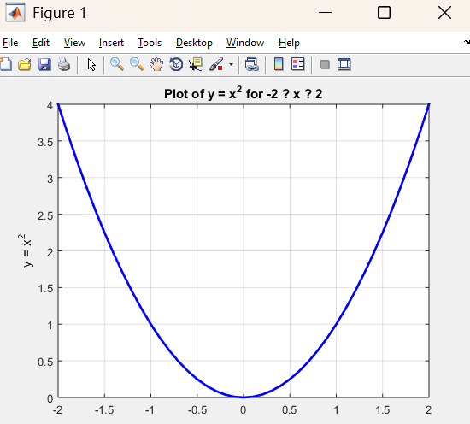

**Labtask_4**

x = linspace(0, 2*pi, 500);

% Define the functions

y = x.^2 .* cos(x);

g = x .* cos(x);

f = 2.^x .* sin(x);

% Plot the functions

plot(x, y, 'b-', 'LineWidth', 1.5);

hold on;

plot(x, g, 'g--', 'LineWidth', 1.5);

plot(x, f, 'r-.', 'LineWidth', 1.5);

% Labels and title

xlabel('x');

ylabel('Function values');

title('Plot of y(x), g(x), and f(x) in the same figure');

legend('y(x) = x^2 cos(x)', 'g(x) = x cos(x)', 'f(x) = 2^x sin(x)', 'Location', 'Best');

grid on;

hold off;

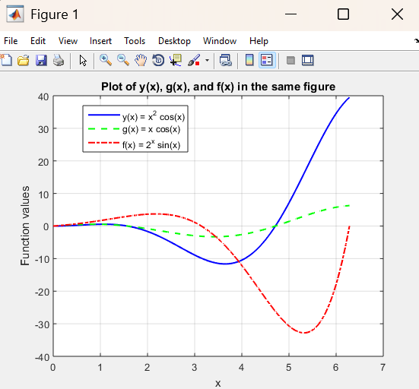

**Labtask_5**

x = linspace(0, 2*pi, 500);

y = x.^2 .* cos(x);

g = x .* cos(x);

subplot(2,1,1);

plot(x, y, 'b-', 'LineWidth', 1.5);

title('Subplot 1')

subplot(2,1,2);

plot(x, g, 'g--', 'LineWidth', 1.5);

title('Subplot 2')

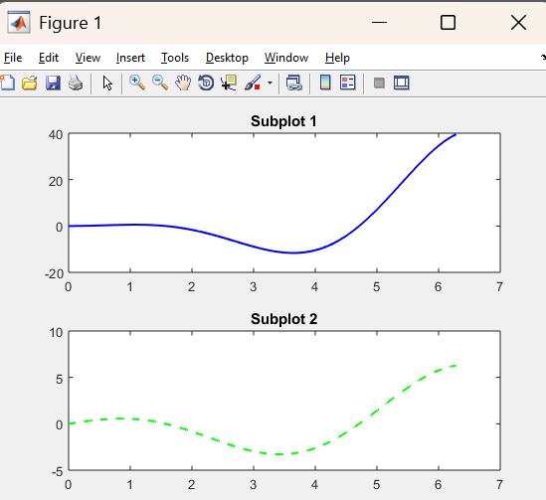

**Labtask_6**

n = -3:0.01:3;

% or

n = linspace(-3, 3, 50);

f= n.^2 ;

stem(n,f) ;

xlabel('Time Axis')

ylabel('Amplitude')

title('Graph of f(n)')

**Labtask_7**

t1=-2:.1:2;

t2=2.1:.1:4.9;

t3=5:.1:8;

f1=ones(size(t1));

f2=zeros(size(t2));

f3=t3.*sin(4*pi*t3);

t=[t1 t2 t3];

f=[f1 f2 f3];

plot(t,f)

title('Multi-part function f(t)')

xlabel( 'time')

ylabel( 'Amplitude')

