**Pre_lab 01**

t= 0:0.1:20;

x=t.*exp(-0.1*t).*cos(t);

% b even = (x(t)+x(-t))/2

x_e=0.5*(x+flip(x));

% c odd

x_o=0.5*(x-flip(x));

% even+odd

x_eo=x_e+x_o;

subplot(221)

plot(t,x)

title(' signal x(t)');

subplot(222)

plot(t,x_e)

title('even decomposition x_even(t) of x(t)');

subplot(223)

plot(t,x_o)

title('odd decomposition x_odd(t) of x(t)');

subplot(224)

plot(t,x_eo)

title('x_even(t) + x_odd(t)');

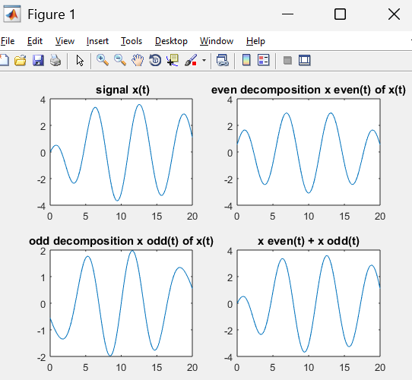

**Pre_lab 02**

t1 = 0:0.01:2;

x1 = t1;

t2 = 2:0.01:4;

x2 = 4 - t2;

% Full x(t)

t = [t1, t2];

x = [x1, x2];

% Define transformations

t_neg = -t; % x(-t)

t_scale = t / 2; % x(t/2)

t_shift_scale1 = (2 + 4*t); % x(2 + 4t)

t_shift_scale2 = (-2 - 4*t); % x(-2 - 4t)

% Plot original signal x(t)

subplot(3,2,1);

plot(t, x, 'b', 'LineWidth', 2);

xlabel('t'); ylabel('x(t)');

title('Original Signal x(t)');

grid on;

% Plot x(-t) (Time reversal)

subplot(3,2,2);

plot(t_neg, x, 'r', 'LineWidth', 2);

xlabel('t'); ylabel('x(-t)');

title('Time-Reversed Signal x(-t)');

grid on;

% Plot x(t/2) (Time scaling)

subplot(3,2,3);

plot(t_scale, x, 'g', 'LineWidth', 2);

xlabel('t'); ylabel('x(t/2)');

title('Time-Scaled Signal x(t/2)');

grid on;

% Plot x(2 + 4t) (Time scaling and shifting)

subplot(3,2,4);

plot(t_shift_scale1, x, 'm', 'LineWidth', 2);

xlabel('t'); ylabel('x(2 + 4t)');

title('Scaled and Shifted Signal x(2 + 4t)');

grid on;

% Plot x(-2 - 4t) (Time reversal, scaling, and shifting)

subplot(3,2,5);

plot(t_shift_scale2, x, 'c', 'LineWidth', 2);

xlabel('t'); ylabel('x(-2 - 4t)');

title('Transformed Signal x(-2 - 4t)');

grid on;

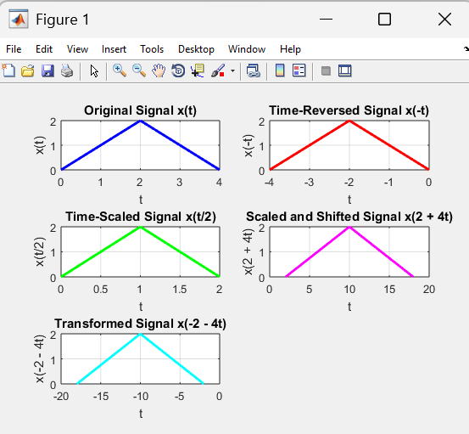

**lab 01**

t = 0:.1:2*pi

x=sin(t);

T=2*pi;

%using command window

for k=1:10

xk(k,:)=sin(t+k*T)

end

%using signal

x_shifted = sin(t + T);

figure;

plot(t, x, 'b', 'LineWidth', 2);

hold on;

plot(t, x_shifted, 'r--', 'LineWidth', 2);

axis([0 2*pi -1 1]);

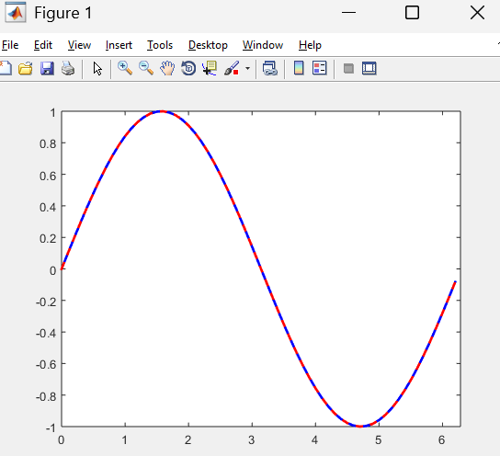

**lab 02**

t = 0:0.1:6*pi;

x = cos(t) + sin(3*t)

plot (t,x) 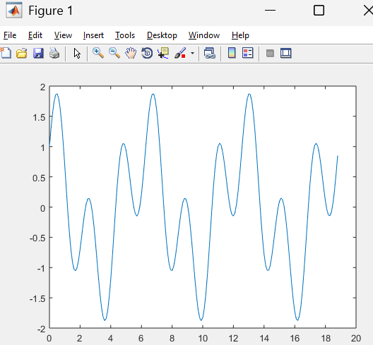

**lab 03**

subplot(311)

% Causal Signal (t >= 0)

t = 0:0.1:5;

x = t .* exp(-t);

plot(t, x)

title('Causal Signal')

xlabel('t')

ylabel('x(t)')

grid on

subplot(312)

% Anti-Causal Signal (t <= 0)

t = -5:0.1:0;

x = t .* exp(-t);

plot(t, x)

title('Anti-Causal Signal')

xlabel('t')

ylabel('x(t)')

grid on

subplot(313)

% Non-Causal Signal: x(t) = t*exp(-t) for t from -5 to 5

t = -5:0.1:5;

x = t .* exp(-t);

plot(t, x)

title('Non-Causal Signal')

xlabel('t')

ylabel('x(t)')

grid on

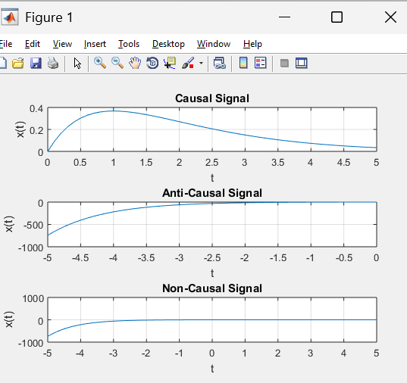

**lab 04**

subplot(311)

% Causal Signal (t >= 0)

t = 0:0.1:5;

x = t .* exp(-t);

plot(t, x)

title('Causal Signal')

xlabel('t')

ylabel('x(t)')

grid on

subplot(312)

% Anti-Causal Signal (t <= 0)

t = -5:0.1:0;

x = t .* exp(-t);

plot(t, x)

title('Anti-Causal Signal')

xlabel('t')

ylabel('x(t)')

grid on

subplot(313)

% Non-Causal Signal: x(t) = t*exp(-t) for t from -5 to 5

t = -5:0.1:5;

x = t .* exp(-t);

plot(t, x)

title('Non-Causal Signal')

xlabel('t')

ylabel('x(t)')

grid on

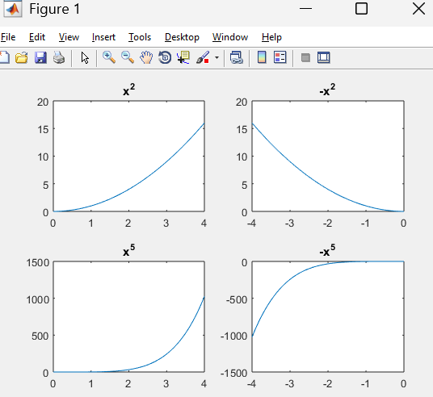

**lab 08**

t =-1:0.1:3;

% Define the original signal x(t)

x_t = t .* exp(-t);

% Define the time-reversed signal x(-t)

x_neg_t = (-t) .* exp(t);

% Plot both signals

figure;

subplot(211);

plot(t, x_t, 'b', 'LineWidth', 2);

xlabel('t'); ylabel('x(t)');

title('Original Signal x(t)');

grid on;

subplot(212);

plot(t, x_neg_t, 'r', 'LineWidth', 2);

xlabel('t'); ylabel('x(-t)');

title('Time-Reversed Signal x(-t)');

grid on;

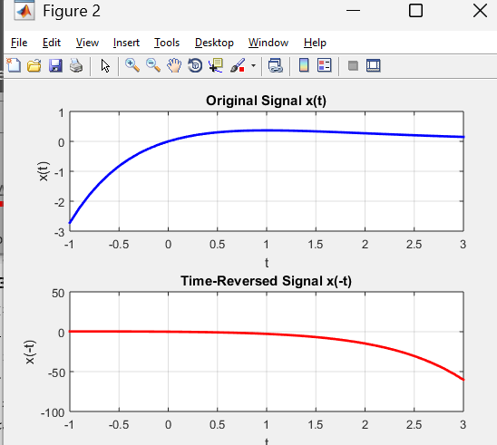

**lab 09**

t = -1:0.01:3;

x_t = t .* exp(-t); % Original signal x(t)

% Time compression (a = 2): x1(t) = x(2t)

x1_t = (2*t) .* exp(-2*t);

% Time expansion (a = 0.5): x2(t) = x(0.5t)

x2_t = (0.5*t) .* exp(-0.5*t);

% Plot the original and scaled signals

figure;

subplot(311);

plot(t, x_t, 'b', 'LineWidth', 2);

xlabel('t'); ylabel('x(t)');

title('Original Signal x(t)');

grid on;

subplot(312);

plot(t, x1_t, 'r--', 'LineWidth', 2);

xlabel('t'); ylabel('x(2t)');

title('Time-Compressed Signal (x(2t))');

grid on;

subplot(313);

plot(t, x2_t, 'g-.', 'LineWidth', 2);

xlabel('t'); ylabel('x(0.5t)');

title('Time-Expanded Signal (x(0.5t))');

grid on;

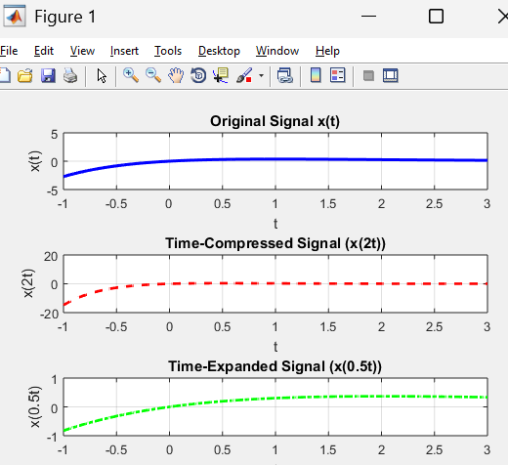

**lab 10**

t=-1:.01:3;

x_t = t .* exp(-t);

x1_t = (t - 2) .* exp(-(t - 2));

x2_t = (t + 3) .* exp(-(t + 3));

subplot(311)

plot(t,x_t,'g');

title('orignal');

xlabel('t');

ylabel('x_t');

grid on;

subplot(312)

plot(t,x1_t,'b-');

title('shifted version of x_t by two units to the right');

xlabel('t');

ylabel('x1_t');

grid on;

subplot(313)

plot(t,x2_t,'r--');

title('shifted version of x_t by three units to the left');

xlabel('t');

ylabel('x2_t');

grid on;

