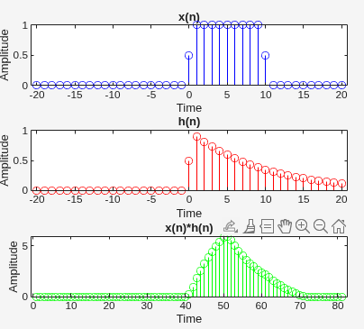
n = -20:20;
x = heaviside(n) - heaviside(n-10);
h = 0.9 .^ n .* heaviside(n);
c = conv (x , h);
subplot (311); stem (n , x , 'b')
title ('x(n)')
xlabel("Time"); ylabel("Amplitude")
subplot (312); stem (n,h,'r')
title ('h(n)')
xlabel("Time"); ylabel("Amplitude")
subplot (313) ; stem (c , 'g')
title ('x(n)*h(n)')
xlabel("Time"); ylabel("Amplitude")

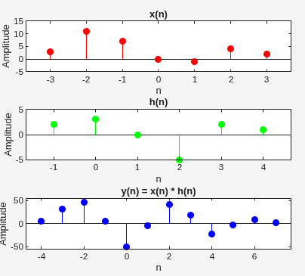
n1 = -3 : 3;
x = [3,11,7,0,-1,4,2];
n2 = -1 : 4 ;
h = [2,3,0,-5,2,1];
% set the sample for conv signal
n = -4 : 7 ;
y = conv (x, h);
subplot(311)
stem (n1 , x , 'r', 'filled' )
xlabel('n'); ylabel('Amplitude');
title('x(n)'); ylim ([-5 15])
subplot(312)
stem ( n2 , h , 'g' , 'filled')
xlabel('n'); ylabel('Amplitude');
title('h(n)'); ylim ([-5 5])
subplot(313)
stem (n , y , 'b' , 'filled')
xlabel('n'); ylabel('Amplitude');
title('y(n) = x(n) * h(n)');
ylim ([-55 55])

% Take input signal x
x = input('Enter array for input signal x:');
% Specify the time index range for x
n1 = input('Specify starting value for x: ');
n2 = input('Specify ending value for x: ');
nx = n1:n2;
% Take impulse response h
h = input('Enter array for impulse response h:');
% Specify the time index range for h
n3 = input('Specify starting value for h: ');
n4 = input('Specify ending value for h: ');
nh = n3:n4;
[y, n] = convolution(x, nx, h, nh);
% Plot the convolved signal
stem(n, y, 'filled');
xlabel('n'); ylabel('Amplitude');
title('Convolved Signal y(n) = x(n) * h(n)');

function [y ,n] = convolution(x , n1, h , n2)
n = (n1(1) + n2(1)) : (n1(end) + n2(end));
y = conv(x ,h)
end

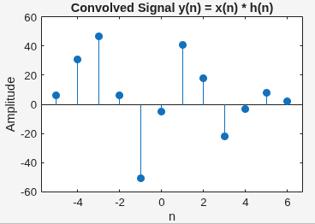

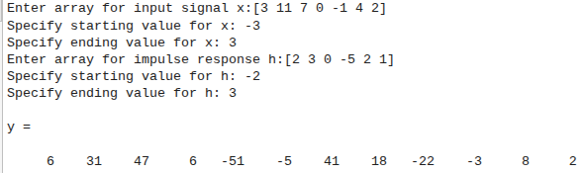

n1 = -3:3
n2 = -1:4
x = [3 11 7 0 -1 4 2]
h = [2 3 0 -5 2 1]
length_xh = length(x) + length(h) -1
y = conv(x,h)
length_conv = length(y)
if(length_xh == length_conv)
disp('Length(y) = M + N - 1 ');
else
disp('Length(y) != M + N - 1 ');
end

% Define sequences
x = [3,11,7,0,-1,4,2];
y = [2,3,0,-5,2,1];
z = [2,3,0,-5,2,1];
% Associative Property: (x*y)*z = x*(y*z)
r1 = conv(x,y);
r3 = conv(y,z);
lhs_assoc = conv(r1,z);
rhs_assoc = conv(x,r3);
figure;
subplot(2,1,1);
stem(lhs_assoc,'filled');
title('(x*y)*z');
xlabel('n'); ylabel('Amplitude');
subplot(2,1,2);
stem(rhs_assoc,'filled');
title('x*(y*z)');
xlabel('n'); ylabel('Amplitude');

% Define sequences
x = [3,11,7,0,-1,4,2];
y = [2,3,0,-5,2,1];
z = [2,3,0,-5,2,1];
% Commutative Property: x*y = y*x
c1 = conv(x,y);
c2 = conv(y,x);
figure;
subplot(2,1,1);
stem(c1,'filled');
title('x*y');
xlabel('n'); ylabel('Amplitude');
subplot(2,1,2);
stem(c2,'filled');
title('y*x');
xlabel('n'); ylabel('Amplitude');

% Define sequences
x = [3,11,7,0,-1,4,2];
y = [2,3,0,-5,2,1];
z = [2,3,0,-5,2,1];
% Distributive Property: x*(y+z) = x*y + x*z
lhs_dist = conv(x, y+z); % LHS
rhs_dist = conv(x,y) + conv(x,z); % RHS
figure;
subplot(2,1,1);
stem(lhs_dist,'filled');
title('x*(y+z)');
xlabel('n'); ylabel('Amplitude');
subplot(2,1,2);
stem(rhs_dist,'filled');
title('x*y + x*z');
xlabel('n'); ylabel('Amplitude');

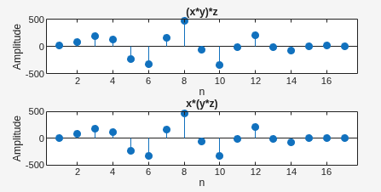
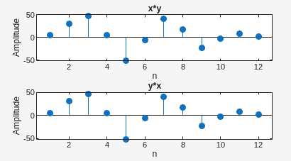
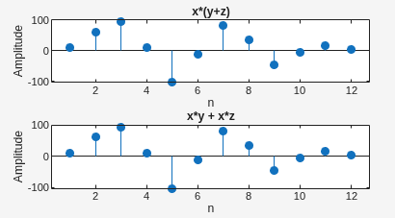
ASSOCIATIVE PROPERTY
DISTRIBUTIVE PROPERTY
COMMUTATIVE PROPERTY

