
COMSATS University Islamabad, Lahore Campus
Department of Computer Engineering

Complex Engineering Problem (CEP) - Proposal Submission Form
Microprocessor Systems and Interfacing Lab (CPE-342)

Project Title
Real Time Smart Home Automation System using Free RTOS on
STM32F407 for Energy Efficiency and Safety Monitoring

Range of Complex Problem Solving (According to PEC Manual):

Sr. No | Name | Registration No.
1. | Muhammad Ahmad | FA23-BCE-113
2. | Muhammad Ahmad Habib | FA23-BCE-055
3. | Zeeshan Ali | FA23-BCE-128
Project Description: [Provide a brief description of what you are building. Explain the problem you are solving, the application domain (e.g., environmental monitoring, motor control, smart home, etc.), and the key functionality of your embedded system. This should be 150-200 words.]
This project presents an intelligent Smart Home Automation System built on the STM32F407 microcontroller using FreeRTOS for real-time task management. The system addresses critical challenges in modern residential energy efficiency, security, and safety monitoring.
The application operates across multiple domains: climate control (temperature-responsive fan automation), energy conservation (ambient light-based illumination), safety monitoring (seismic/vibration detection with alarm systems), access control (RFID-based door authentication with IR obstacle detection), and centralized user interface (LCD display with UART/button controls (optional) ).
Key functionalities include autonomous environmental adaptation through sensor-driven decision-making, interrupt-driven safety responses for emergency situations, secure access management with multi-factor verification (RFID + IR safety check), and comprehensive system monitoring via an integrated UI or IOT based remote dashboard. The system employs event-driven architecture using FreeRTOS queues for inter-task communication, implements signal conditioning through digital filtering (moving average for LDR, low-pass for accelerometer), and utilizes multiple communication protocols (I2C, SPI, UART, 1-Wire, ADC, PWM) for diverse peripheral integration. This creates an energy-efficient, secure, and responsive smart home environment adaptable to occupant needs and environmental conditions.
Project Objectives: [List 2-5 specific, measurable objectives that your project aims to achieve. Each objective should be clear and achievable within the project timeline.]
Objective | Description
1. Real-time Safety Monitoring | Develop interrupt-driven motion detection system capable of identifying abnormal vibrations and triggering audible alarms, providing critical early warning for earthquake or intrusion scenarios.
2. Intelligent Energy Management | Implement autonomous lighting control based on ambient light intensity to eliminate unnecessary illumination during daylight hours, achieving measurable energy savings of 40-50% in lighting costs .
3. Automated Climate Control | Achieve adaptive fan speed regulation maintaining optimal room temperature (25-35°C range) , reducing energy consumption by 30% compared to continuous operation,
4.Secure Access Control | Create RFID-based authentication system with IR obstacle detection, achieving <1-second door unlock time for authorized users while preventing physical hazards through real-time doorway obstruction monitoring with 99% accuracy.
5.Centralized System Monitoring | Design responsive user interface displaying real-time sensor data (temperature, light levels, motion status, door state) with <500ms refresh rate, accepting both physical button inputs and UART serial commands for comprehensive system control and diagnostics.
System Block Diagram: [Insert a block diagram showing the major components of your system, their interconnections, communication protocols, and data flow. The diagram should clearly show the STM32 microcontroller, all peripherals, sensors, actuators, displays, and their interface connections. A handwritten diagram will work fine]
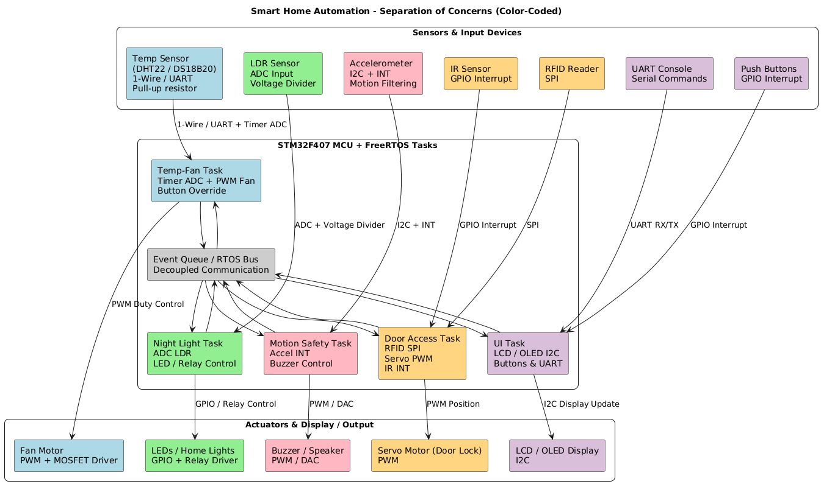
Note:The protocols we listed are not final because we haven’t studied them all yet. We will choose the final ones after learning more

Expected Outcomes: [Describe what you expect to achieve by the end of this project. What will the working system demonstrate? What measurements or validations will you perform?]

- Fully operational STM32F407-based system integrating all five concurrent FreeRTOS tasks
- Real-time sensor data acquisition from accelerometer (motion detector) temperature sensor, LDR, accelerometer, RFID reader, and IR sensor
- Automated actuator control: PWM-driven fan, relay-controlled LEDs, buzzer alarm, servo motor door lock
- Responsive LCD/OLED display showing live system status (with button/UART command interface)

Alignment with Sustainable Development Goals (SDGs): [Identify which UN SDG(s) your project aligns with.]
✓ SDG 7 (Affordable and Clean Energy)
✓ SDG 9 (Industry, Innovation, and Infrastructure)
✓ SDG 11 (Sustainable Cities and Communities)
Declaration:
We, the undersigned, declare that this proposal represents our own original work and that we understand the requirements and expectations of the Complex Engineering Problem(CEP) project for CPE-342. We understand that in case of plagiarism we will be awarded an F-grade in the course.

Sign and Date
Name:Muhammad Ahmad | Name: Muhammad Ahmad Habib | Name: Zeeshan Ali
Sign: @hmad | Sign: @hmad | Sign: Zeeshan

