FA23-BCE-113
Muhammad Ahmad
MSI-Lab # 1

Task 1: Fill the table after compiling the code
Write the following program in editor, compile and emulate it. Also fill the table.
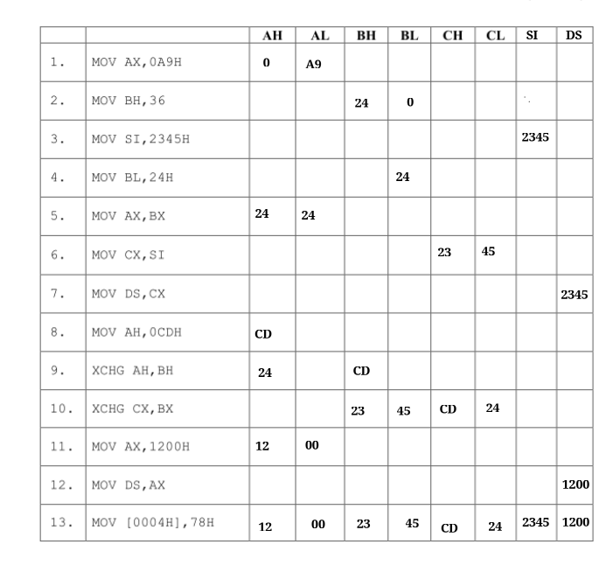

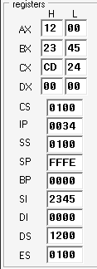

Description: The table is filled in an incremental way, like at every step, value of registers are updated according to the instruction given, the new value is written to register when it is overwritten by the new register, at the end, all upgraded values are written in one row, also the screenshot of final register content is also attached above

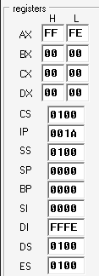
Task 2: Without using XCHG command, write 8086/8088 Assembly language programthat swap the contents of
a) SP and DI registers

MOV AX, SP
MOV SP, DI
MOV DI, AX

Description: SP is the stack pointer ,DI is the destination index, by default SP points to the top of the stack (sp = FFFE), We use a helper register AX to store the value of SP , and then update the SP with the value of the DI and at the end we update the DI with the value store in helper register AX
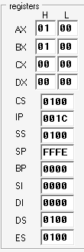
b) SS and DS registers

MOV BX, DS
MOV AX, SS ; NOTE: MOV SS,DS , Move DS,SS (WE ARE UNABLE TO DO THAT IT CAN BE DONE DURING EXECUTION
MOV SS, BX
;mov bx , ax
MOV DS, AX

Description: We are unable to change the content of SS and DS so we first store
them in a helper register and then repeat the task 1

c) Memory locations ABCDH: 2345H and 1234H: 78DEH

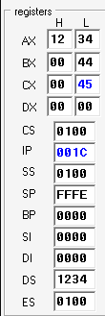
; load ABCDH: 2345H into bx
MOV AX , 0abcdh
MOV DS , AX
MOV [2345h],44h ; hamara kaam
MOV BX,[2345h] ; bx = 44h
; load 1234H: 78DEH into cx
MOV AX , 1234h
MOV DS , AX
MOV [78DEH],45h ; hamara kaam
MOV CX , [78DEH] ; 45h

; swap bx and cx
MOV DX , BX
MOV BX , CX
MOV CX , DX

; now store value back to memory
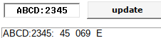
MOV AX , 0abcdh
MOV DS , AX
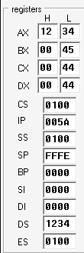
MOV [2345h],BX
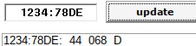
MOV AX , 1234h
MOV DS , AX
MOV [78DEH],CX

; now load back to verify
; load ABCDH: 2345H into bx
MOV AX , 0abcdh
MOV DS , AX
MOV BX,[2345h]

; load 1234H: 78DEH into cx
MOV AX , 1234h
MOV DS , AX
MOV CX , [78DEH]

Description: We first store the values at both memory locations ABCDH: 2345H and 1234H: 78DEH also load them in BX , CX respectivley . Then we swap BX and CX using the method use in task2a. Finally, we store back the swapped values in the respective address location. To verify result we load back the values form respective address , or we also see the swaped value fron the memory

