FA23-BCE-113
Muhammad Ahmad
MSI-Lab # 2

Task 1: Fill the table after compiling the code
Type in the following program in editor of EMU8086 and fill in the table.
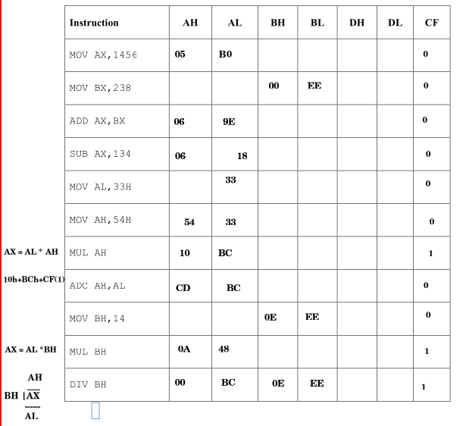

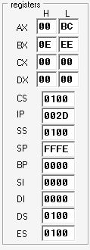

Description: The table is filled in an incremental way, like at every step, value of registers are updated according to the instruction given, the new value is written to register when it is overwritten by the new register, at the end, all upgraded values are written in one row, also the screenshot of final register content is also attached above
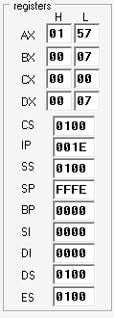
Task 2: Write an assembly language code to compute the cube of a number
Write an assembly language program that cube the 8-bit number found in DL. Load DL with 7 initially,and make sure that your result is a 16-bit number.
MOV DL , 7
MOV AL , DL
MOV BL , DL
MUL BL ; 7*7
MUL BL ; 49*7
Description: We have 8bit number found in DL, we mov it to AL, since we have to take cube of a number we multiply given number 3 times, so we also move 8bit number found in DL to BL and multiply it 2 times. At the end final result is in AX.
Task 3: Write an assembly code that converts the Fahrenheit reading of temperature into
the equivalent Celsius reading
Write an assembly language program that converts the Fahrenheit reading of temperature into the equivalent Celsius reading. Celsius reading is found in AH register and Fahrenheit reading is to be stored in AL register.
Hint: Formula for conversion is as follows
𝐶 = 5/9 𝑥 (𝐹 − 32)

; C = AH , F = AL
MOV AL , 100 ; F = 100
MOV BL , 32
SUB AL , BL ; al = F - 32

MOV BL , 5
MUL BL ; AX = AL * BL
; AX = (F-32) * 5
MOV BL , 9
DIV BL ; AX/BL -> AL = quotient , AH = remainder
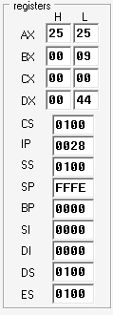
mov ah , al ; Celsius -> AH

Description: Above code is well commented at every step.

