Task 01:
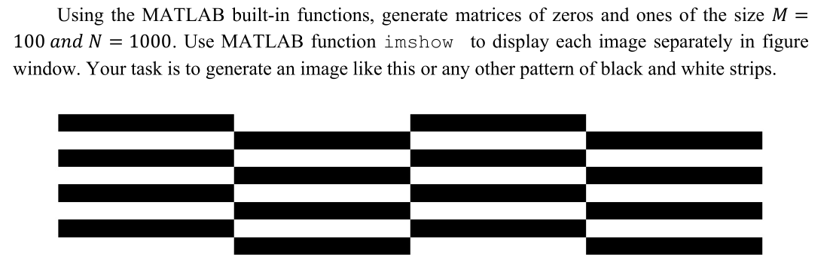
m = 100;  n = 1000;  img_zeros = zeros(m, n);  img_ones = ones(m, n);  % Number of repetitions  row_repeat = 8;  col_repeat = 4;  % Initialize final grid  grid_pattern = [];  for r = 1:row_repeat  % Initialize one row of blocks  row_blocks = [];  for c = 1:col_repeat  if mod(r + c, 2) == 0  row_blocks = [row_blocks img_zeros];  else  row_blocks = [row_blocks img_ones];  end  end  % Stacking rows downward  grid_pattern = [grid_pattern; row_blocks];  hold on  imshow(grid_pattern)  pause (0.01)  end  imshow(grid_pattern);  hold off | 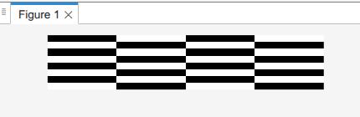

Task 02:


clc  clear  close all  %% read an image  img_path = '/MATLAB Drive/DIP/img1.jpg';  % read an image  i = imread(img_path );  % showing image  imshow(i)  % checking size of that image  size(i)  %% modify the image  subplot(121)  j = imread(img_path );  imshow(j)  % decreasing the intensity of an image  subplot(122)  u = j-100;  imshow(u)  %% saving modified image  % stored  imwrite(u,"/MATLAB Drive/DIP/img1_low-intens.jpg")  %% imshow(i,[low,high] -> below low -> black , above high -> white  subplot(121)  k = imread('cameraman.tif'); % from matlab images  imshow(k)  subplot(122)  imshow(k,[33,120]) | 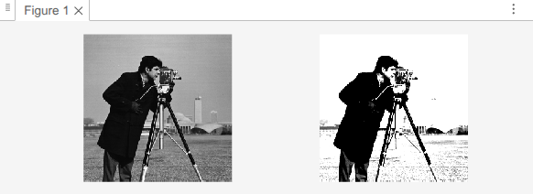  

Task 03:
Display a grayscale image with varying pixel intensity transitions.
clc  clear  close all  gray_scale_image = [  0.0 0.0 0.0 0.0 0.0  0.0 0.5 0.5 0.5 0.0  0.0 0.5 0.1 0.5 0.0  0.0 0.5 0.5 0.5 0.0  0.0 0.0 0.0 0.0 0.0  ];  imshow(gray_scale_image)  % to store row and col size in a variable  [m,n] = size (gray_scale_image); | 