Assignment 02
Name: Muhammad Ahmad
Roll Number: FA23-BCE-113
Course: CSC462 - Artificial Intelligence

(i) Pseudocode for Simple Linear Regression using Gradient Descent
ALGORITHM: Simple Linear Regression using Gradient Descent
INPUT:
X: array of input features (Years of Experience)
Y: array of target values (Salary)
learning_rate: step size for gradient descent (α)
iterations: number of iterations for gradient descent
OUTPUT:
b0: intercept (bias)
b1: slope (weight)
PROCEDURE:
1. INITIALIZE b0 = 0, b1 = 0
2. SET n = number of samples in X
3. FOR i = 1 TO iterations DO:
a. COMPUTE predictions: Y_pred = b0 + b1 * X
b. COMPUTE error: error = Y_pred - Y
c. COMPUTE gradients:
- gradient_b0 = (2/n) * Σ(error)
- gradient_b1 = (2/n) * Σ(error * X)
d. UPDATE parameters:
- b0 = b0 - α * gradient_b0
- b1 = b1 - α * gradient_b1
4. RETURN b0, b1
END PROCEDURE

(ii) Scatter Plot and Regression Line - Gradient Descent Model
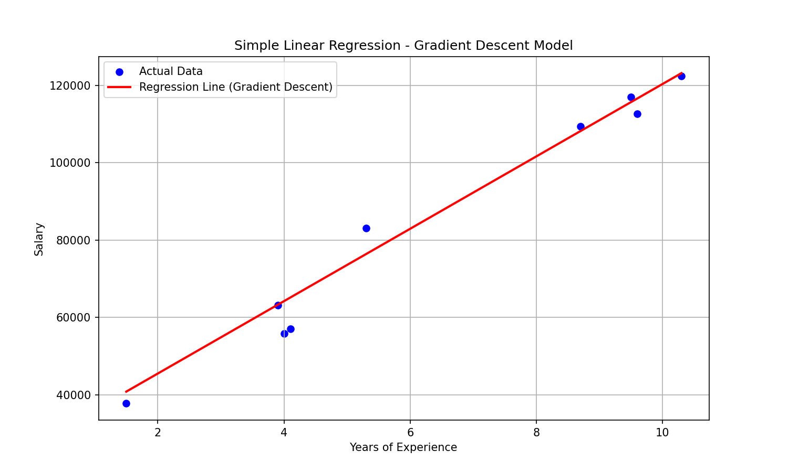

(iii) Scatter Plot and Regression Line - sklearn Model
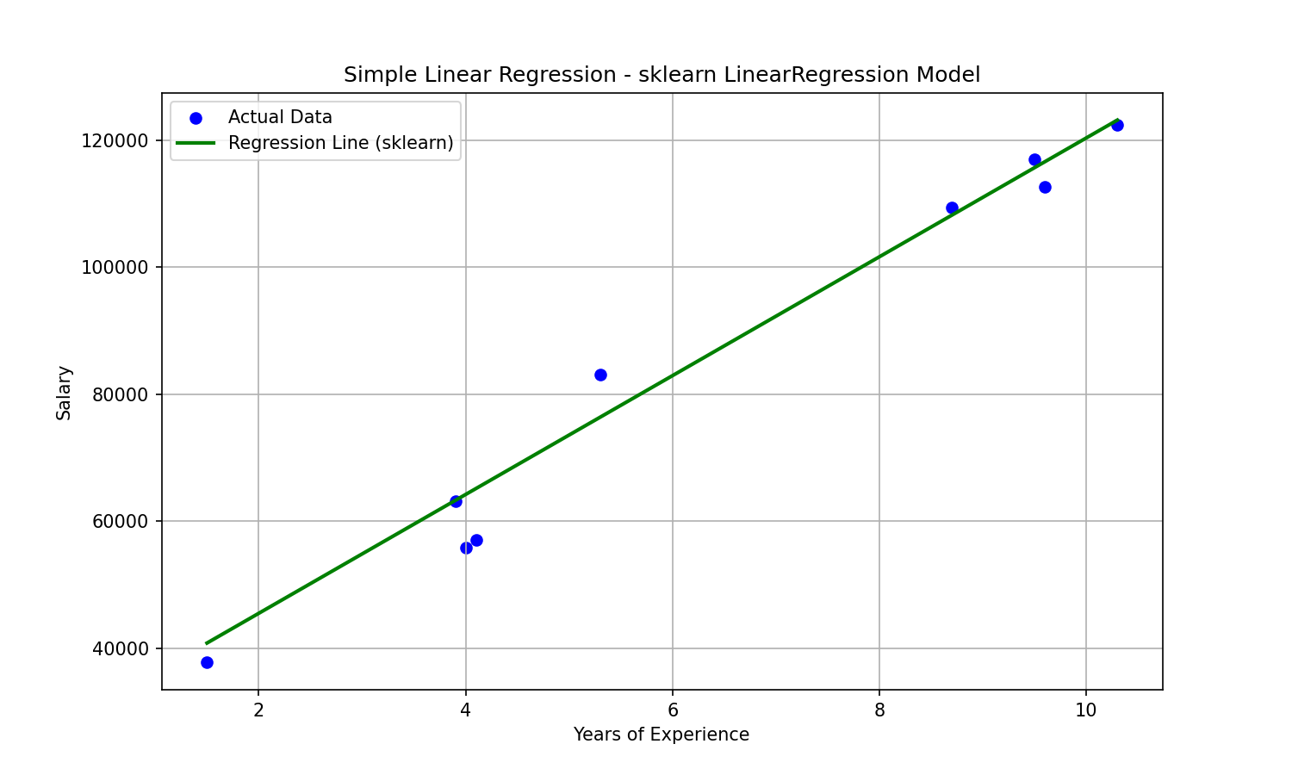

(iv) Coefficients Comparison Table
Model | b0 (Intercept) | b1 (Slope)
Gradient Descent | 26777.391341 | 9360.261286
sklearn LinearRegression | 26777.391341 | 9360.261286

(v) Performance Metrics Comparison Table
Model | RMSE | MAE | R2 Score
Gradient Descent | 4834.2609 | 3737.4179 | 0.9741
sklearn LinearRegression | 4834.2609 | 3737.4179 | 0.9741

