Task 01:
In addition to performing the above tasks using imtool, discuss at least two other applications of imtool on your images and display results
i = imread("peppers.png");
i_gray = rgb2gray(i);
imtool(i_gray);

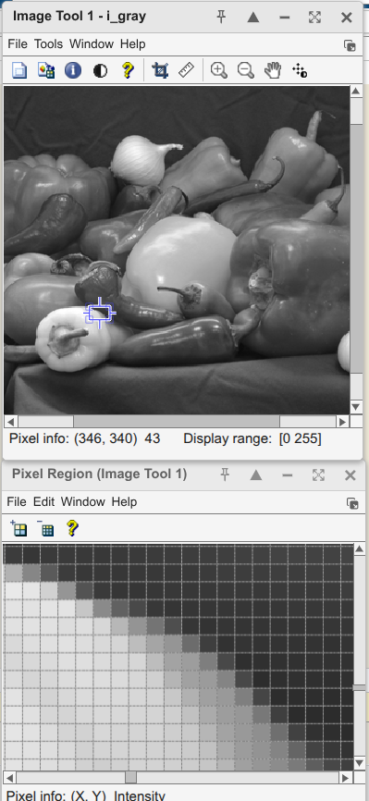 | 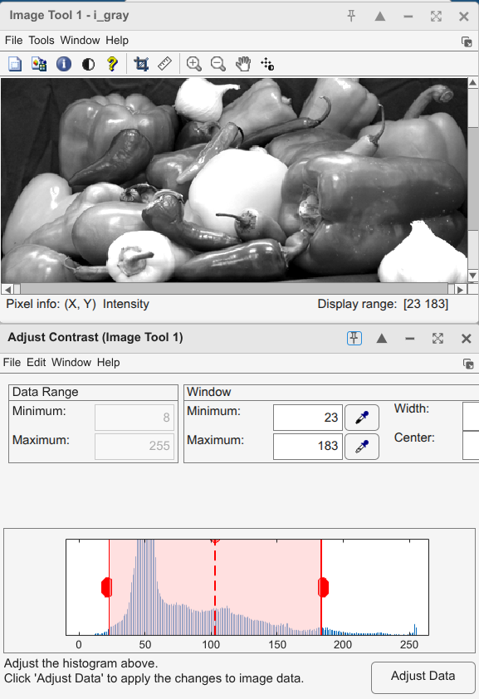

Task 02:
Display at least two utilizations of imtool for RGB image. Briefly explain limitations of imtool
for RGB images (if any).
i = imread("peppers.png");  imtool(i,[]) | 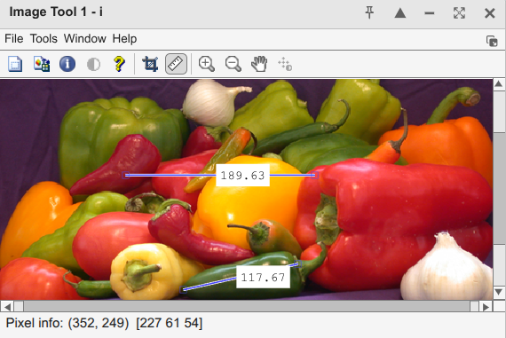
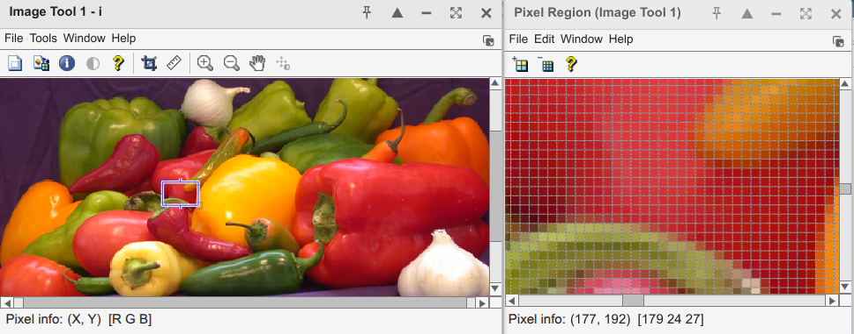
Task 03:
Display a grayscale image ith varying pixel intensity transitions.

img = imread('peppers.png');  figure;  % --- Original Image ---  subplot(1, 2, 1); % 1 row, 2 columns, position 1  h_orig = imshow(img)  title('Original RGB Image');  % --- Modified Image ---  subplot(1, 2, 2);  h_rgb = imshow(img);  title('Modified RGB Image (Vertically Flipped)');  % Overwrite properties using OOP approach  set(h_rgb, 'CData', flipud(img)); % ColourData flip up down  % flip -> left right flip  set(h_rgb, 'Interpolation','bilinear'); % check the quality improvment | 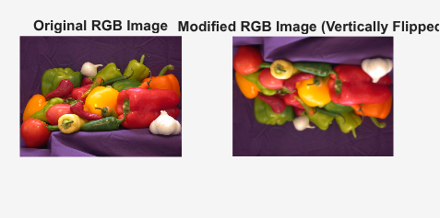

Task 4
Learn and apply the following functions for gray scale and RGB images without using imtool.
imcontrast
imdisplayrange
imdistline
immagbox

clc;clear;close all
img_gray = imread('cameraman.tif');
fig1 = figure('Name', 'Grayscale Image with Tools');
h_panel_gray = imscrollpanel(fig1, imshow(img_gray));
h_img_gray = findobj(h_panel_gray, 'Type', 'image');
imcontrast(h_img_gray);
imdisplayrange(h_img_gray);
immagbox(fig1, h_img_gray);
imdistline(gca);

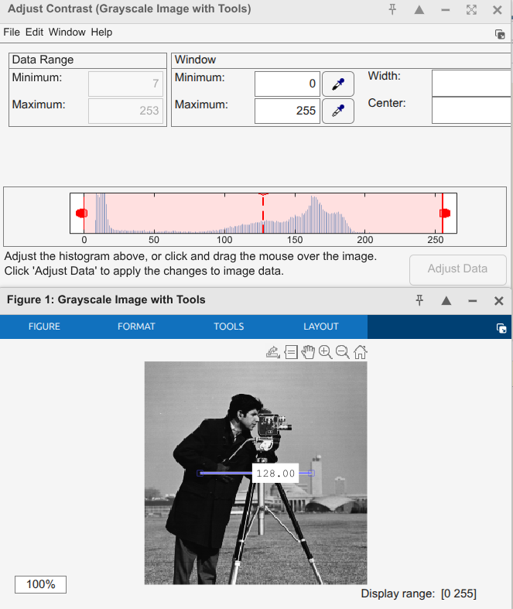

Lab Task 5
Print an image at the resolution of 300 dots per inch (dpi) in vector graphic format. You should use the MATLAB help to find how to set resolution of the image in print function. You can print your figure in any of the following vector graphic format shown in Table 2.3.

clc;clear;close all  img = imread('cameraman.tif');  imshow(img);  title('Cameraman Image');  print('-dsvg', '-r300', 'cameraman_300dpi.svg'); | 