Task 01:
Use the MATLAB help to understand the basic intensity transformation function imadjust,and use
the examples in help to produce various image transformation results.
%img_adjust = imadjust(img_gray, [inputrange], [output range], gamma);  % Load and process image  img = imread('peppers.png');  img = im2double(img);  % Convert to grayscale  img_gray = rgb2gray(img);  % Apply contrast adjustment  img_adjust = imadjust(img_gray, [0.3 0.7], [0 1]);  figure();  subplot(1, 3, 1);  imshow(img);  title('Original RGB Image');  subplot(1, 3, 2);  imshow(img_gray);  title('Grayscale Image');  subplot(1, 3, 3);  imshow(img_adjust);  title('Contrast Adjusted Image') | 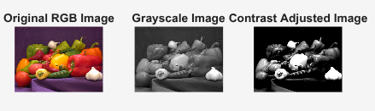  [0.3 0.7], [0 1]  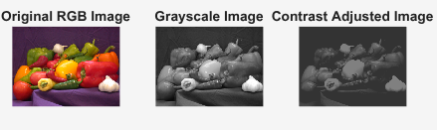  [0.3 0.7], [0.2 0.5]

Task 02:
Use the MATLAB imadjust to display and analyse the impact of using different values of gamma.
Display images using at least three different values of gamma. Briefly discuss the observations.
clc; clear; close all;  img = imread('cameraman.tif');  figure;  subplot(221);  imshow(img);  title('Original Image');  % Apply imadjust with gamma < 1 (brighten)  img_gamma_low = imadjust(img, [], [], 0.5);  subplot(222);  imshow(img_gamma_low);  title('Gamma = 0.5 (Brighter)');  % Apply imadjust with gamma = 1 (no change)  img_gamma_one = imadjust(img, [], [], 1);  subplot(223);  imshow(img_gamma_one);  title('Gamma = 1 (No Change)');  % Apply imadjust with gamma > 1 (darken)  img_gamma_high = imadjust(img, [], [], 2);  subplot(224);  imshow(img_gamma_high);  title('Gamma = 2 (Darker)'); | 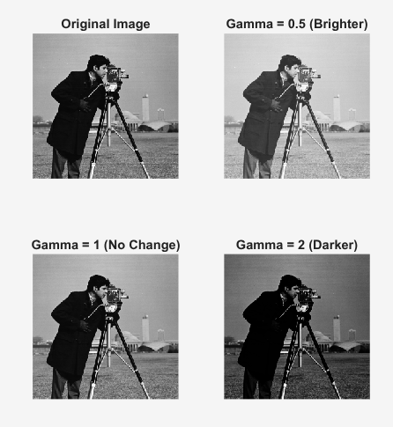

Task 03:
Use the MATLAB help to understand the function imcomplement,and use the examples in help to
produce various image transformation results. Apply the imcomplement function to RGB image,
display the results and discuss.

orignal = imread("cameraman.tif");  comp = imcomplement(orignal);  subplot (211)  imshowpair(orignal , comp , "montage");  title ("using imcomplement")  % adj = imadjust(orignal,[],[], 0.1);  adj = imadjust(orignal, [0 1], [1 0]);  subplot (212)  imshowpair(orignal , adj , "montage");  title ("using adjust") | 