
COMSATS UNIVERSITY ISLAMABAD
Lahore Campus
Department of Computer Engineering

CSC462 – Artificial Intelligence

Assignment # 01

Resource Person
Dr. Farooq-e-Azam

Submitted by
Muhammad Ahmad (FA23-BCE-113)

Submission Date: 12-03-2026
(I) Pseudo Code:
ALGORITHM: Simple Linear Regression

INPUT: SalaryData.csv [YearsExperience, Salary]
OUTPUT: Model coefficients (b0, b1) and evaluation metrics

1. LOAD DATA
- Read CSV file
- x = YearsExperience column
- y = Salary column

2. SPLIT DATA (70% training, 30% testing)
- x_train, x_test, y_train, y_test = train_test_split(x, y, test_size=0.3, random_state=0)

3. CALCULATE COEFFICIENTS
a) Convert X and y to numpy arrays, reshape to 1D
b) Calculate means:
x_mean = mean(x_train)
y_mean = mean(y_train)
c) Calculate b1:
b1 = sum((x_train - x_mean) * (y_train - y_mean)) / sum((x_train - x_mean)²)
d) Calculate b0:
b0 = y_mean - (b1 * x_mean)

4. MAKE PREDICTIONS
FOR each sample in X_test:
y_predicted = b0 + b1 * x_test

5. CALCULATE EVALUATION METRICS

a) MAE (Mean Absolute Error):
mae = sum(|y_test - y_predicted|) / length(y_test)
b) RMSE (Root Mean Square Error):
mse = sum((y_test - y_predicted)²) / length(y_test)
rmse = sqrt(mse)
c) R² Score:
ssr = sum((y_test - y_predicted)²)
sst = sum((y_test - mean(y_test))²)
r2 = 1 - (ssr / sst)

6. OUTPUT RESULTS
- Print b0, b1
- Print MAE, RMSE, R² Score
- Plot scatter and regression line

END
(II) Scatter plot and regression line of model:
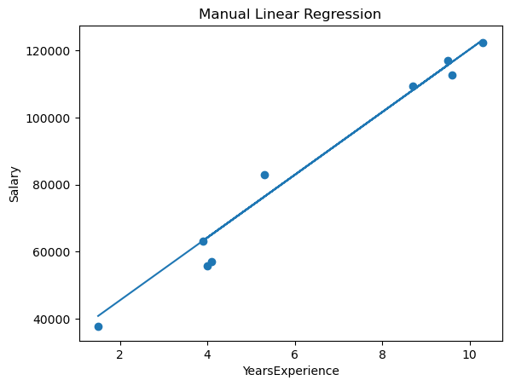Figure 1: Scatter plot and regression line for test data of custom model.
(III) Scatter plot and regression line of model:
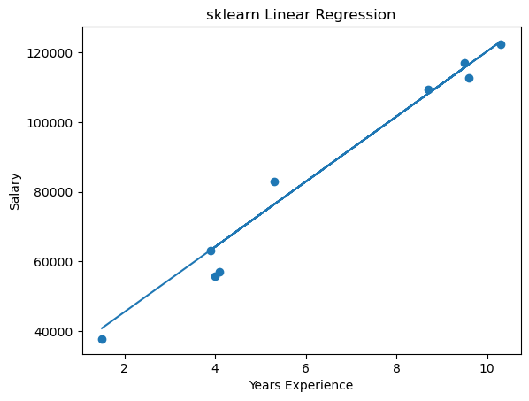Figure 2: Scatter plot and regression line for test date using built-in model.
(IV) Coefficients Comparison:
The following table compares the coefficients (b0 and b1) calculated by the manual implementation and the sklearn Linear Regression model:
Coefficient | sklearn Model | Manual Model
b0 | 9360.261286193654 | 9360.261286193658
b1 | 26777.391341197632 | 26777.39134119761
Both implementations produce nearly identical coefficients.
(V) RMSE, MAE and R2 score Comparison:
The following table compares the MAE, RMSE, and R² score between the manual implementation and the sklearn Linear Regression model:
Value | sklearn Model | Manual Model
MAE | 3737.4178618788987 | 3737.417861878893
RMSE | 4834.260936361728 | 4834.260936361725
R2 | 0.9740993407213511 | 0.9740993407213511
Both implementations produce identical MAE, RMSE, and R² scores.

