|  |  |
| --- | --- |
| Name: Muhammad Ahmad | EE-272L Digital Systems Design |
| Reg. No.: 2023-EE-68 | Marks Obtained: ____________ |

**Lab Manual 5**

|  |  |  |  |  |  |
| --- | --- | --- | --- | --- | --- |
| **DSD Lab Manual Evaluation Rubrics** | | | | | |
|  |  |  |  |  |  |
| **Assessment** | **Total Marks** | **Marks Obtained** | **0-30%** | **30-60%** | **70-100%** |
| Code Organization (CLO1) | 3 |  | No Proper Indentation and descriptive naming, no code organization.  Zero to Some understanding but not working | Proper Indentation or descriptive naming or code organization.  Mild to Complete understanding but not working | Proper Indentation and descriptive naming, code organization.  Complete understanding, and proper working |
| Simulation (CLO2) | 5 |  | Simulation not done or incorrect, without any understanding of waveforms | Working simulation with errors, don't cares's(x) and high impedance(z), partial understanding of waveforms | Working simulation without any errors, etc and complete understanding of waveforms |
| FPGA (CLO2) | 2 |  | Not implemented on FPGA and questions related to synthesis and implementation not answered. | Correctly Implemented on FPGA or questions related to synthesis and implementation answered. | Correctly Implemented on FPGA and questions related to synthesis and implementation answered. |

**(a)Truth Table:**

|  |  |  |  |  |  |  |  |  |  |  |  |
| --- | --- | --- | --- | --- | --- | --- | --- | --- | --- | --- | --- |
| **Character** | **c[3]** | **c[2]** | **c[1]** | **c[0]** | **Seg a** | **Seg b** | **Seg c1** | **Seg d** | **Seg e** | **Seg f** | **Seg g** |
| 0 | 0 | 0 | 0 | 0 | 0 | 0 | 0 | 0 | 0 | 0 | 1 |
| 1 | 0 | 0 | 0 | 1 | 1 | 0 | 0 | 1 | 1 | 1 | 1 |
| 2 | 0 | 0 | 1 | 0 | 0 | 0 | 1 | 0 | 0 | 1 | 0 |
| 3 | 0 | 0 | 1 | 1 | 0 | 0 | 0 | 0 | 1 | 1 | 0 |
| 4 | 0 | 1 | 0 | 0 | 1 | 0 | 0 | 1 | 1 | 0 | 0 |
| 5 | 0 | 1 | 0 | 1 | 0 | 1 | 0 | 0 | 1 | 0 | 0 |
| 6 | 0 | 1 | 1 | 0 | 0 | 1 | 0 | 0 | 0 | 0 | 0 |
| 7 | 0 | 1 | 1 | 1 | 0 | 0 | 0 | 1 | 1 | 1 | 1 |
| 8 | 1 | 0 | 0 | 0 | 0 | 0 | 0 | 0 | 0 | 0 | 0 |
| 9 | 1 | 0 | 0 | 1 | 0 | 0 | 0 | 0 | 1 | 0 | 0 |
| A | 1 | 0 | 1 | 0 | 0 | 0 | 0 | 1 | 0 | 0 | 0 |
| B | 1 | 0 | 1 | 1 | 1 | 1 | 0 | 0 | 0 | 0 | 0 |
| C | 1 | 1 | 0 | 0 | 0 | 1 | 1 | 0 | 0 | 0 | 1 |
| D | 1 | 1 | 0 | 1 | 1 | 0 | 0 | 0 | 0 | 1 | 0 |
| E | 1 | 1 | 1 | 0 | 0 | 1 | 1 | 0 | 0 | 0 | 0 |
| F | 1 | 1 | 1 | 1 | 0 | 1 | 1 | 1 | 0 | 0 | 0 |

* **Truth Table for selector:**

|  |  |  |  |  |  |  |  |  |  |  |  |
| --- | --- | --- | --- | --- | --- | --- | --- | --- | --- | --- | --- |
| **segment** | **s[2]** | **s[1]** | **s[0]** | **Seg0** | **Seg1** | **Seg2** | **Seg3** | **Seg4** | **Seg5** | **Seg6** | **Seg7** |
| 0 | 0 | 0 | 0 | 0 | 1 | 1 | 1 | 1 | 1 | 1 | 1 |
| 1 | 0 | 0 | 1 | 1 | 0 | 1 | 1 | 1 | 1 | 1 | 1 |
| 2 | 0 | 1 | 0 | 1 | 1 | 0 | 1 | 1 | 1 | 1 | 1 |
| 3 | 0 | 1 | 1 | 1 | 1 | 1 | 0 | 1 | 1 | 1 | 1 |
| 4 | 1 | 0 | 0 | 1 | 1 | 1 | 1 | 0 | 1 | 1 | 1 |
| 5 | 1 | 0 | 1 | 1 | 1 | 1 | 1 | 1 | 0 | 1 | 1 |
| 6 | 1 | 1 | 0 | 1 | 1 | 1 | 1 | 1 | 1 | 0 | 1 |
| 7 | 1 | 1 | 1 | 1 | 1 | 1 | 1 | 1 | 1 | 1 | 0 |

**(b) K-Maps use to minimize the logic:**

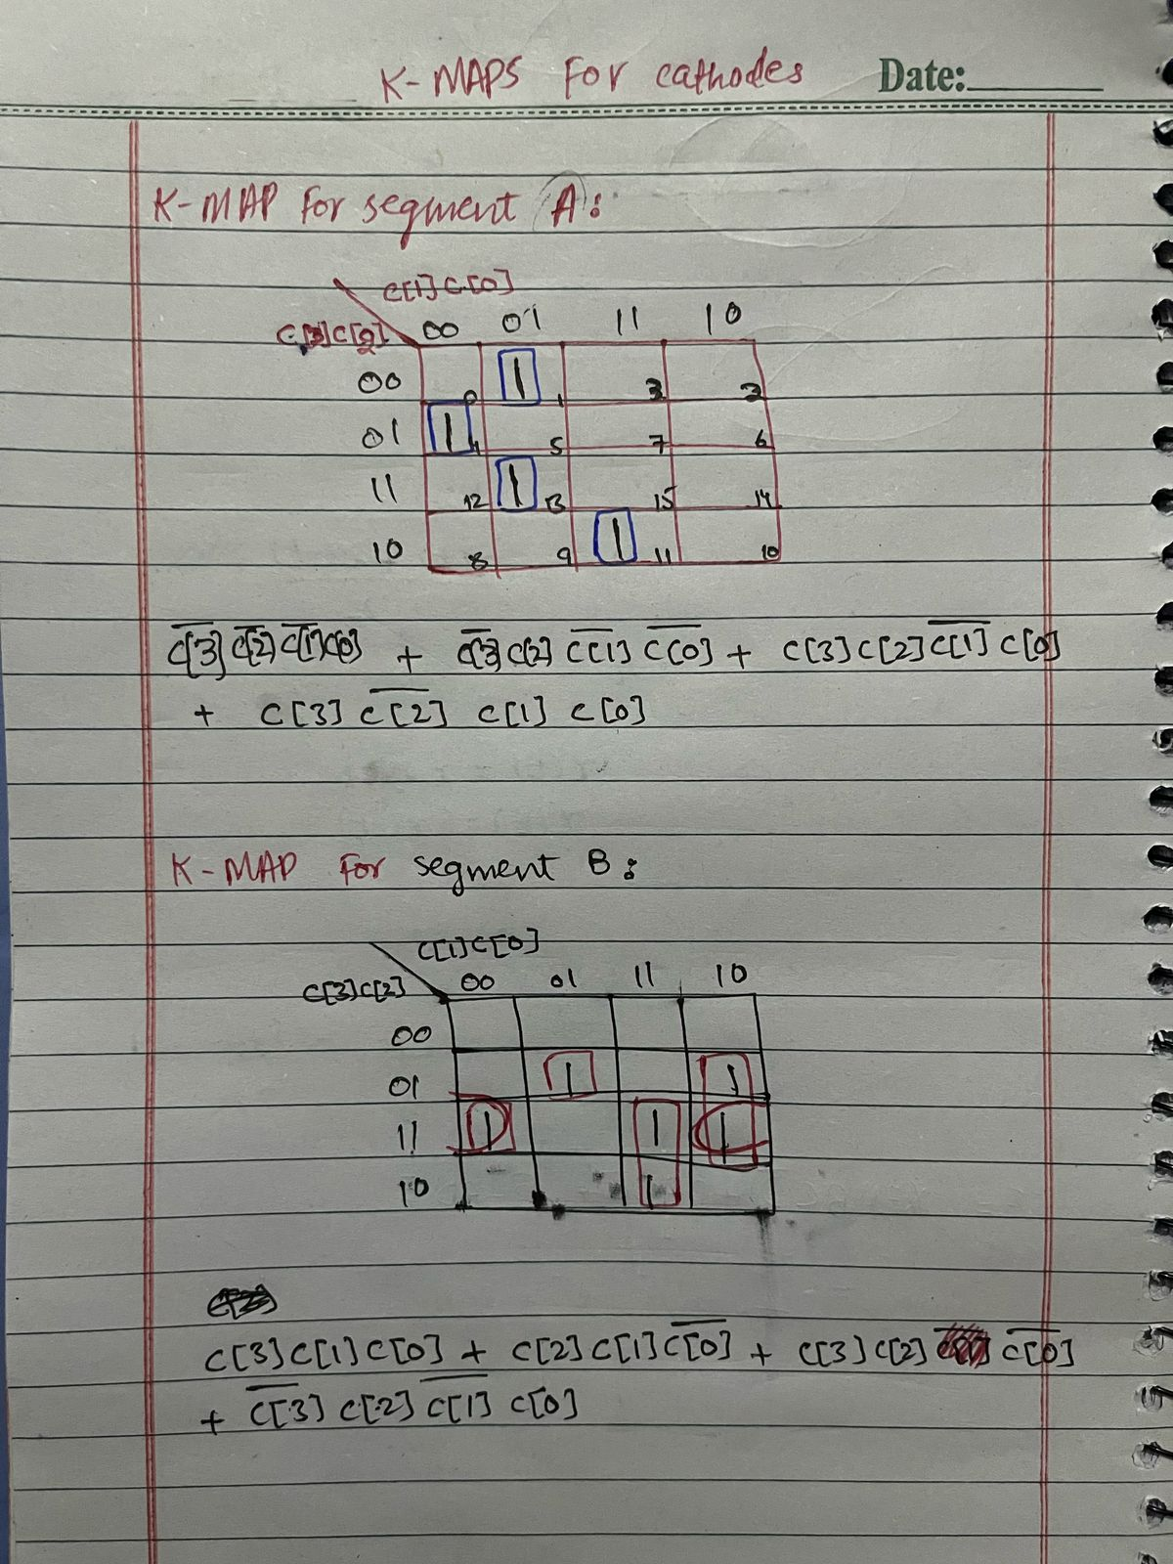

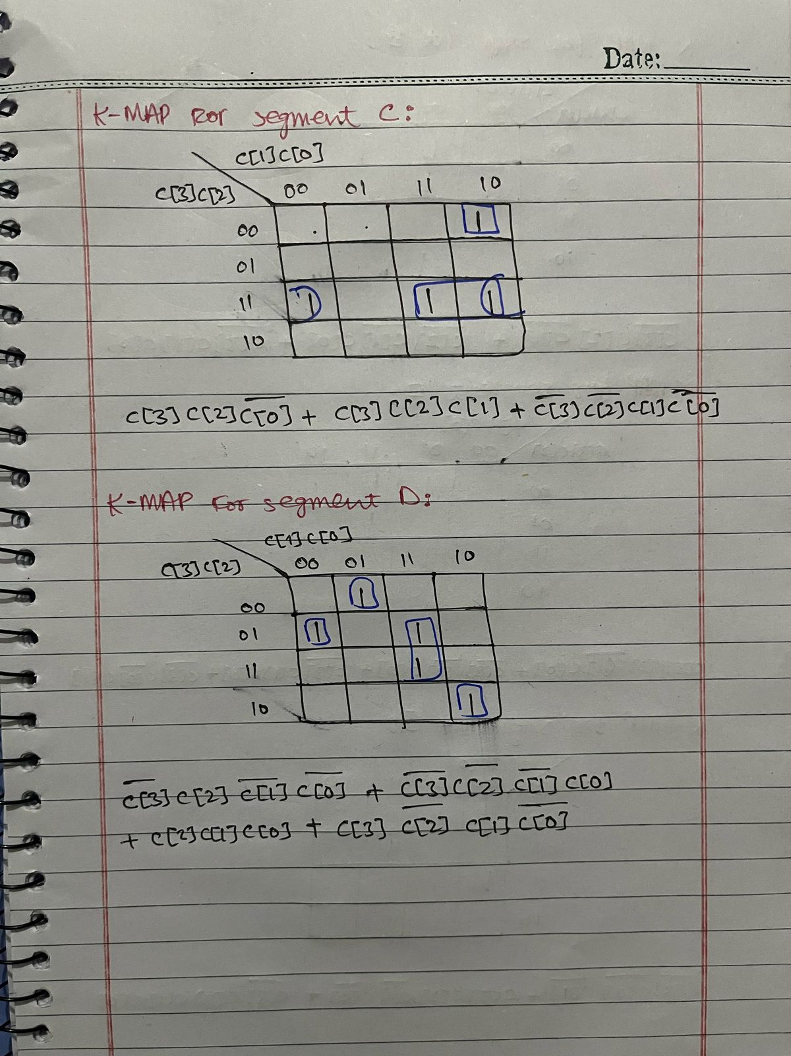

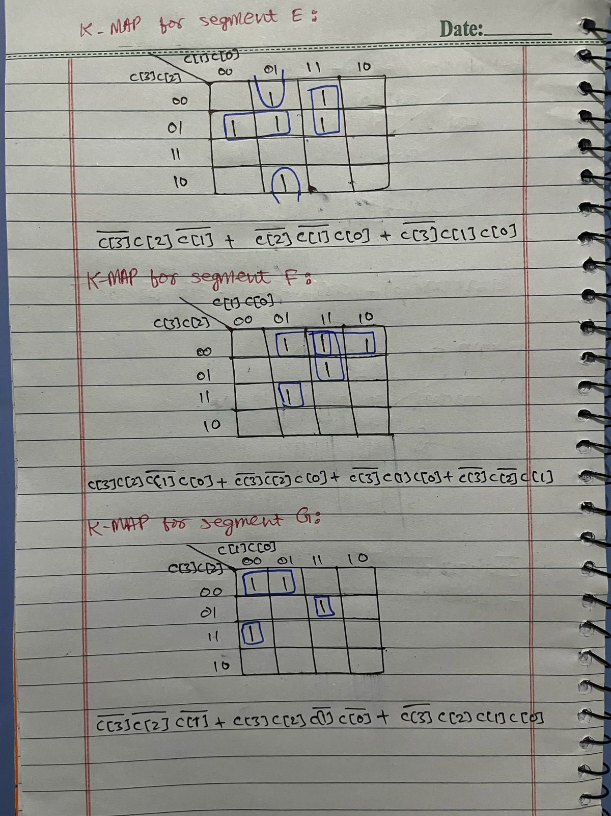

**(d) Circuit diagram:**

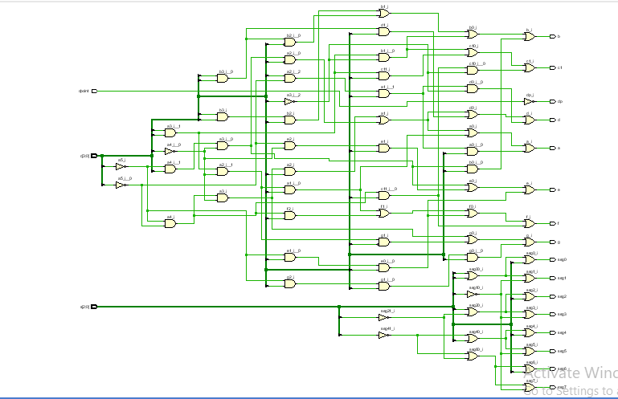

**(e) Maximum Combinational delay in synthesis:**

Maximum combinational delay in synthesis is from path c[3] to f , that is 6.882

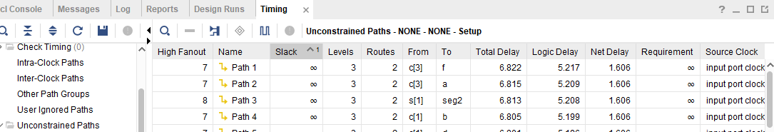

**(f) Maximum Combinational delay in implementation:**

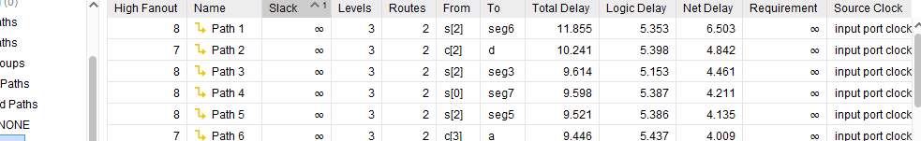Maximum combinational delay in implementation is from path s[2] to seg6,that is 11.855

**(g) Resource Utilization:**

+-------------------------+------+-------+-----------+-------+

| Site Type | Used | Fixed | Available | Util% |

+-------------------------+------+-------+-----------+-------+

| Slice LUTs* | 9 | 0 | 63400 | 0.01 |

| LUT as Logic | 9 | 0 | 63400 | 0.01 |

| LUT as Memory | 0 | 0 | 19000 | 0.00 |

| Slice Registers | 0 | 0 | 126800 | 0.00 |

| Register as Flip Flop | 0 | 0 | 126800 | 0.00 |

| Register as Latch | 0 | 0 | 126800 | 0.00 |

| F7 Muxes | 0 | 0 | 31700 | 0.00 |

| F8 Muxes | 0 | 0 | 15850 | 0.00 |

+----------+------+---------------------+

| Ref Name | Used | Functional Category |

+----------+------+---------------------+

| OBUF | 16 | IO |

| LUT3 | 8 | LUT |

| IBUF | 8 | IO |

| LUT4 | 7 | LUT |

| LUT1 | 1 | LUT |

+----------+------+---------------------+