|  |  |
| --- | --- |
| Name**:** Muhammad Ahmad | EE-272L Digital Systems Design |
| Reg. No: 2023-EE-68 | Marks Obtained: |

**Lab Manual**

|  |  |  |  |  |  |
| --- | --- | --- | --- | --- | --- |
| **DSD Lab Manual Evaluation Rubrics** | | | | | |
|  |  |  |  |  |  |
| **Assessment** | **Total Marks** | **Marks Obtained** | **0-30%** | **30-60%** | **70-100%** |
| Code Organization (CLO1) | 3 |  | No Proper Indentation and descriptive naming, no code organization.  Zero to Some understanding but not working | Proper Indentation or descriptive naming or code organization.  Mild to Complete understanding but not working | Proper Indentation and descriptive naming, code organization.  Complete understanding, and proper working |
| Simulation (CLO2) | 5 |  | Simulation not done or incorrect, without any understanding of waveforms | Working simulation with errors, don't cares's(x) and high impedance(z), partial understanding of waveforms | Working simulation without any errors, etc and complete understanding of waveforms |
| FPGA (CLO2) | 2 |  | Not implemented on FPGA and questions related to synthesis and implementation not answered. | Correctly Implemented on FPGA or questions related to synthesis and implementation answered. | Correctly Implemented on FPGA and questions related to synthesis and implementation answered. |

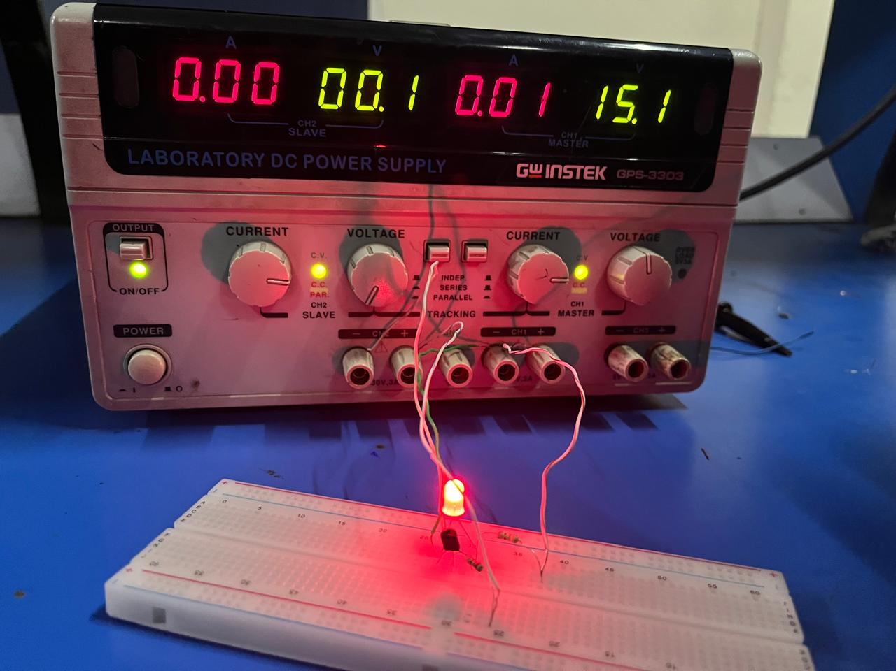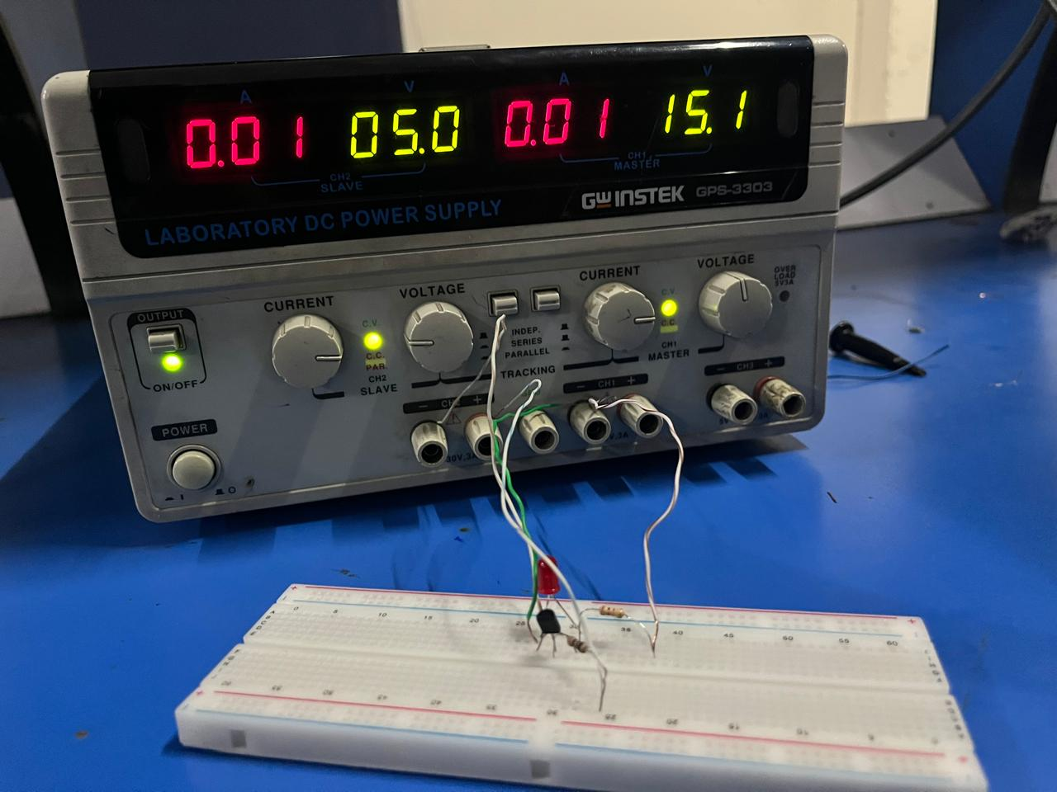Fig1 when voltage at A terminal =5V Fig2 when voltage at A terminal = 0V

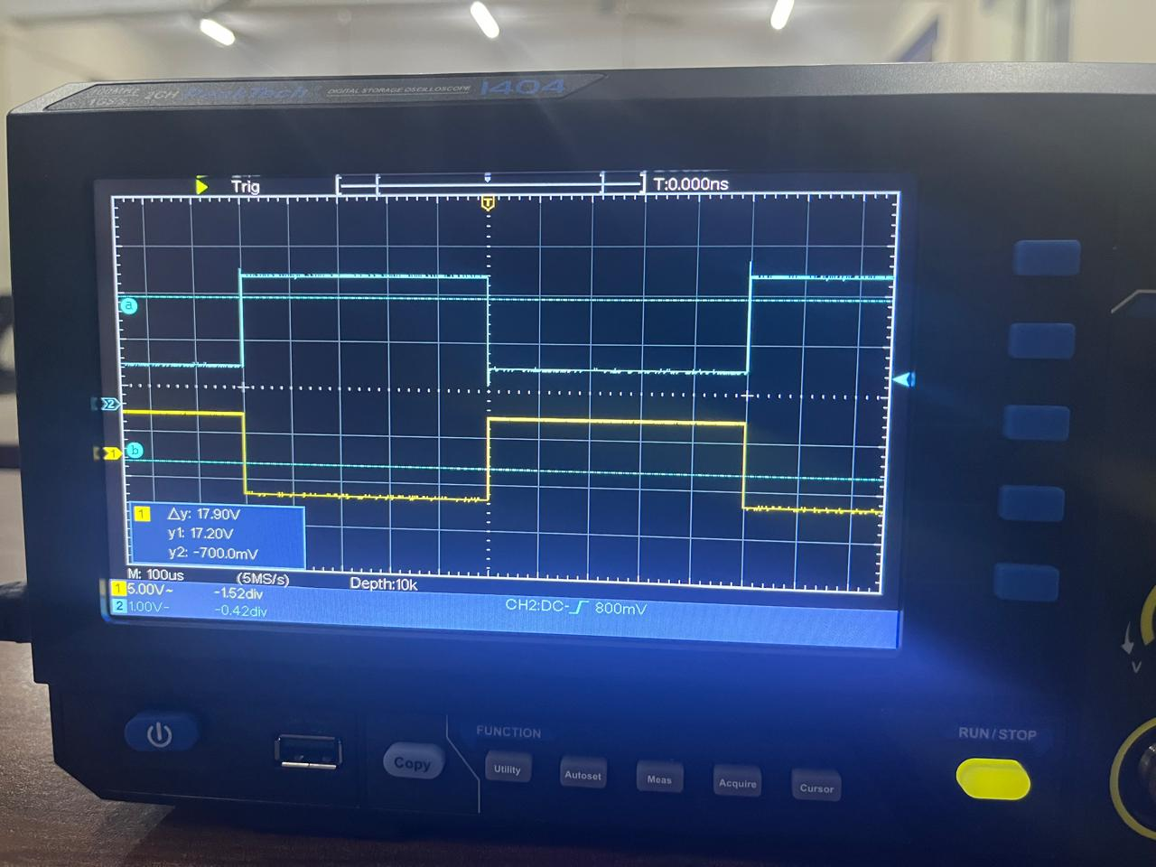

Fig3 plot of output waveform (blue) and input waveform (yellow)

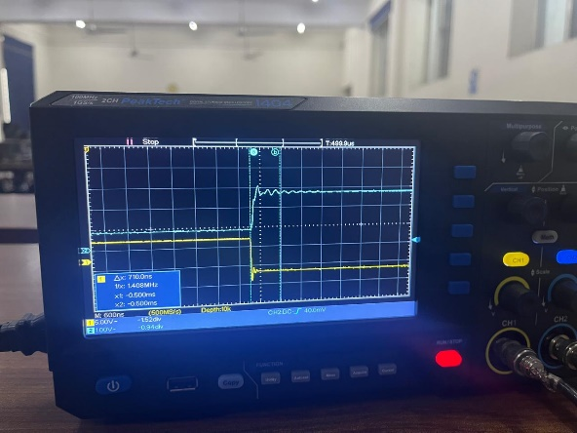

Fig4 visualization of propogation delay (710ns) when output is 1 at frequency = 1KHz

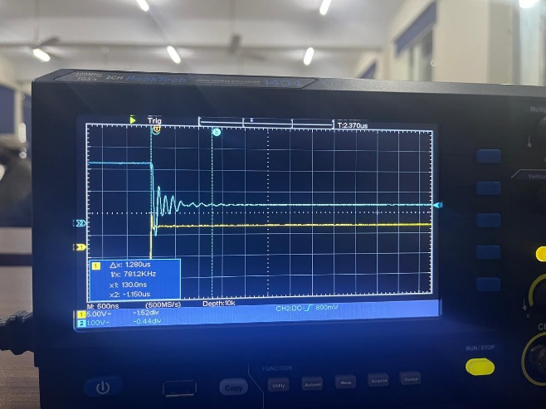

Fig4 visualization of propogation delay (1.280us) when output is 0 at frequency = 1KHz

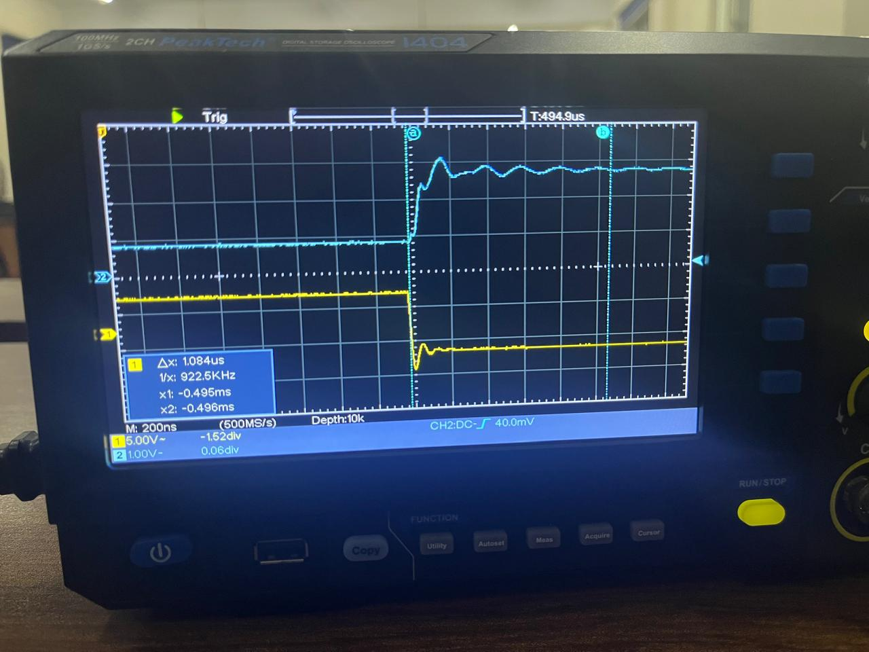

Fig4 visualization of propogation delay (1.084us) when output is 1 at frequency = 100KHz

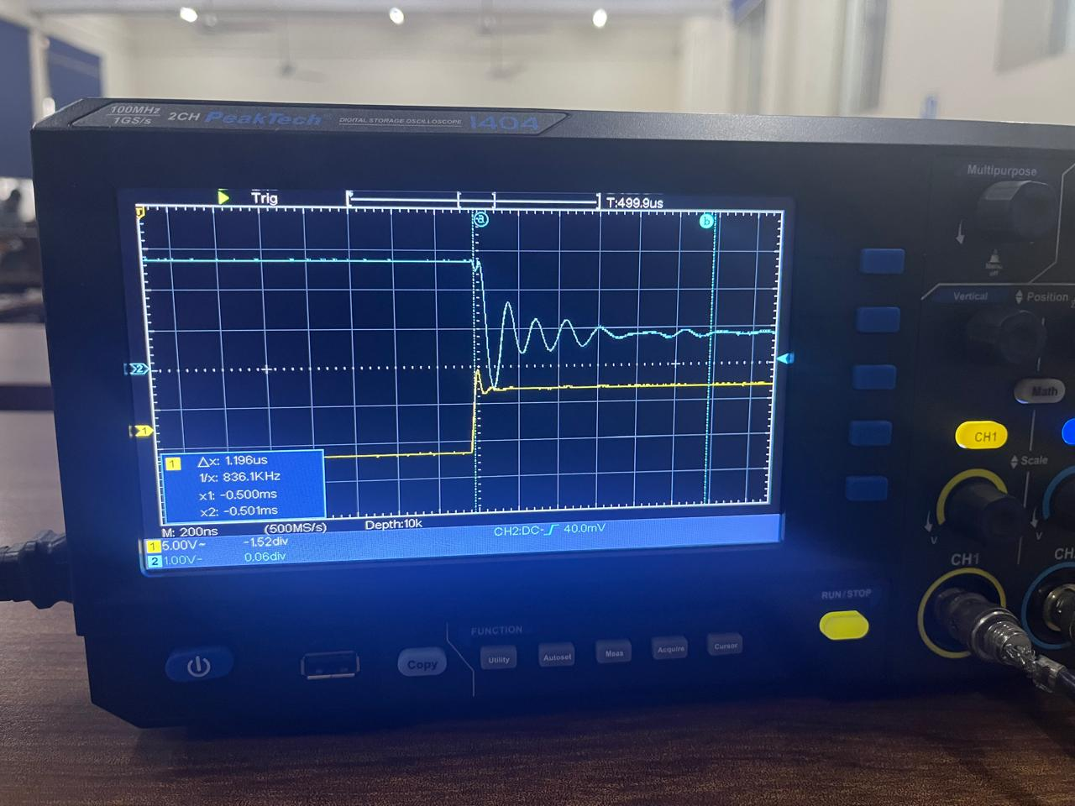

Fig4 visualization of propogation delay (1.196us) when output is 0 at frequency is 100KHz

**TASKS**

1. When we apply 5V at terminal A then the voltages at terminal B is 60mV and LED does not glow because of very low volages.
2. When we apply 0V at terminal A then the voltages at terminal B is 1.98V and LED does glow.
3. When the input goes from high voltages to low voltages then the propogation delay is 710ns and when output goes from high voltages to low voltage then the propogation delay is about 1.28us.
4. When the input goes from high voltages to low voltages then the propogation delay is 1.084us and when output goes from high voltages to low voltage then the propogation delay is about 1.196us.
5. Here, In my case by increasing frequency the propogation delay reduced but it should be increased because at higher frequencies there will be more change of voltage per second and there will be more resistance offered by the little capacitive effect of transistor to the change in voltage at the output. I might have some problem with my transistor.