IMAGE MATCHING
By
- Mohamed Ahmed Ibrahim 231002063
- Mazen Kamal Morsy 231002151
- Mahmoud Hassan Sharaf 231000496
- Shehab Sayed 231002292

Game Description:
In an image matching game, cards are shown at the beginning of the game. After a moment, all cards will be hidden. You are supposed to choose every pair of cards which has the same picture. There are two levels of the game: easy, and hard. In easy level, there are no counter and there will be just six pairs of pictures. In hard level, there will be a one-minute counter and there will be ten pairs of pictures.

Game GUI
When you run the code, the window of the game will open. The title and icon of the window are specified.
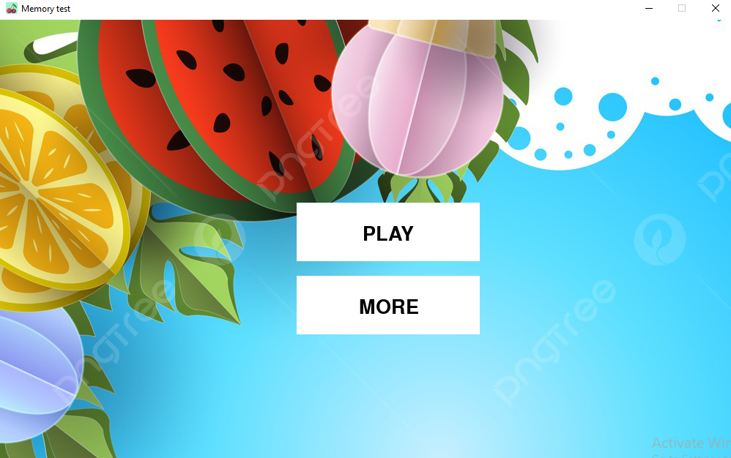
There are two buttons: play and more. On pressing the play button, you will choose the mode of the game (easy or hard). Then the game will begin.
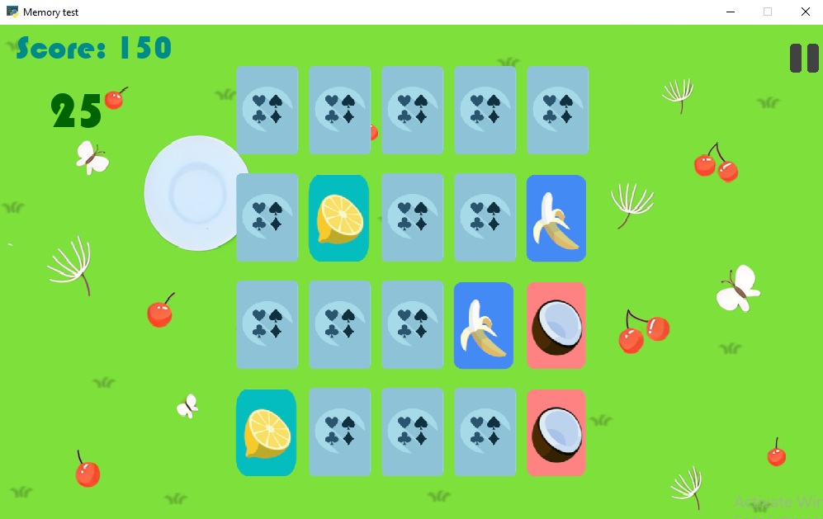
All cards will be shown for about 1.5 seconds. Then, all cards will be hidden. You can mute the background sound with the speaker button. You can pause the game with the pause button. When you win or lose, you can play again.
___________________________________________________________________
Our Roles
- Mohamed Ahmed
He took the main game function (the game core). The showing and hiding of cards, randomizing of cards, events of cards choosing, music, game appearance, and winning system were his responsibility.
- Mazen Kamal Morsy
His responsibility was GUI. He designed the buttons and menus of the game. He also made their events. He also made the animation.
- Mahmoud Hassan Sharaf
He designed the home page and made the events of its buttons.
- Shehab Sayed
He designed the mode menu (Easy, Hard) and its functions.
___________________________________________________________________
References
- Geeksforgeeks.org
- freeCodeCamp.org on YouTube
- Clear Code channel on YouTube
- HB Coding on YouTube
- Coding with Russ on YouTube
- BaralTech on YouTube

