NexusChat
Real-Time LAN Chat Application

A full-stack, fully-offline multi-room chat platform demonstrating all 7 OSI layers
with real-time WebSocket messaging, LAN multi-device support, and a live Network Dashboard

TECH STACK
PHP 8 • MySQL • WebSocket • Vanilla JavaScript • XAMPP

COMPUTER NETWORKS PROJECT

1. Project Overview
NexusChat is a full-featured, real-time multi-room chat application built with PHP, MySQL, WebSocket, and vanilla JavaScript — no frameworks, no Composer, no npm. It runs on a standard XAMPP stack and was built to demonstrate core Computer Networking concepts in a visible, interactive way.

Key LAN Innovation: Multiple people can chat on the same Wi-Fi or Ethernet network without any internet connection. The host machine runs Apache and the WebSocket server; every other device opens NexusChat in their browser using the host's LAN IP address — no installation, no configuration needed on client devices.

Core Features
- Real-time messaging via WebSocket with automatic HTTP-polling fallback
- LAN Mode — zero-config multi-device chat on any local network
- Emoji picker (850+ emoji) with five-emoji message reactions, read receipts (✓ → ✓✓ grey → ✓✓ green), and live typing indicators
- File & media sharing — images, video, audio, PDFs, Office docs (up to 10 GB)
- Voice messages recorded in-browser with waveform-level meter
- Public and password-protected private rooms
- Live IP + Port display in every user's chat footer
- Admin Network Dashboard — six tabs: Overview (24-hr chart), Active Users (IP:port table + quick-ban), Bandwidth meter, Ban Manager, Audit Log, and Packet Log
- Full security — CSRF tokens, bcrypt, rate-limiting, MIME verification, session fixation prevention
- Profile pictures — upload a custom avatar (JPEG/PNG/GIF/WebP, up to 5 MB); shown in messages, sidebar, and members list
- Edit & delete messages — sender can edit within 1 minute; delete for self or everyone within 2 minutes; room admins have 24 hours
- Floating admin bar — persistent navigation pill (bottom-right) linking Dashboard, LAN Setup, and Rooms; visible to admin on every page
- Ban Manager — timed or permanent bans with optional IP ban, reason field, and one-click Unban; enforced at login
- Audit Log — immutable record of every admin action (ban, unban, kick, login, delete) with actor, target, IP, and timestamp
- Bandwidth Meter — dual inbound/outbound bar chart across 60 minutes with per-minute peaks and totals

2. Application Screenshots

Sign In — With LAN Mode Banner
When the host accesses the sign-in page, a banner at the top shows the shareable LAN URL. One click copies it to clipboard so it can be sent to other devices.

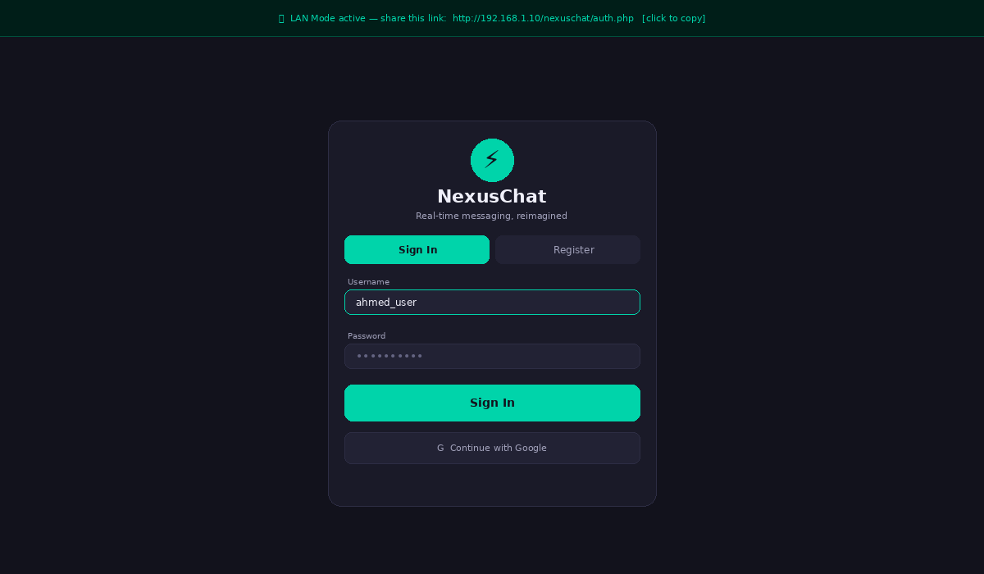
Figure 1 — Sign In page showing the LAN Mode banner with the shareable URL at the top

Register Page
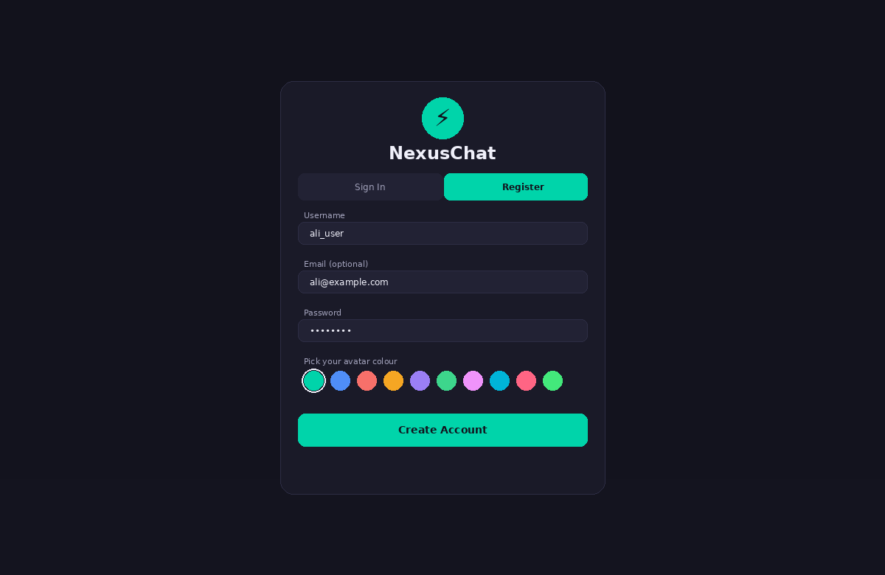
Figure 2 — Register form with avatar colour picker (10 swatches) and profile picture upload, stored per user in the database

Rooms Browser
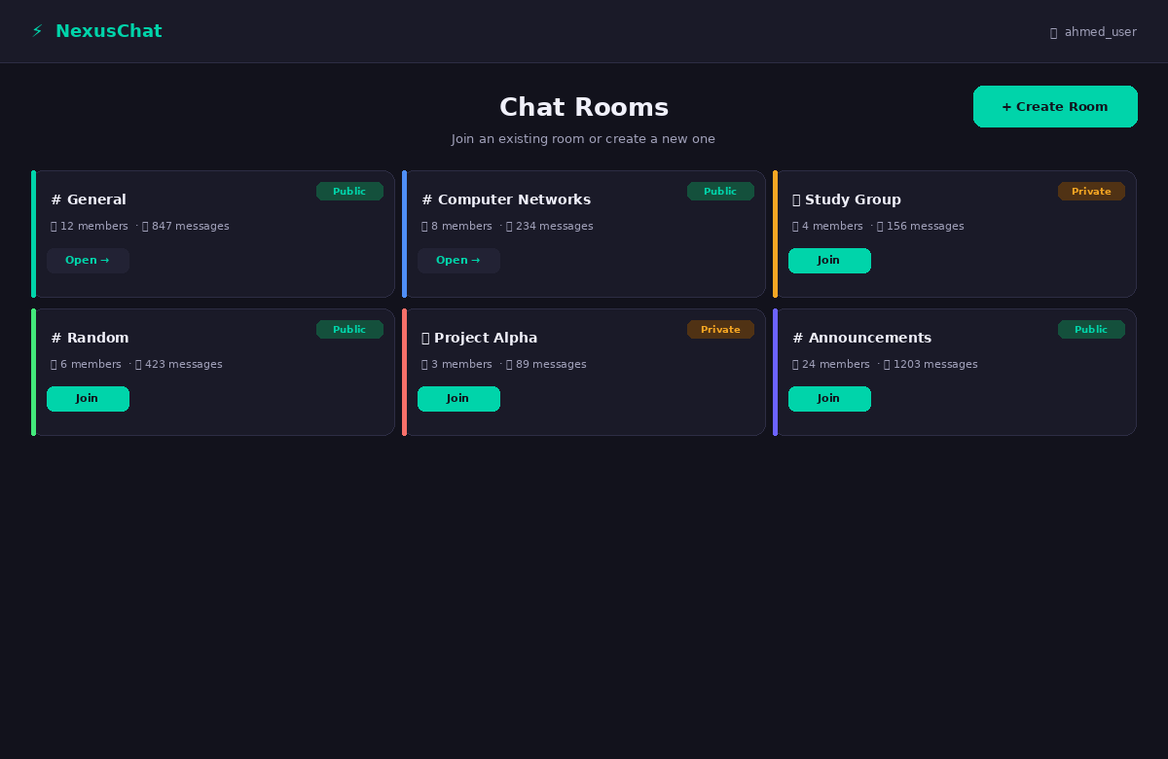
Figure 3 — Room browser showing public/private badges, member counts, and join/open buttons

Real-Time Chat Interface — LAN Session
In LAN mode the sidebar shows the shareable URL. The footer displays each device's real LAN IP and unique TCP port — making the Transport Layer visible.

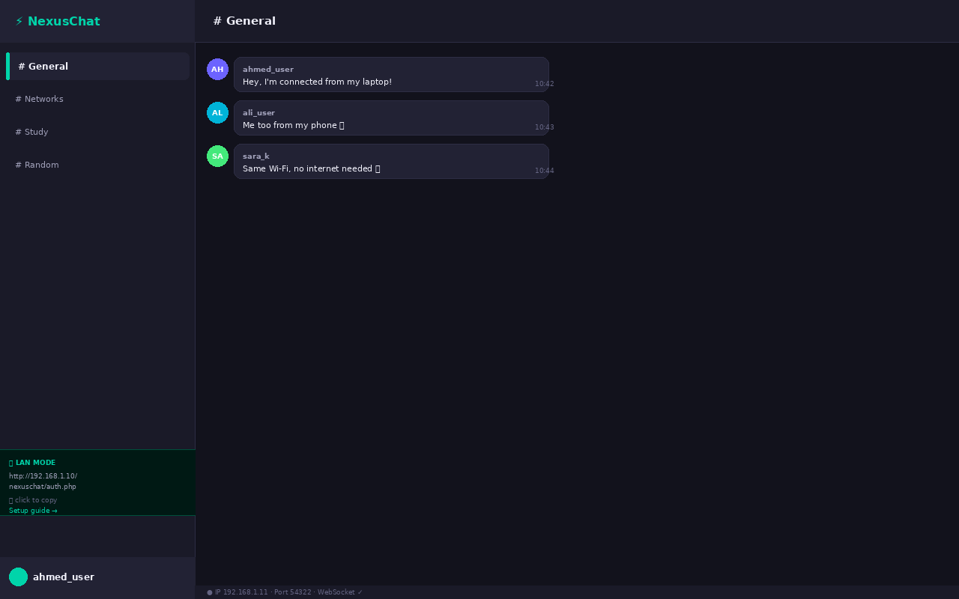
Figure 4 — Chat interface in LAN mode: messages from three different devices, LAN banner in sidebar, real IP:Port in footer

Network Dashboard (Admin)
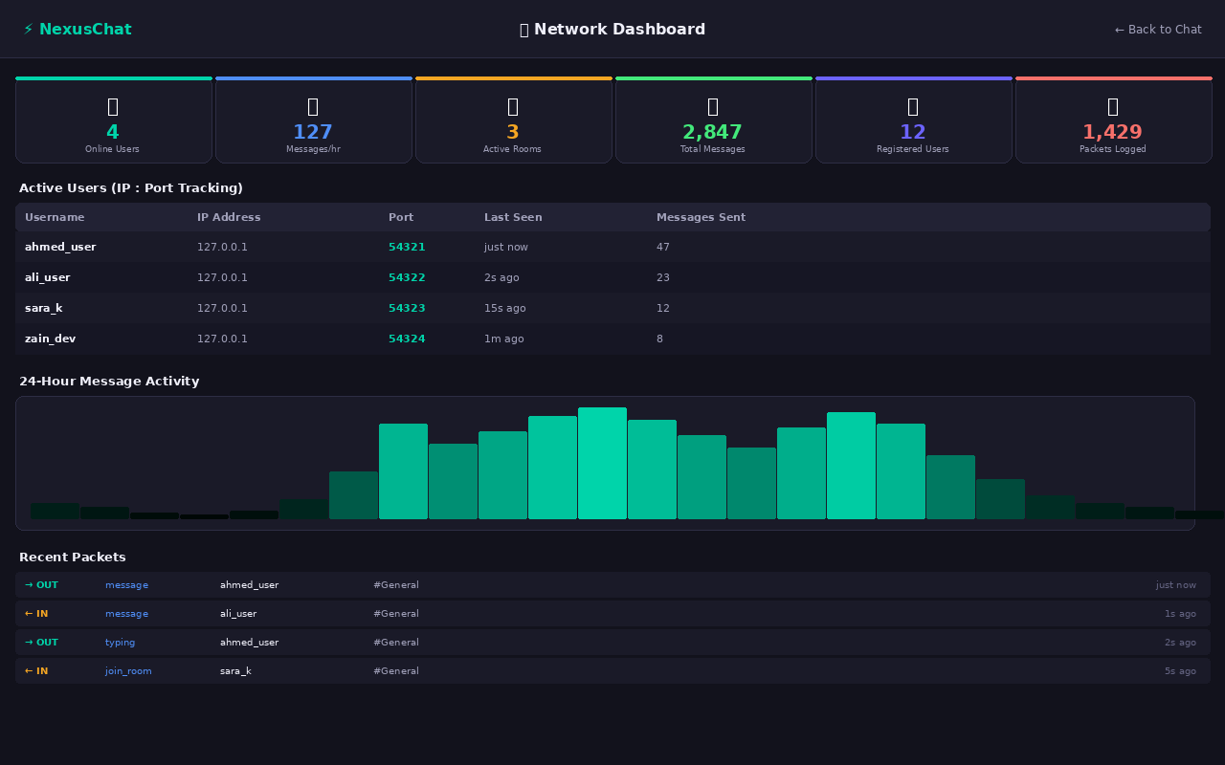
Figure 5 — Live Network Dashboard: six tabs covering Overview, Active Users (IP:port + quick-ban), Bandwidth meter, Ban Manager, Audit Log, and real-time Packet Log

LAN Setup Helper Page
lan_setup.php is a built-in helper page that auto-detects the host's LAN IP, shows the exact URL to share, and runs live connectivity tests for both Apache and the WebSocket server.

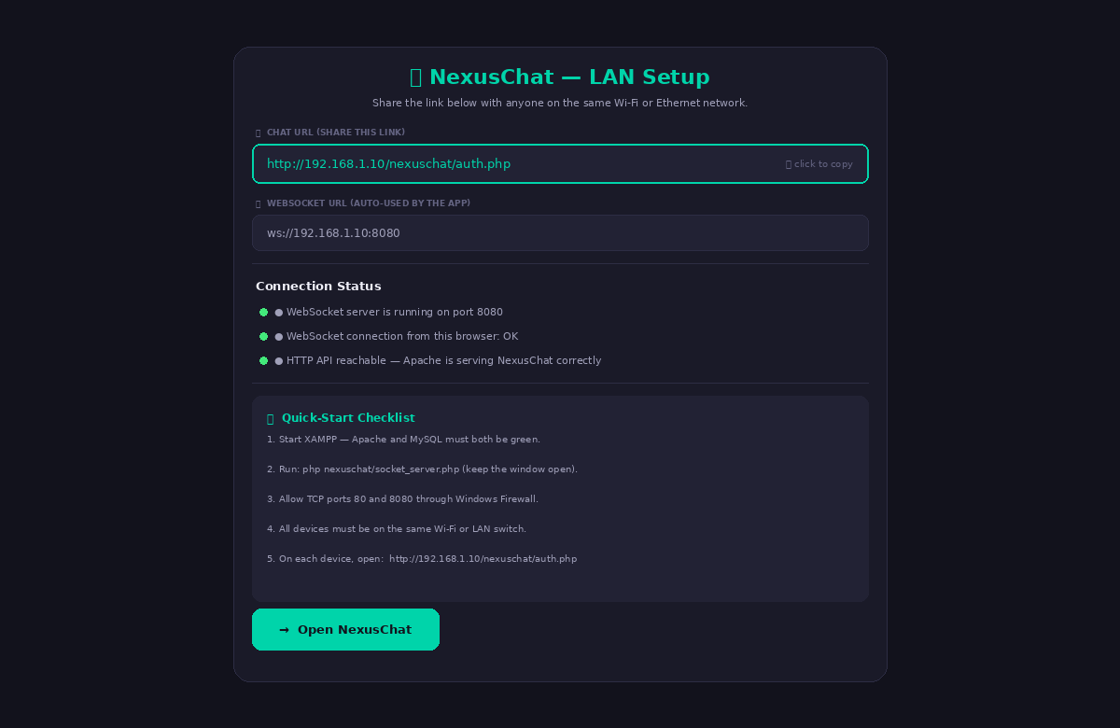
Figure 6 — LAN Setup helper: auto-detected URL, one-click copy, live Apache + WebSocket status checks, step-by-step checklist

3. LAN Architecture
NexusChat operates in a classic Client-Server model over a local area network. The host machine runs all server-side components. Client devices connect using only a web browser.

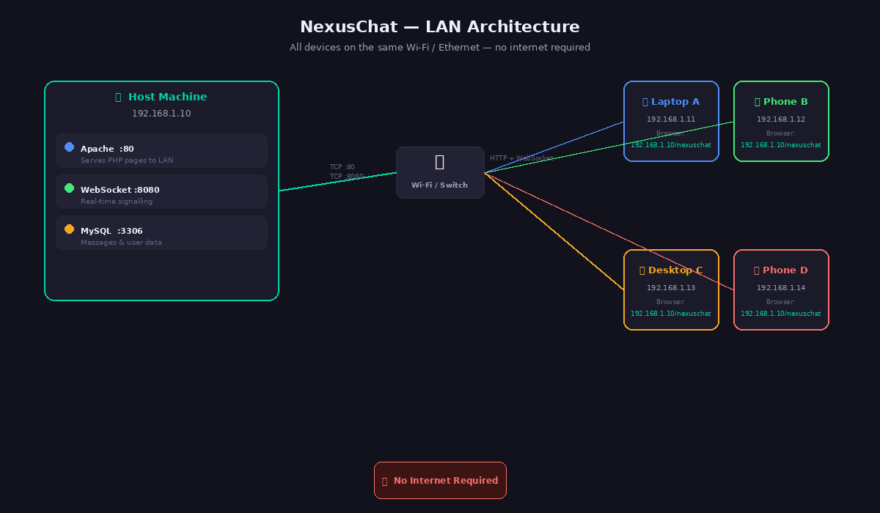
Figure 7 — LAN architecture: host machine serves Apache (:80) and WebSocket (:8080); all devices connect via Wi-Fi/Ethernet with no internet required

What Each Component Does
Component | Port | Role in LAN | Technology
Apache HTTP Server | 80 | Serves PHP pages, API, and static files to all LAN clients | XAMPP / Apache 2.4
WebSocket Server | 8080 | Real-time message delivery; listens on 0.0.0.0 (all interfaces) | Pure PHP (socket_server.php)
MySQL Database | 3306 (local) | Stores messages, users, rooms, uploads — local only | MySQL 5.7+ / MariaDB
LAN IP Auto-detect | N/A | detectLanIp() in config.php auto-finds host IP for browser connections | PHP gethostbyname() + HTTP_HOST

Network Flow
1. Client opens http://192.168.1.10/nexuschat/auth.php → TCP :80 → Apache → PHP → HTML response
2. Browser connects WebSocket to ws://192.168.1.10:8080 → TCP :8080 → socket_server.php
3. User sends message → WS frame → server broadcasts to all clients in same room
4. If WS unavailable → HTTP polling every 2 s via ajax_server.php

4. LAN Setup Guide

Step 1 — Find the Host's LAN IP
- Windows: open Command Prompt → ipconfig → look for IPv4 Address (e.g. 192.168.1.10)
- macOS: System Settings → Wi-Fi → Details → IP Address
- Linux: ip addr show or hostname -I

Step 2 — Start XAMPP
- Start Apache and MySQL from the XAMPP Control Panel
- Both status indicators must be green before continuing

Step 3 — Start the WebSocket Server
Open a terminal on the host machine and run:
php C:\xampp\htdocs\nexuschat\socket_server.php
Keep this terminal window open for the entire session. The server already binds to 0.0.0.0 so it accepts connections from any LAN device automatically.

Step 4 — Open the Firewall
Windows: Windows Defender Firewall → Advanced Settings → Inbound Rules → New Rule:
- Rule type: Port → TCP → Specific local ports: 80, 8080
- Action: Allow the connection
- Profile: tick Domain and Private

macOS: Accept the 'Allow incoming connections?' dialog when it appears for Apache and PHP.

Linux (ufw):
sudo ufw allow 80/tcp
sudo ufw allow 8080/tcp

Step 5 — Share the URL
On the host machine, open the LAN Setup page:
http://localhost/nexuschat/lan_setup.php
This page shows the exact shareable URL, runs live connectivity checks, and has a one-click copy button. Share the URL with other devices on your network.

Step 6 — Connect Other Devices
On each other device (phone, laptop, tablet), open any browser and navigate to:
http://192.168.1.10/nexuschat/auth.php ← replace with your host's IP
- No installation needed on client devices
- Each device registers its own account or uses an existing one
- All devices must be on the same Wi-Fi network or Ethernet switch

5. LAN Technical Implementation

Auto IP Detection (config.php)
The detectLanIp() function automatically resolves the correct IP without any manual configuration:
function detectLanIp() {
// 1. Use the IP the browser sent (works for LAN clients)
if (!empty($_SERVER['HTTP_HOST'])) {
$ip = explode(':', $_SERVER['HTTP_HOST'])[0];
if (filter_var($ip, FILTER_VALIDATE_IP) &&
!in_array($ip, ['127.0.0.1','::1'])) return $ip;
}
// 2. Resolve machine hostname
$ip = gethostbyname(gethostname());
if (filter_var($ip, FILTER_VALIDATE_IP)) return $ip;
// 3. Fallback
return 'localhost';
}

WebSocket Binds to All Interfaces
The WebSocket server is configured with WS_HOST = '0.0.0.0', which means it listens on every network interface simultaneously — localhost, LAN, and any VPN adapters. No change needed for LAN mode.

WS_PUBLIC_HOST is Auto-Resolved
The JavaScript constant WS_URL in index.php is generated from WS_PUBLIC_HOST, which is set to detectLanIp(). So when a LAN client opens the chat page, the WebSocket URL automatically points to the host's LAN IP — not localhost.

Session Cookies Work Across IPs
PHP sessions are configured with session.cookie_samesite = Lax which allows the session cookie to travel with requests from any IP — required for LAN logins to persist correctly.

6. OSI Model Implementation
NexusChat implements all seven OSI layers — visible and measurable in a real LAN environment.

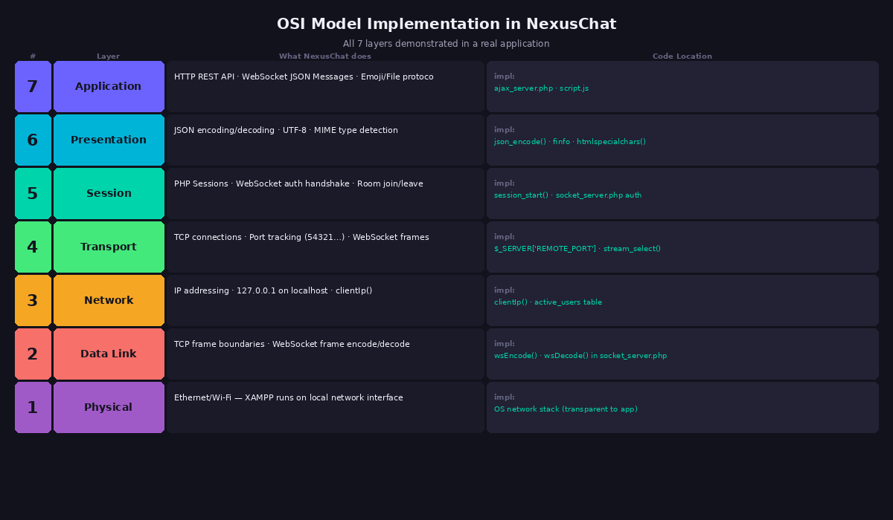
Figure 8 — OSI Model: all 7 layers mapped to the actual PHP/JS code that handles each

Layer | Name | NexusChat on LAN | Code Location
7 | Application | HTTP REST API · WebSocket JSON · Emoji/File protocol | ajax_server.php · script.js
6 | Presentation | JSON encode/decode · UTF-8 · MIME detection | json_encode() · finfo extension
5 | Session | PHP Sessions (Lax cookie) · WS auth · Room management | socket_server.php · session_start()
4 | Transport | TCP :80 + :8080 · Port tracking (54321…) · WS frames | $_SERVER['REMOTE_PORT'] · stream_select()
3 | Network | LAN IP addressing · 192.168.x.x · detectLanIp() | active_users table · config.php
2 | Data Link | TCP frame boundaries · WebSocket frame encode/decode | wsEncode() · wsDecode()
1 | Physical | Wi-Fi 802.11 / Ethernet 802.3 — XAMPP on LAN adapter | OS network stack

7. The Localhost Challenge — Same IP, Different Ports
Even in LAN mode, when multiple browser tabs are open on the same device, they share the same IP. Port numbers remain the primary identifier.

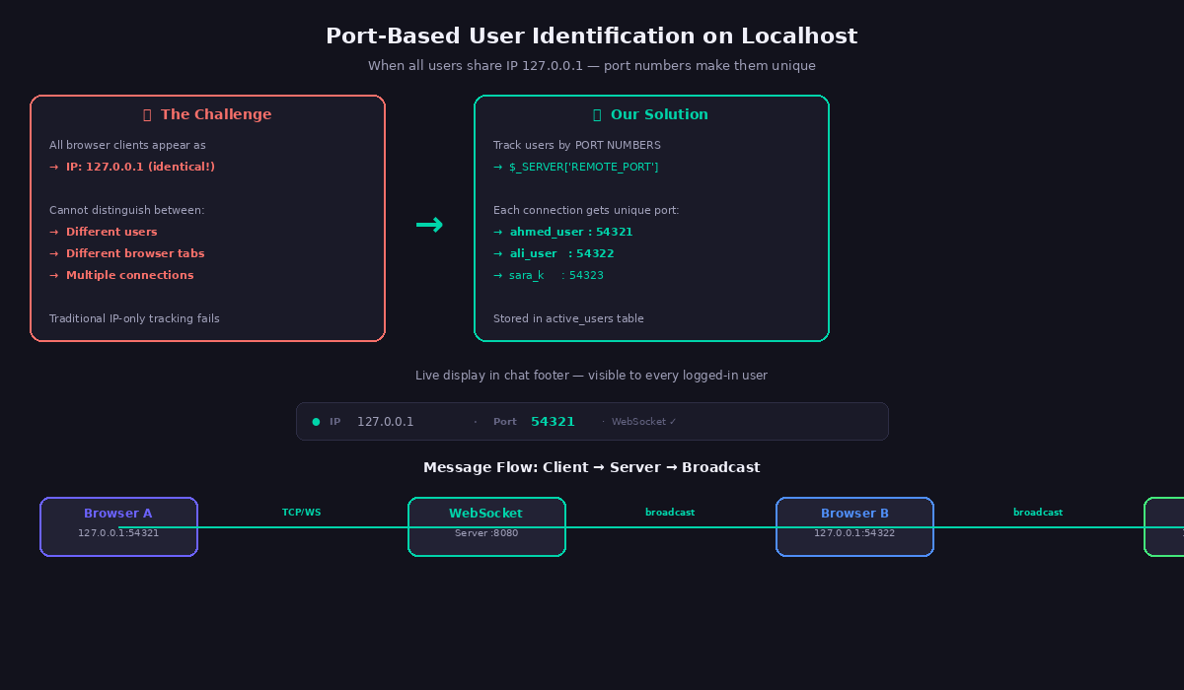
Figure 9 — Port-based identification: each TCP connection gets a unique port, making all clients distinguishable

Scenario | IP Address | Port | How Distinguished
Device A (Laptop) | 192.168.1.11 | 54321 | Unique LAN IP + port
Device B (Phone) | 192.168.1.12 | 54322 | Different IP and port
Device C (Desktop) | 192.168.1.13 | 54323 | Different IP and port
Tab 1 on Device A | 192.168.1.11 | 54321 | Same IP — different port
Tab 2 on Device A | 192.168.1.11 | 54324 | Same IP — different port

8. Network Metrics Collected
Metric | Value on LAN | What It Demonstrates
IP Address | 192.168.x.x (unique per device) | Network Layer — LAN addressing
Port Numbers | 54321, 54322… (unique per connection) | Transport Layer multiplexing
Protocols | HTTP (:80) + WebSocket (:8080) | Application Layer protocols
Packet Size | 50–500 bytes per message | Data Link Layer framing
Active Users | Count of unique IP:port pairs | Session Layer management
Connection State | WebSocket open/closed per client | Transport Layer state machine
Heartbeat | Server ping/pong every 25 seconds | Connection maintenance
Packet Log | Direction · type · payload · username | Full application-layer capture

9. Troubleshooting LAN Issues
Problem | Likely Cause | Fix
'This site can't be reached' | Firewall blocking port 80 | Add inbound rule: TCP port 80 allowed
Page loads but no real-time messages | Firewall blocking port 8080 | Add inbound rule: TCP port 8080 allowed
IP shows as 'localhost' in setup page | Auto-detect fell back to localhost | Set LAN_HOST_OVERRIDE in config.php manually
Logged out on every page change | Session cookie domain mismatch | Ensure session.cookie_samesite = Lax (already set)
Apache only reachable on host | httpd.conf bound to 127.0.0.1 | Change Listen 127.0.0.1:80 to Listen 80 in httpd.conf
WebSocket 'connection refused' | socket_server.php not running | Start it in a terminal; keep it open
Only localhost users connect | WS_PUBLIC_HOST still 'localhost' | This is auto-fixed by detectLanIp() — no action needed

10. Why NexusChat Fulfils Computer Networking Requirements
Networking Requirement | How NexusChat Fulfils It
IP Addressing | Unique LAN IPs per device (192.168.x.x) — visible in footer and dashboard
Port Numbers | Each TCP connection has unique port — Transport Layer multiplexing in real time
TCP Connections | Persistent WebSocket connections with full state management
Client-Server Model | Multiple LAN devices connecting to single PHP server
Multiple Protocols | HTTP + WebSocket + TCP all working together
Packet Analysis | Live packet log — direction, type, payload, username, timestamp
LAN Without Internet | Fully offline chat across an entire local network
Network Monitoring | Real-time dashboard showing all active IP:port connections
Connection Lifecycle | Handshake → transfer → heartbeat → teardown all visible
OSI Layers | All seven layers implemented and traceable to source code
Access Control & Ban Management | Ban Manager with timed/permanent bans, optional IP ban, enforcement at login; full ban history with one-click Unban
Audit & Accountability | Immutable Audit Log records every admin action (ban, kick, delete) with actor, IP, and timestamp; filterable by action type

11. Key Learning Outcomes
- LAN Networking — deploying a web application across a local network with no internet
- Same IP, Different Ports — Transport Layer multiplexes multiple connections per device
- Socket Programming — raw TCP WebSocket server in pure PHP, no libraries
- Protocol Handshakes — WebSocket upgrade from HTTP with frame encoding/decoding
- Connection State Management — heartbeats, timeouts, and automatic reconnection
- Network Monitoring — real-time packet capture with IP:port tracking per message
- OSI Layers in Practice — all seven layers working together in one real application
- Dual-Transport Resilience — automatic WebSocket → HTTP polling fallback
- Network Security — CSRF, bcrypt, rate-limiting, MIME verification, session fixation prevention
- Admin Systems Design — ban enforcement, audit logging, and bandwidth tracking implemented end-to-end across database, API, and UI

12. Conclusion
NexusChat demonstrates all seven OSI layers while enabling real LAN multi-user chat without any internet connection. The auto-detecting LAN IP system, built-in setup helper page, and live Network Dashboard make abstract networking concepts visible, measurable, and interactive. Multiple devices on the same Wi-Fi or Ethernet network can communicate in real time — hosted entirely on a single XAMPP machine.

Attribute | Value
Project Type | Web-Based Real-Time LAN Chat Application
Platform | XAMPP on Windows/Mac/Linux — any local network
LAN Mode | Zero-config — auto IP detection, no manual setup
Real-time Protocol | WebSocket on Port 8080 (all interfaces: 0.0.0.0)
Fallback Mechanism | HTTP Polling every 2 seconds
Network Monitoring | Live packet capture with LAN IP:port tracking; Ban Manager, Audit Log, and Bandwidth Meter tabs
Internet Required | No — fully offline LAN operation supported
OSI Layers Demonstrated | All 7 layers
Security | CSRF · bcrypt · rate-limiting · MIME verification · session protection

