**DNN LAB 10 ASSIGNMENT**

**2020270**

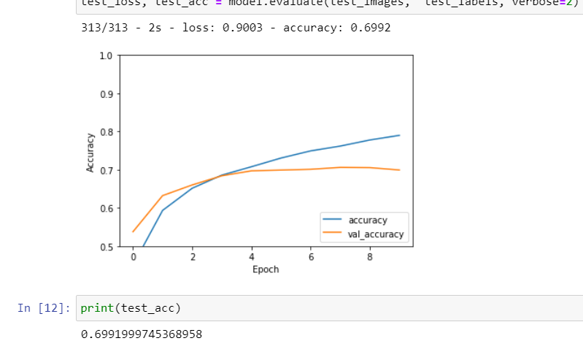

On test set, our model was giving 0.6991 accuracy with number of epochs 10.

**Changing Hypermeters**

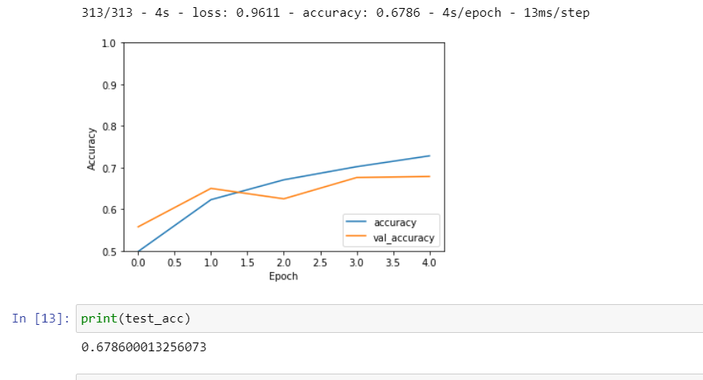

1. By changing the number of epochs to 5 and using ELU instead of relu we get 0.678 accuracy that is less than previous.

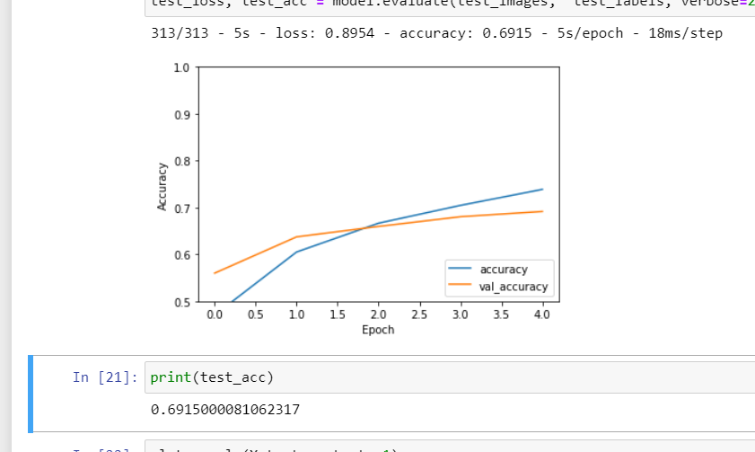

1. Using Swish activation Funtion, we get 0.691 accuracy

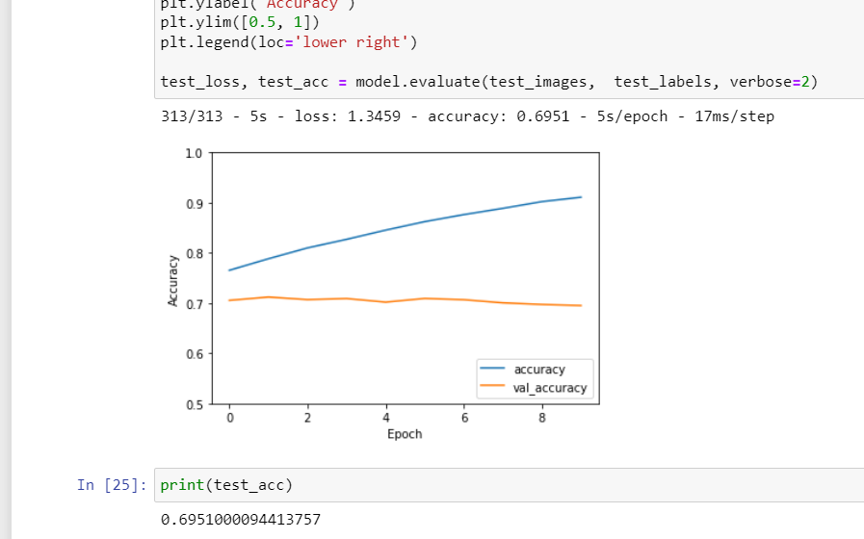

1. Using 10 epochs with swish activation function, we get 0.695 accuracy.