**Lab 11: ExeML Food Classification**

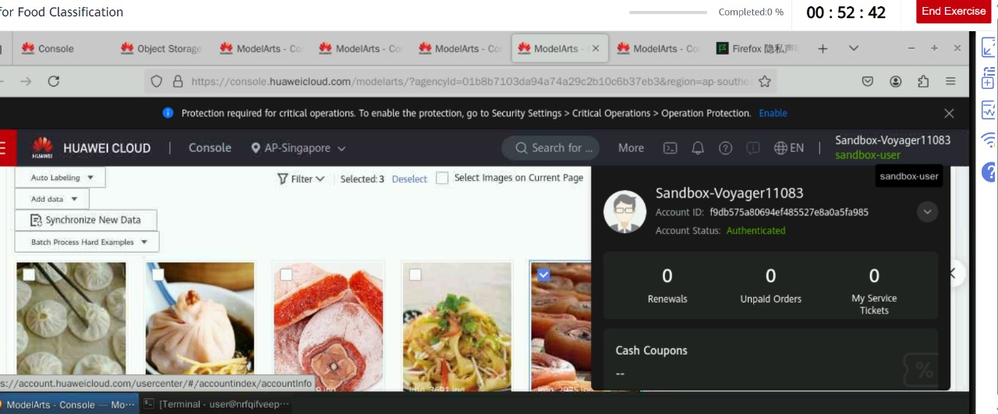

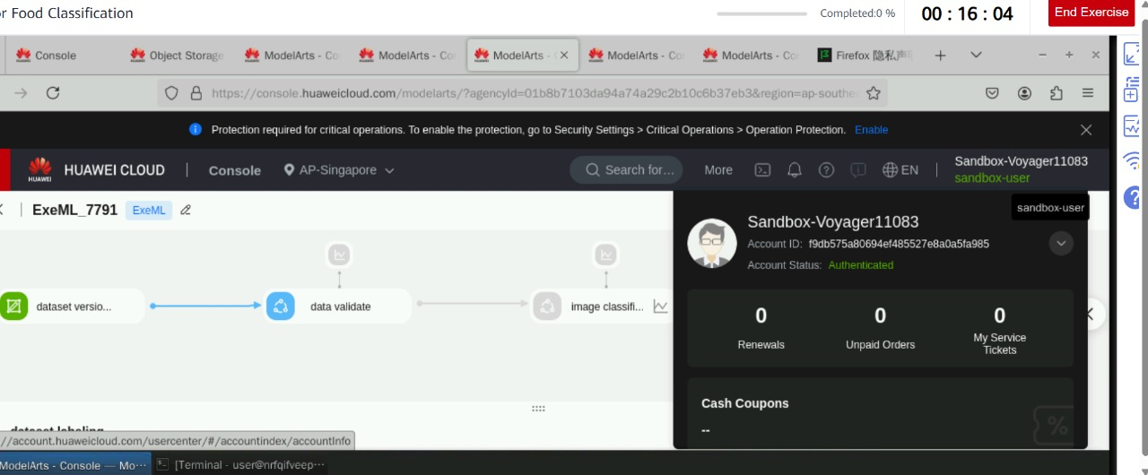

Issue:

I was stuck on the screen for over half an hour due to a cloud service issue, which caused the exercise to hang or not load properly. As a result, you couldn’t proceed, and the exercise time ended before you could complete it.

