**Lab01: Compute Services Practice**

**Issue:**

After creating ECS instances on HUAWEI Cloud, I was unable to remotely access both the Windows and Linux ECS. Despite the instances showing as running, remote desktop (RDP) for Windows and SSH for Linux were unresponsive. This issue appears to be related to cloud service configuration or network settings. A screenshot of the issue has been attached for reference.

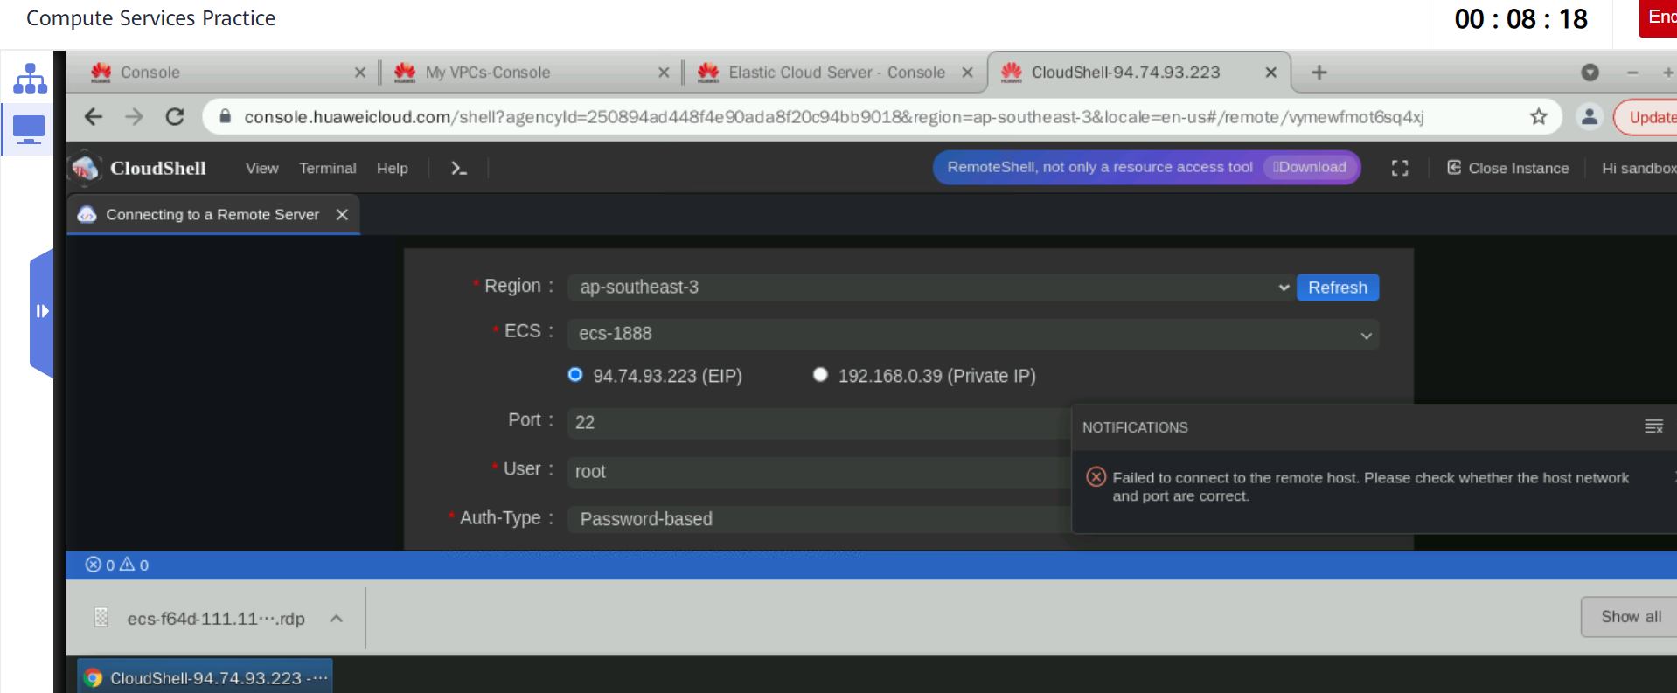

**Lab 11: ExeML Food Classification**

Issue:

I was stuck on the screen for over half an hour due to a cloud service issue, which caused the exercise to hang or not load properly. As a result, you couldn’t proceed, and the exercise time ended before you could complete it.

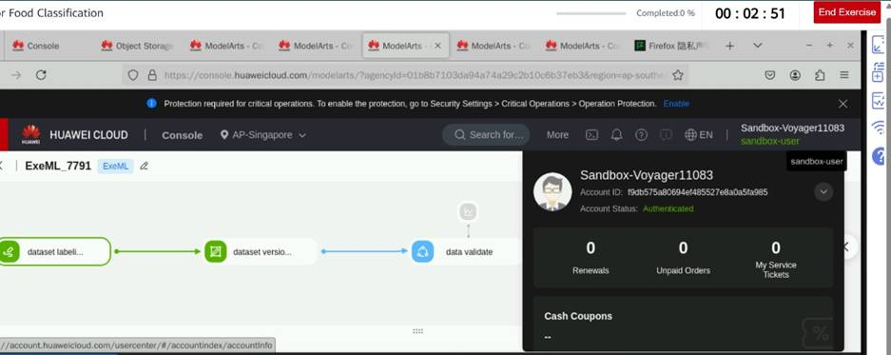

**Login problem:**

After completing one exercise on HUAWEI Cloud, I was unable to log in again for the subsequent exercise, despite multiple attempts over several hours. The platform did not grant access or load the next environment, which prevented further progress. This appears to be a recurring access issue on the cloud service side.

