**Title: Bank Management System**

**Introduction:** The Secure Banking System is a console-based application that provides various banking services such as account creation, password verification, generating account numbers, and virtual debit cards. The system also provides functions for validating CNIC, email, and cell numbers. The main aim of this project is to provide a secure and user-friendly banking system.

**Background:** The Banking System was developed as a part of a course project for OOP lab class. The project was selected based on the requirement of developing a secure and user-friendly console-based application.

**Project Specification:** The Secure Banking System provides the following features:

• Account creation with account number and CVV generation

• Password verification with minimum length and character set requirements

• CNIC validation with a specific format and length

• Email validation with a specific format and domain

• Cell number validation with a specific format and length

• Date of birth validation with a specific range

• Virtual debit card generation with a specific format and length

• Debit card expiry date calculation

• Transaction password validation with a specific length and character set

**Problem Analysis:** The Secure Banking System was developed to address the following problems:

• Lack of secure coding practices in console-based applications

• Lack of user-friendly interfaces in console-based applications

• Lack of input validation in console-based applications

• Lack of password verification in console-based applications

**Solution Design:** The Banking System was designed to provide a secure and user-friendly interface for various banking services. The system uses secure coding practices such as input validation, password verification, and error handling. The system also provides a user-friendly interface with clear instructions and feedback.

The system uses the following functions to provide the required features:

• VerifyPassword: Verifies the password with minimum length and character set requirements

• GetPasswordValidity: Checks the password validity with specific character set requirements

• GenerateAccountNumber: Generates a random account number with a specific length

• GenerateCVV: Generates a random CVV with a specific length

• GenerateVirtualDebitCard: Generates a virtual debit card with a specific format and length

• GetCurrentDay, GetCurrentMonth, GetCurrentYear: Returns the current day, month, and year

• GetExpireYear: Returns the expire year for the debit card

• GetCurrentDate: Returns the current date with a specific format

• DebitCardExpiry: Returns the expiry date for the debit card

• ValidatePin: Validates the PIN with a specific length

• GenerateIBAN_Number: Generates a random IBAN number with a specific length and format

• VerifyCNIC: Verifies the CNIC with a specific format and length

• DateOfBirthValidity: Validates the date of birth with a specific range

• ForgetPasswordValidity: Verifies the CNIC and debit card number for password recovery

• ValidateEmail: Validates the email with a specific format and domain

• ValidateCellNumber: Validates the cell number with a specific format and length

• ValidateTransactionPassword: Validates the transaction password with a specific length and character set

**Implementation & Testing:** The Secure Banking System was implemented using C++ programming language. The system was tested for input validation, password verification, and error handling.

**Project Breakdown Structure:** The Secure Banking System was developed by three students in 10 weeks. The workload distribution is as follows:

* each student worked on 1 of the 3 classes in the code and the main() function was prepared by the 3 students collectively

**Results:** The Secure Banking System provides the following outputs:

• Account creation with account number and CVV generation

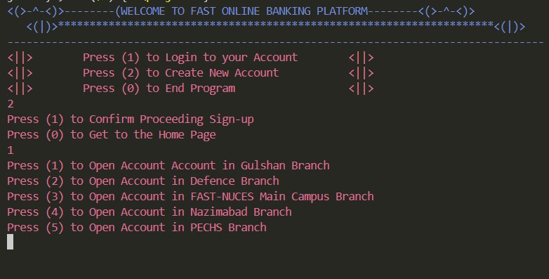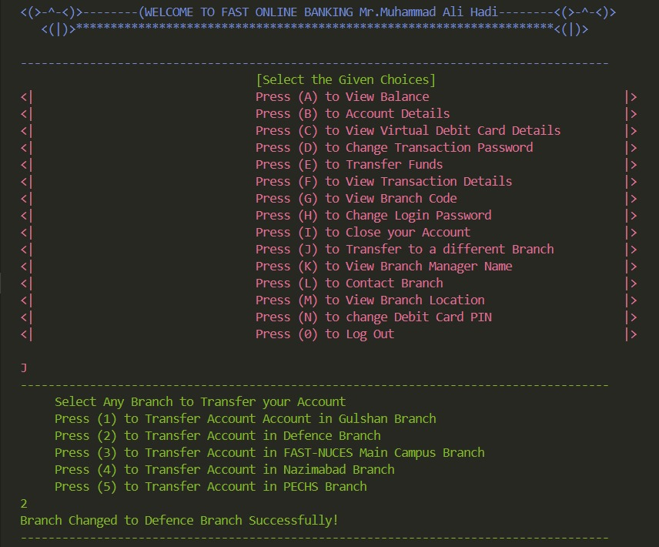

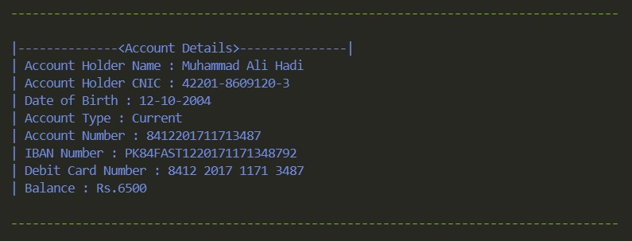

• Password verification with minimum length and character set requirements

• CNIC validation with a specific format and length

• Email validation with a specific format and domain

• Cell number validation with a specific format and length

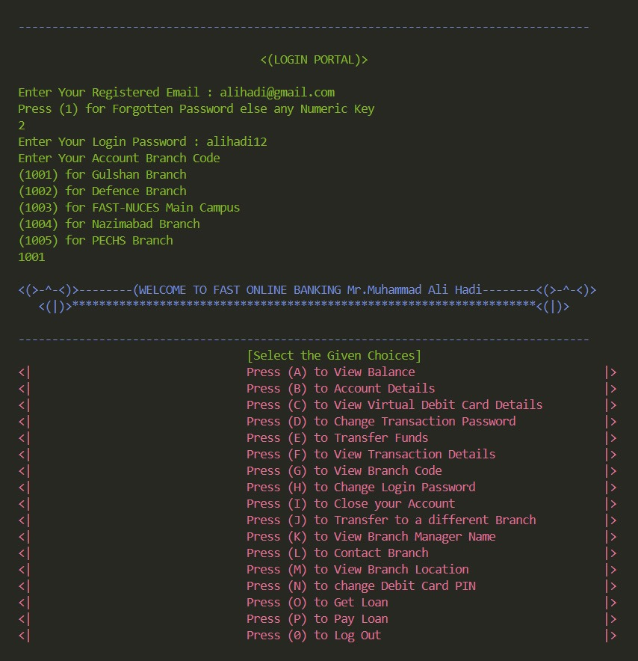

• Date of birth validation with a specific range

• Virtual debit card generation with a specific format and length

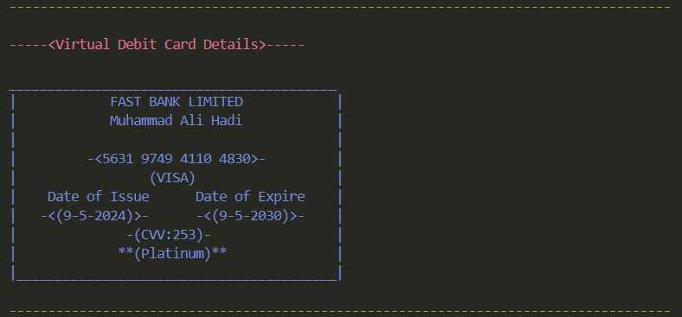

• Debit card expiry date calculation

• Transactions and password validation with a specific length and character set

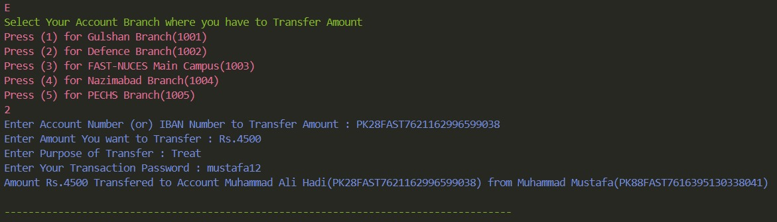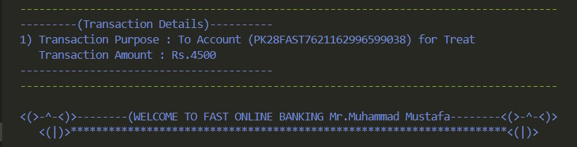

**Conclusion:** The Banking System is a secure and user-friendly console-based application that provides various banking services. The system uses secure coding practices and provides a user-friendly interface with clear instructions. The system was was tested using various test cases to ensure the correctness and security of the system.