***Installing ROS***

First you have to Install and setup ubuntu and run it in a virtual machine.

then open the terminal and follow these steps:

you need to update the Software before this with

sudo apt update

and then Type this command:

sudo apt install ros-melodic-desktop-full

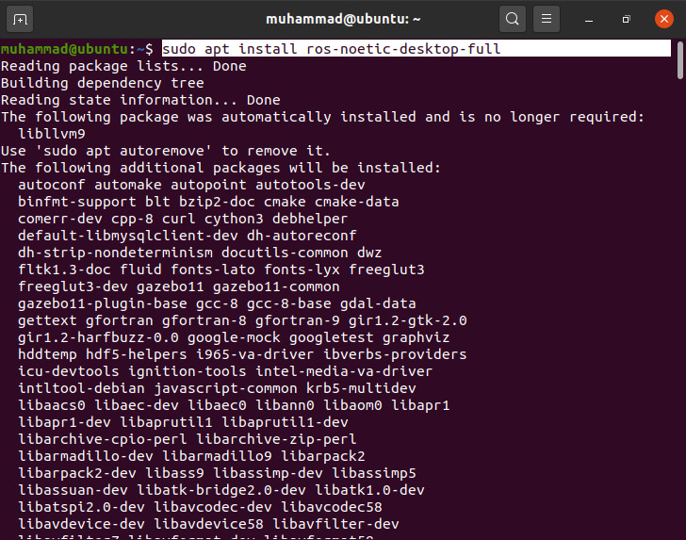

It will start the installation you just need to type Y here as yes to continue

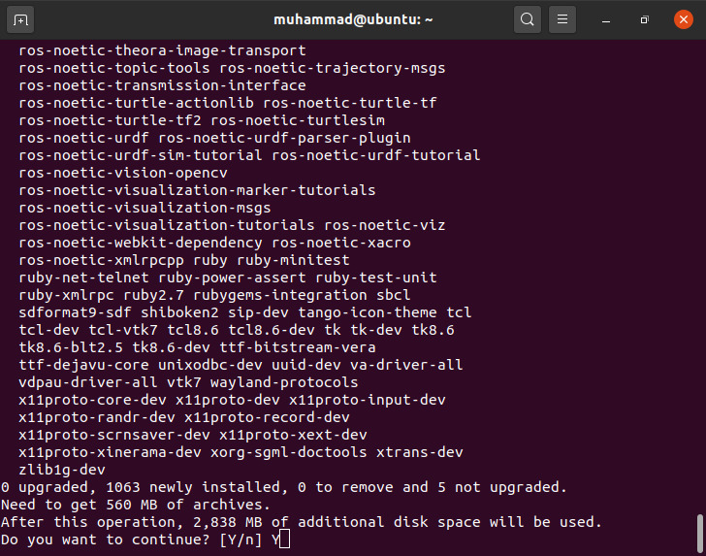

Installation process

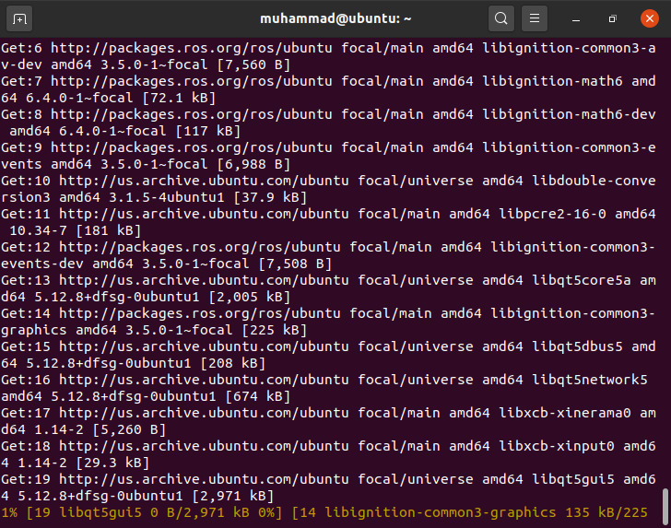

It will take a while to process the installation progress then the installation will be completed.