Machine Learning Design and Implementation for Agentic AI Cyber Defense System

1. Introduction
This document explains the complete Machine Learning (ML) component of the Agentic AI Cyber Defense System. The ML layer is responsible for detecting malicious network traffic using supervised learning models trained on the UNSW-NB15 dataset.

2. Dataset Description (UNSW-NB15)
The UNSW-NB15 dataset is a modern intrusion detection dataset containing real and synthetic network traffic. Each record represents a network flow with labeled normal or attack behavior. The dataset is highly imbalanced, which is common in real-world cybersecurity scenarios.

3. Data Preprocessing
A unified preprocessing pipeline was designed to ensure consistency between training and inference.
Key steps:
- Removal of attack_cat from features to prevent data leakage.
- Missing value handling:
• Numerical features: median imputation
• Categorical features: most frequent value imputation
- IP hashing: Source and destination IPs are hashed to numeric values to preserve uniqueness while avoiding raw IP usage.
- Feature scaling: StandardScaler applied to numerical features.
- Categorical encoding: OneHotEncoder with handle_unknown='ignore' to support unseen categories.
- Sparse matrices are used to efficiently handle high-dimensional feature space.

4. Feature Engineering Summary
The final feature space consists of scaled numerical attributes and one-hot encoded categorical attributes. This results in a high-dimensional sparse representation, which is realistic for intrusion detection systems.

5. Models Used
Three models were trained and evaluated:
• Random Forest – used as a comparative baseline.
• XGBoost – selected as the primary model due to superior precision-recall balance.
• Logistic Regression – used as an interpretable baseline model.

6. Model Training Strategy
The dataset was split into training and testing sets using stratified sampling. Sampling was applied during training to accommodate hardware constraints while preserving class distribution.

7. Evaluation Metrics
The following metrics were used:
- Accuracy: overall correctness
- Precision: proportion of correctly identified attacks
- Recall: ability to detect actual attacks (critical for IDS)
- F1-score: harmonic mean of precision and recall

8. Results and Analysis
Separate confusion matrices were generated for each model.
Images:
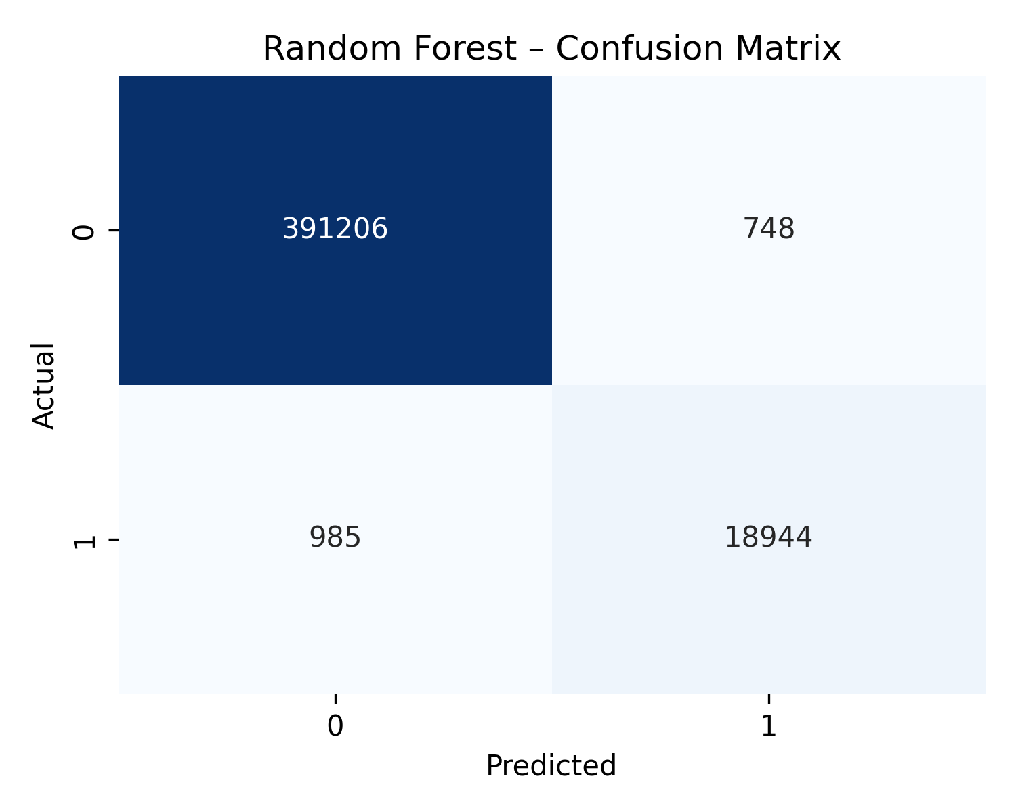

What this plot shows
How Random Forest predicts Normal vs Attack traffic.
Important points
- Very high correct Normal predictions
- Very high correct Attack predictions
- Fewer false alarms than Logistic Regression
Simple conclusion
Random Forest is very accurate, but it is heavy and less interpretable compared to other models.

Images:
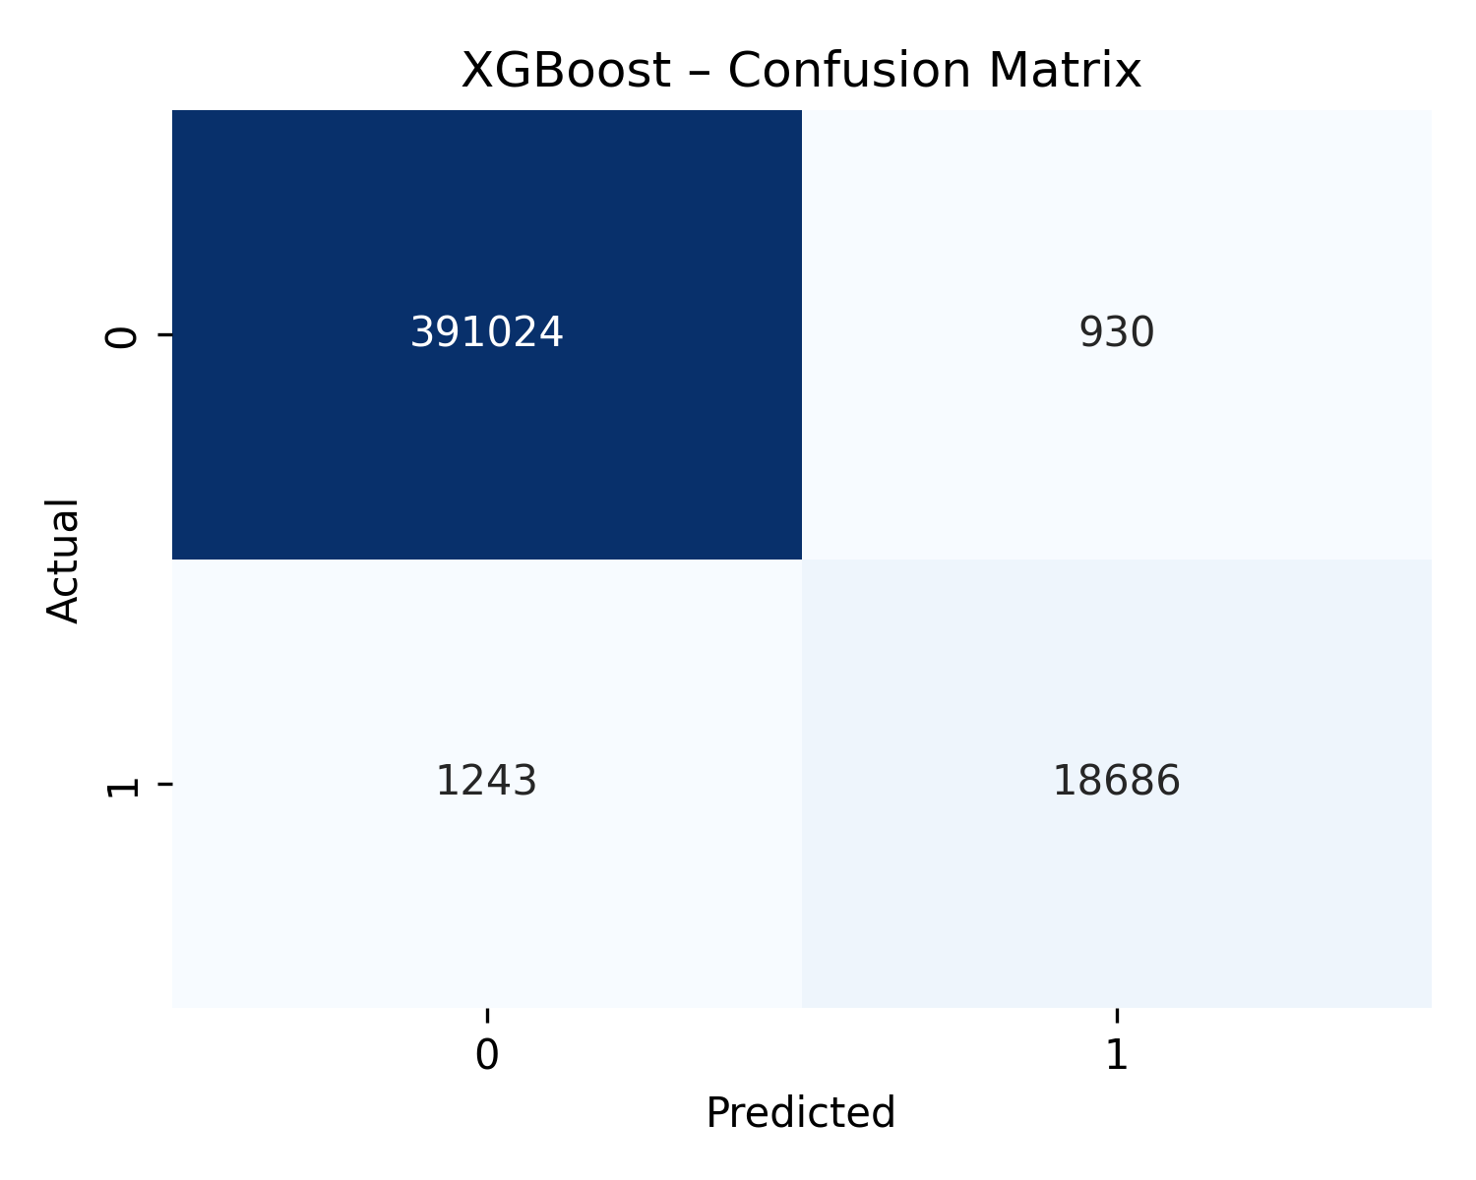
What this plot shows
Performance of XGBoost in detecting attacks.
Key observation
- Very few missed attacks
- Very few false alarms
- Strong balance between both classes
Simple conclusion
XGBoost is the most reliable model for intrusion detection in this system.

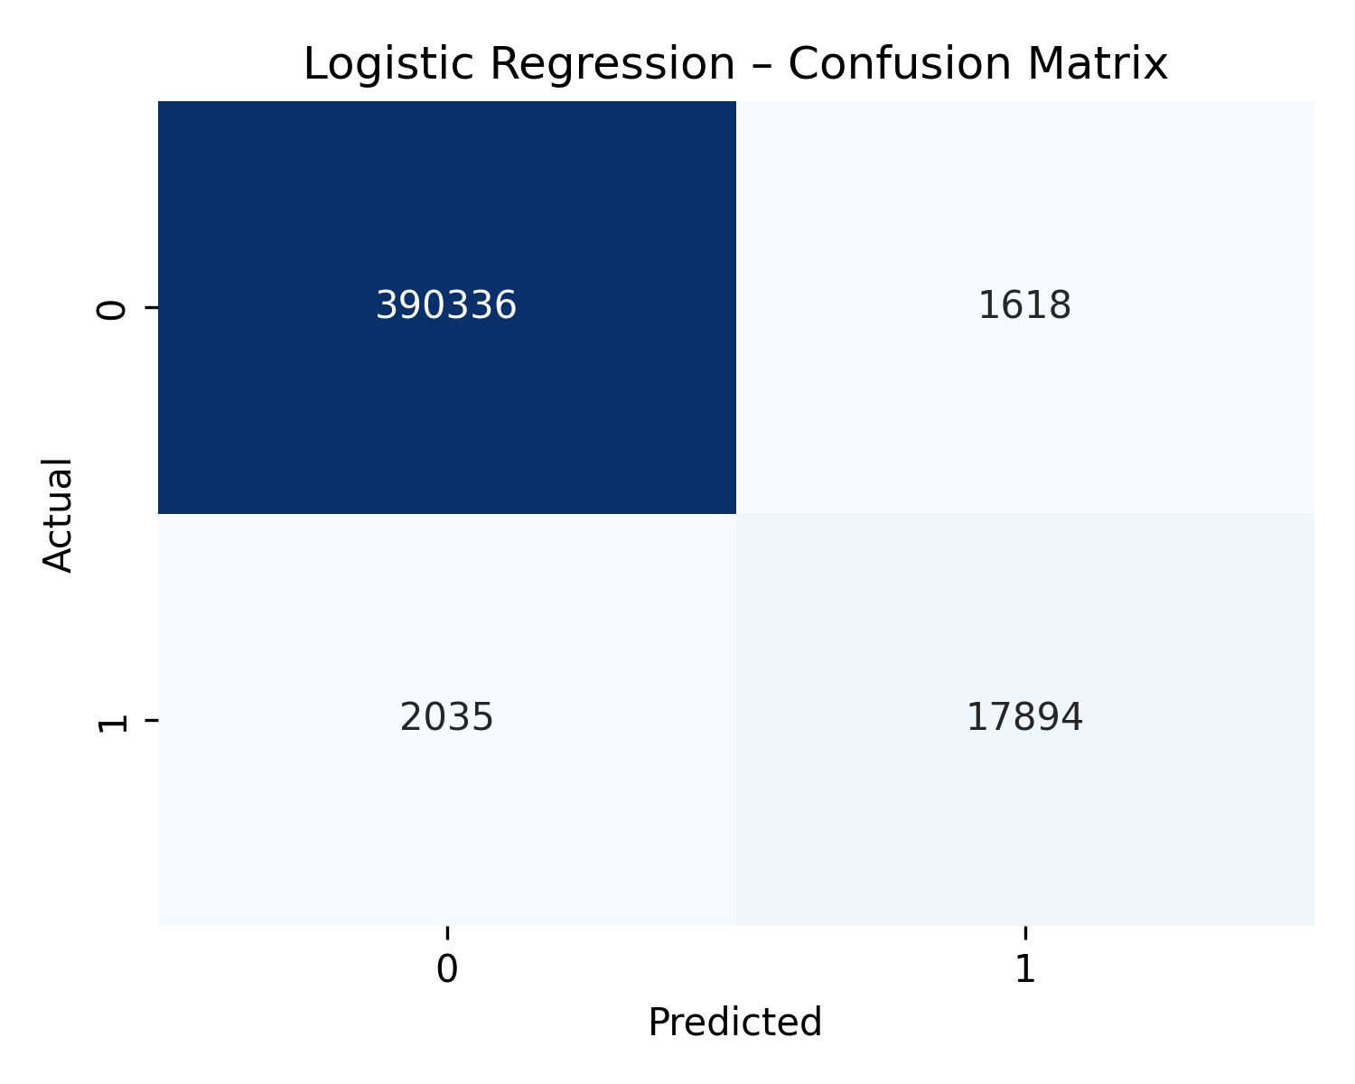

What this plot shows
It shows how well Logistic Regression classifies Normal (0) and Attack (1) traffic.
How to read it
- Top left (390,336) → Normal traffic correctly predicted as Normal
- Top-right (1,618) → Normal traffic wrongly predicted as Attack (False Alarms)
- Bottom-left (2,035) → Attacks missed (False Negatives)
- Bottom-right (17,894) → Attacks correctly detected
Simple conclusion
Logistic Regression detects most attacks but still misses some. It gives a good balance and is easy to explain.

A model comparison plot was generated:
- model_comparison.png
Caption: Model Comparison Across Accuracy, Precision, Recall, and F1-score
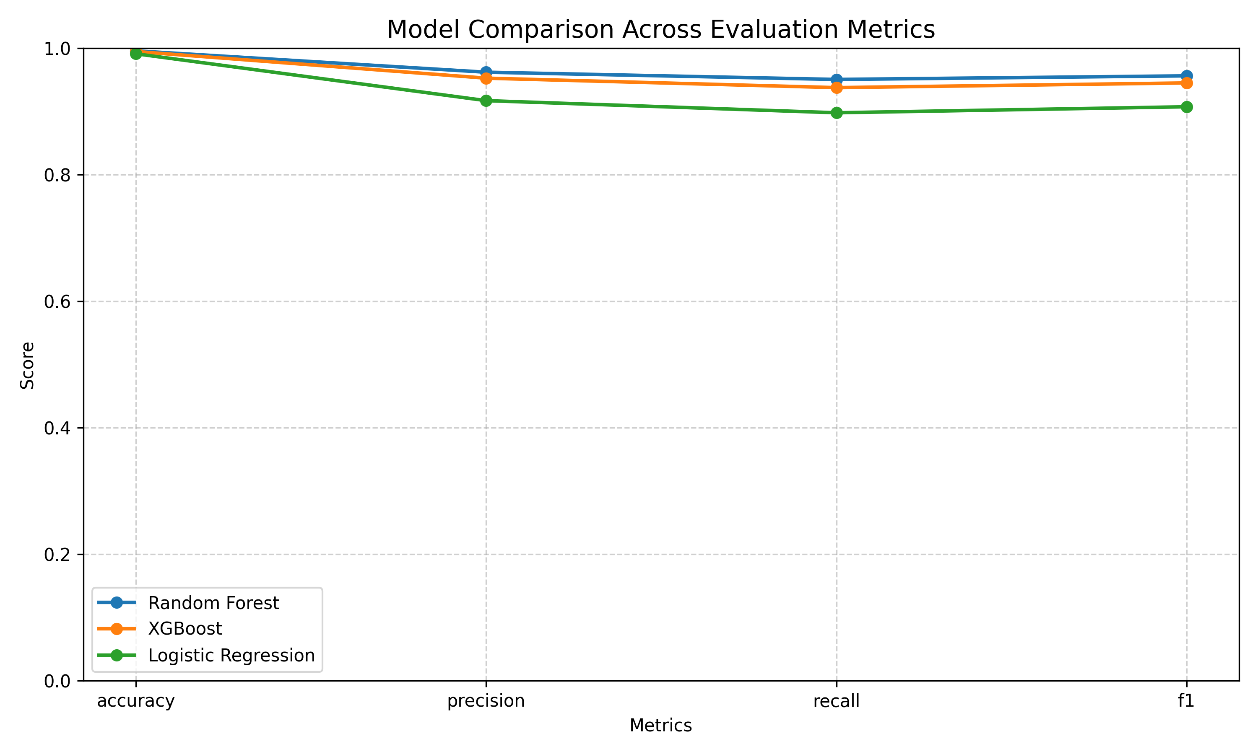
What this plot shows
It compares three models across:
- Accuracy
- Precision
- Recall
- F1-score
How to read it
- Each colored line = one model
- Higher line = better performance
Key observation
- Random Forest → very high accuracy
- XGBoost → best balance of precision & recall
- Logistic Regression → slightly lower but very stable
Simple conclusion
XGBoost performs best overall, while Logistic Regression is a strong and interpretable baseline.

Feature importance plots (normalized) were generated for all models:
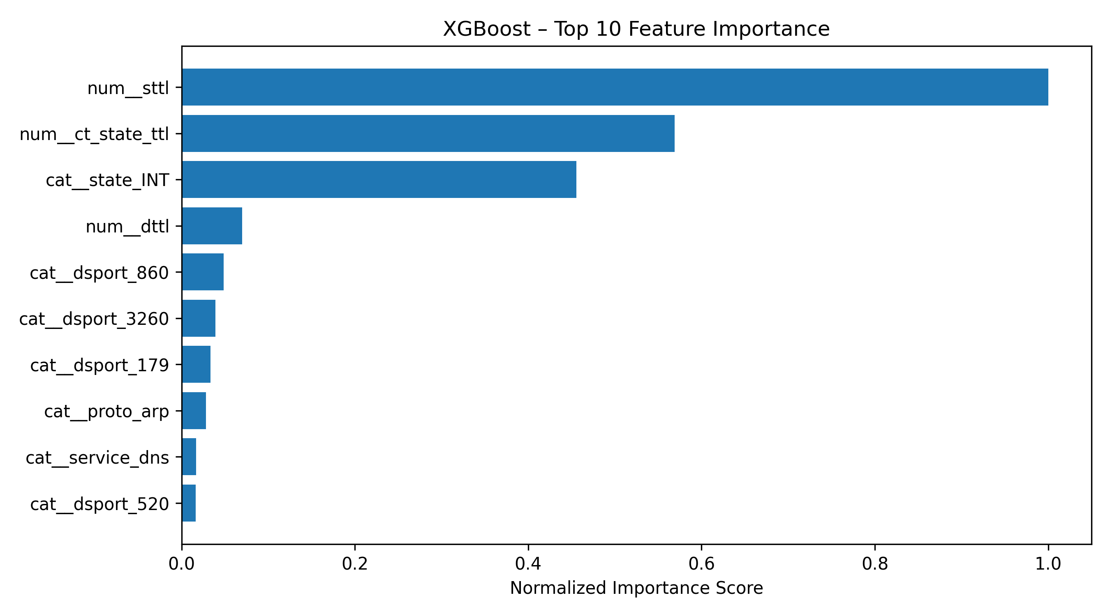
What this plot shows
Top features used by XGBoost for decisions.
Key features
- sttl, ct_state_ttl → connection behavior
- state, service, dport → protocol and service-level patterns
Simple conclusion
XGBoost combines both traffic behavior and protocol-level information, which explains its high accuracy.

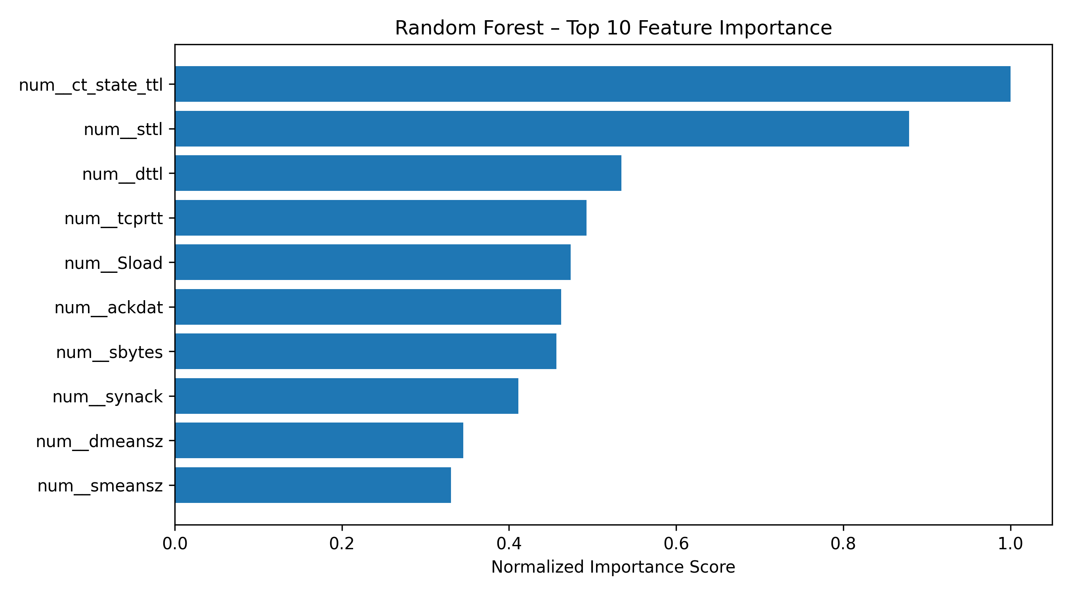
What this plot shows
Top numerical features used by Random Forest.
Key features
- ct_state_ttl, sttl, dttl → packet timing behavior
- tcprtt, synack → TCP handshake behavior
- sbytes, Sload → traffic volume
Simple conclusion
Random Forest focuses mainly on packet timing and traffic flow statistics.

FINAL ONE-LINE SUMMARY (VERY IMPORTANT)
XGBoost is selected as the main IDS (Intrusion Detection System) model because it achieves the best balance between detecting attacks and minimizing false alarms, while Logistic Regression is kept for explainability and Random Forest for comparison.

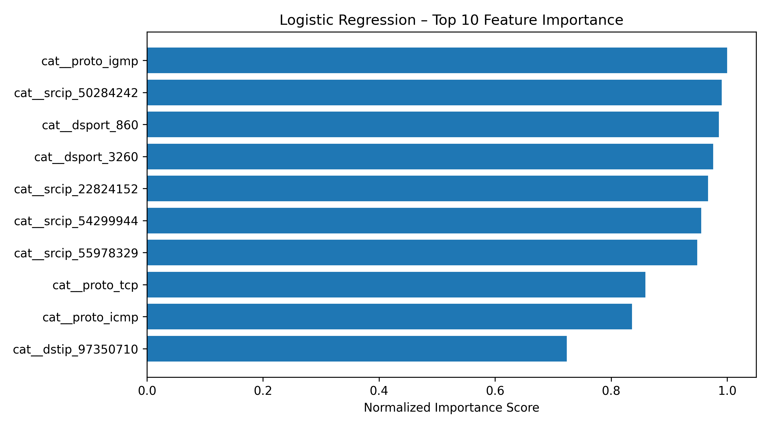
What this plot shows
It shows the top 10 features that most influenced Logistic Regression decisions.
How to read it
- Higher bar = more influence
- Values are normalized (0–1) so comparison is fair
- Features starting with cat__ come from OneHotEncoder
- Features like proto, dport, srcip indicate protocols and ports matter a lot
Simple conclusion
Logistic Regression mainly relies on protocol type, ports, and IP-related patterns to detect attacks.

9. Final ML Architecture
Input network flow → preprocessing pipeline → trained ML model → prediction (Normal / Attack with confidence).

10. Conclusion
The ML component is complete, stable, and deployment-ready. The system achieves high detection performance while maintaining reproducibility and explainability.

