Q1 Pilot Report — Ajaia Docs
Prepared for the Internal Productivity working group. This file tests bold, italic, underline and a link to ajaia.com.

1. Summary
The pilot ran for eight weeks with 70 invited writers. Adoption grew steadily and crossed the 50-writer target in week 8.

Key outcomes
- 52 weekly active writers by week 8
- Median time to first shared document: 11 minutes
- Comment threads replaced 60% of review emails

2. Adoption
Weekly active writers per week (embedded image — should import as an image you can resize):
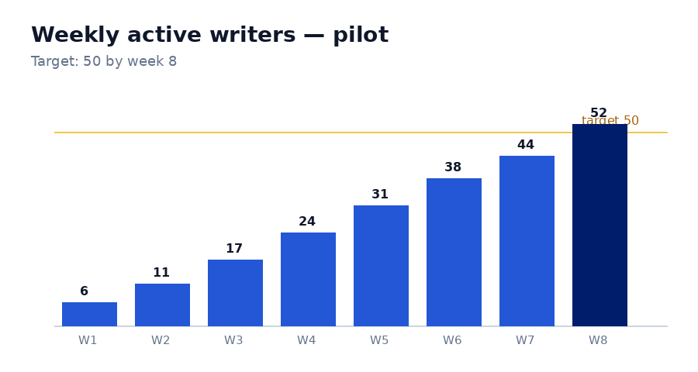

3. Results by team
Team | Writers | Docs created | Comments
Product | 18 | 64 | 212
Engineering | 21 | 88 | 301
Operations | 13 | 37 | 96

4. Next steps
- Roll out to two more departments
- Add real sign-in (SSO)
- Pilot suggestion mode with the legal team
Questions? Leave a comment on any passage in this document.

