**Group Member’s Name:-**

**Muhammad Arsalan (2303.KHI.DEG.025)**

**Abdul Rehman (2303.KHI.DEG.035)**

* Firstly we update the apt with sudo command.

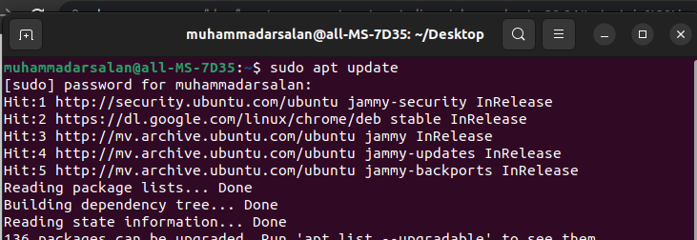

* Then we create a Ars.sh File with Nano Command.
* After That we use crontab -e to Select an Editor,In which we select the first one.

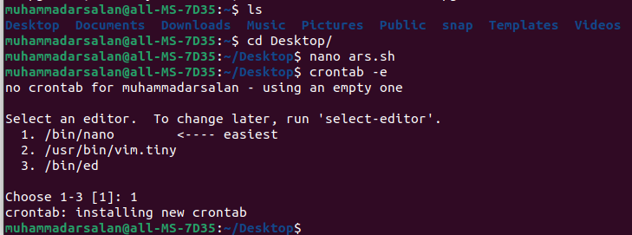

* In the Editor First we set the time when the work should be done So We Select the time after Every Minutes.
* Then we use rsync -a with give the location of source to destination where file should we want to save.
* After that we save this the Crtl+S and Exit with Crtl+X.  
    
  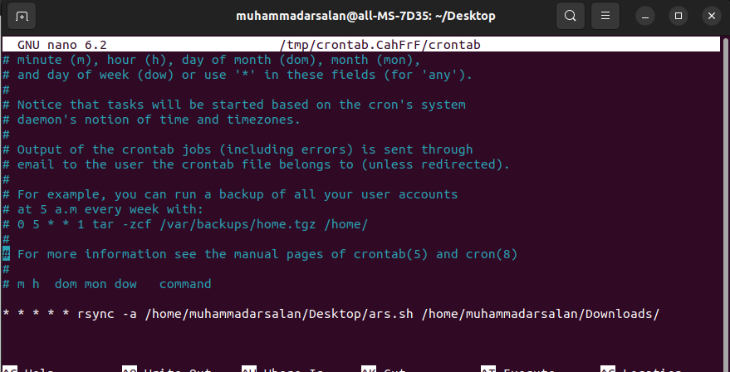
* After Exit In Editor we use crontab -l to Listed all the commands we put it in Above Editor.

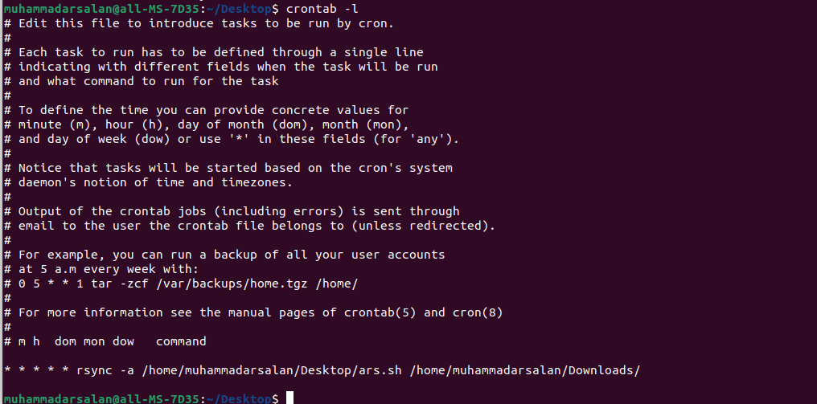

* 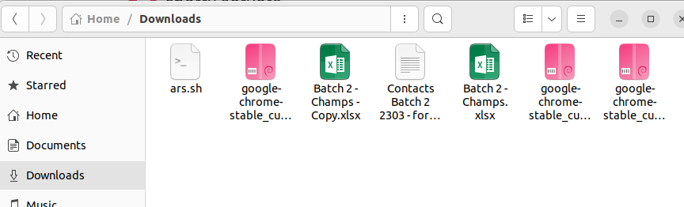This the Location of a File Where we give the command to save a File.

Reference:-Getting Help From Muzzammil Mehmod