**Group Member’s Name:-**

**Muhammad Arsalan (2303.KHI.DEG.025)**

**Abdul Rehman (2303.KHI.DEG.035)**

* First we create an Repo with git init with name “Myrepo”
* Then we create an file with touch Command,then we use git add and then we Commit it.
* After that we make branches of Even And Odd.
* Then we Go first Odd branch and open file with None Command And Add Odd Number and then git add and commit it,This same Process work for Even Branch too.

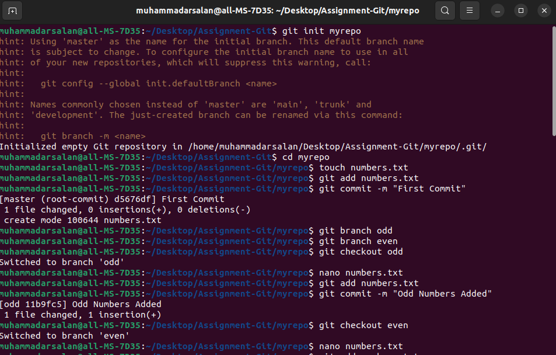

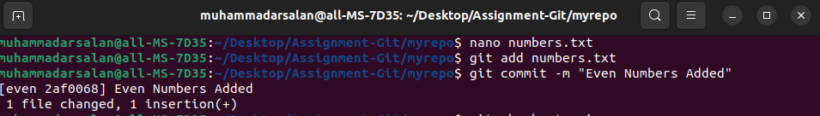

* After that we can go the master branch and start Merg the Odd Branch with the Master.
* Then same goes to Even branch,but even branch we face an Conflict.

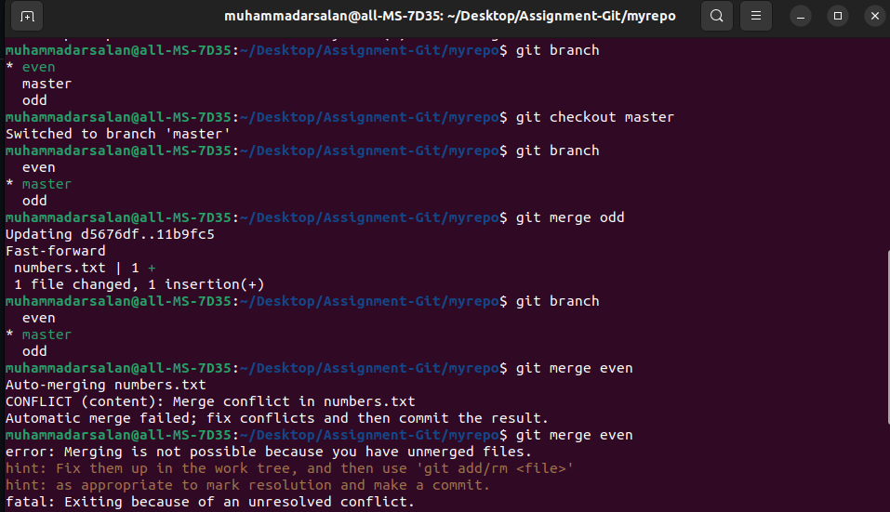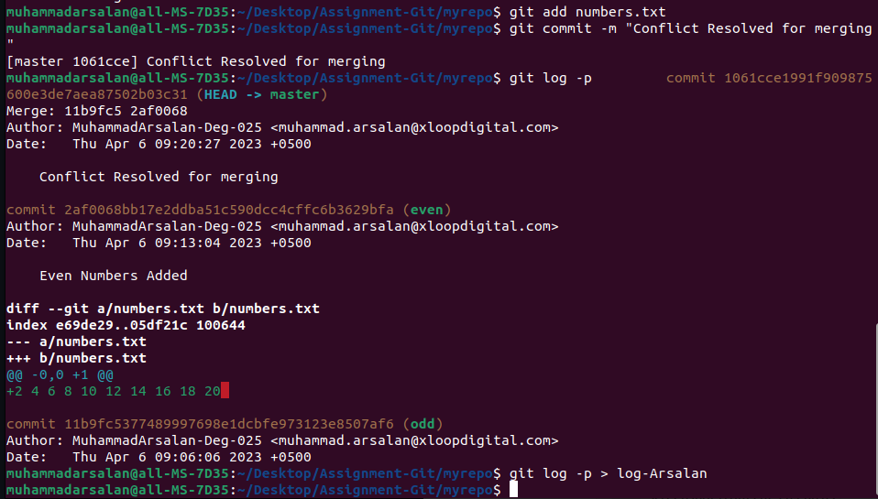

* When Conflict occurred,we open the file and Delete all the Arrows and equals Symbols.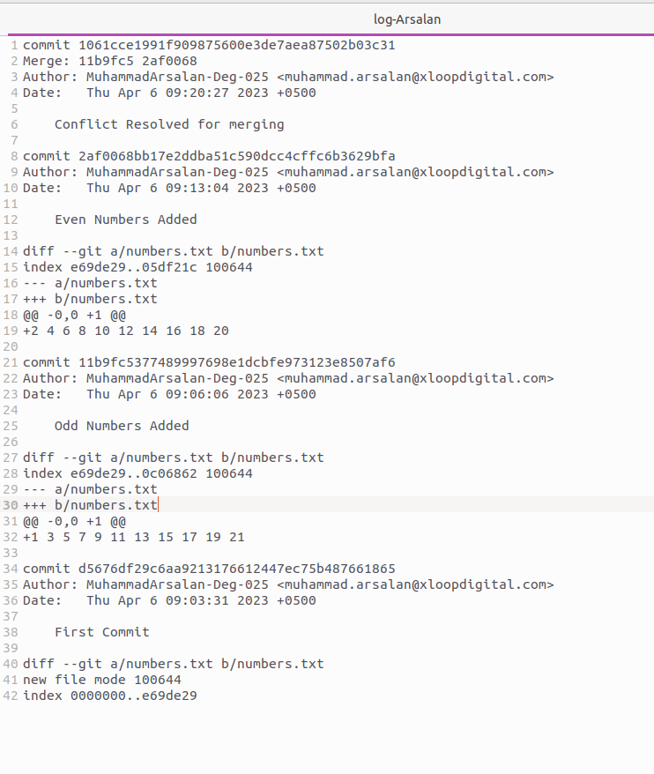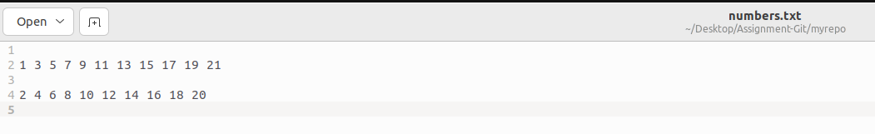
* After all of these Commands we run the Log Command and Generate the log-File of it.