**Group Member’s Name:-**

**Muhammad Arsalan (2303.KHI.DEG.025)**

**Abdul Rehman (2303.KHI.DEG.035)**

**Create an Funtion that will Label encoded the Category of a “Diagnosis” Column.**

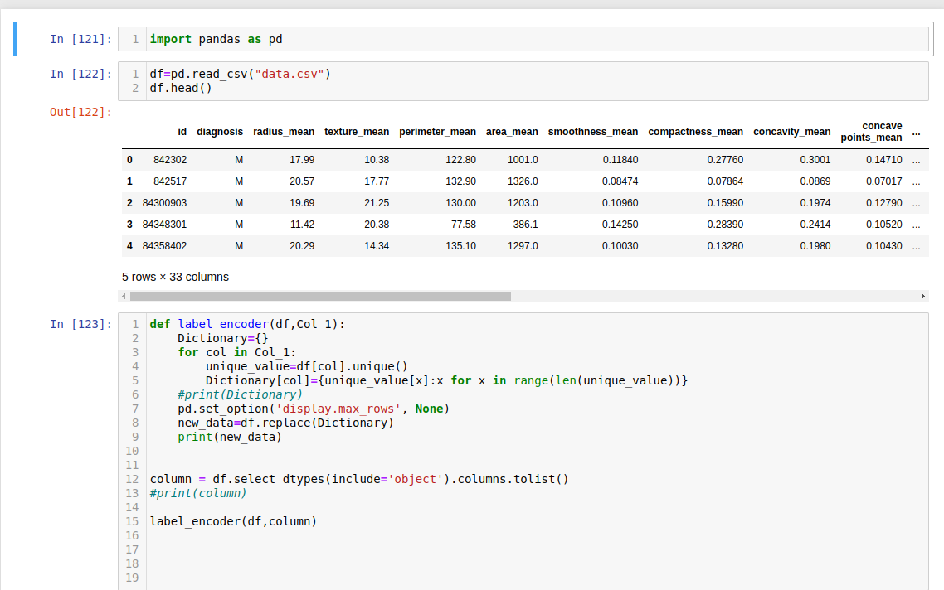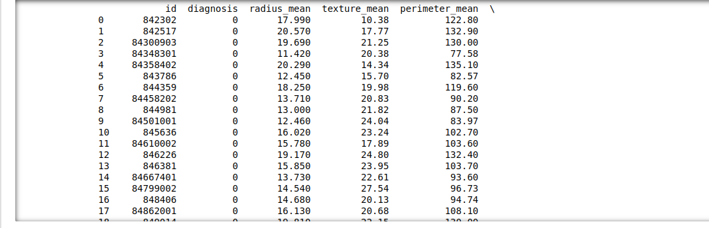 **Create an Funtion that will Label encoded the Category of a “Species” Column.**

