**CONTROL SYSTEM LAB REPORTS**

**LAB 06**

**SUBMITTED BY**

**ZARAFSHAN IQBAL**

**REG NO**

**17KTELE0556**

**SEMESTER**

**8TH**

**SUBMITTED TO**

**ENGR.M.AMJAD**

**LAB 06**

TASK 01:

**For unit step input**  
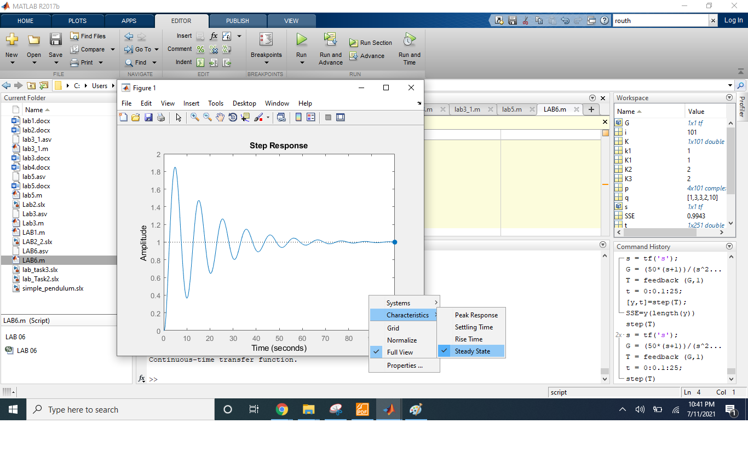

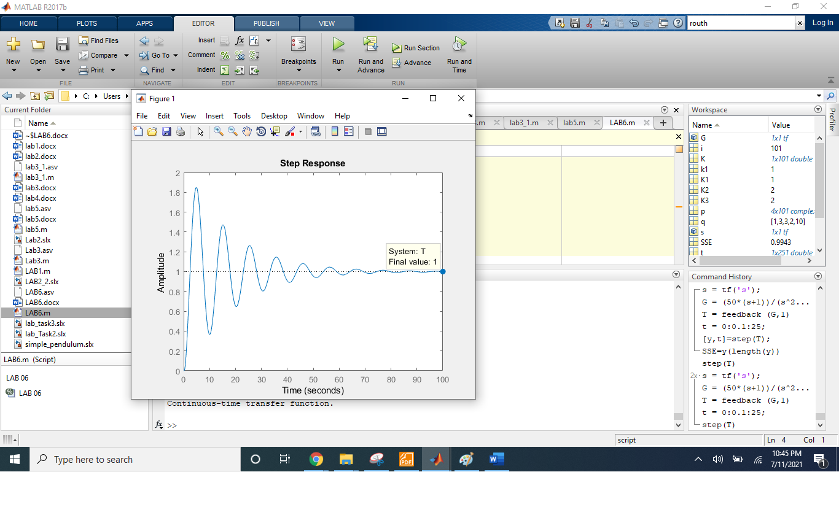

Since the final value of the system is 1, so the steady state error having step input is zero.

**For unit ramp input:**

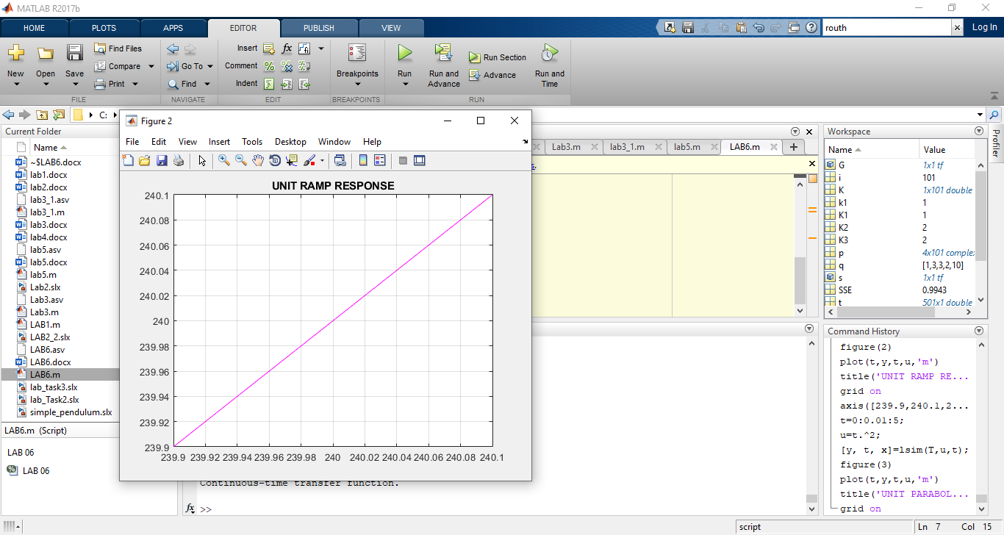

There is also no steady state error shown in graph,

**For unit parabolic response:**

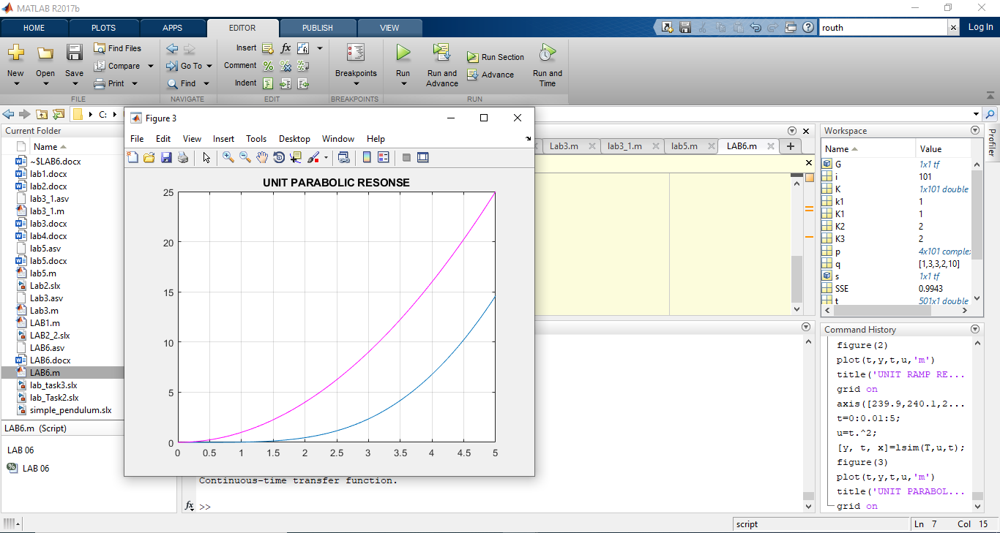

As shown in the graph, there is a finite error in the graph.

**Task 02:**

**MATLAB CODE:**

s=tf('s');

G=((2)/((s)*(s+1)));

T=feedback(G,1);

t=0:0.01:5;

u=(1/2)*t.^2;

[y, t, x]=lsim(T,u,t);

plot(t,y,t,u,'m')

title('r(t)=1/2*t^2 RESPONSE OF SYSTEM')

axis([0,5,0,5]);

grid on

**MATLAB RESULT:**

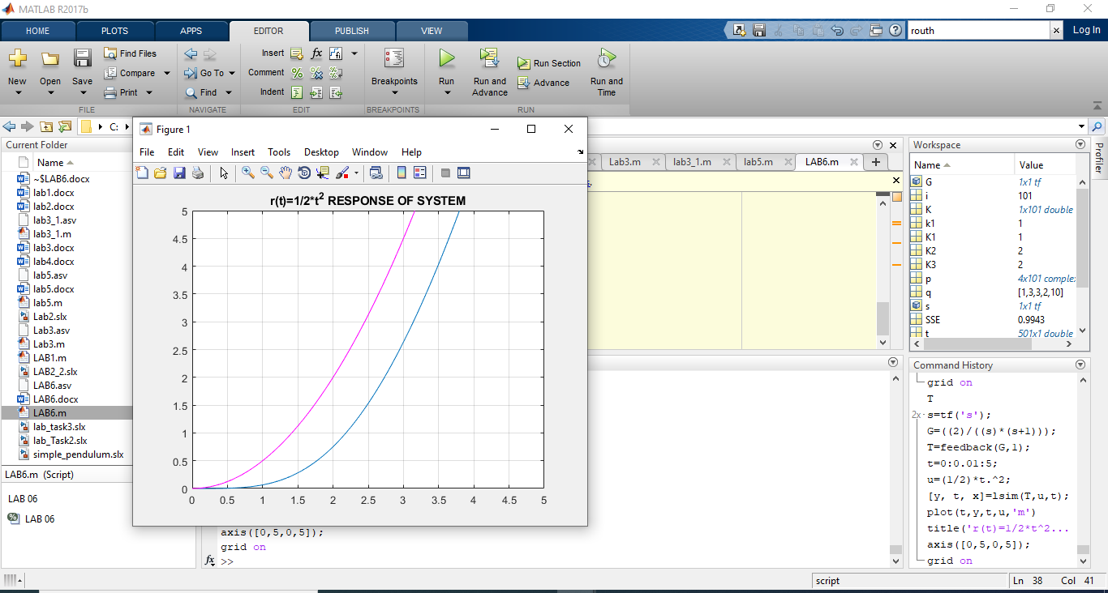

**Task 03:**

Effect of value B, when all other values are taken constant

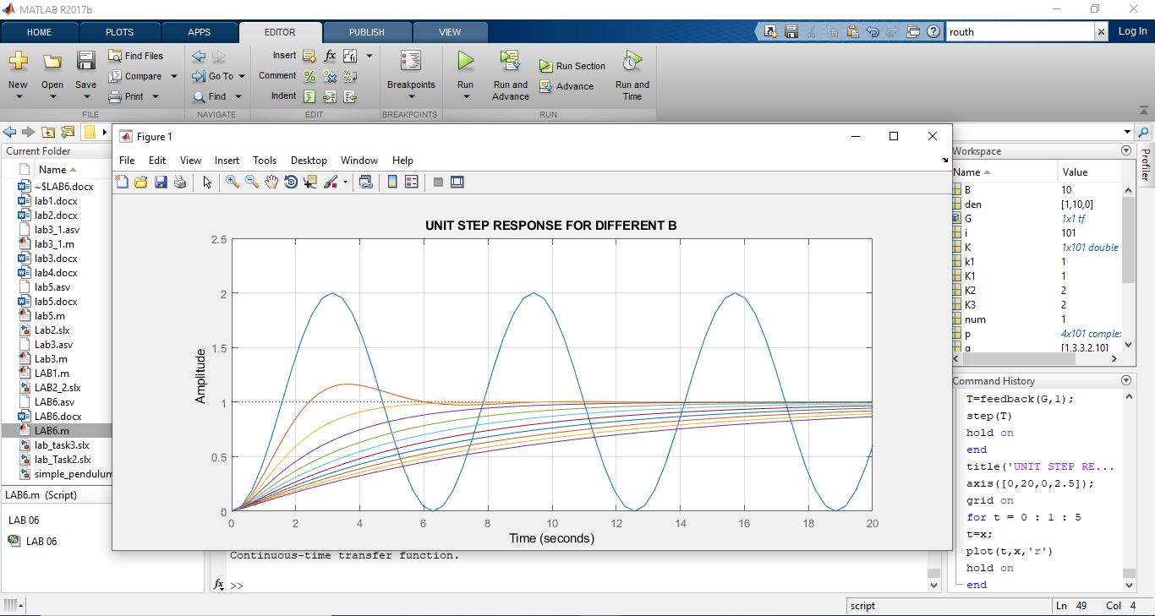

Effect of value K, when all other values are taken constant

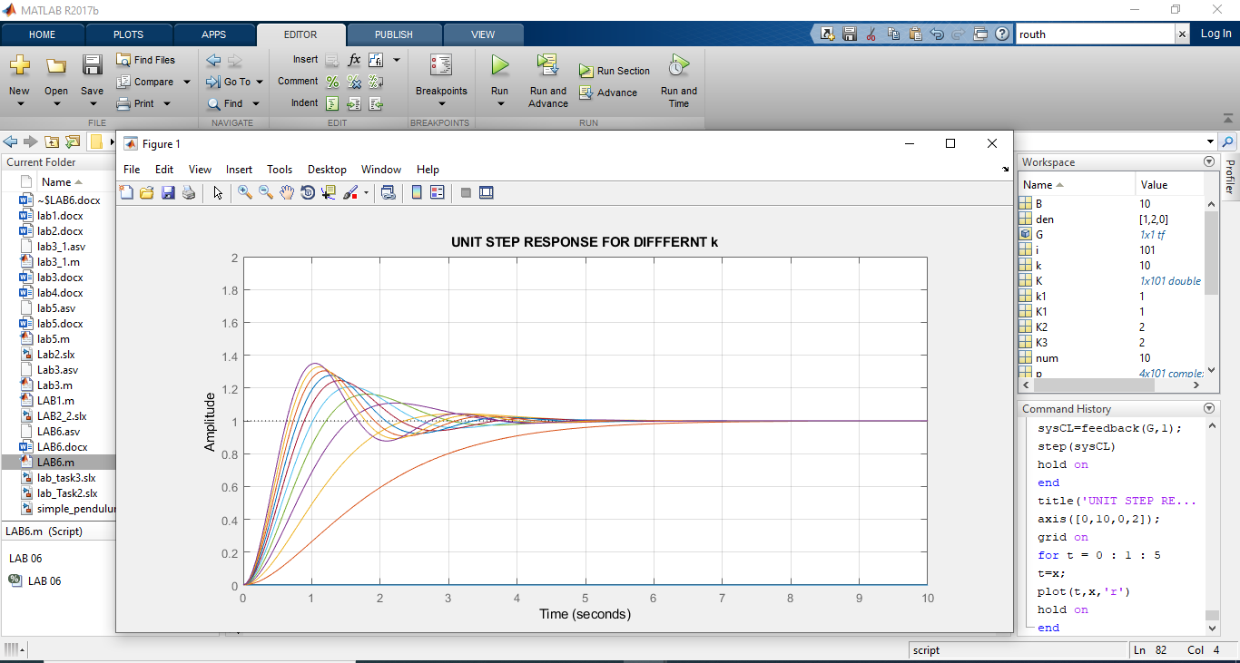

Unit ramp response for small , medium and large value of K.

