**CONTROL SYSTEM LAB REPORTS**

**LAB 01**

**SUBMITTED BY**

**ZARAFSHAN IQBAL**

**REG NO**

**17KTELE0556**

**SEMESTER**

**8TH**

**SUBMITTED TO**

**ENGR.M.AMJAD**

**LAB TASK 1**

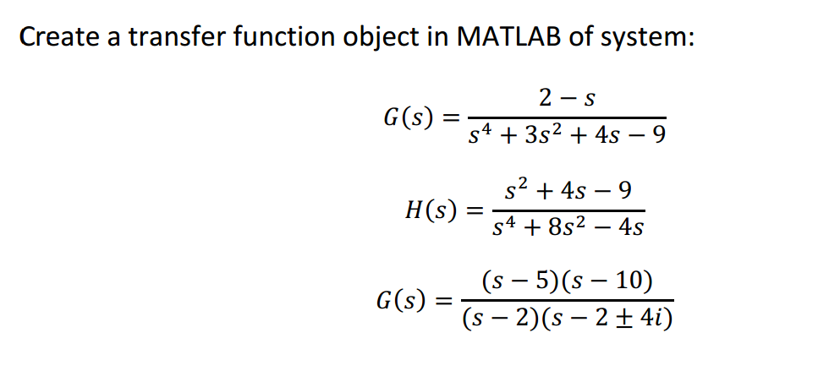

**1). MATLAB CODE:**

%G(s)= (-s+2)/ (s^4+3s^2+4s-9)

num = [-1 2];

den = [1 3 4 -9];

G = tf(num,den)

**MATLAB RESULT:**

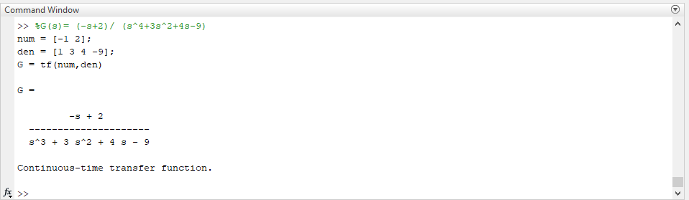

**2. MATLAB CODE:**

% H(s)=(s^2 +4s-9)/(s^4 +8s^2-4s)

num=[1 4 -9];

den=[1 0 8 -4 0];

H=tf(num,den)

**MATLAB RESULT:**

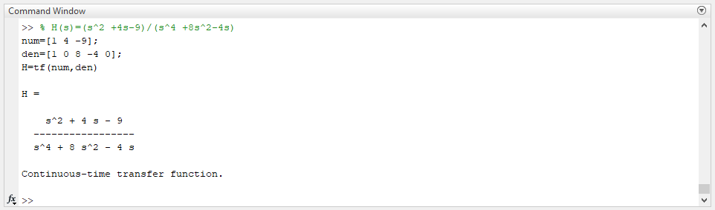

**3. MATLAB CODE:**

% G(s)= (s-5)(s-10)/(s-2)(s-2+-4i))

s=tf('s');

G=((s-5)*(s-10))/((s-2)*(s-2+4i)*(s-2-4i))

**MATLAB RESULT:**

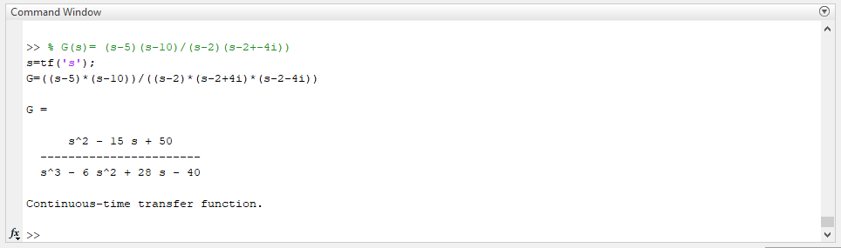

**LAB TASK 2**

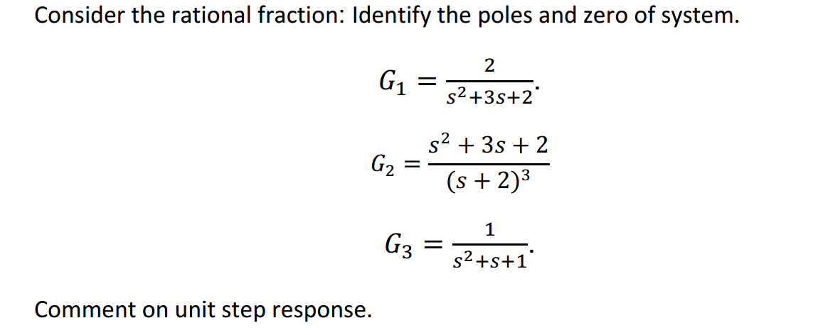

**MATLAB CODE:** %G1= 2/(s^2 +3*s+2)

num=[2];

den=[1 3 2];

G1=tf(num,den)

p1=pole(G1)

z1=zero(G1)

step(G1)

**MATLAB RESULT:**

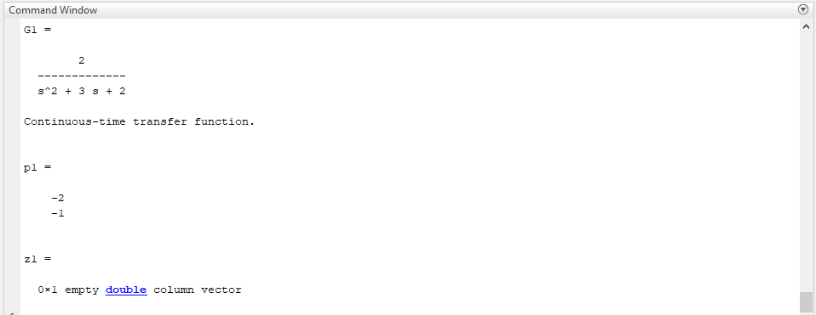

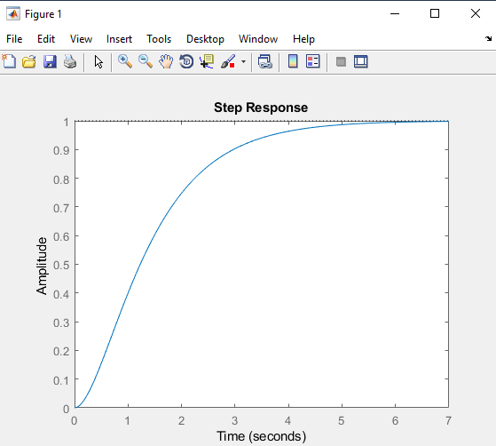

**MATLAB CODE:**

% G2=(s^2+3s+2)/(s+2)^3

s=tf('s')

G2=(s^2+3*s+2)/(s+2)^3

p2=pole(G2)

z2=zero(G2)

step(G2)

**MATLAB RESULT:**

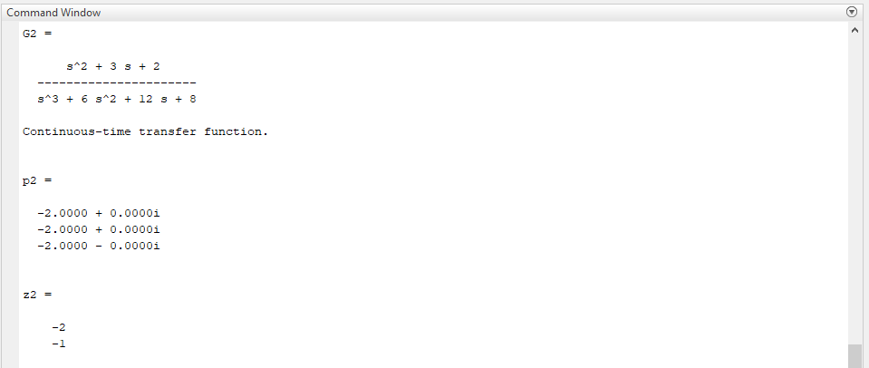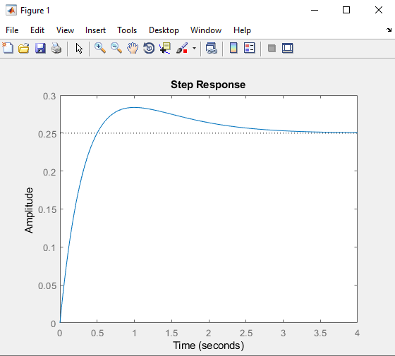

**MATLAB CODE:**

%G3=1/(s^2+s+1)

s=tf('s')

G3=1/(s^2+s+1)

p3=pole(G3)

z3=zero(G3)

step(G3)

**MATLAB RESULT:**

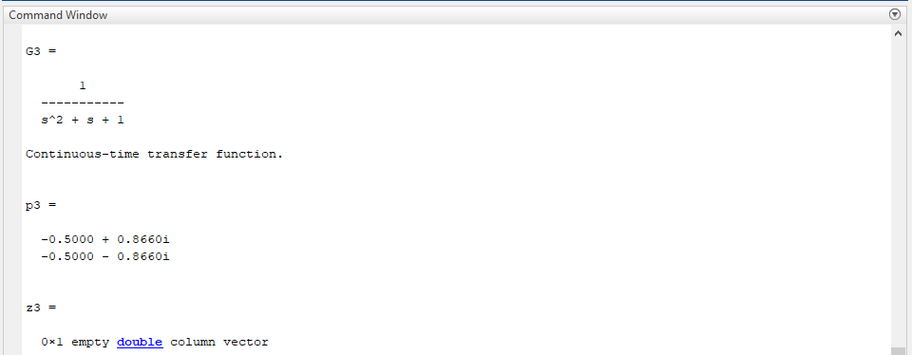

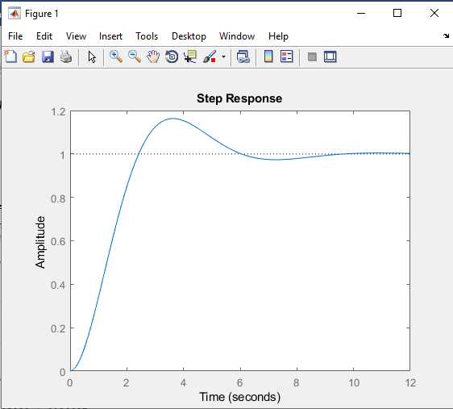

**LAB TASK 3**

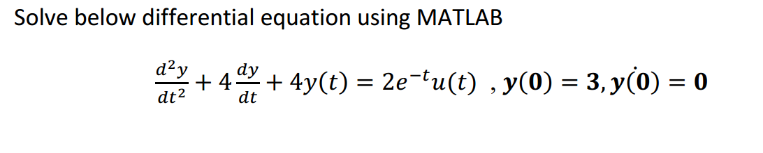

**MATLAB CODE:**

%Lab TASK 3

xt=dsolve('D2y+4*Dy+4*y=2*exp(-t)*1','y(0)=3','Dy(0)=0')

**MATLAB RESULT:**

