**CONTROL SYSTEM LAB REPORTS**

**LAB 02**

**SUBMITTED BY**

**ZARAFSHAN IQBAL**

**REG NO**

**17KTELE0556**

**SEMESTER**

**8TH**

**SUBMITTED TO**

**ENGR. M. AMJAD**

**LAB 02**

LAB TASK 1:

(a)

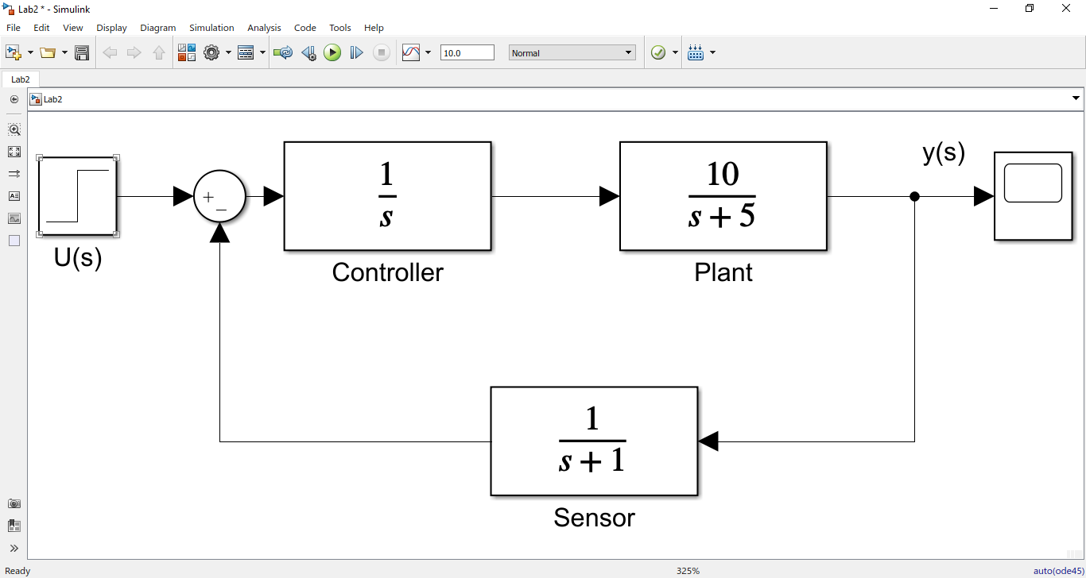

UNIT STEP RESPONSE OF SYSTEM AT T=2 SEC

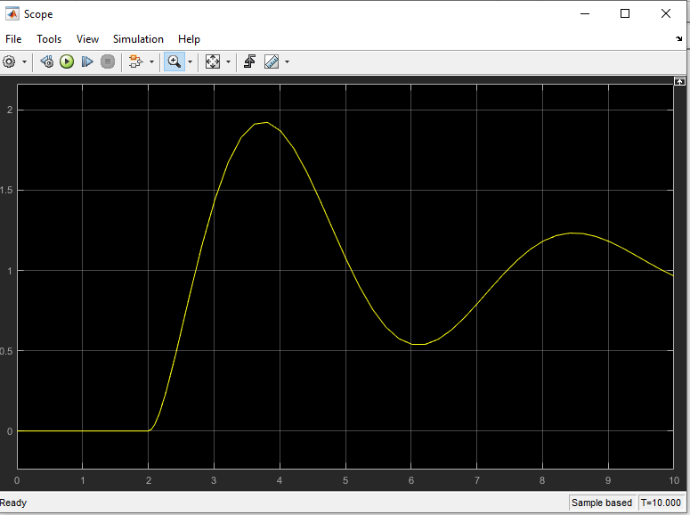

(B)

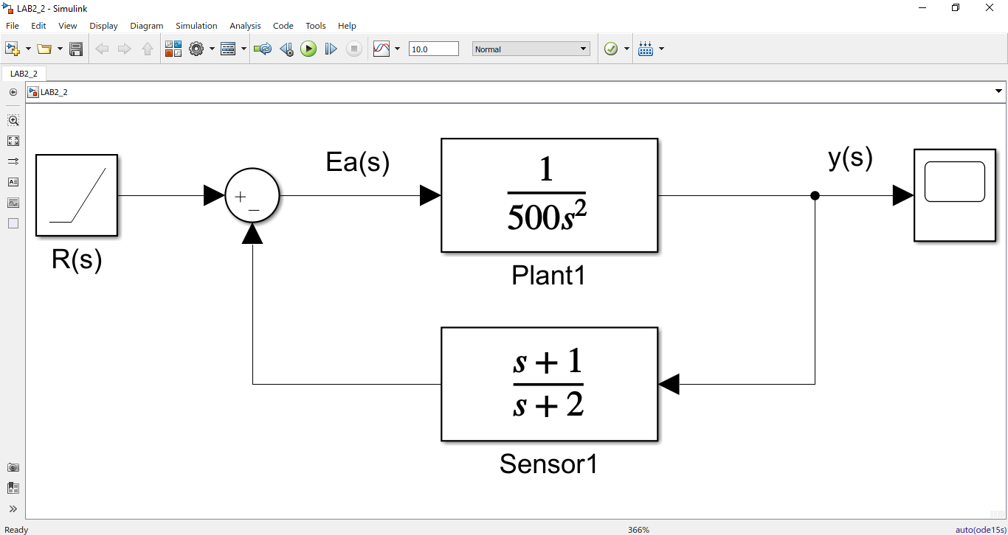

Ramp input signal at t=2 sec

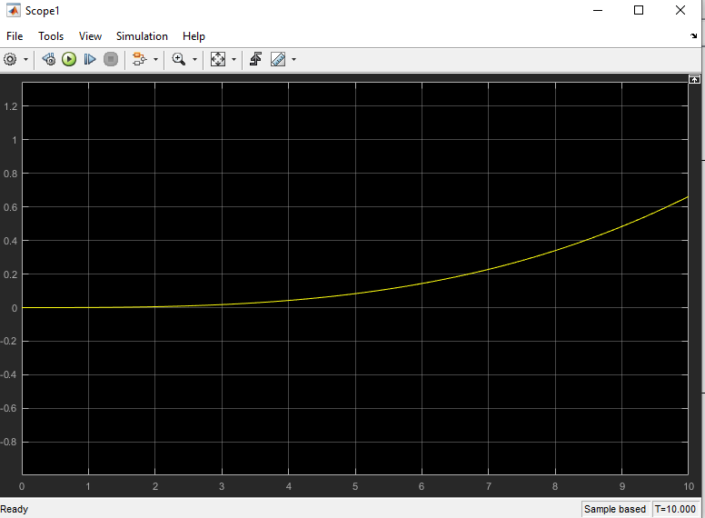

Lab task 02:

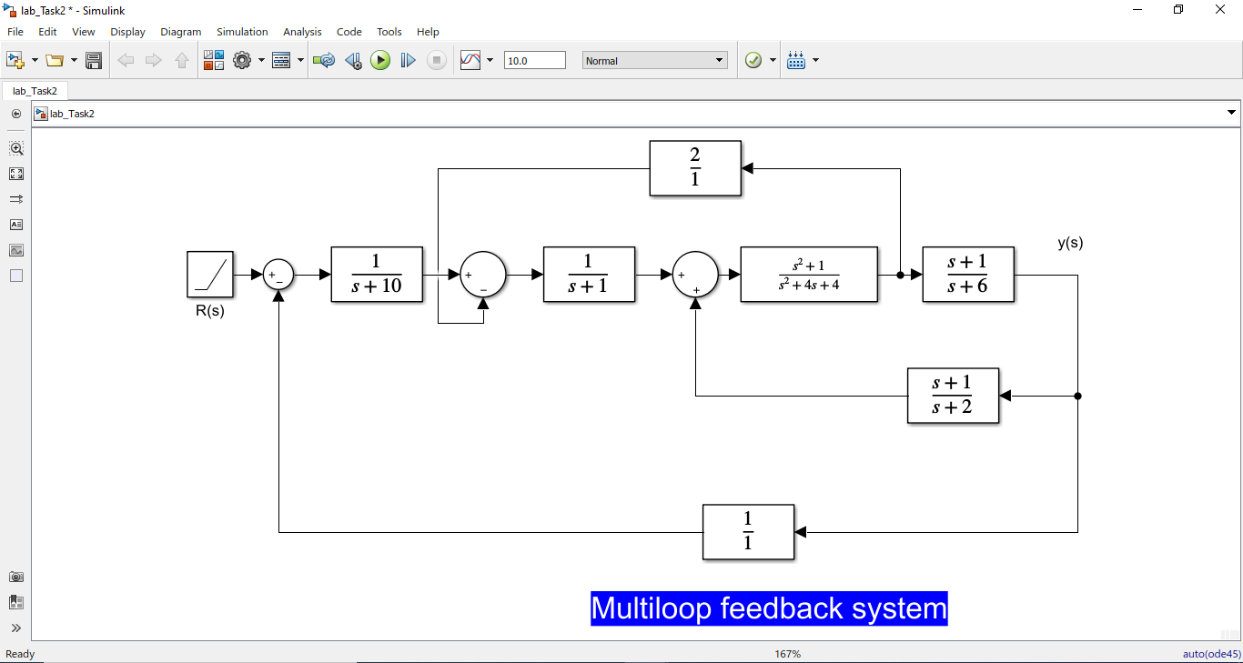

Lab task 03:

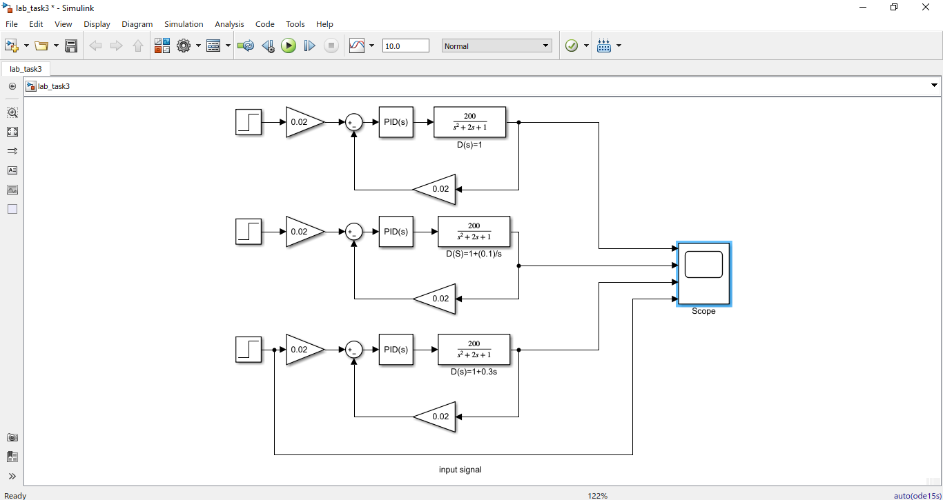

Results:

