**CONTROL SYSTEM LAB REPORTS**

**LAB 03**

**SUBMITTED BY**

**ZARAFSHAN IQBAL**

**REG NO**

**17KTELE0556**

**SEMESTER**

**8TH**

**SUBMITTED TO**

**ENGR. M. AMJAD**

**LAB 03**

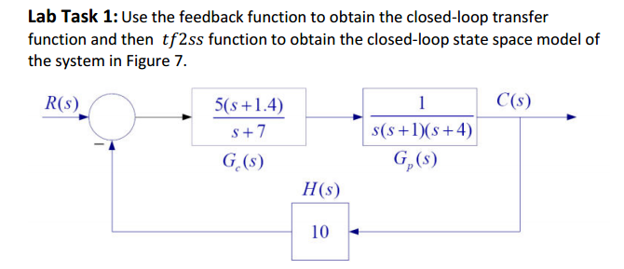

**MATLAB CODE:**

s=tf('s')

Gc=(5*(s+1.4))/(s+7)

Gp=(1)/(s*(s++1)*(s+4))

Ge=series(Gc,Gp)

feed=feedback(Ge,[10])

num=[5 7]

den=[1 12 39 78 70]

[A,B,C,D]=tf2ss(num,den)

**MATLAB RESULT:**

First we have to find the series of two transfer function,

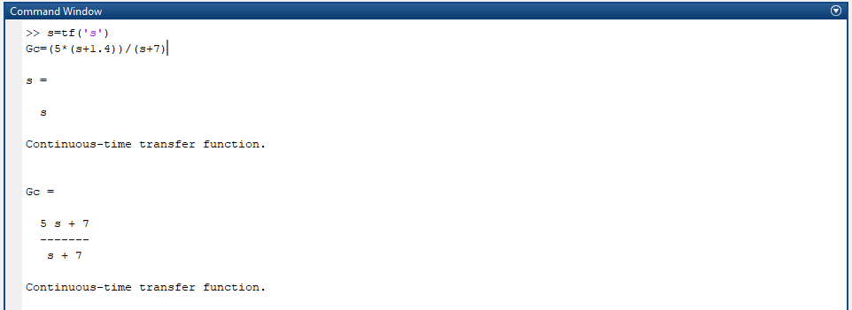

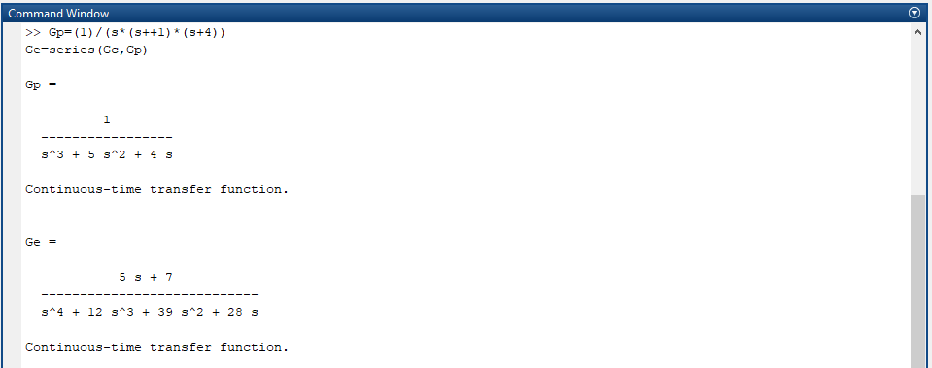

Our feedback has gain of 10, so using feedback command to find the closed loop transfer function,

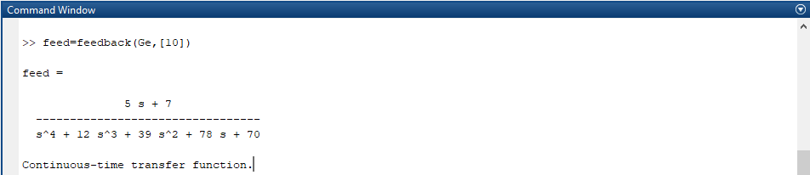

Closed loop transfer function is achieved, so extract the num and den values,

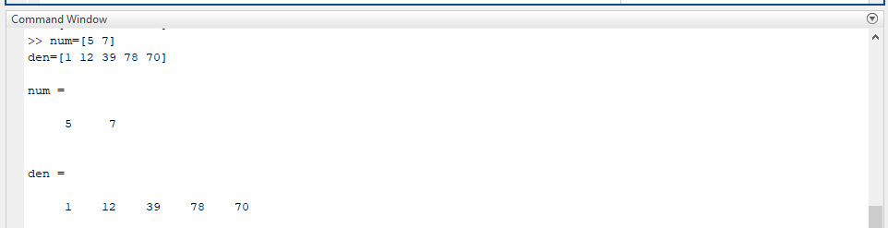

Now use tf2ss command to find the state matrix from closed loop transfer function

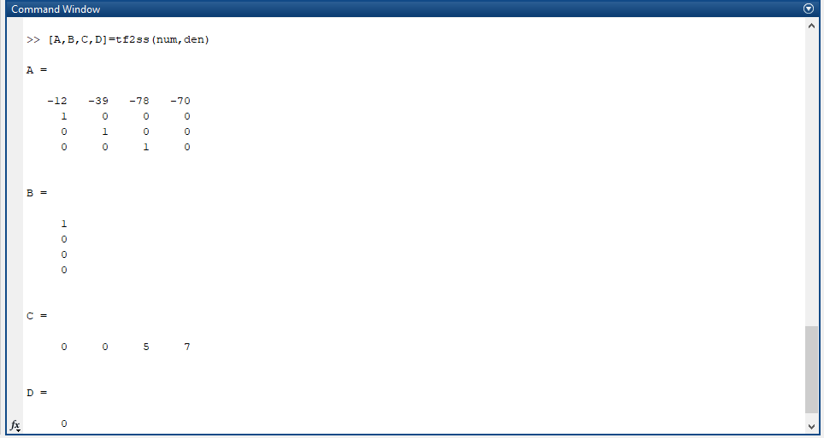

**TASK 02:**

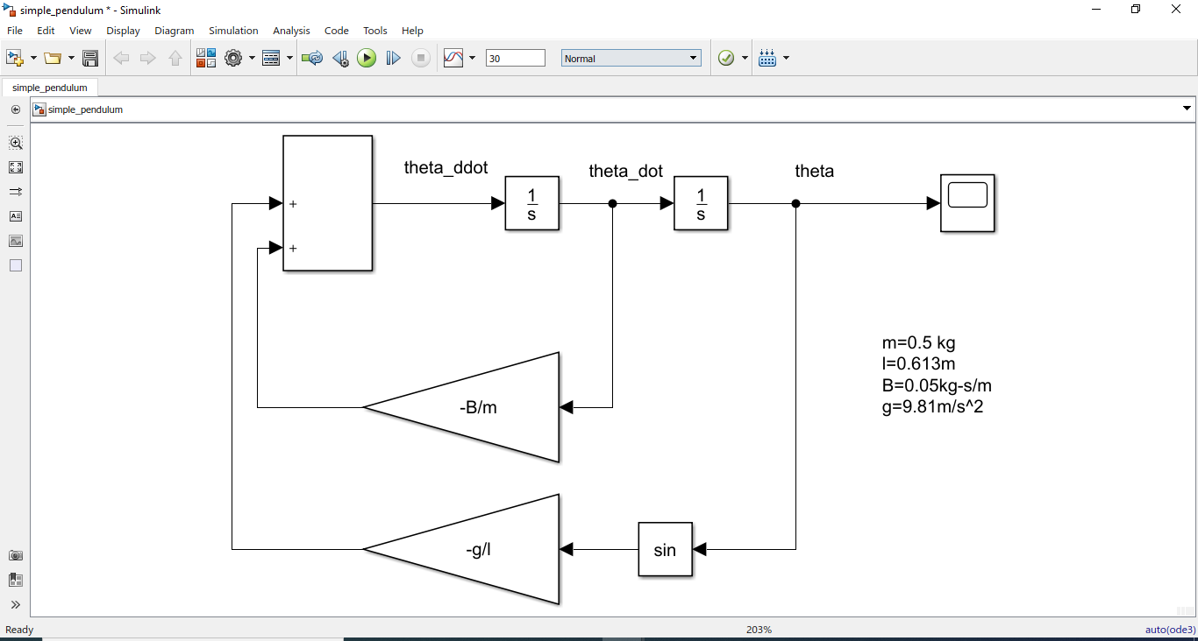

Simulation results:

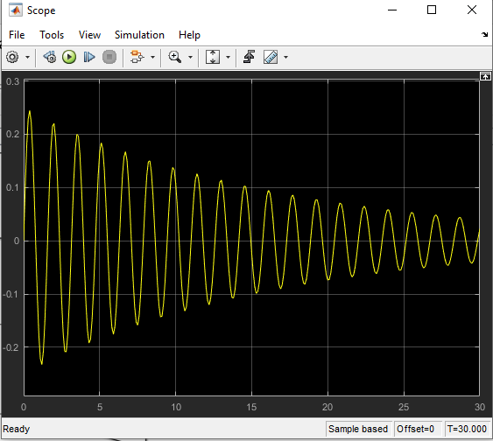

**TASK 03:**

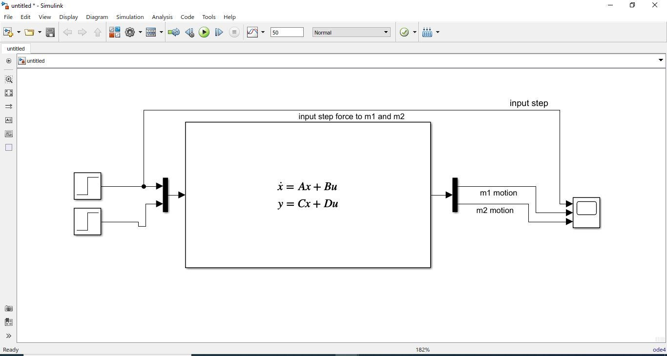

**SIMULINK RESULT:**

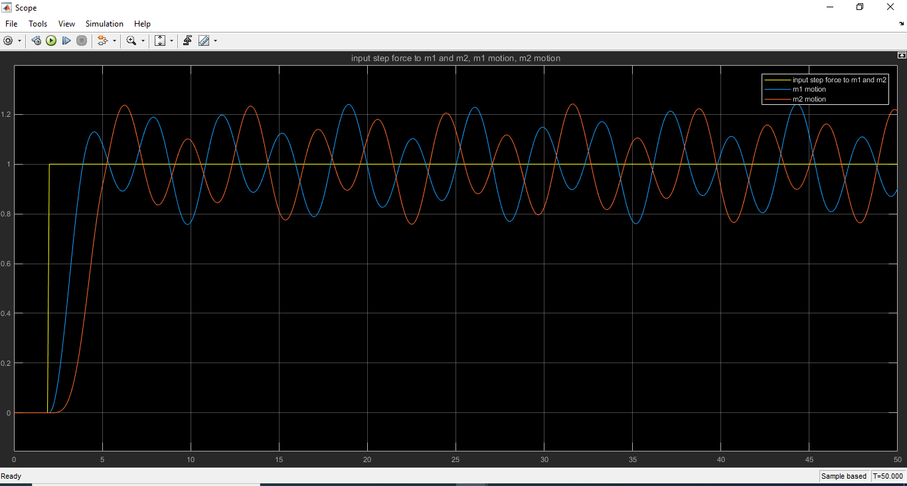

When the A-Matrix is changed so the result obtained is;

