**CONTROL SYSTEM LAB REPORTS**

**LAB 04**

**SUBMITTED BY**

**ZARAFSHAN IQBAL**

**REG NO**

**17KTELE0556**

**SEMESTER**

**8TH**

**SUBMITTED TO**

**ENGR.M.AMJAD**

**LAB 04**

**Task 01:**

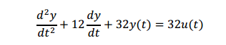

**Answer:**  first of all we have to convert second order differential equation to the closed loop transfer function to obtain the system characteristics parameters.

$$TF=\frac{32}{s^{2}+12s+32 }$$

**MATLAB CODE:**

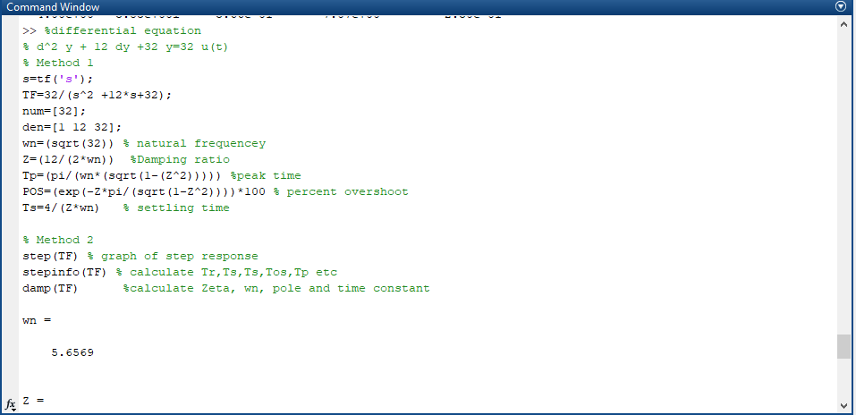

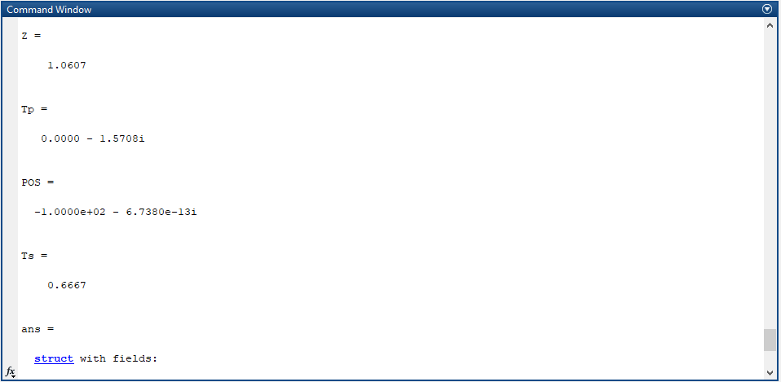

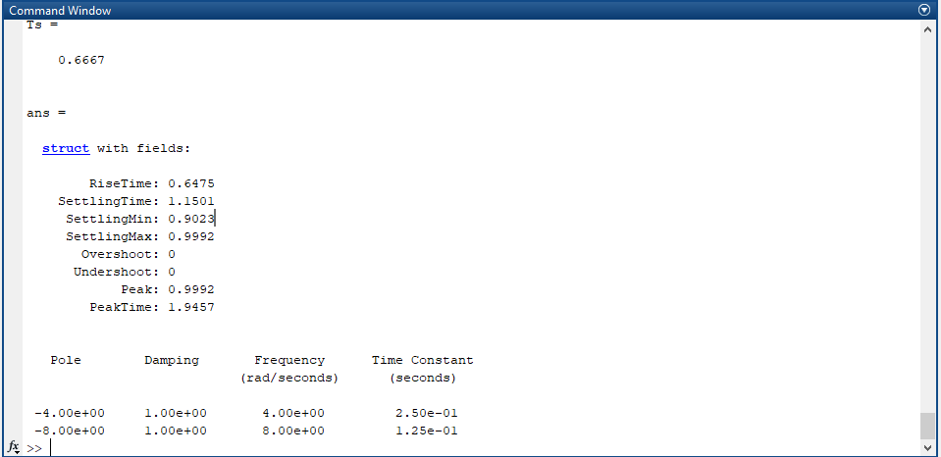

**Step response of the transfer function, $$TF=\frac{32}{s^{2}+12s+32 }$$**

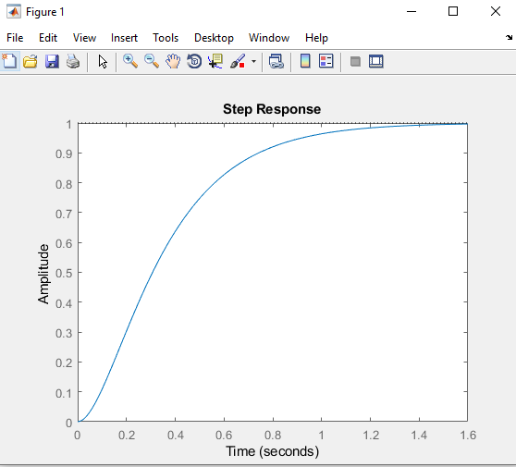

**Task 02:**



**Answer:**

First of all we have to make transfer function of closed loop system, so we will use feedback command with unity as feedback system.

**MATLAB CODE:**

% G(s)= 25/(s^2 + 8*s +25)

Gs=25/(s^2 +8*s +25)

C_Gs=feedback(Gs,[1])

% Method 1

wn=(sqrt(25)) % natural frequencey

Z=(8/(2*wn)) %Damping ratio

Tp=(pi/(wn*(sqrt(1-(Z^2))))) %peak time

POS=(exp(-Z*pi/(sqrt(1-Z^2))))*100 % percent overshoot

Ts=4/(Z*wn) % settling time

% Method 2

step(C_Gs) % graph of step response

stepinfo(C_Gs) % calculate Tr,Ts,Ts,Tos,Tp etc

damp(C_Gs) %calculate Zeta, wn, pole and time constant

**MATLAB RESULTS:**

