**CONTROL SYSTEM LAB REPORTS**

**LAB 05**

**SUBMITTED BY**

**ZARAFSHAN IQBAL**

**REG NO**

**17KTELE0556**

**SEMESTER**

**8TH**

**SUBMITTED TO**

**ENGR.M.AMJAD**

**LAB 05**

**Task 01:**

We have found the range of K on which the system is stable, the range is K<1386 then the system is stable.

The solution of Routh stability criteria ,

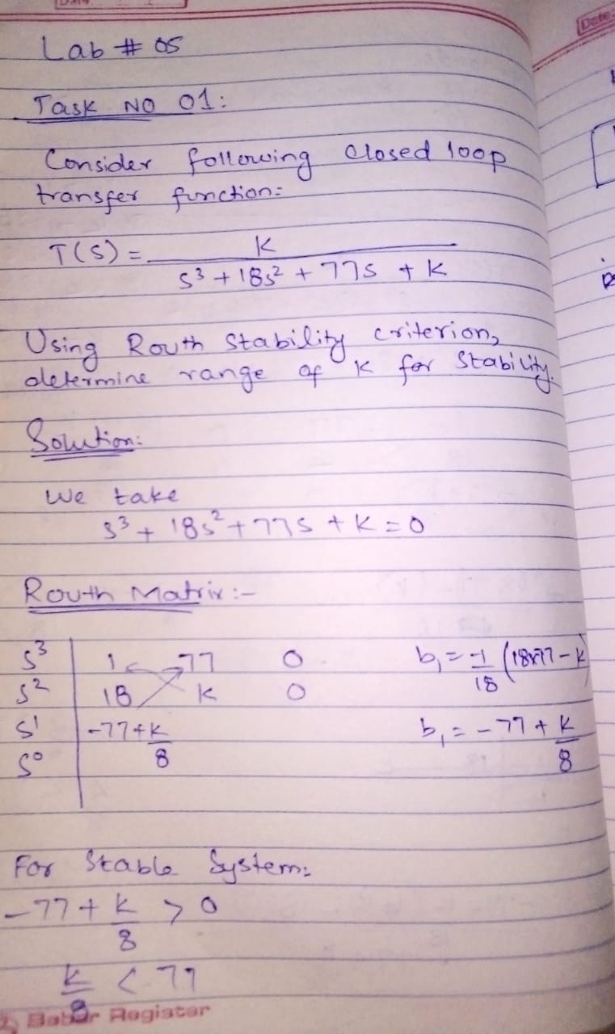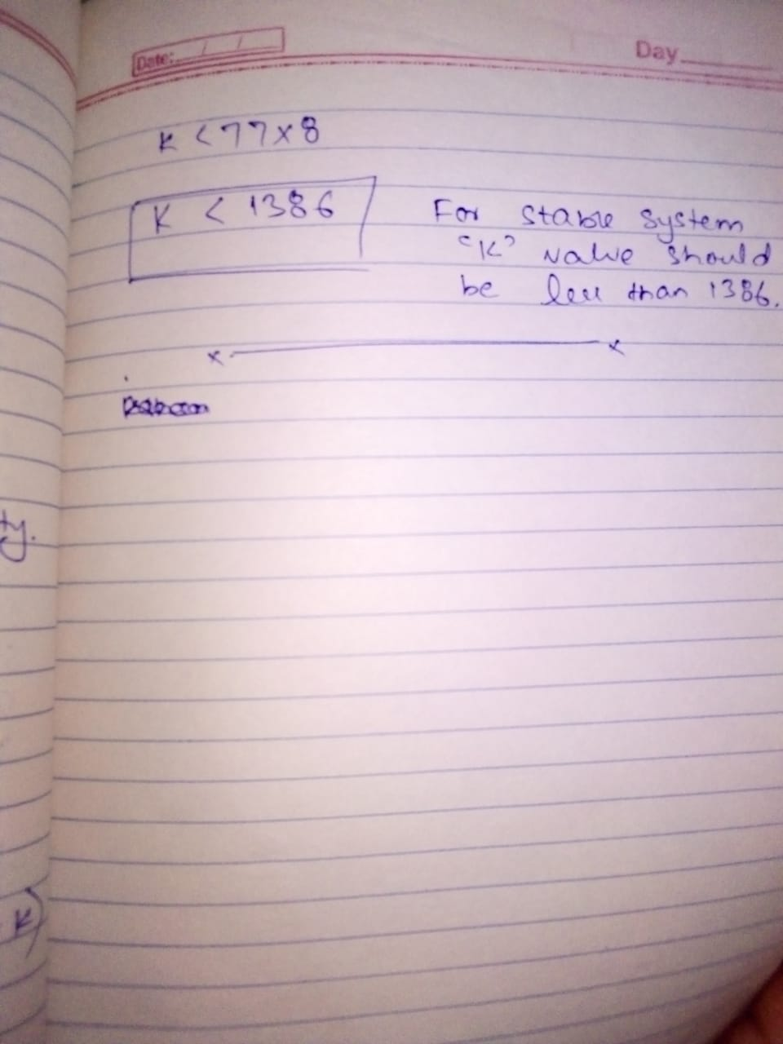

**MATLAB code to check whether our obtained range is correct,**

s=tf('s');

G= 1/(s^3+18*s^2+77*s)

K1=1000;

step(feedback(K1*G,1),10)

hold on

K2= 1400;

step(feedback(K2*G,1),10)

legend('K=1000','K=1400')

**MATLAB RESULT:**

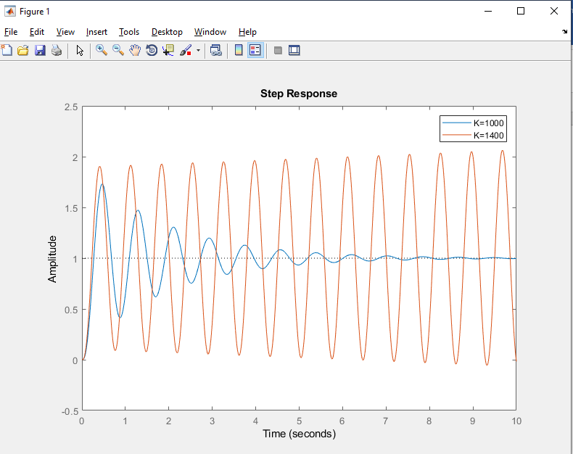

**TASK 02:**

We have found the range of K on which the system is stable, the range is K<1.5 then the system is stable and if K> 1.5 the system will be unstable and when the K=1.5 the system will be marginally stable

The solution of Routh stability criteria,

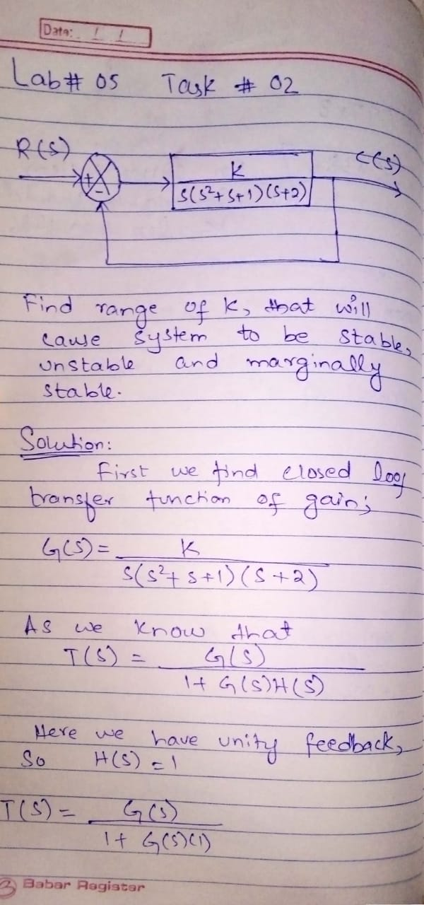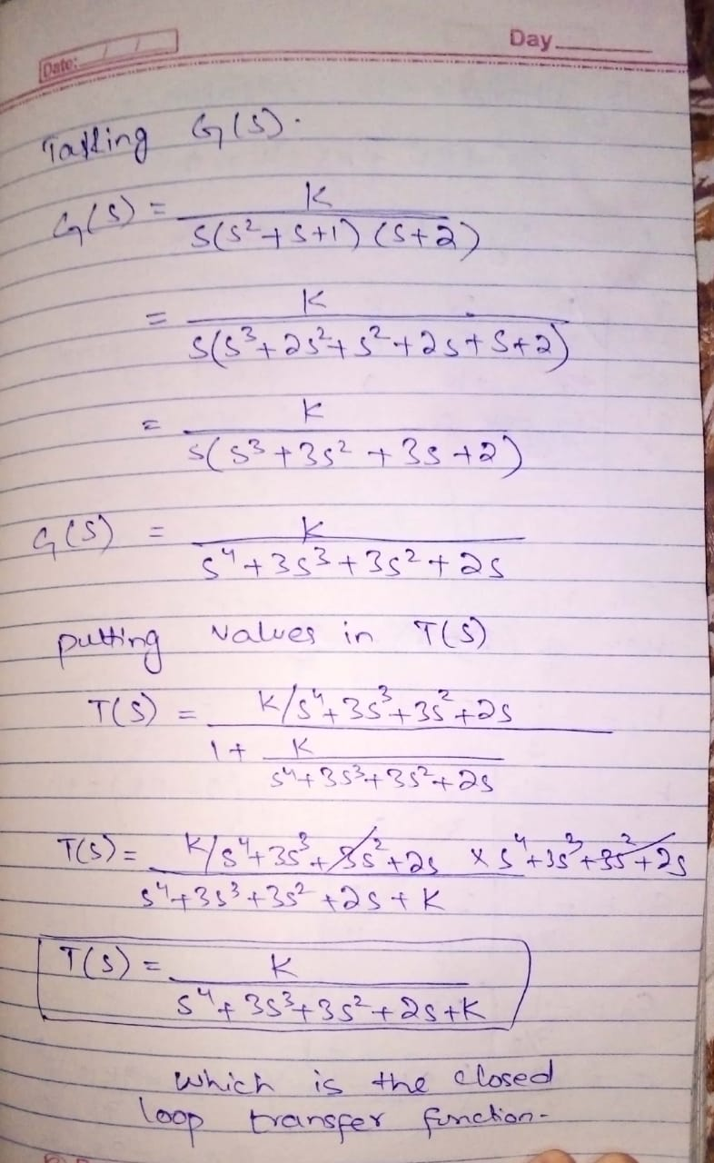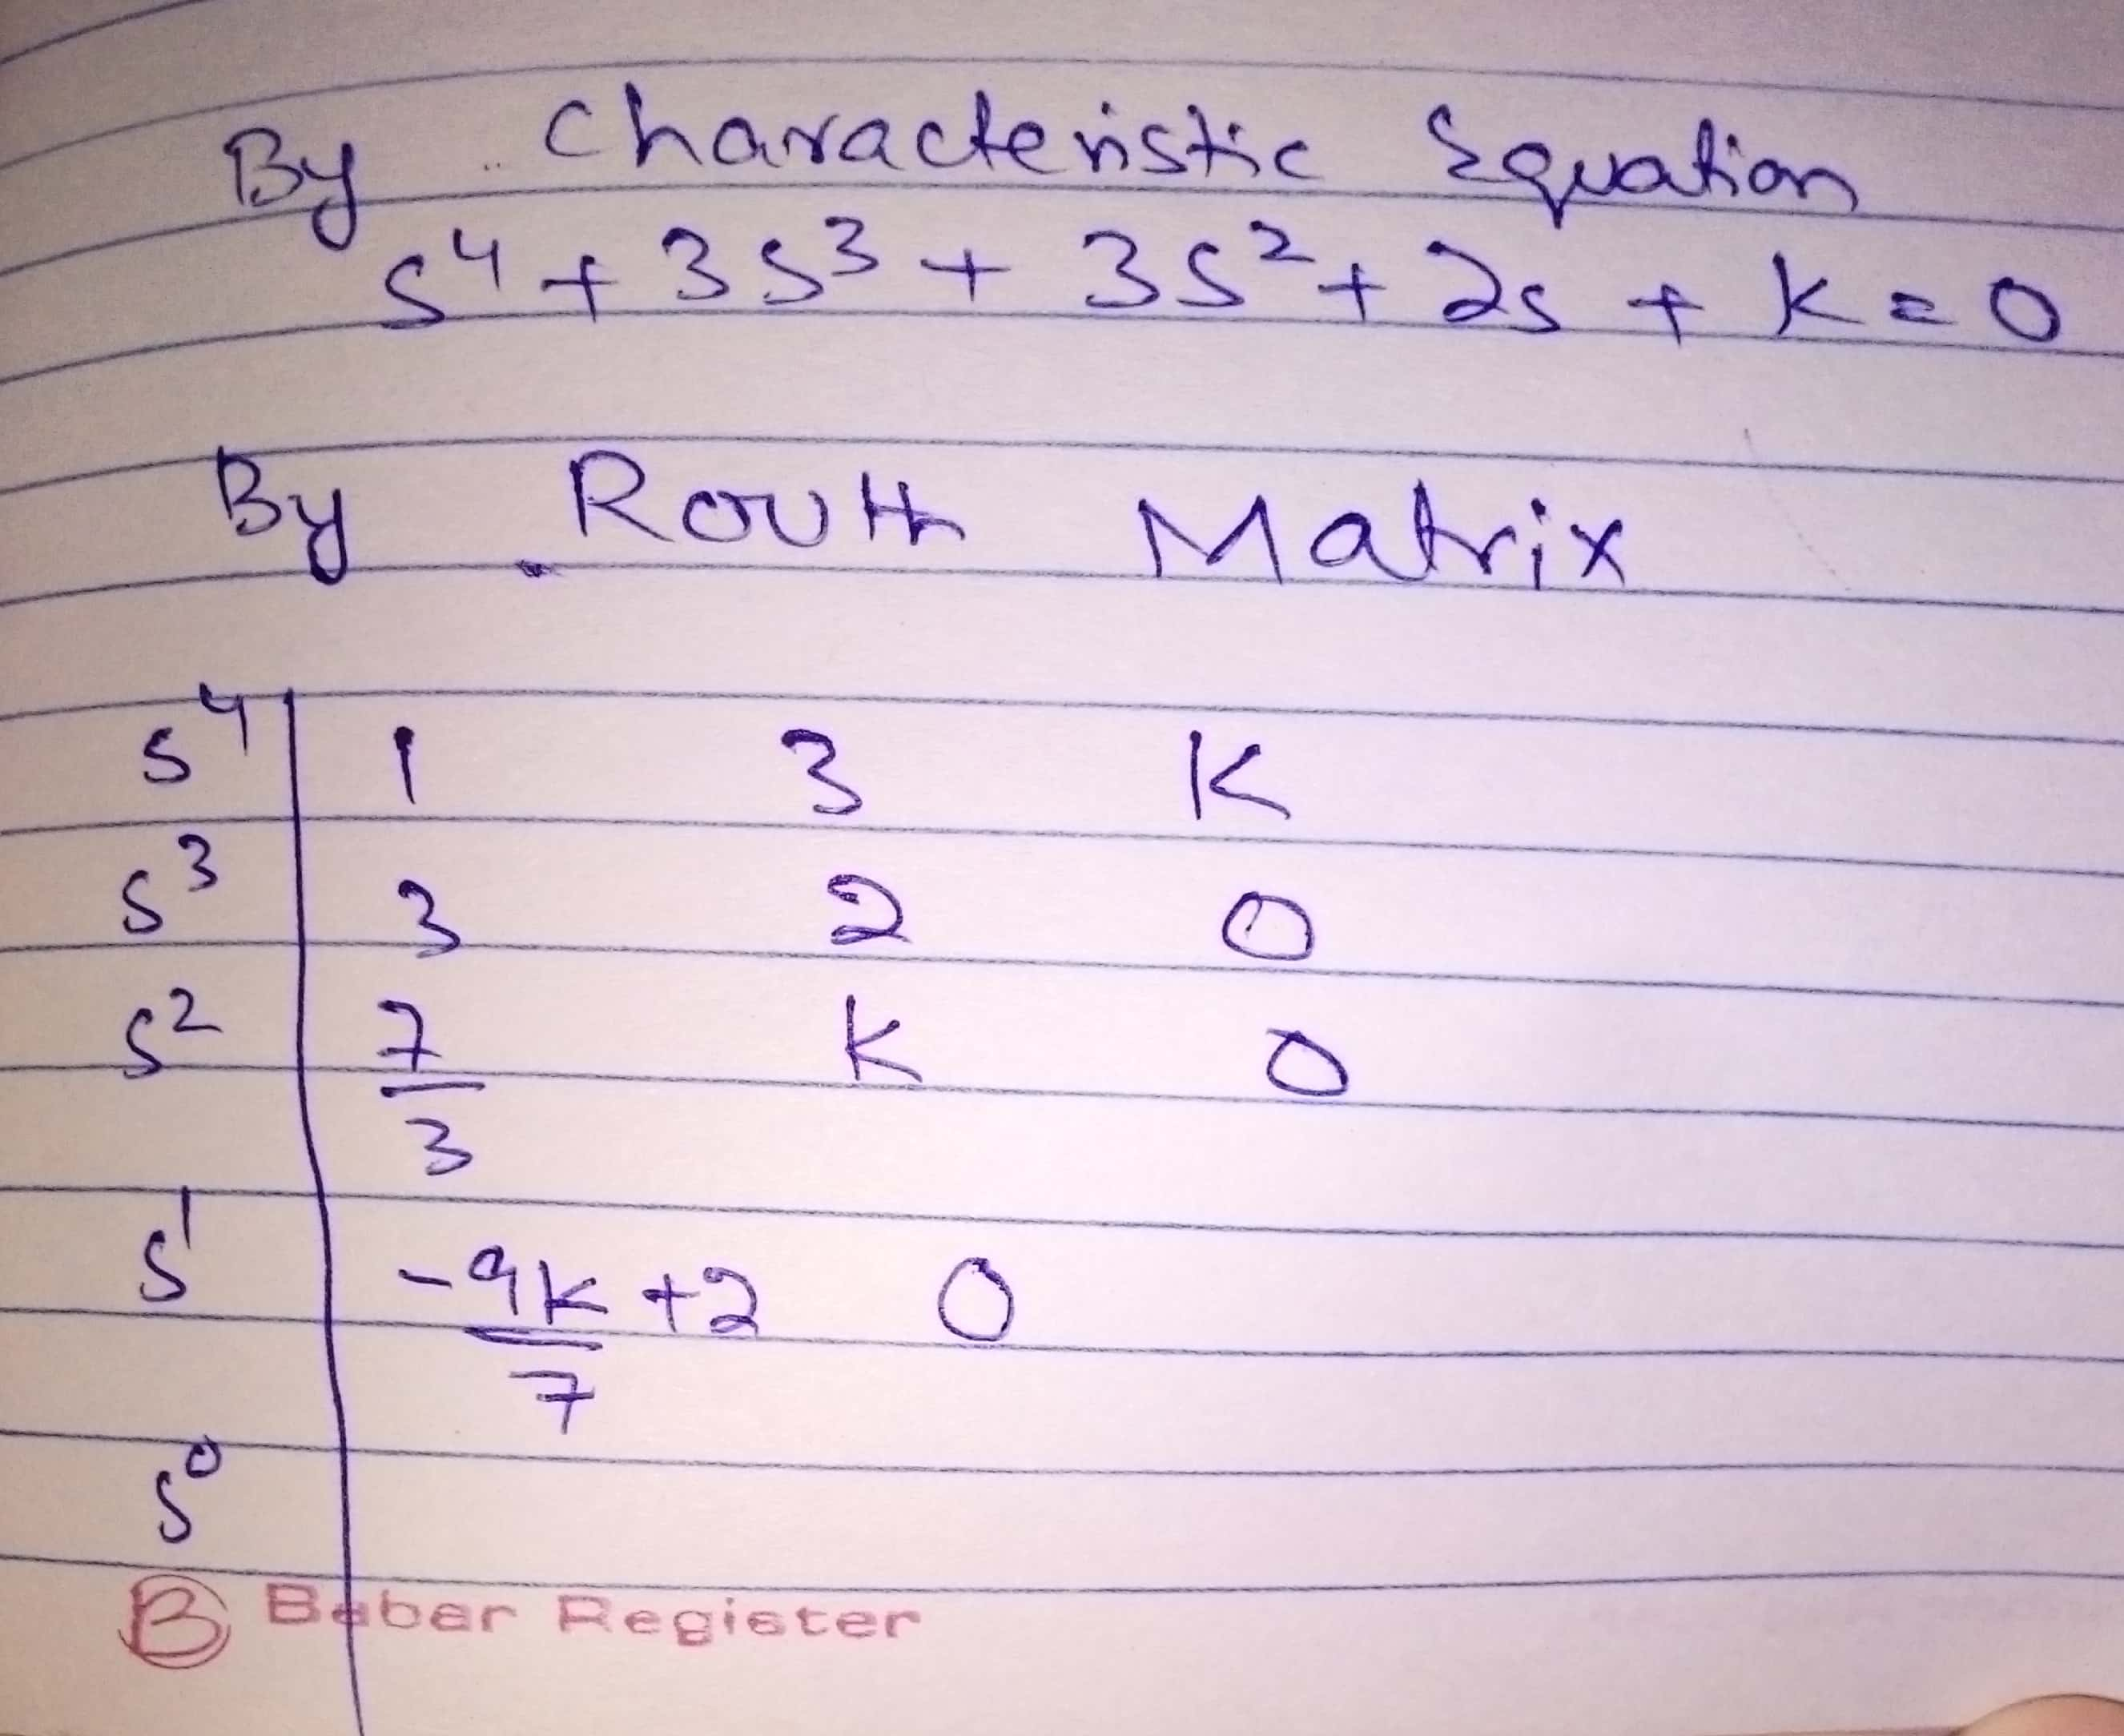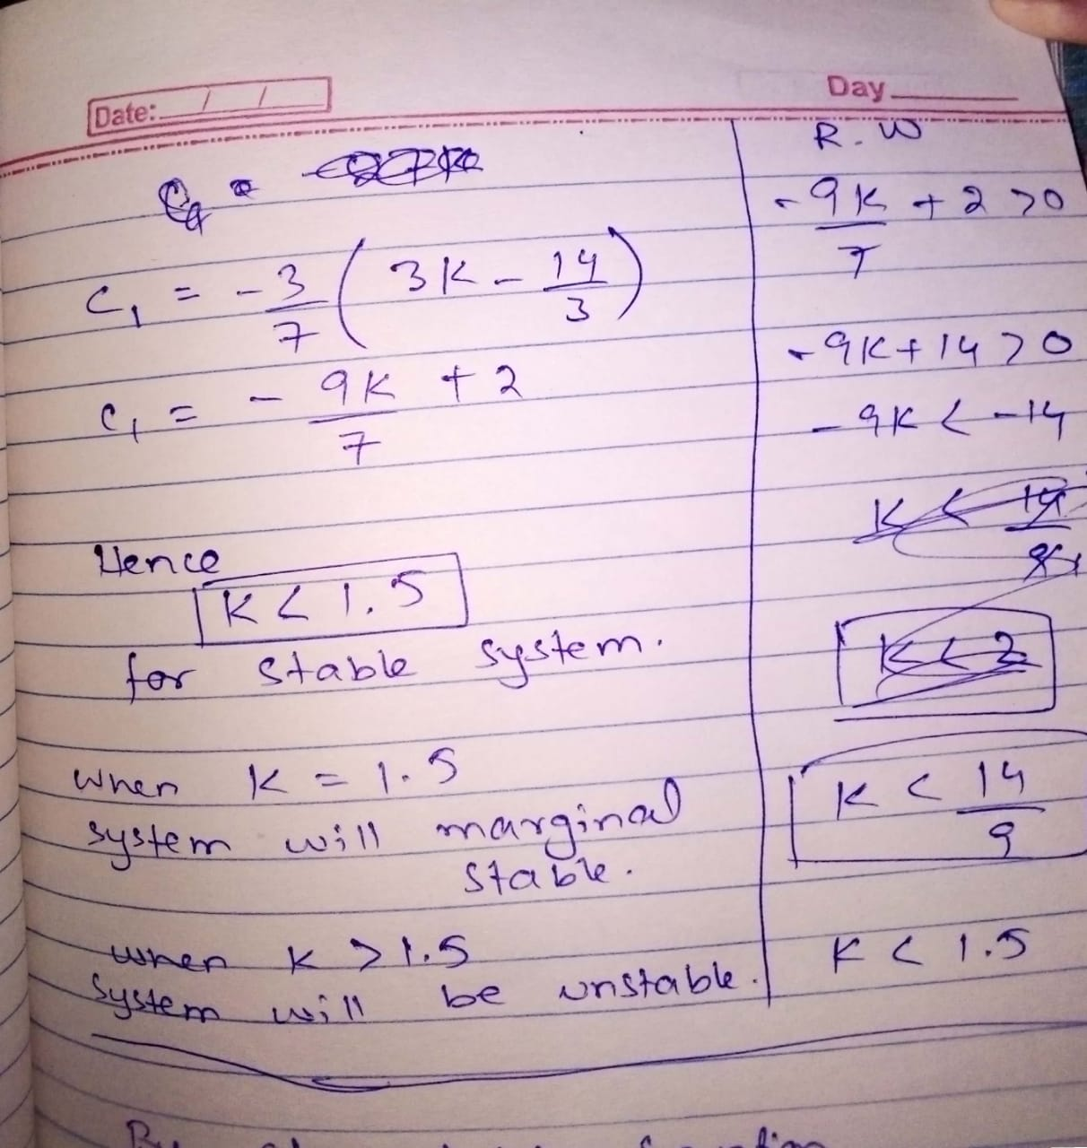

**MATLAB code to check whether our obtained range is correct,**

s=tf('s');

G= 1/(s^4+3*s^3+3*s^2+2*s)

K1=0.9;

step(feedback(K1*G,1),50)

hold on

K2= 5;

step(feedback(K2*G,1),50)

legend('K=2','K=10')

**MATLAB RESULT:**

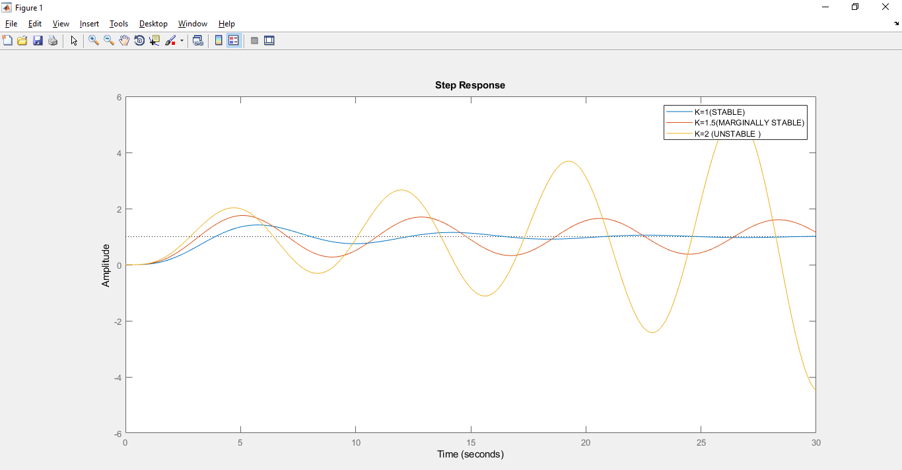

**TASK 03:**