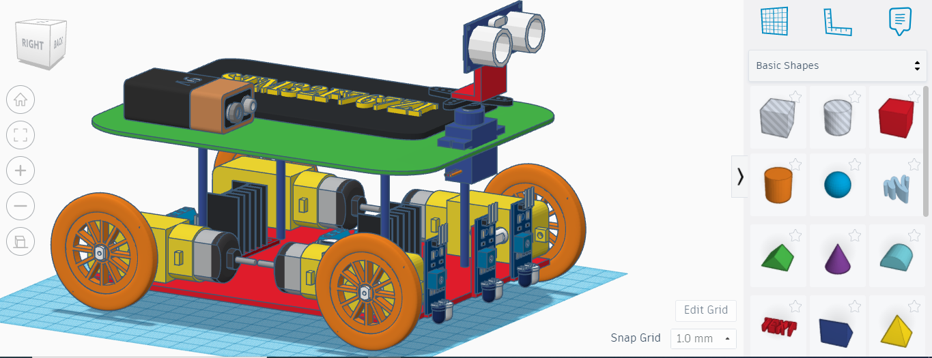

Figure :Overall robot design

1. **Wheel design**

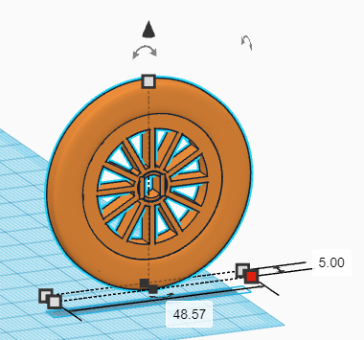

1. **Base frame**

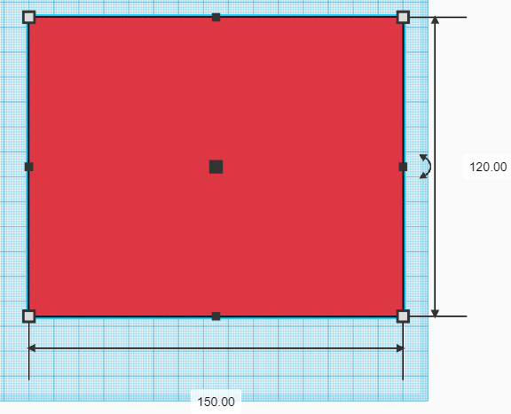

1. **Stand to support second frame**

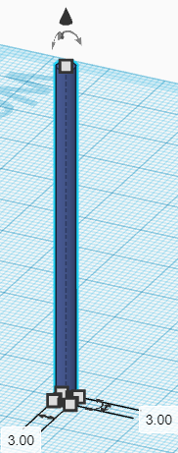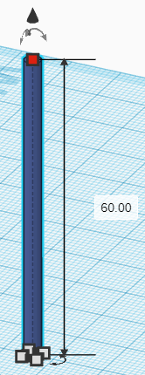

1. **Second frame**

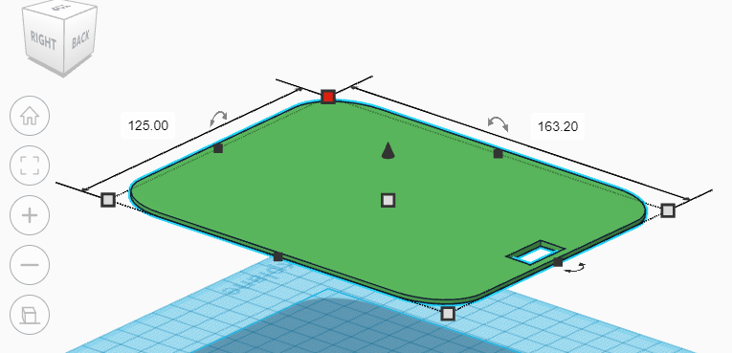

1. **Hinge to support ultrasonic sensor**

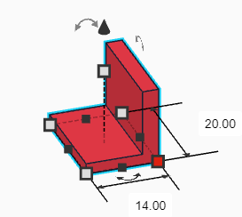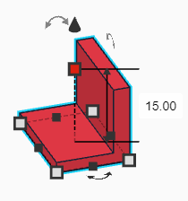

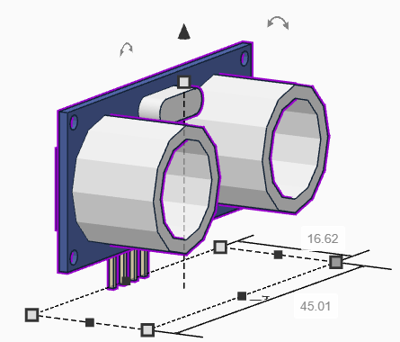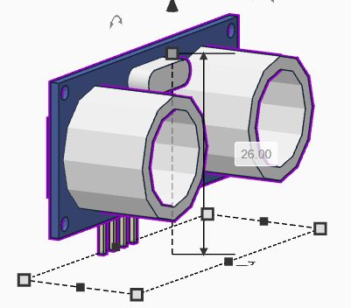

1. **IR sensor**

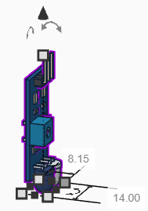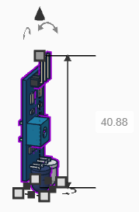

1. **STM- controller**

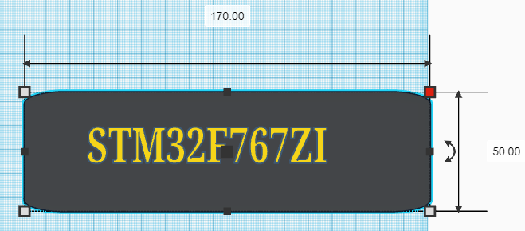

1. **H-bridge**

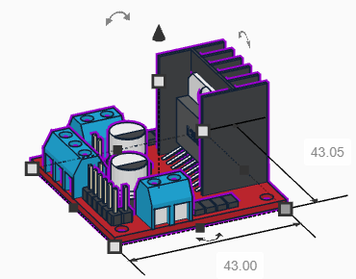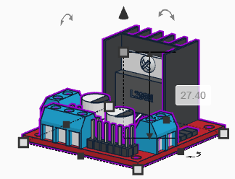

1. **DC-Motor**

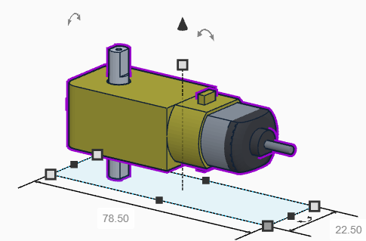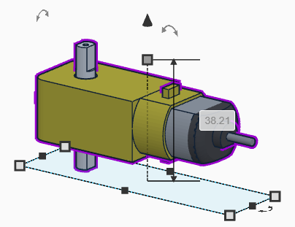

**ADVANTAGE AND DISADVANTAGES:**

Because the distance between the ground and the lowest frame is just approximately 20mm, the robot is stable. As the distance between the ground and the base frame grows, the likelihood of an unstable robot grows.

Because the robot's overall size is modest, it has the advantage of being able to navigate through small gaps between objects without colliding.

For outdoor navigation, the robot must navigate over a variety of terrains, including plain, dusty, grassy, uneven, and obstacle-filled terrains. To effectively move over various terrains, the robot must be sturdy and small in size.

The disadvantage of this design is the lack of space in the robot to support extra sensors for navigation purposes, such as GPS (laser rangefinder, kinetic camera module, laptop etc.).

**Design Analysis:**There are a lot of analysis in which we check the durability of our design,

1. **Stress Analysis:**

The study of stresses and strains in materials and structures as force is applied is known as stress analysis. SolidWorks and ANSYS are used in the process. We put our design to the test against the weight of a robot in this study to discover how robust it is.

The design of the robot will fail under load if it is built without any prior analysis, resulting in mechanical failure.

1. Importing a 3D model created in CAD software into the FEA environment, which can be done in ANSYS, is the first step in analysing the design. The material properties of the building will be applied next. After then, the meshing of the entire structure is finished. Meshing divides the body into a large number of little components. Boundary constraints are set for static structure analysis, and some components are fixed. The total deformation and Von-Mises stress are then solved for in the model.
2. **Vibration Analysis:**

Vibration analysis is also done with SolidWorks and ANSYS. We put our concept to the test by pushing our robot across an uneven surface while applying constant force.

1. **Thermal Analysis:**

Thermal study is carried out to verify if our design can tolerate the ambient temperature. If our robot is in the midst of a fire that is dangerously close by. Then we'll examine how long it lasts in a high-temperature environment.