1). Install the ROBOTICS TOOLBOX by peter corke. After installing the toolbox, then import the robot model.

Mdl_puma560, use this command to import robot model. Then your block will work in Simulink.

2). **Workspace generation:**

MATLAB CODE:

%% workspace generation

for i=1:1:1000

%generate random sample within the joint limits

a1(i)=(160+160)*rand()-160;

a2(i)=(225+45)*rand()-45;

a3(i)=(45+225)*rand()-225;

a4(i)=(170+110)*rand()-110;

a5(i)=(100+100)*rand()-100;

a6(i)=(266+266)*rand()-266;

end

for i=1:1000

q=[a1(1,i),a2(1,i),a3(1,i),a4(1,i),a5(1,i),a6(1,i)];

T=robot.fkine(q);

p=transl(T);

plot=plot3(p(1,1),p(1,2),p(1,3),'r.')

plot.LineWidth=5;

hold on

% pause(0.1);

grid on

end

hold on

robot.plot([0 0 0 0 0 0])

**RESULTLS:**

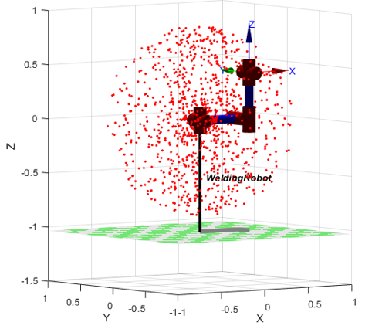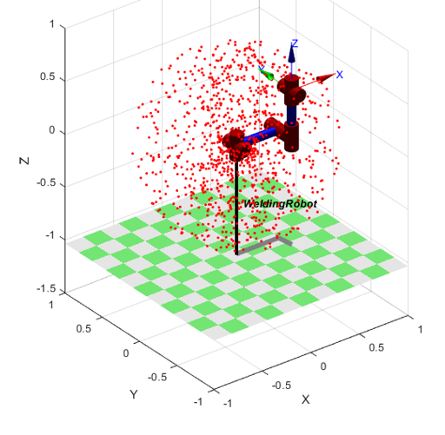

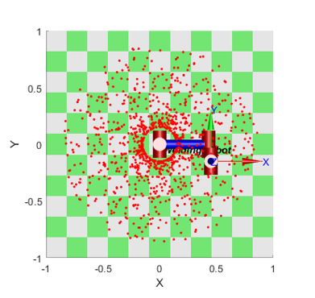

3).

Graph among the desired and actual joint angles

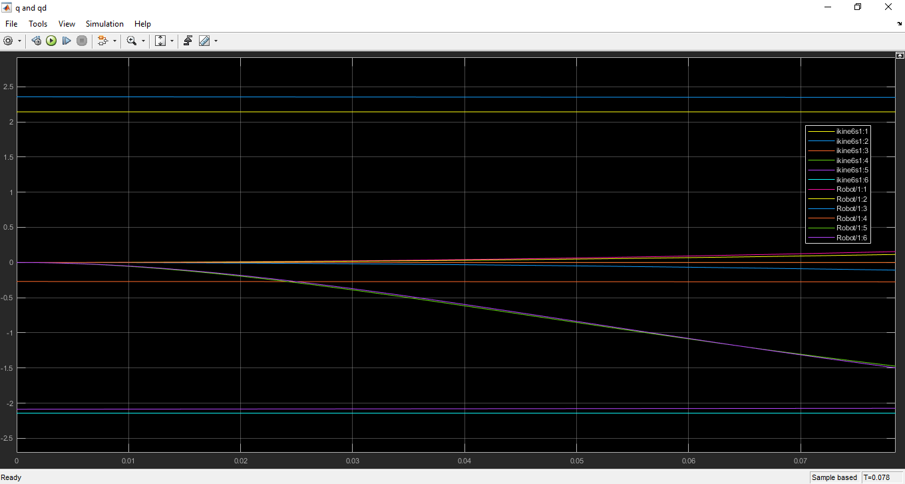

Joint errors

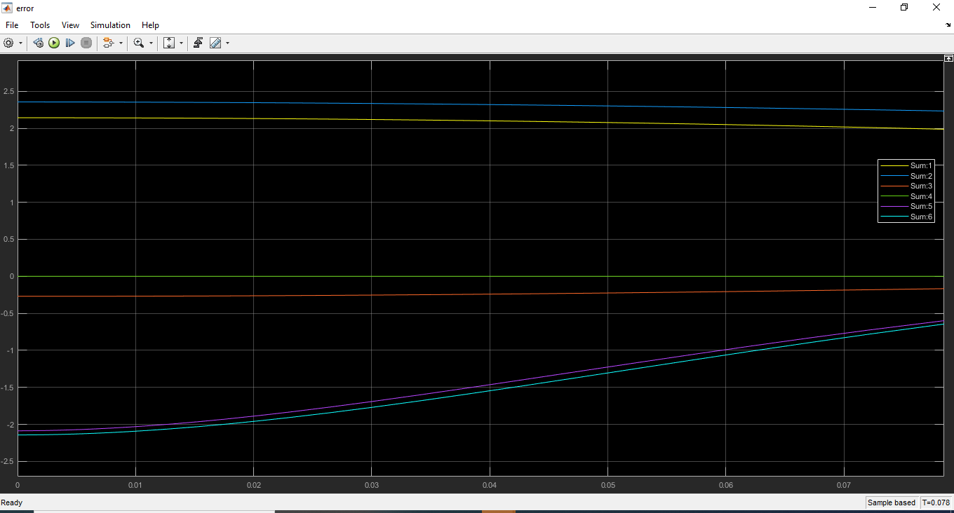

Joint torques

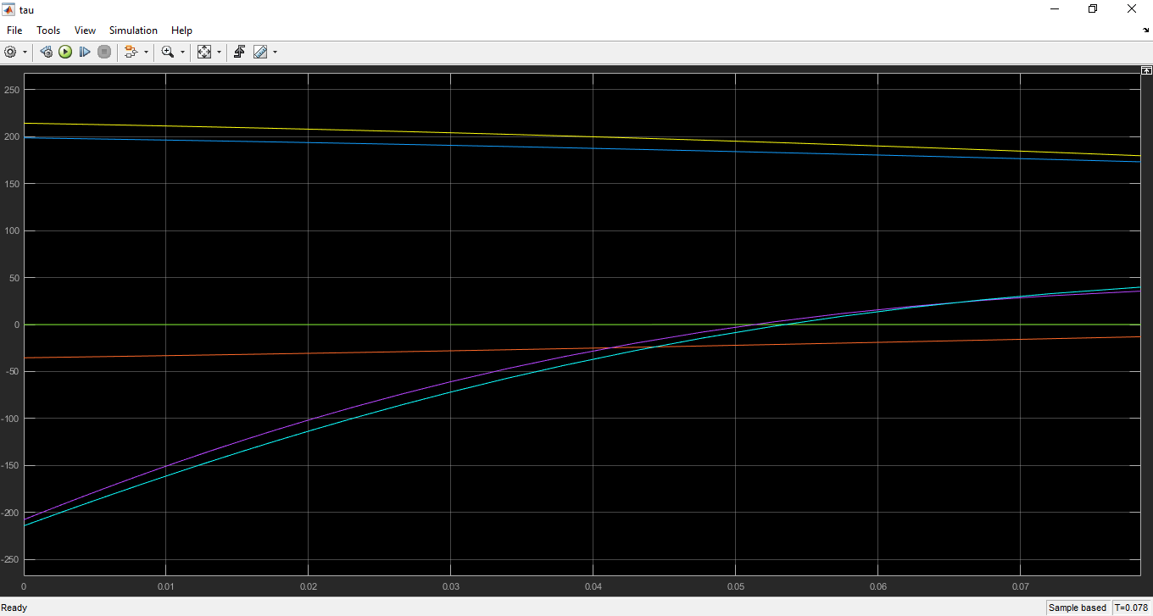

Simulink model

