MODIFIED DES IMPLEMENTATION REPORT
Made By: Ahmed Othman Fahim
Course: Computer Security
Contents
1. Introduction 1
2. Algorithm Summary 1
2.2 Round-Key Generation 1
2.3 Round Function 2
2.4 Encryption (8 Rounds) 2
2.5 Decryption 2
3. Main Functions Explained 2
4. Test Case and Results 4
4.1 Sample Input 4
4.2 Generated Round Keys 4
4.3 Encryption Rounds (Li and Ri) 4
4.4 Final Ciphertext 5
4.5 Decryption Verification 5
5. Input Validation 5
6. CMD Screenshots 6
7. Comparison with Real DES 8
8. Academic Integrity Statement 8

1. Introduction
This report documents the design and implementation of a Modified DES (Data Encryption Standard) cipher in Python. The implementation follows a Feistel network structure with a simplified XOR-only round function, making it ideal for understanding the fundamental concepts of block ciphers without the full complexity of real DES.
The algorithm is simplified for educational and conveniences.

2. Algorithm Summary
2.1 Block and Key Sizes
The cipher operates on 64-bit plaintext blocks and uses a 32-bit master key. The plaintext block is divided into two equal halves: L0 (bits 1-32) and R0 (bits 33-64).

2.2 Round-Key Generation
Eight round keys are derived from the 32-bit master key using left circular (rotation) shifts. The shift amount increases by 1 for each round:
Round | Shift Amount | Round Key
K1 | 0 | LeftRotate(master_key,0)
K2 | 1 | LeftRotate(master_key,1)
K3 | 2 | LeftRotate(master_key,2)
K4 | 3 | LeftRotate(master_key,3)
K5 | 4 | LeftRotate(master_key,4)
K6 | 5 | LeftRotate(master_key,5)
K7 | 6 | LeftRotate(master_key,6)
K8 | 7 | LeftRotate(master_key,7)

2.3 Round Function
The round function F is a simplified XOR operation:
F(Ri-1, Ki) = Ri-1 XOR Ki
There are no expansion permutations, S-boxes, or P-boxes — only a direct bitwise XOR of the 32-bit right half with the 32-bit round key.

2.4 Encryption (8 Rounds)
For each round i from 1 to 8, the Feistel equations are:
Li = Ri-1
Ri = Li-1 XOR F(Ri-1, Ki) = Li-1 XOR Ri-1 XOR Ki
After the final round, the ciphertext is assembled by swapping the halves:
Ciphertext = R8 || L8

2.5 Decryption
Decryption uses the identical Feistel structure. The only difference is that the round keys are applied in reverse order (K8, K7, ..., K1). The final swap ensures the original plaintext is recovered exactly:
Plaintext = R8_dec || L8_dec

3. Main Functions Explained
validate_binary_input(bits, required_length)
Checks that the input string contains only '0' and '1' characters and is exactly the required length. Raises a ValueError with a descriptive message if either check fails. This function is called at the start of both encrypt_block and decrypt_block.
left_rotate(bits, shift)
Performs a left circular shift on a binary string. It takes the first 'shift' characters from the front and moves them to the end. For example, left_rotate('11110000', 2) returns '11000011'. The shift is taken modulo the string length to handle shifts larger than the bit length.
xor_bits(a, b)
Performs a bitwise XOR on two binary strings of equal length. Each character position is compared: identical bits produce '0', different bits produce '1'. Raises a ValueError if the strings differ in length.
generate_round_keys(master_key, rounds=8)
Generates all round keys by calling left_rotate with shift amounts 0 through 7 (for 8 rounds). Returns a list of 8 binary strings, each 32 bits long.
round_function(right_half, round_key)
Implements F(R, K) = R XOR K. It simply delegates to xor_bits. This function represents where a full DES implementation would include expansion, S-box substitution, and permutation.
encrypt_block(plaintext, master_key, rounds=8)
Orchestrates the full encryption. It validates inputs, generates round keys, splits the plaintext into L0 and R0, applies 8 Feistel rounds, prints all intermediate Li and Ri values, and returns the final ciphertext as R8 || L8.
decrypt_block(ciphertext, master_key, rounds=8)
Mirrors encrypt_block exactly but passes reversed round keys. It validates inputs, generates keys in reverse order, splits the ciphertext, applies 8 Feistel rounds, and returns the recovered plaintext.
main()
Entry point of the program. Runs the required assignment test case (64-bit plaintext and 32-bit master key), performs encryption and decryption, prints all intermediate values, and verifies that the recovered plaintext matches the original. Also demonstrates input validation with intentionally bad inputs.

4. Test Case and Results

4.1 Sample Input
Item | Value
Plaintext | 1011001110001111000011110000111111001100110011000000111111110000
Master Key | 11110000111100001111000011110000
Rounds | 8

4.2 Generated Round Keys
Key | Value (32 bits)
K1 | 11110000111100001111000011110000
K2 | 11100001111000011110000111100001
K3 | 11000011110000111100001111000011
K4 | 10000111100001111000011110000111
K5 | 00001111000011110000111100001111
K6 | 00011110000111100001111000011110
K7 | 00111100001111000011110000111100
K8 | 01111000011110000111100001111000

4.3 Encryption Rounds (Li and Ri)
Round | Li | Ri
L0/R0 | 10110011100011110000111100001111 | 11001100110011000000111111110000
1 | 11001100110011000000111111110000 | 10001111101100111111000000001111
2 | 10001111101100111111000000001111 | 10100010100111100001111000011110
3 | 10100010100111100001111000011110 | 11101110111011100010110111010010
4 | 11101110111011100010110111010010 | 11001011111101111011010001001011
5 | 11001011111101111011010001001011 | 00101010000101101001011010010110
6 | 00101010000101101001011010010110 | 11111111111111110011110011000011
7 | 11111111111111110011110011000011 | 11101001110101011001011001101001
8 | 11101001110101011001011001101001 | 01101110010100101101001011010010

4.4 Final Ciphertext
The ciphertext (R8 || L8) = 0110111001010010110100101101001011101001110101011001011001101001

4.5 Decryption Verification
Recovered plaintext:
1011001110001111000011110000111111001100110011000000111111110000
Result: Decryption successfully recovered the original plaintext. The condition decrypt(encrypt(P)) = P is satisfied.

5. Input Validation
The program enforces the following validation rules before any processing occurs:
- Plaintext must be exactly 64 binary characters (0 or 1 only).
- Master key must be exactly 32 binary characters (0 or 1 only).
- Any character other than '0' or '1' in either input triggers an immediate rejection with a descriptive error message.
- The number of rounds defaults to 8 and can be passed as a parameter.
Validation is implemented in the validate_binary_input function and called at the start of both encrypt_block and decrypt_block, ensuring no invalid data ever enters the cipher rounds.

6. CMD Screenshots
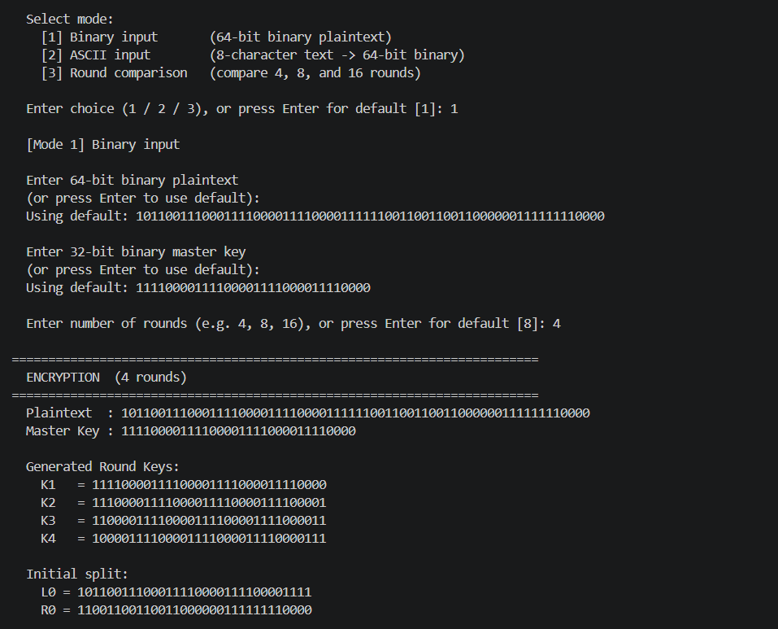
The user is asked to input a number to choose between a standard binary input, ASCII input and Round Comparison it shows the difference between each output in different rounds (4,8,16), then you are prompted to enter a 64-bit binary plaintext or use the default (less headache) same for the 32-bit master key, then choose the number of rounds then the keys are generated and the plaintext is split into 2.
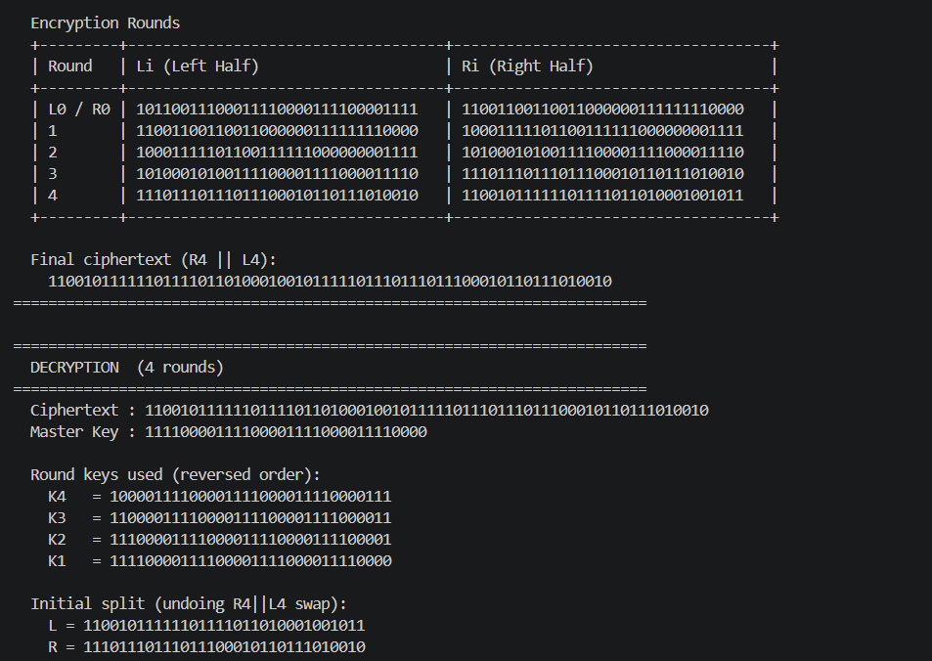

The rounds are then shown in a table like structure and we get the final cipher text,
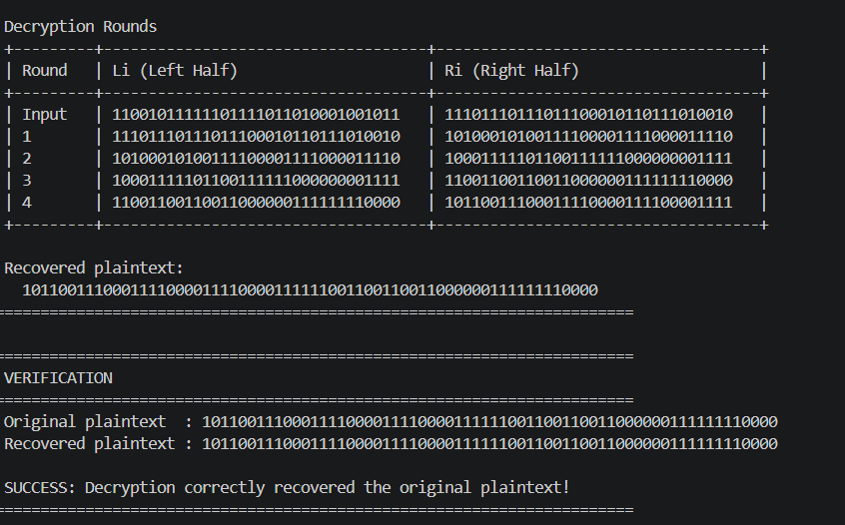
Decryption is also shown by simply reversing the order of the round keys and starting with R4 || L4

Last but not least the decryption rounds are shown in a table and is verified with the original plaintext

7. Comparison with Real DES
A comparison table is displayed at program startup in every mode. It contrasts six structural features between this implementation and real DES:
- Block size: both use 64 bits, so this property is identical.
- Key size: real DES uses a 56-bit effective key (64 bits with 8 parity bits); this cipher uses only 32 bits, making it far weaker.
- Number of rounds: real DES is fixed at 16; this cipher defaults to 8 but is now configurable.
- Key schedule: real DES uses two permutation tables (PC-1 and PC-2) to derive 48-bit subkeys; this cipher simply left-rotates the 32-bit master key by increasing amounts.
- Round function: real DES expands R from 32 to 48 bits, XORs with the subkey, applies 8 S-boxes (4 bits in, 6 bits out each) for non-linear substitution, then applies a P-box permutation. This cipher only XORs R directly with K.
- Avalanche effect and security: real DES achieves strong diffusion and confusion through its S-boxes and permutations. This cipher has neither, so a single bit change in the plaintext produces a very limited and predictable change in the ciphertext.
The key educational insight is that the Feistel structure itself is not what makes DES secure; it is the non-linear S-boxes inside the round function that provide real cryptographic strength. This simplified cipher preserves the structure while making each component transparent and traceable.

8. Academic Integrity Statement
The code and report are all done by me, I will admit that I did use some AI to help me write the code because I was never taught python properly compared to other language I have learned over the years even still I made sure of the code and the fact that it works which it does I have already understood the DES algorithm thanks to you sir I don’t need to cheat.

