# **Documentation of Week 3**

## **Lecture 5 Practice**

* + Let’s start working with layouts.

### **Step 1:** Open android studio and create a new project.

#### **Step 1.1:** Open Android Studio.

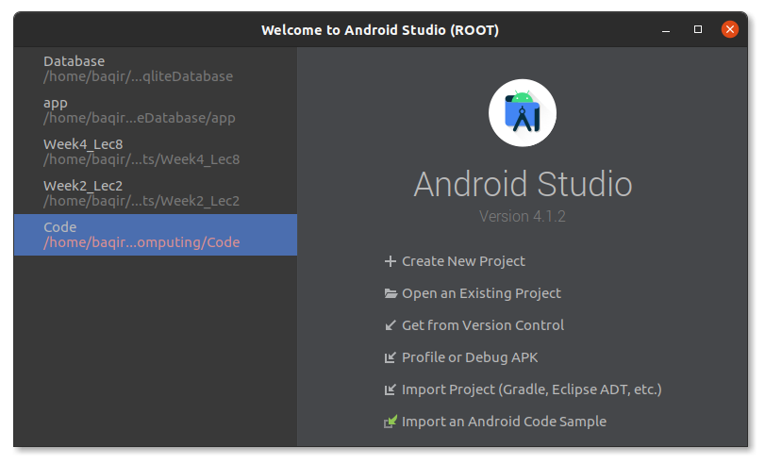

#### **Step 1.2:** Click on Create New Project.

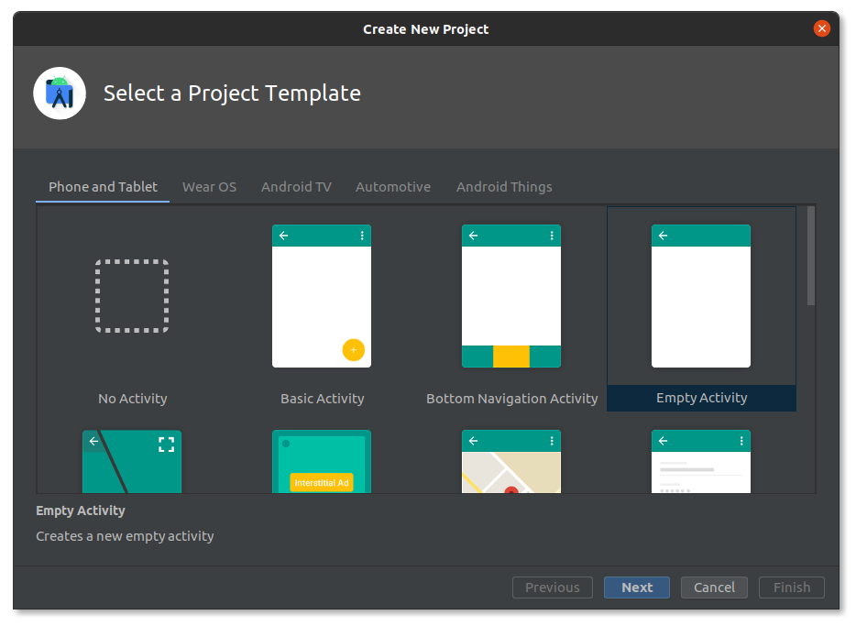

#### **Step 1.3:** Select Empty Activity. Next.

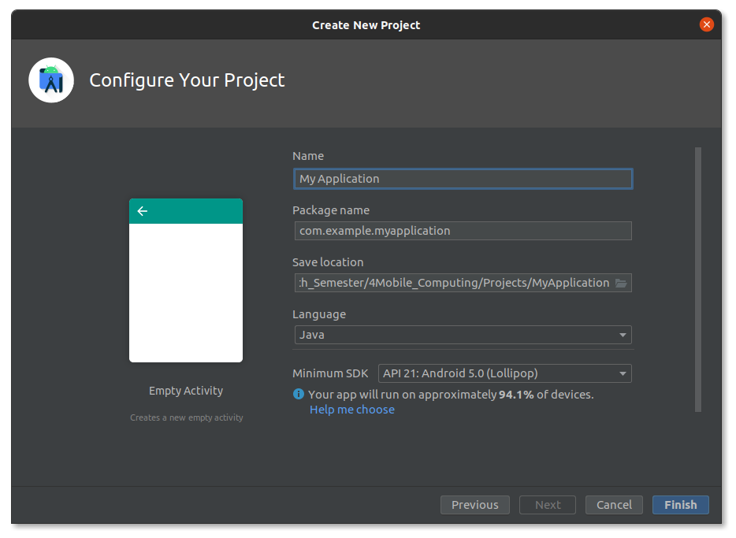

#### **Step 1.4:** Enter name and location of project. Next.

#### **Step 1.5:** Now your project is created. Let's start working with layouts.

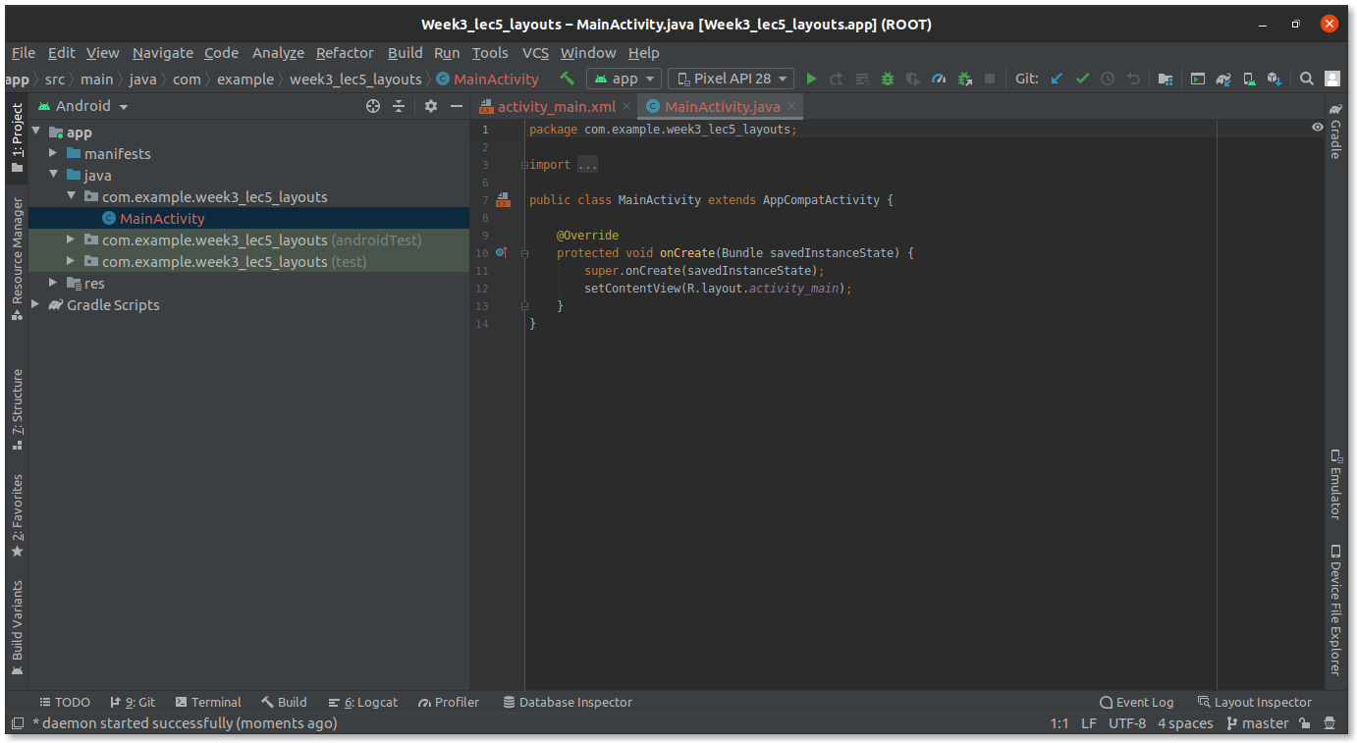

### **Step 2:** Create a new window in linear layout.

#### **Step 2.1:** In component Tree Window, delete already present Views.

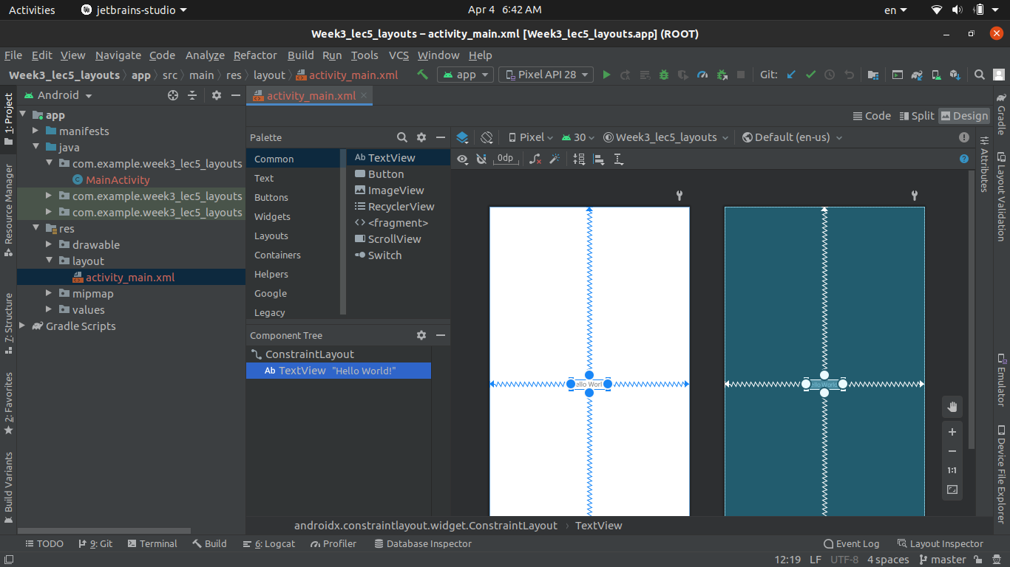

#### **Step 2.2:** Add a new Linear Layout(vertical).

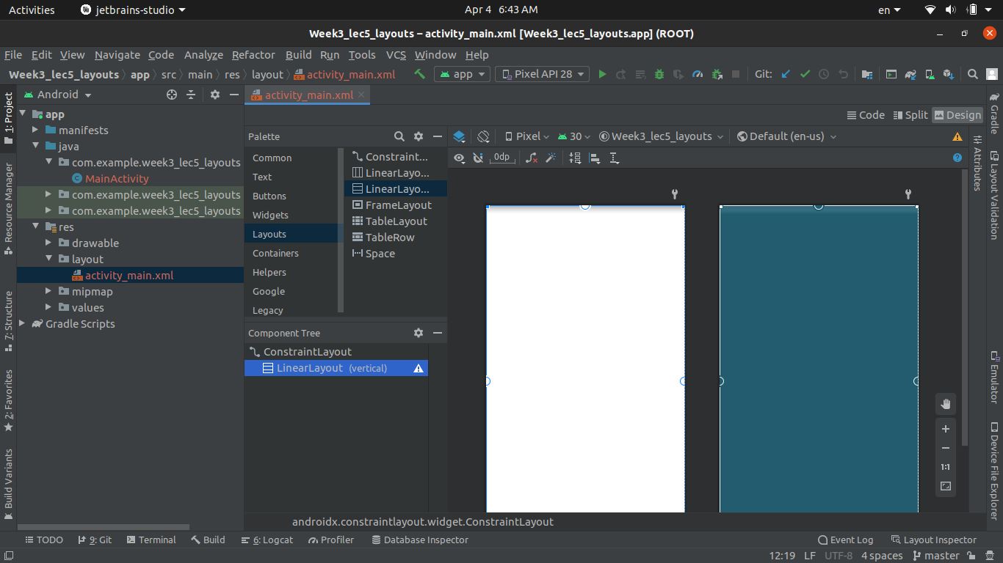

#### **Step 2.3:** Add a TextView, Button, and a Password Widget.

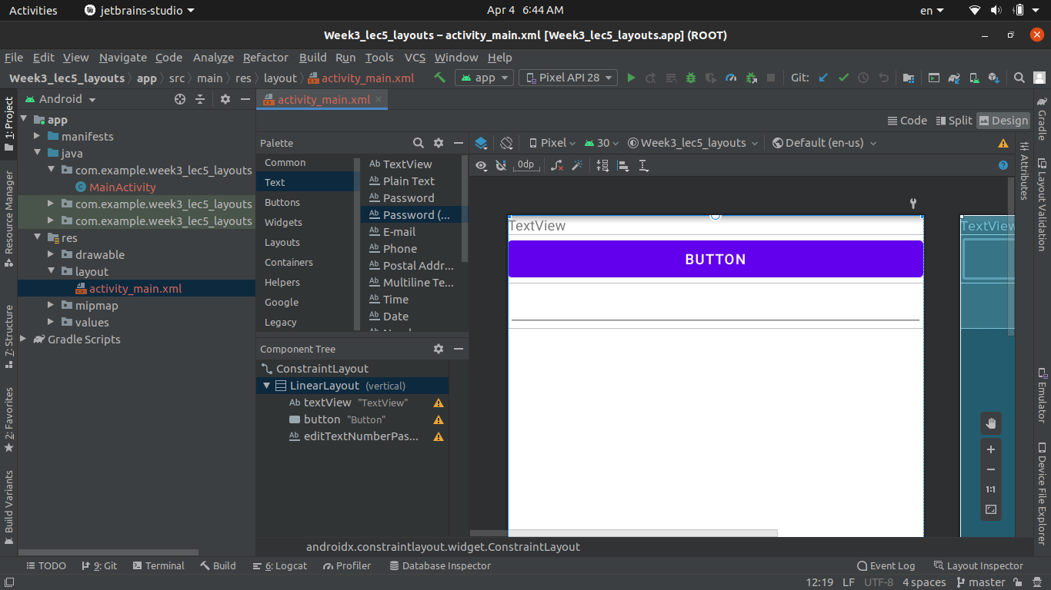

#### **Step 2.4:** Run the app.

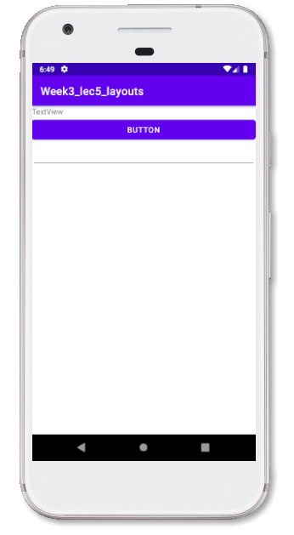

### Step 3: Create a new constraint layout.

#### **Step 3.1:** Remove previous linear layout.

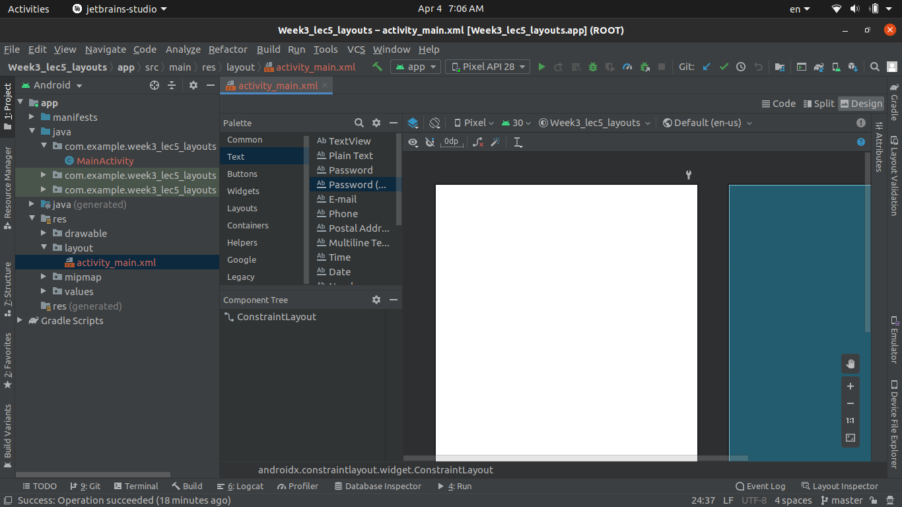

#### **Step 3.2:** Add a TextView and add constraints.

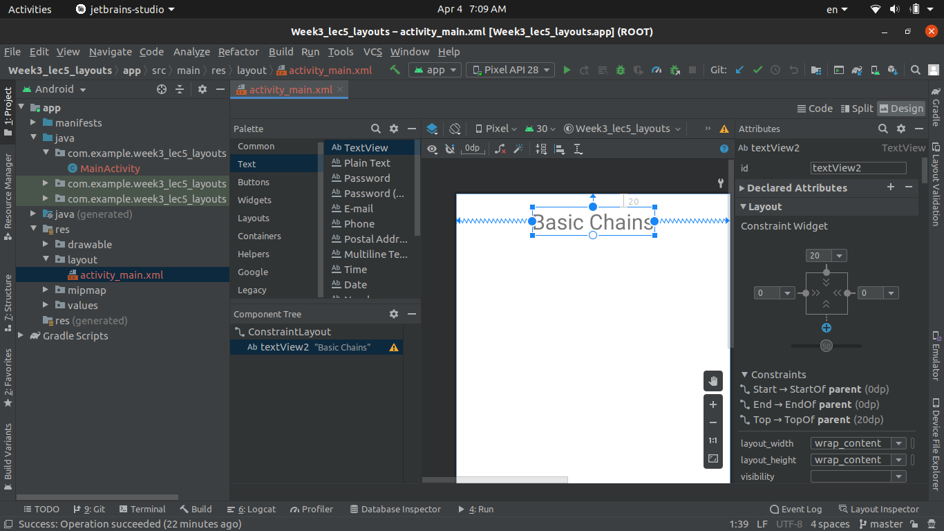

#### **Step 3.3:** Add 5 Buttons and align them vertically.

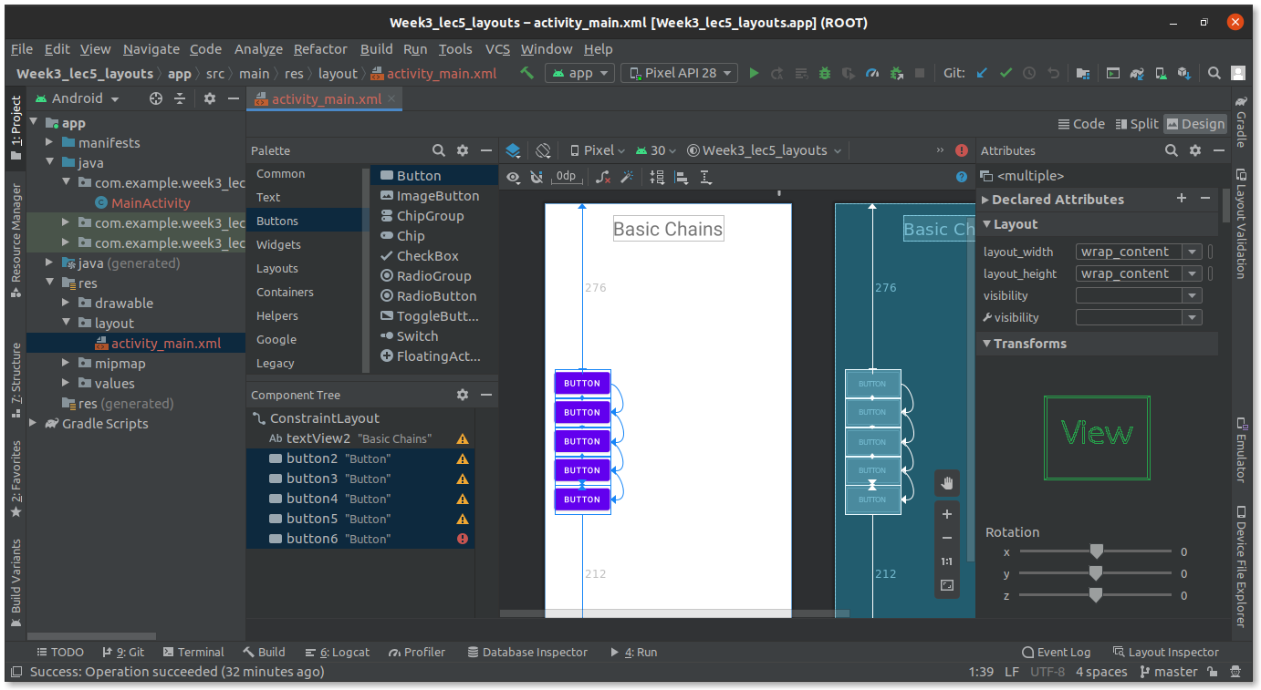

#### **Step 3.4:** Add 2 more buttons and add them at the bottom of previous buttons.

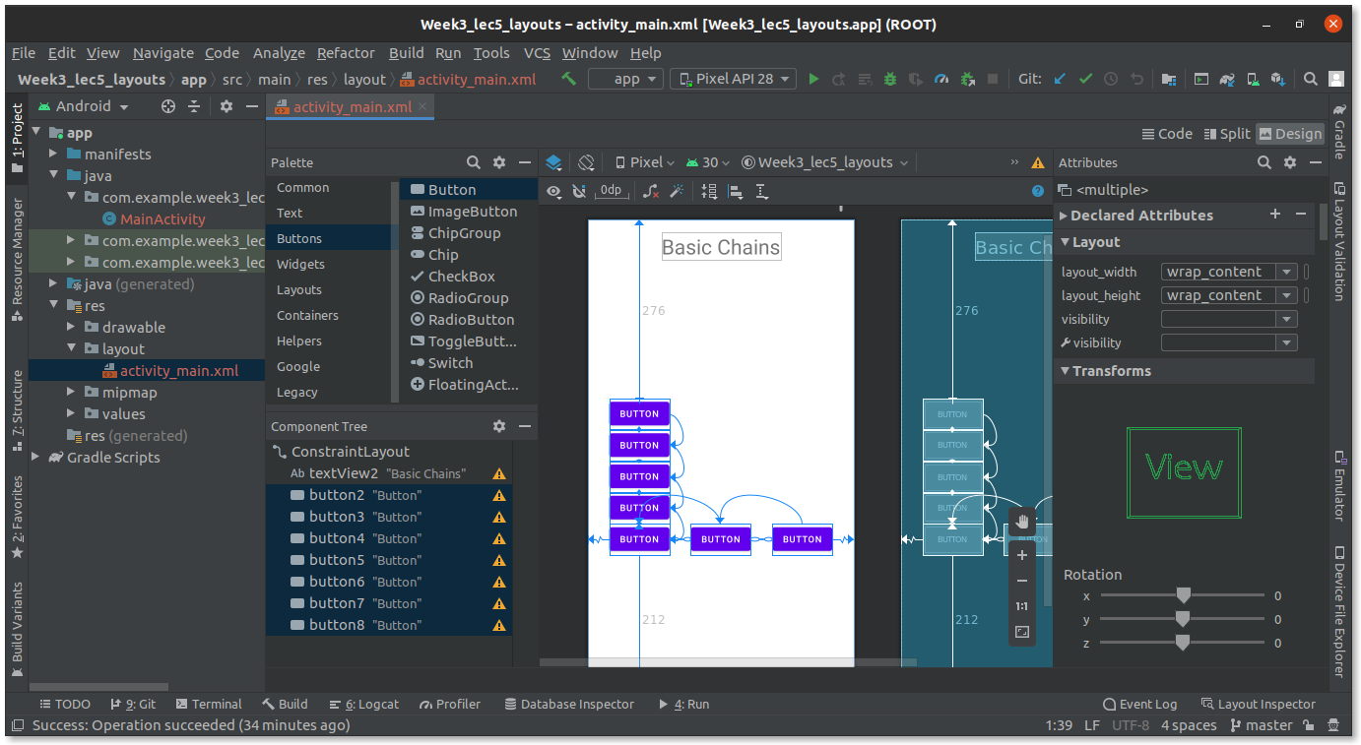

#### **Step 3.5**: Run and see output.

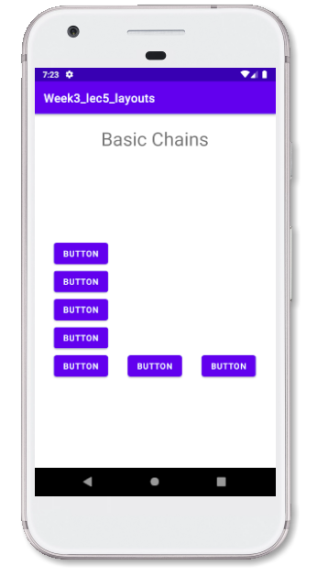

### **Step 4:** Create a new constraint layout.

#### **Step 4.1:** Remove all previous constraint layout.

#### **Step 4.2:** Add a new TextView and add constraints.

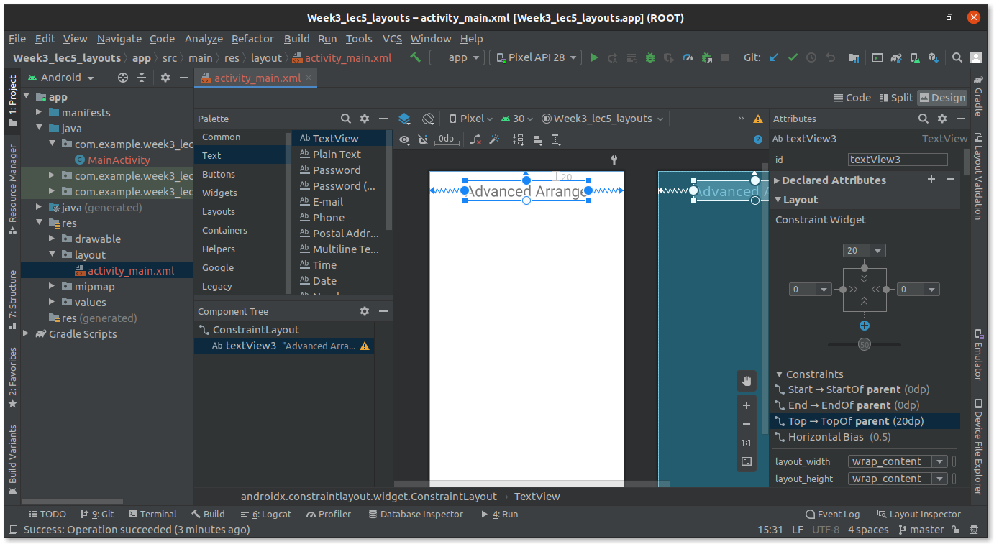

#### **Step 4.3:** Add buttons and add constraints.

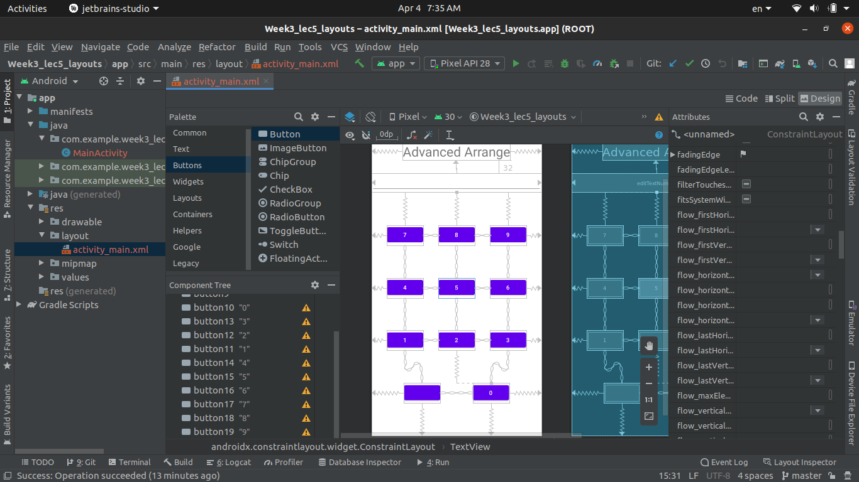

#### **Step 4.4:** Run the App.

