# **Documentation of Week 4**

## **Lecture 8 Practice**

* + Practicing Activity Life Cycle. See what happens when we switch from one activity to another.

### **Step 1:** Create a simple layout in which a Button is used to create a new activity.

#### **Step 1.1:** Create a New Project.

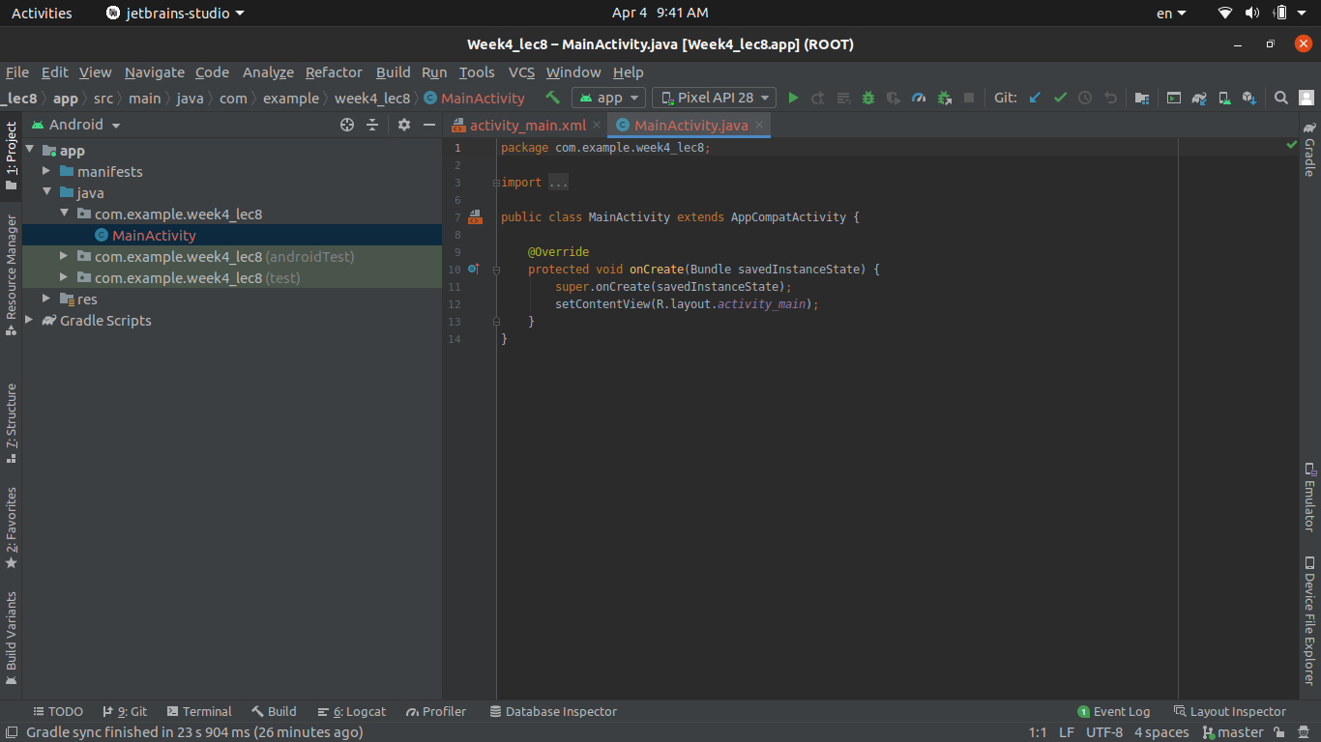

#### **Step 1.2:** Create a New Empty Activity.

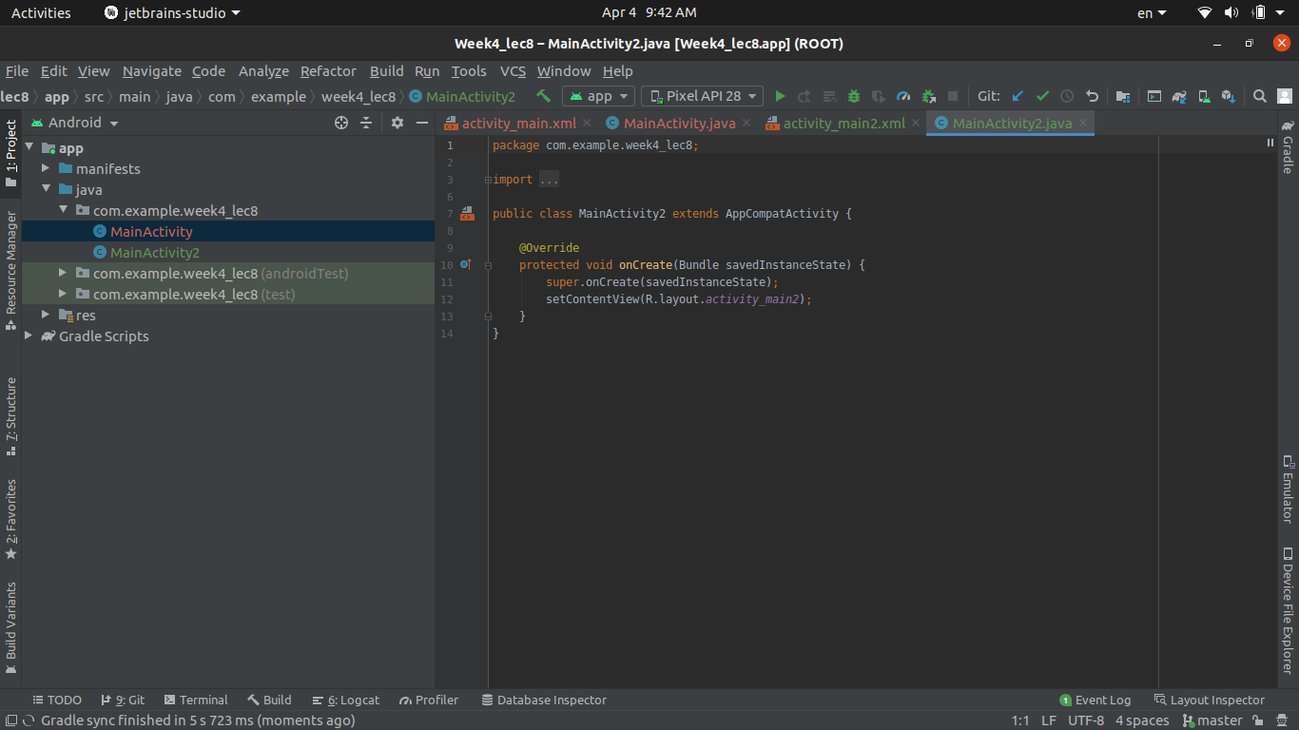

#### **Step 1.3:** In Main Activity add a Button, through which activity 2 is launched.

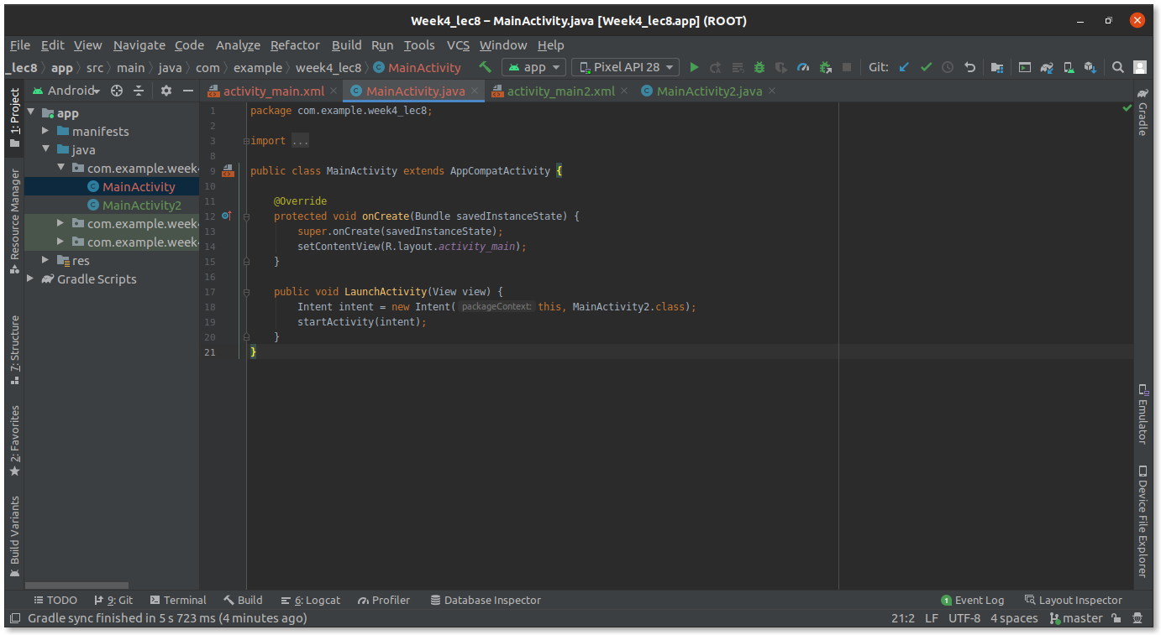

#### **Step 1.4:** Similarly, Add a Button in activity 2 to launch Main Activity.

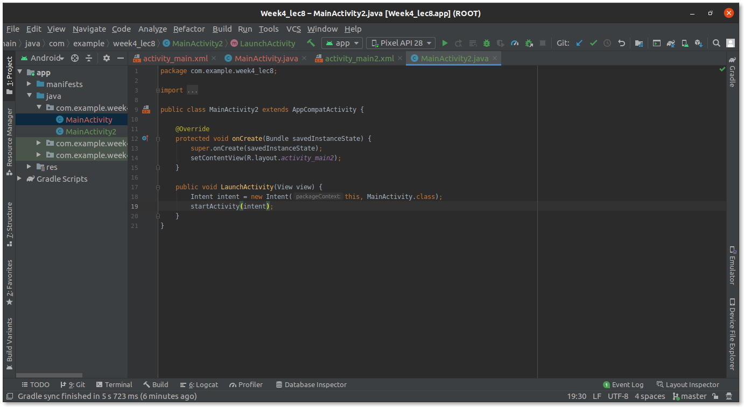

#### **Step 1.5:** Run and see if it is working properly.

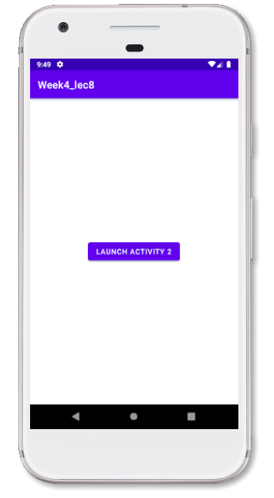

Clicking **Launch Activity 2.**

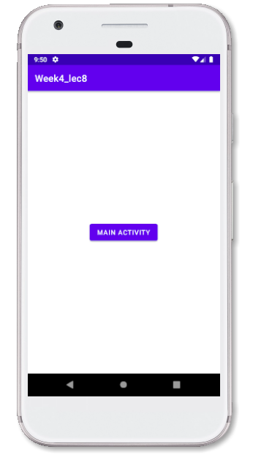

Clicking **Main Activity.**

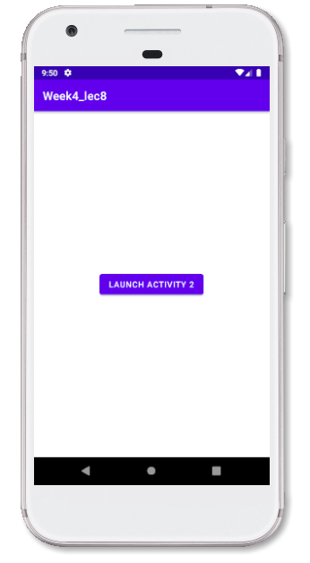

### **Step 2:** Now Add override methods in both activities.

#### **Step 2.1:** In order to see how switching happens, let's override OnCreate, OnStart, OnResume, OnPause, OnStop, OnDestroy in Main Activity.

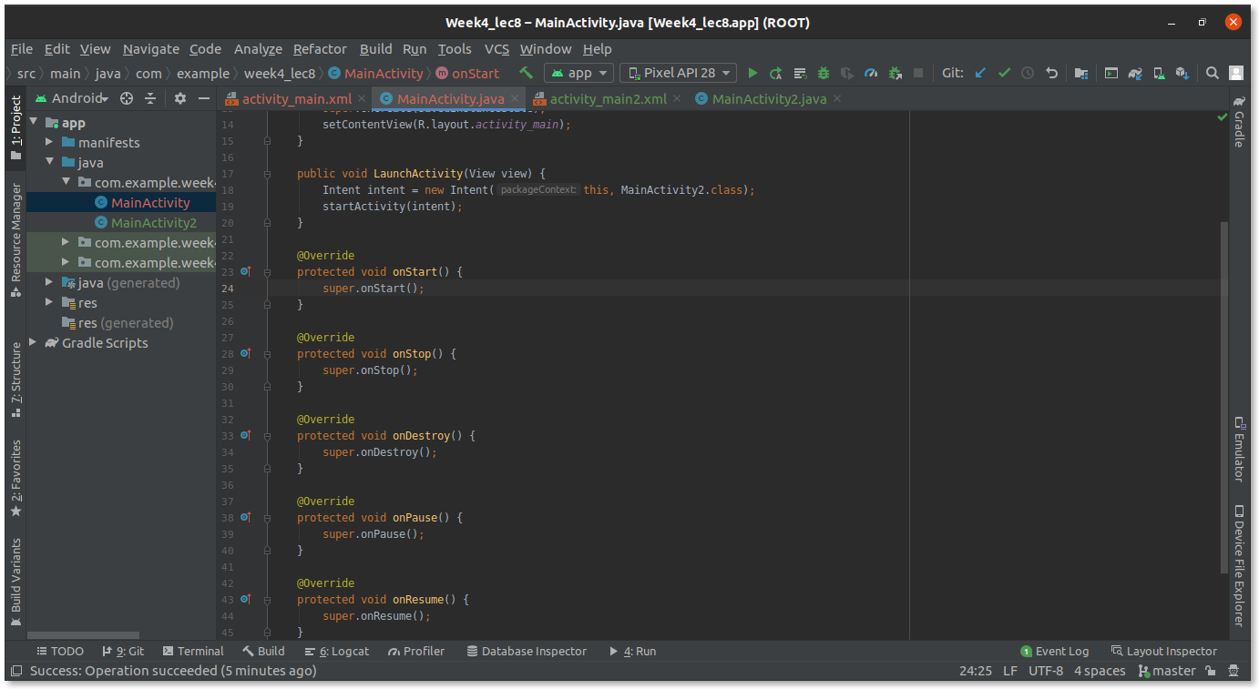

#### **Step 2.2:** Add some log information.

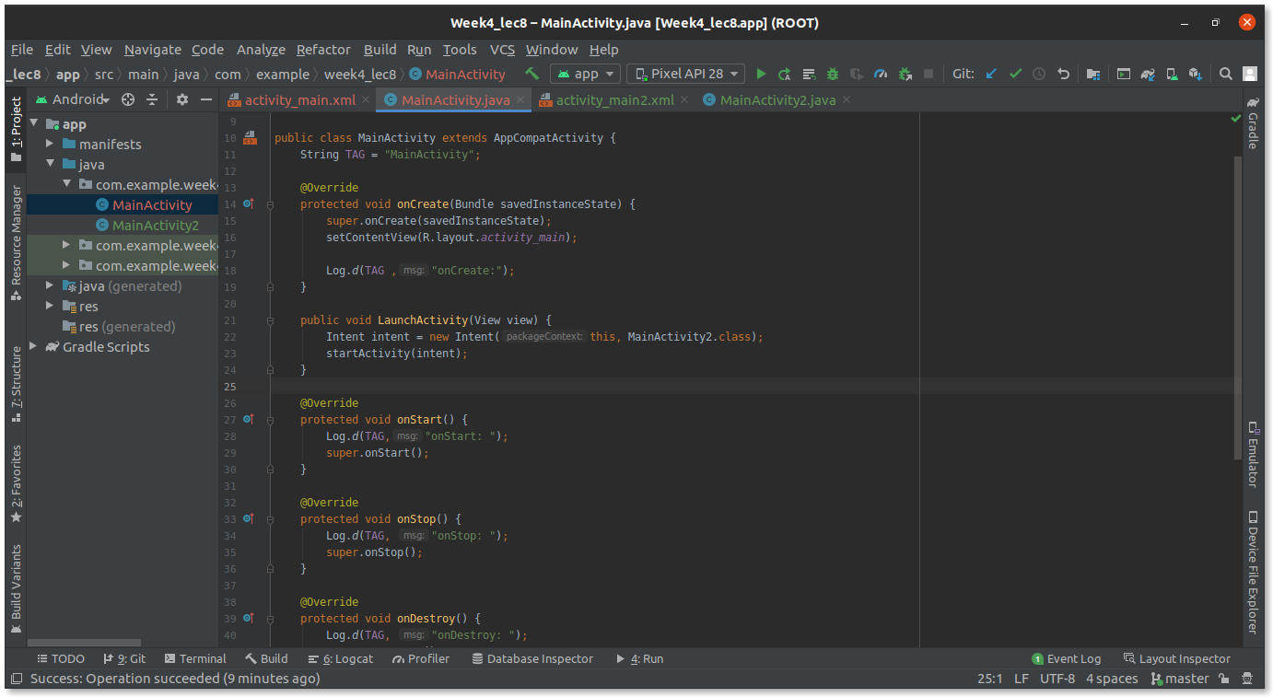

#### **Step 2.3:** Repeat the same procedure with activity 2.

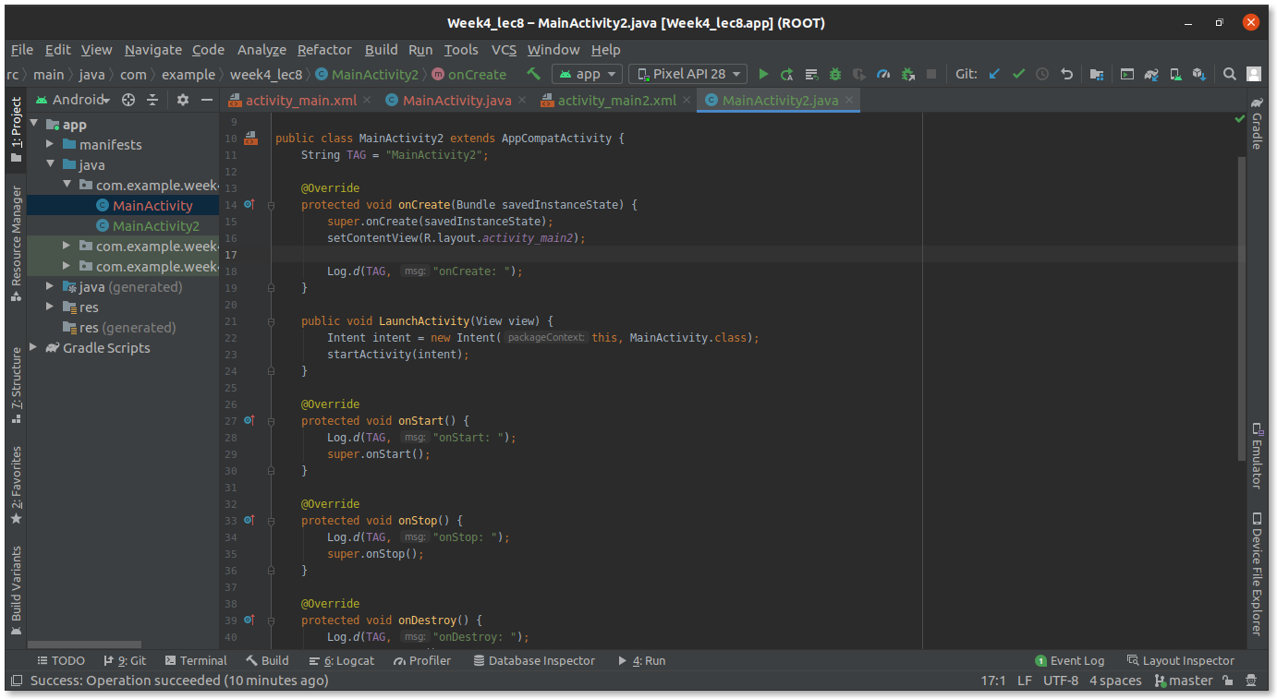

#### **Step 2.4:** Now Run the App and analyze the output.

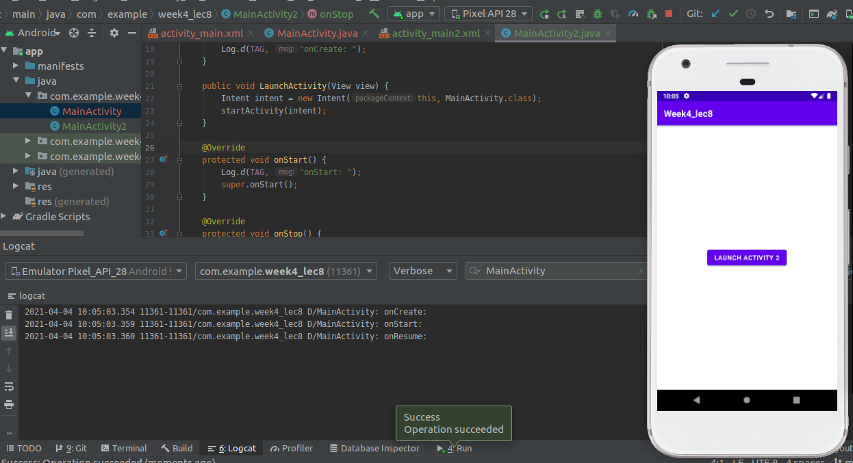

Clicking **Launch Activity 2**, creates a new Activity. And Previous Activity will be stopped.

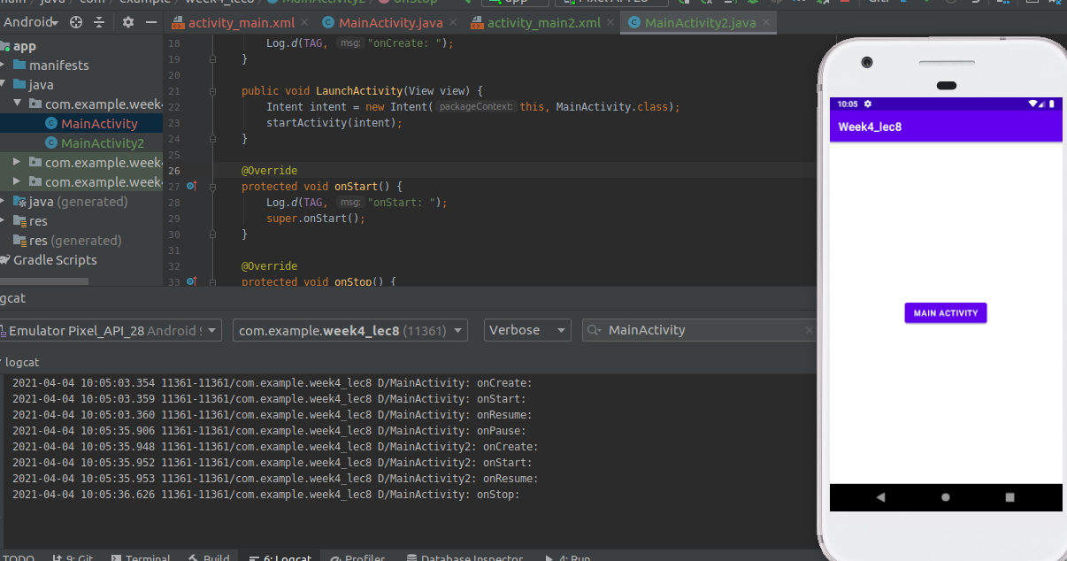

Now clicking **Main Activity**, creates a new Activity, and this activity will be stopped.

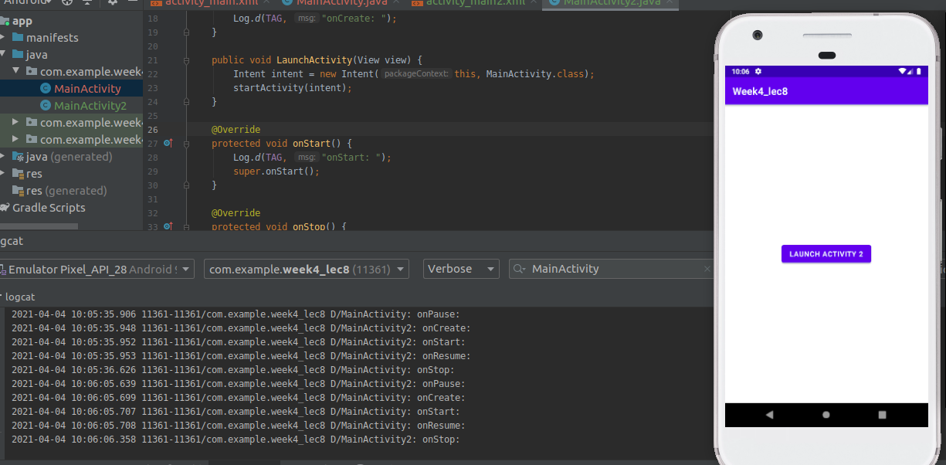

So, it means now on the stack there are two objects of Main Activity and One object of Activity 2. Let’s try to switch activity.

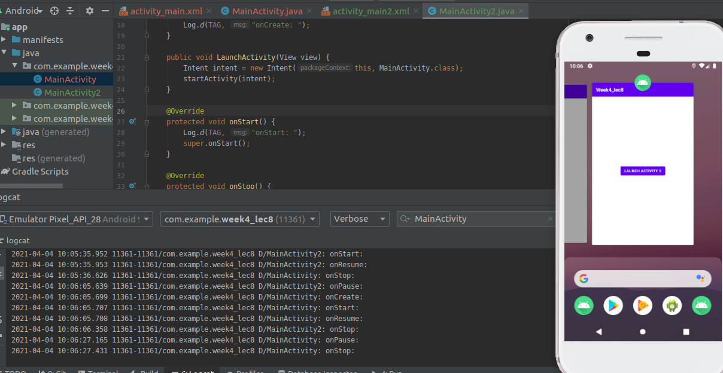

So, its mean activity is Stopped!!!. No Resume it again.

