# **Documentation of Week 5**

## **Lecture 9 Practice**

* + Practicing ListViews

### **Step 1:** Create UI of App.

#### Step 1.1: Create New Project.

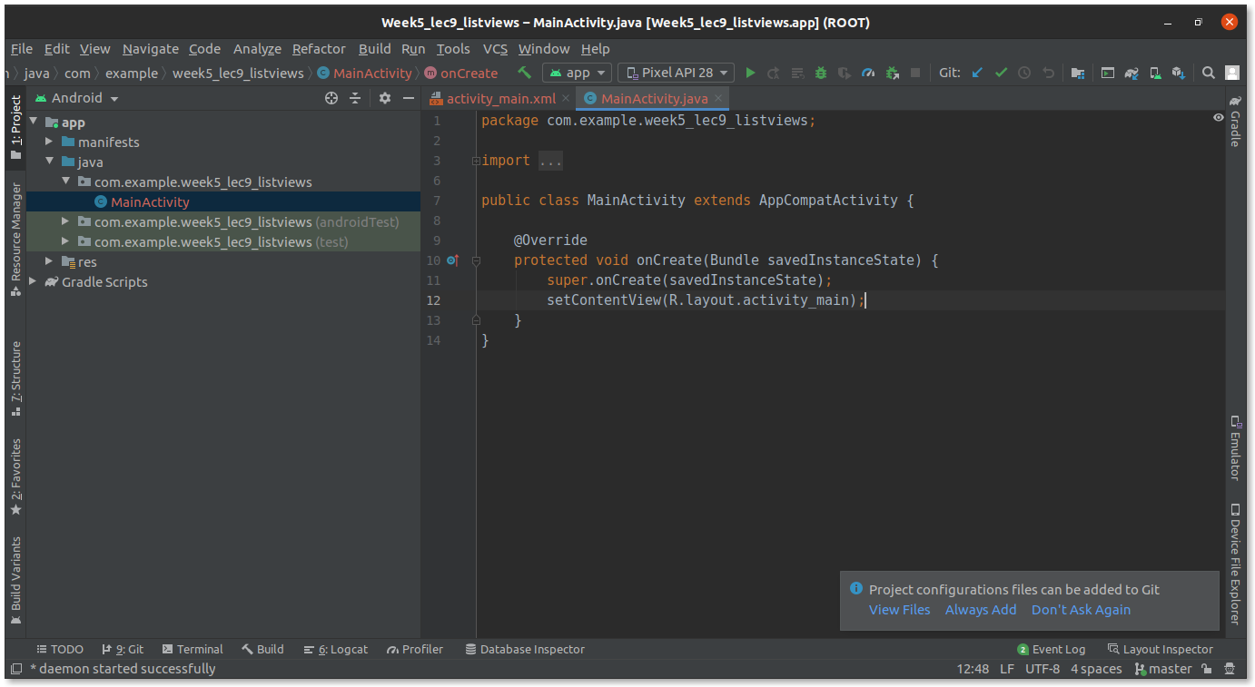

#### Step 1.2: Create a simple UI and add constraints.

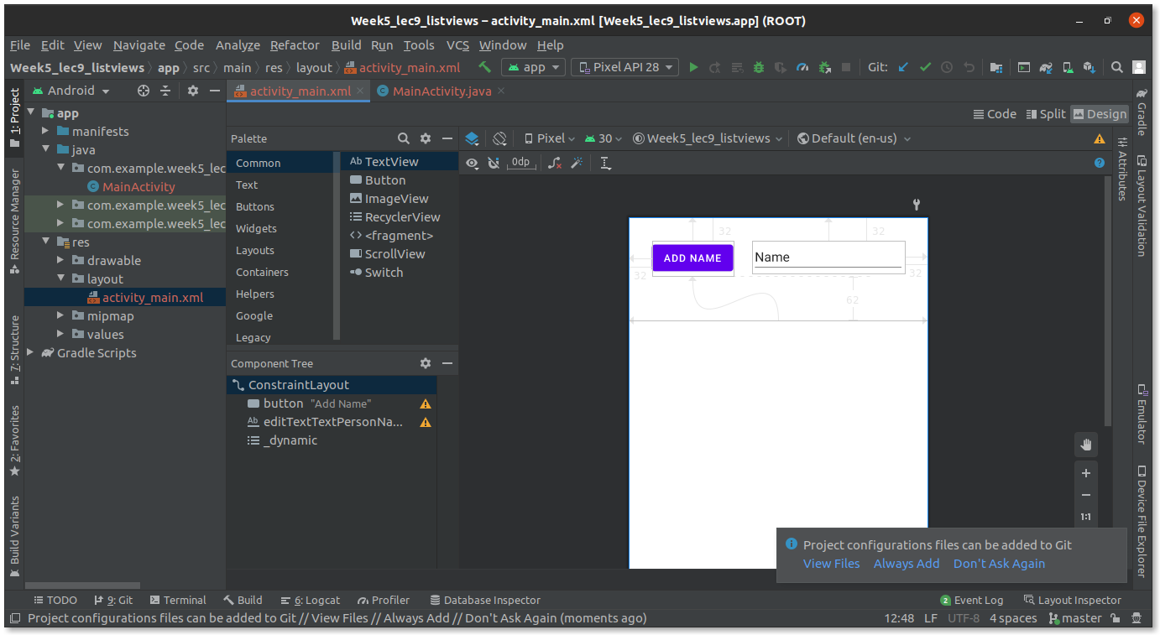

#### Step 1.3: Run the App.

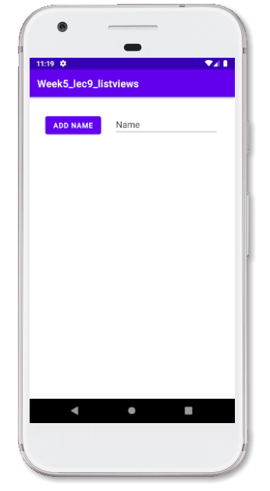

### Step 2: Complete backend of the App.

#### Step 2.1: Add **Add Name** button onClick handler.

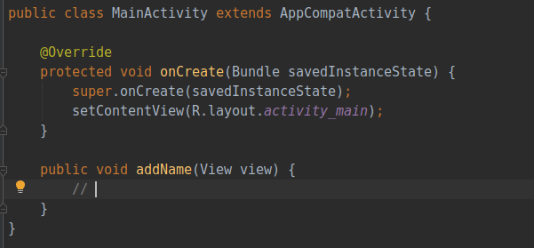

#### Step 2.2: Complete onClick handler.

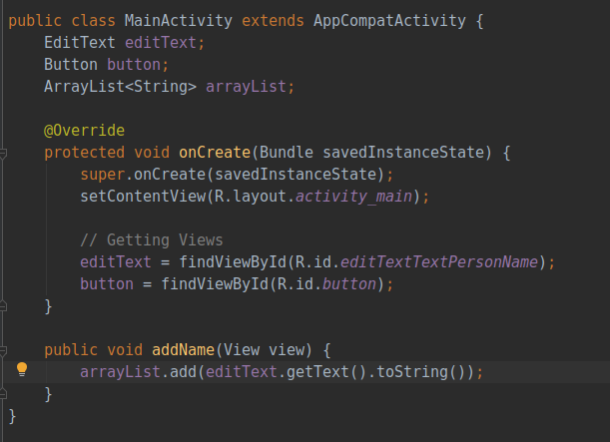

#### Step 2.3: Add ArrayAdapter, and attach it with listView.

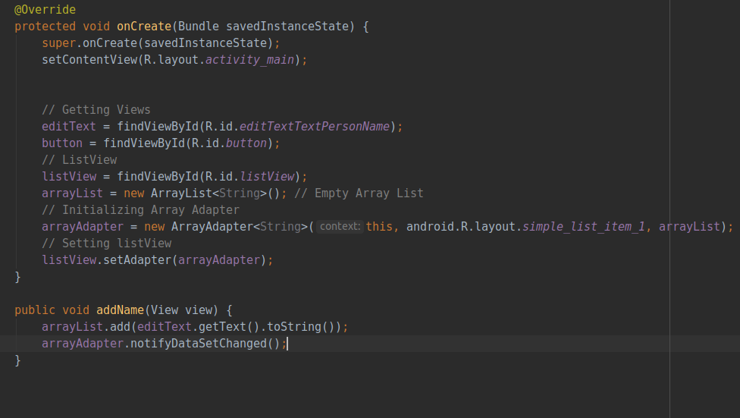

#### Step 2.4: Run the app and see if it is working properly.

### Step 3: Adding onClick listener in listView.

#### Step 3.1: Add new empty activity.

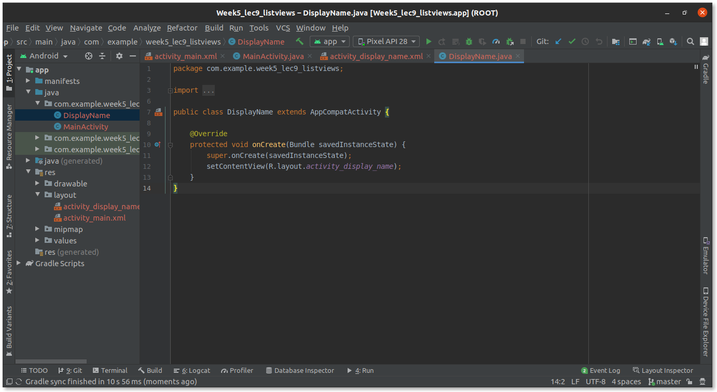

#### Step 3.2: Add event listener in listView.

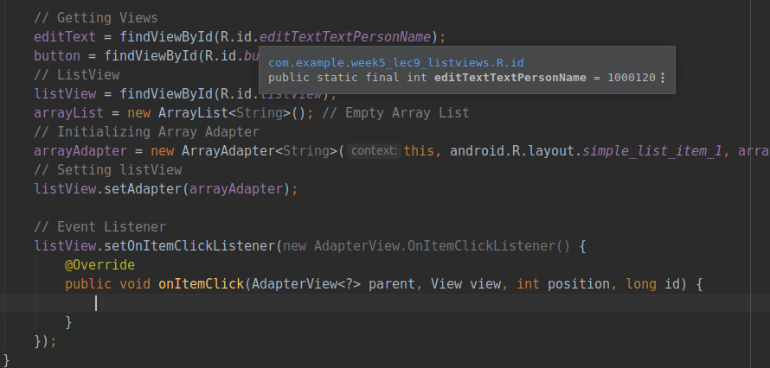

#### Step 3.3: Switch to new activity on clicking an item of listView.

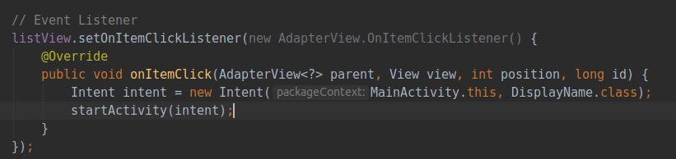

#### Step 3.4: Run the app and see if it is working properly.

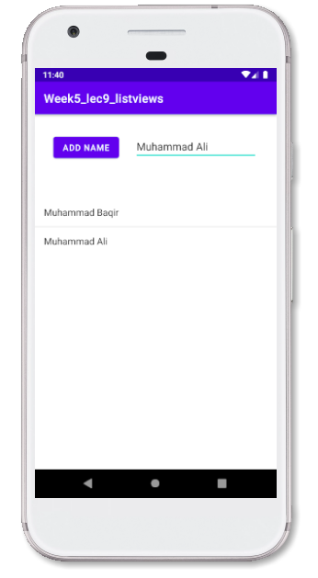

Now on clicking any item.

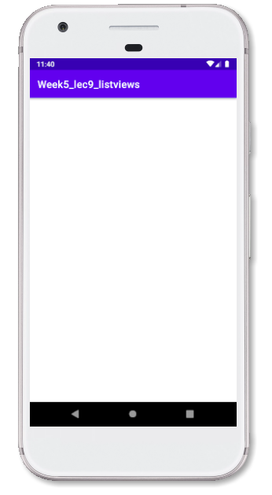

### Step 4: Passing Data to new activity.

#### Step 4.1: Complete UI of New Activity.

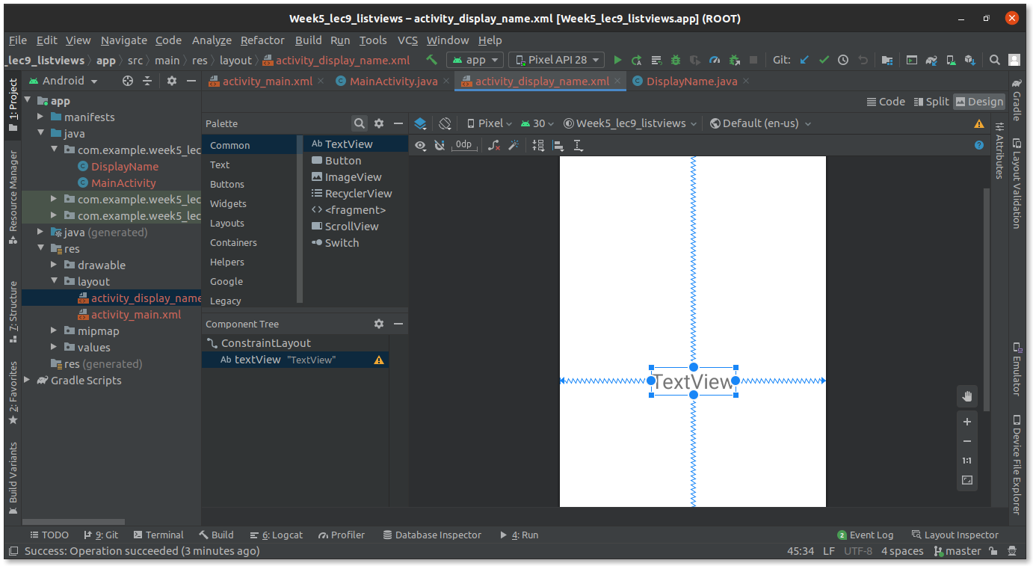

#### Step 4.2: Add code to pass name to new activity.

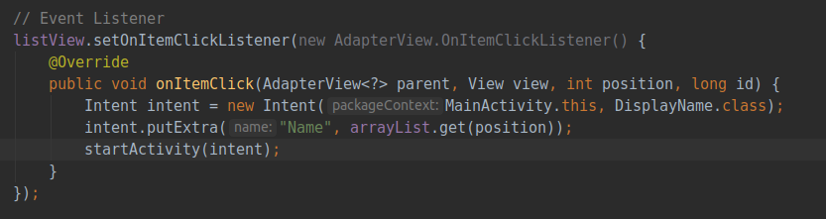

#### Step 4.3: Now get the name in the new activity and set textView.

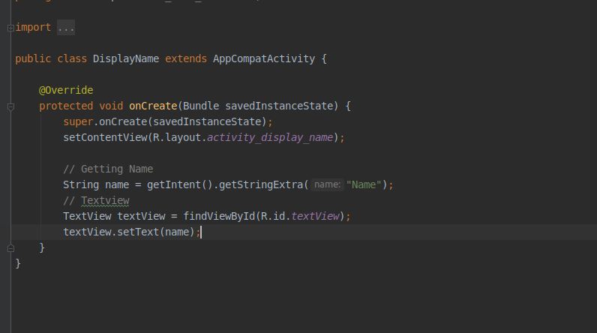

#### Step 4.4: Run the app.

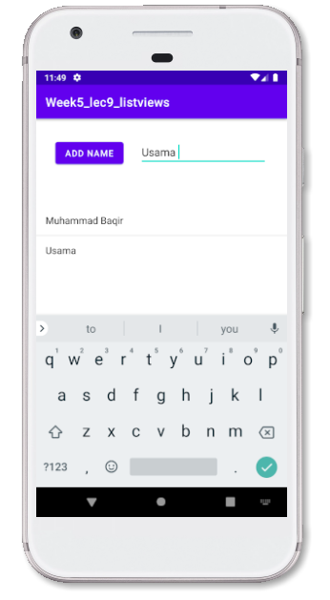

Now clicking **Muhammad Baqir**.

