# **Documentation of Week 5**

## **Lecture 11 Practice**

### Step 1: Clone Project from Github.

#### Step 1.1: In your Github folder clone project

#### .

#### Step 1.2: Open Project in android studio.

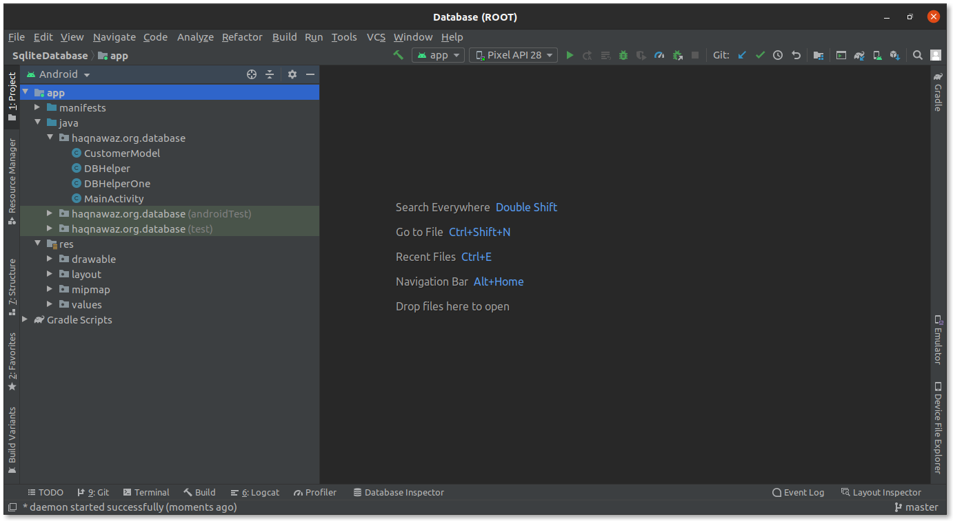

#### Step 1.3: Run the app.

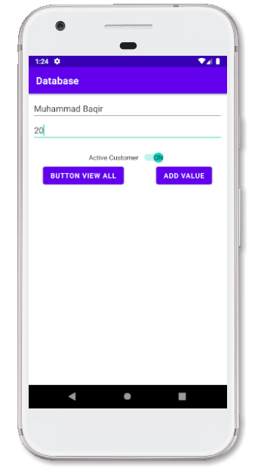

### Step 2: Implement getAllRecords.

#### Step 2.1: Add getAllRecords method in **DBHelper.**

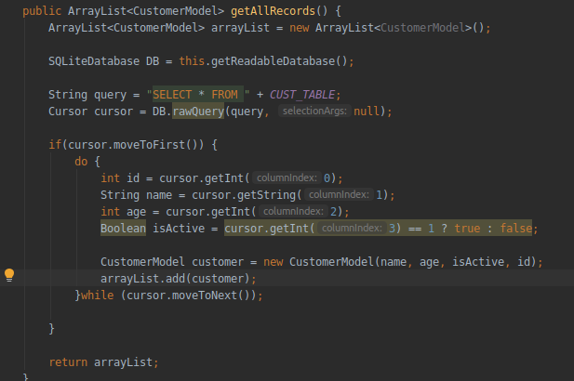

#### Step 2.2: Add ArrayAdapter.

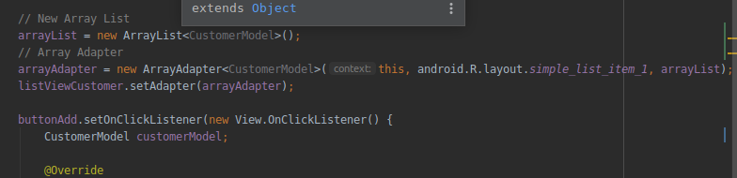

#### Step 2.3: Update buttonAdd onClickListener.

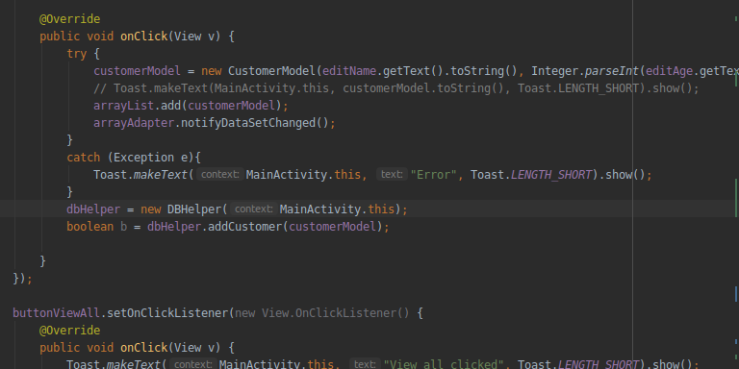

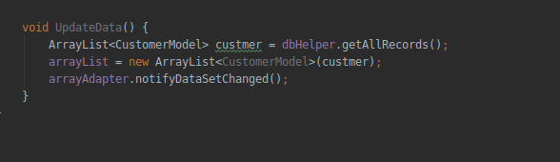

#### Step 2.4: Update buttonViewAll with following code.

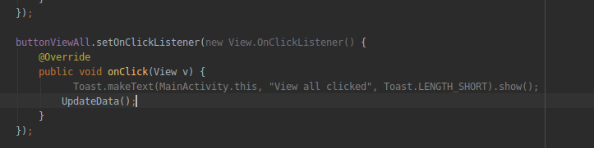

#### Step 2.5: Run and see the output.

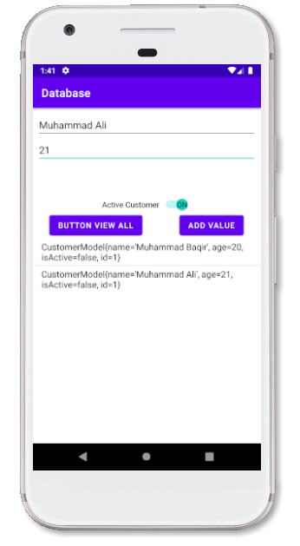

### Step 3 Implement Delete Functionality.

#### Step 3.1: Add delete method in **DBHelper.**

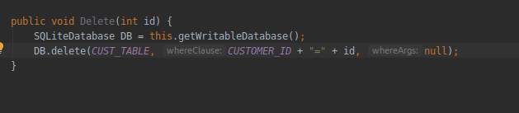

#### Step 3.2: On clicking listView delete the item.

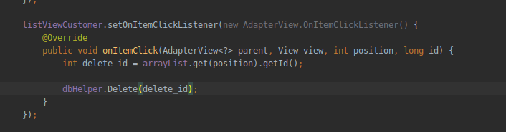

#### Step 3.3: Run the app and see if the app is working correctly.

