# **Documentation of Week 7**

## **Lecture 13 Practice**

* + Recycler View Practice

### Step 1: Create a Simple UI.

## **Lecture 14 Practice**

* + Dialogs Practice

### Step 1: Create a Simple App UI.

#### Step 1.1: Create a new project.

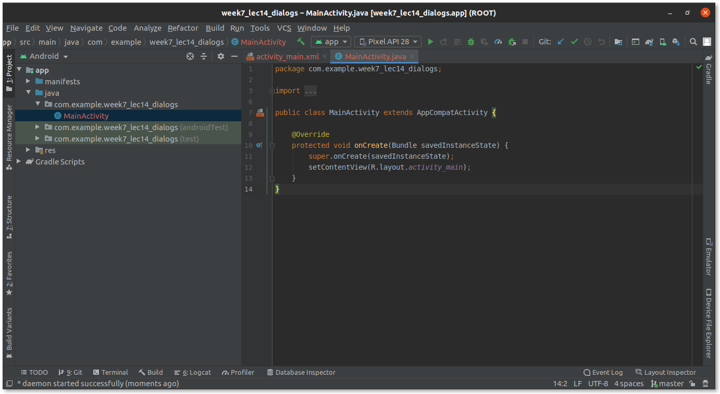

#### Step 1.2: Add a button **Open Dialog** and set its constraints.

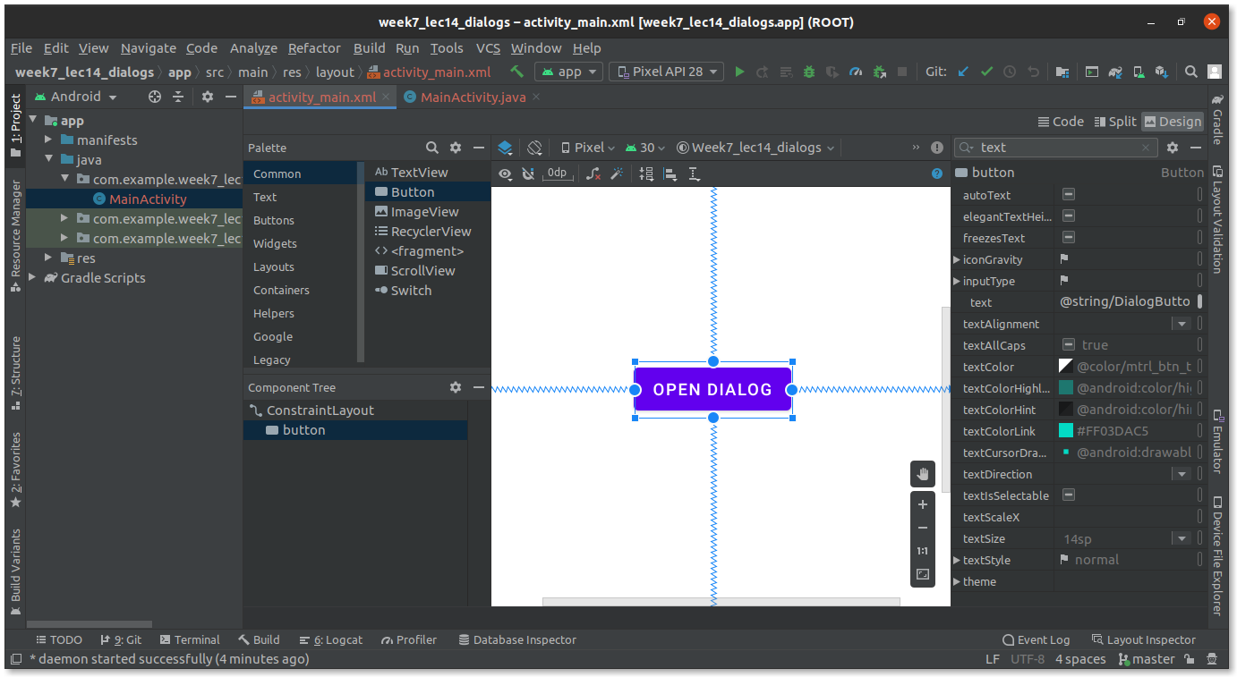

#### Step 1.3: Add onClick event handler.

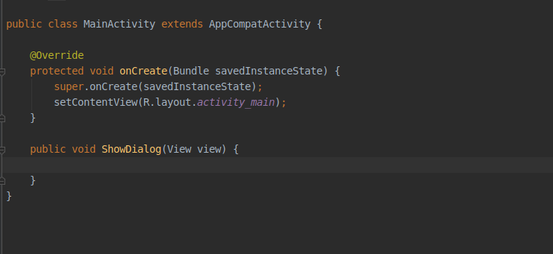

### Step 2: Complete Dialog Code.

#### Step 2.1: Create AlertDialog.Builder and Set Title and Message.

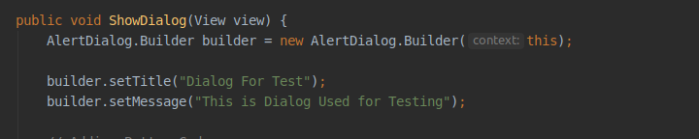

#### Step 2.2: Add positive and negative button code.

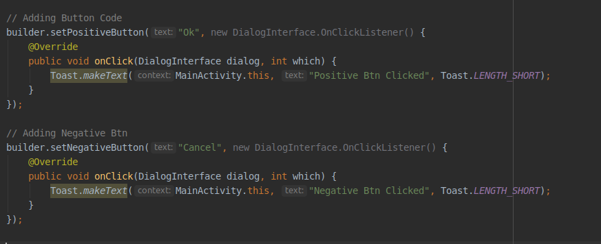

#### Step 2.3: Create AlertDialog and set Builder.

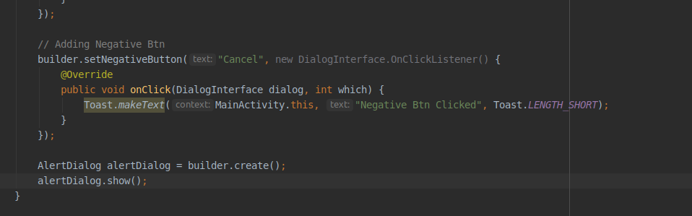

### Step 3: Test the App.

#### Step 3.1: Run the App.

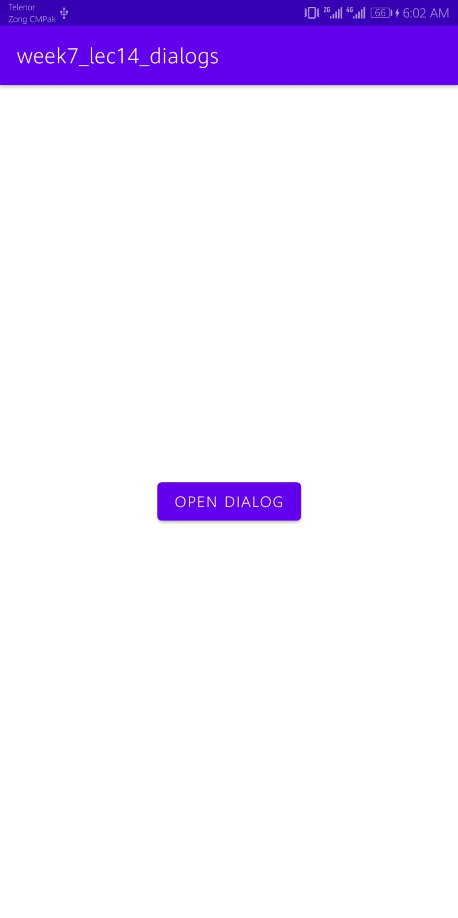

After clicking Open Dialog.

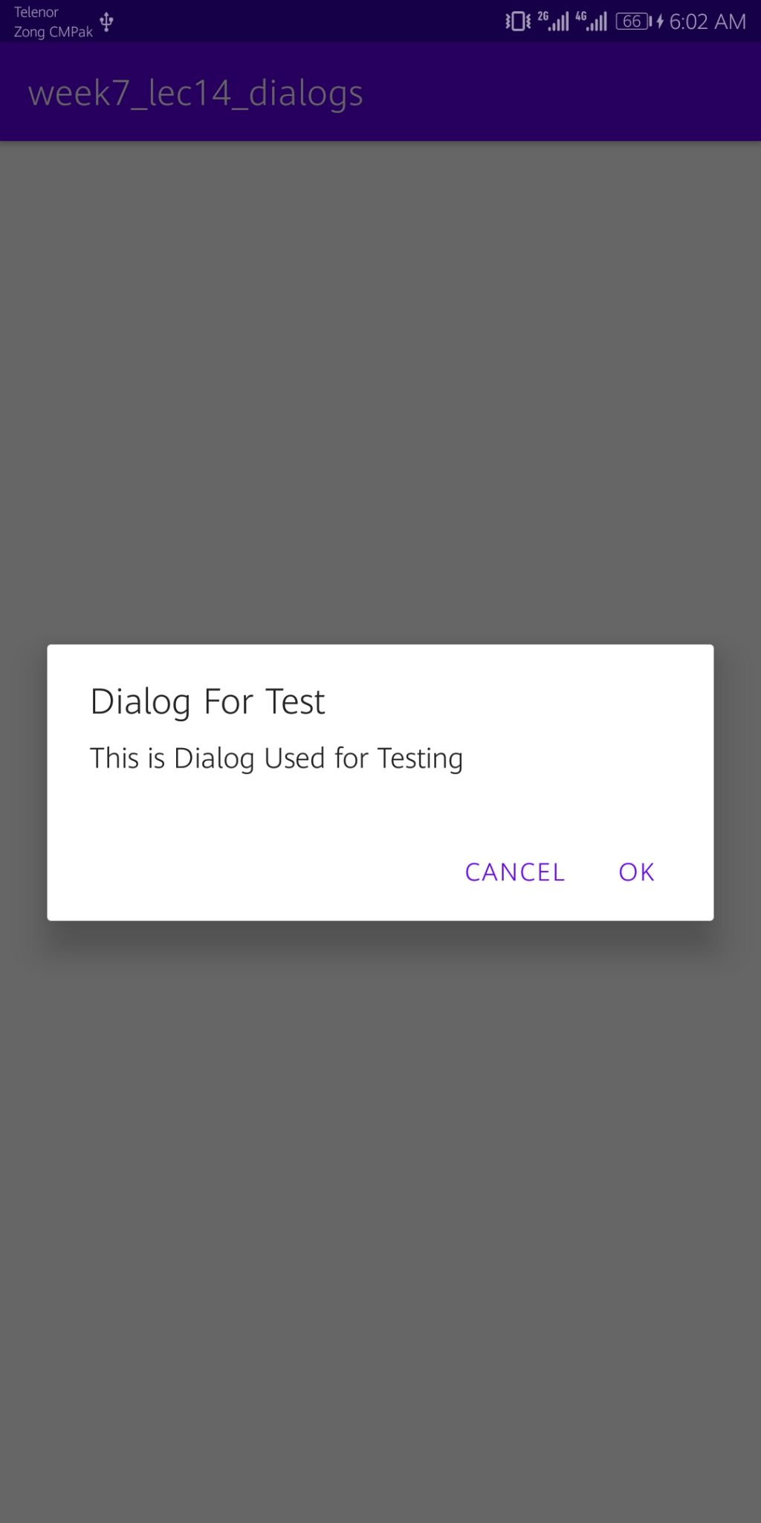

#### Step 3.2: Click on the “Ok” button.

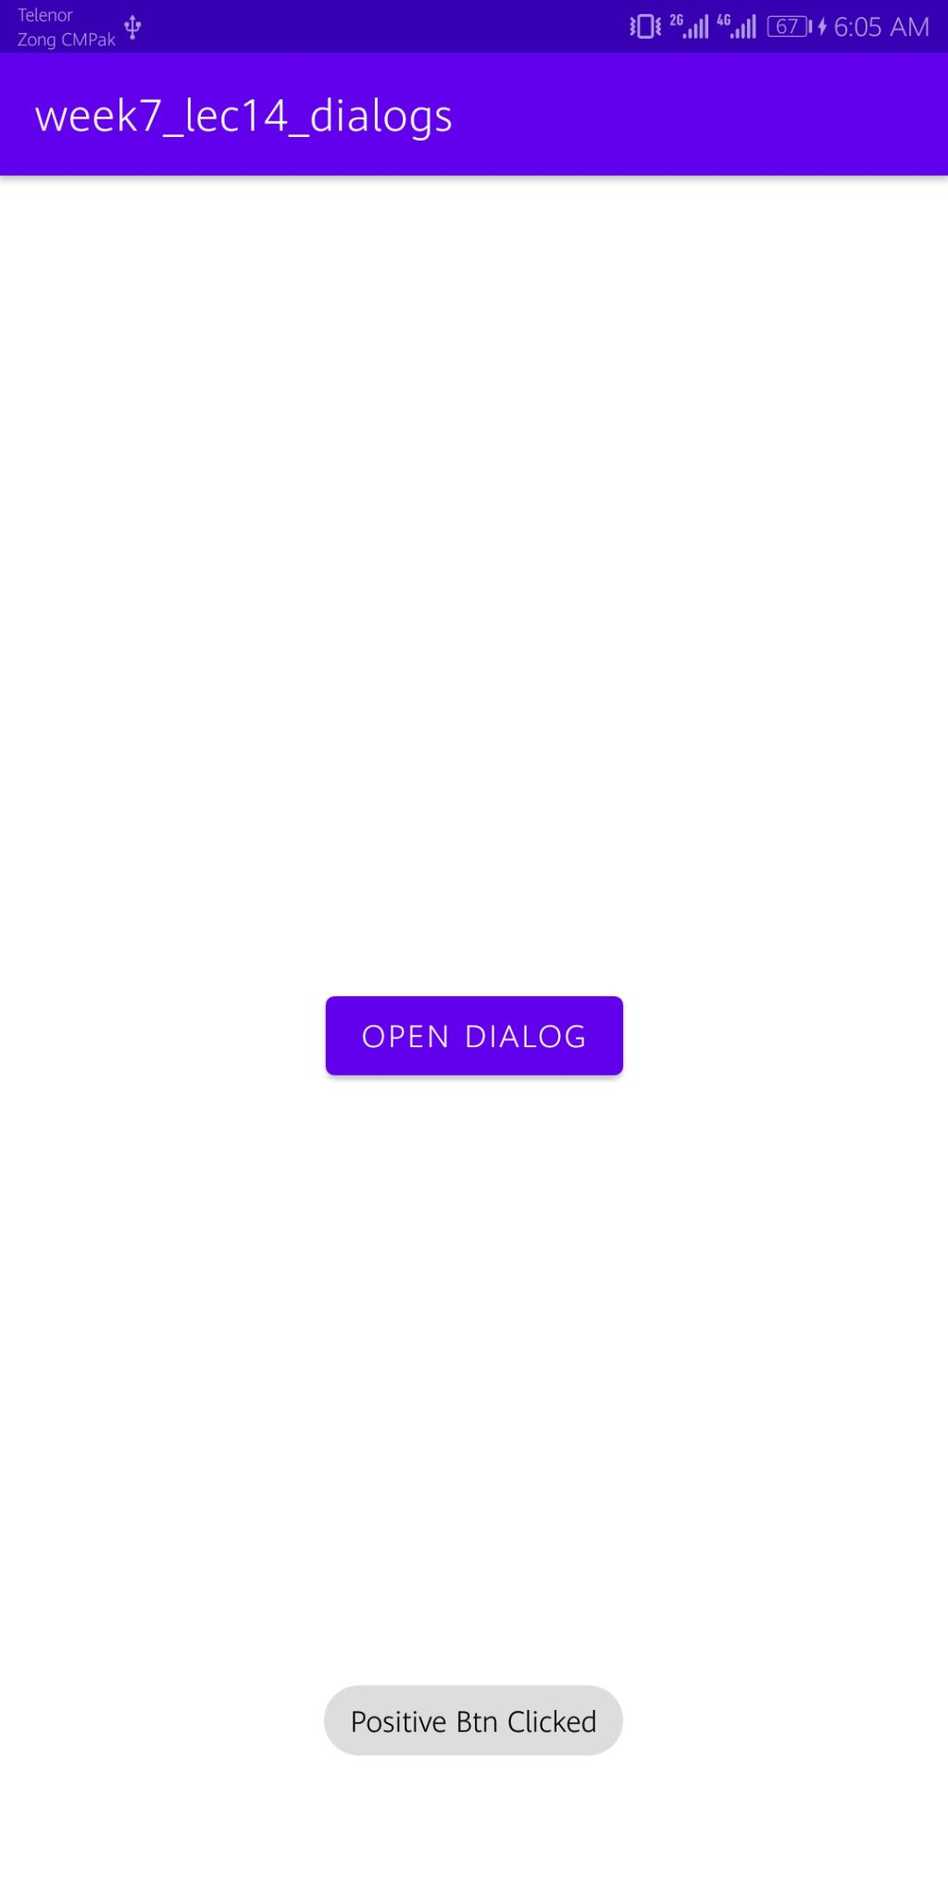

#### Step 3.3: Click on the “Cancel” button.

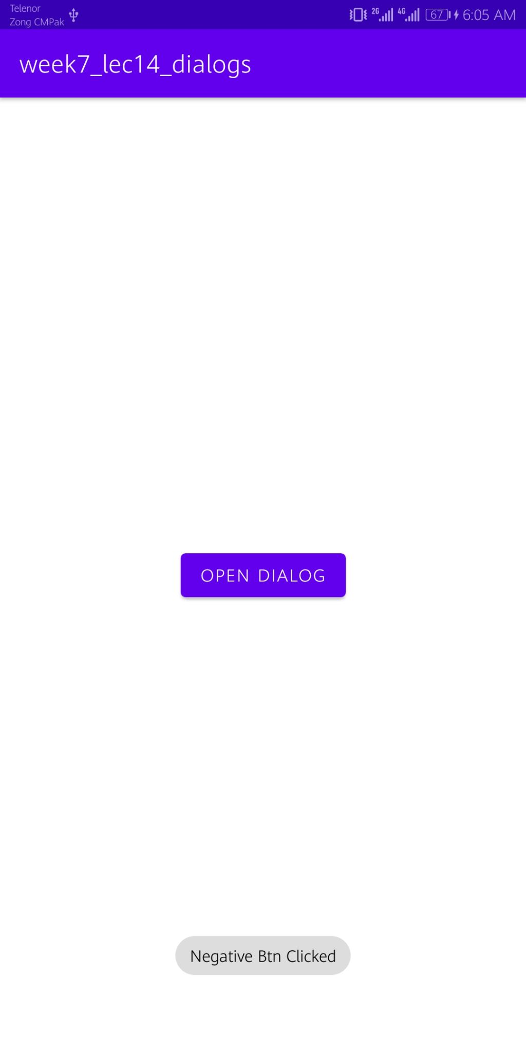

### Step 4: Add new Layout.

#### Step 4.1: Create new Layout.

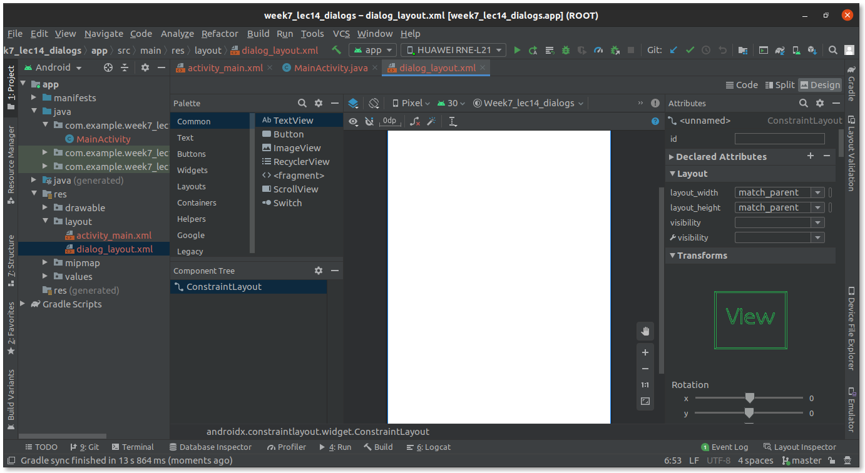

#### Step 4.2: Design UI of the Layout.

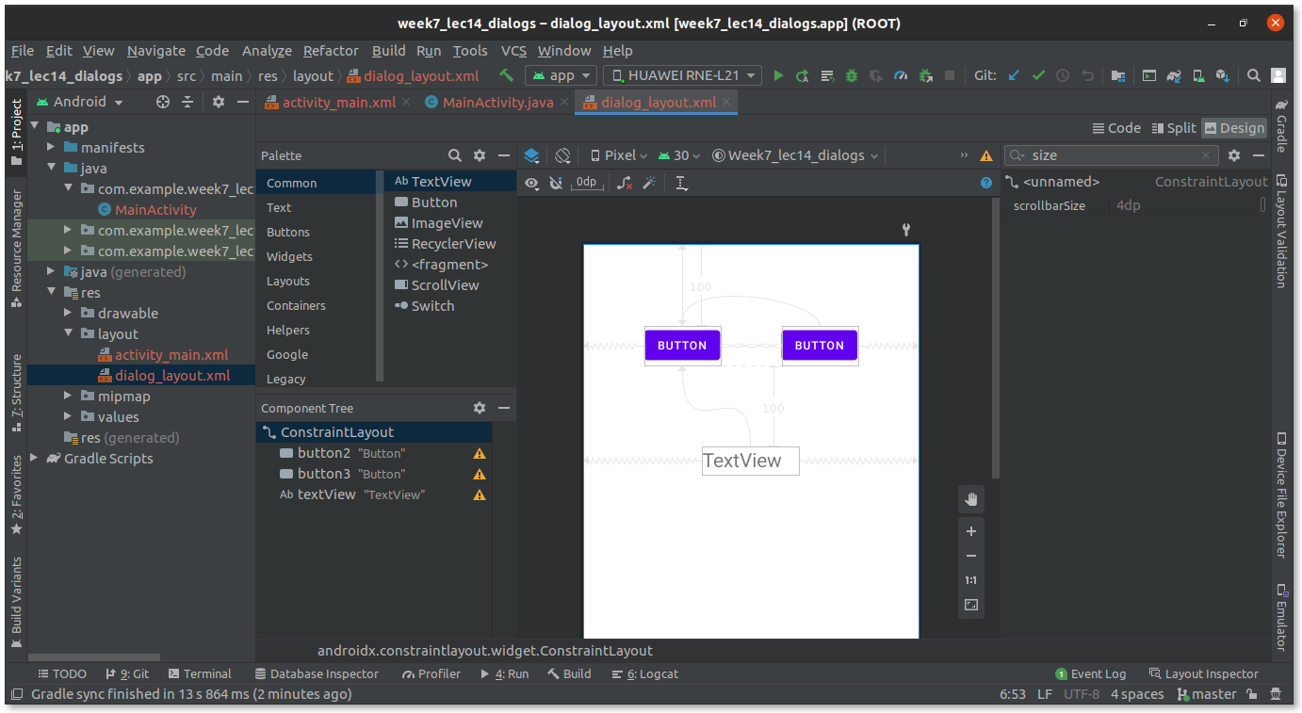

#### Step 4.3: Set layout in MainActivity.java.

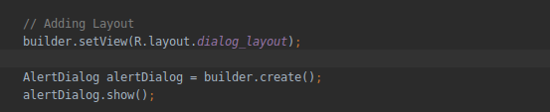

#### Step 4.4: Run the App.

