 COMSATS University Islamabad (CUI)

**1**

**Software Requirement Specification**

**(SRS DOCUMENT)**

**For**

**CardioLink**

Version 1.0

***By***

**Muhammad Bilal SP22-BCS-052/ISB**

**Faizan Maqbool SP22-BCS-022/ISB**

***Supervisor***

**Mr. Tanveer Ahmed**

***Bachelor of Science in Computer Science (2022-2026)***

**Revision History**

|  |  |  |  |
| --- | --- | --- | --- |
| **Name** | **Date** | **Reason for Changes** | **Version** |
|  |  |  |  |
|  |  |  |  |
|  |  |  |  |
|  |  |  |  |
|  |  |  |  |
|  |  |  |  |

**Application Evaluation History**

|  |  |
| --- | --- |
| **Comments (by committee)** | **Action Taken** |
|  |  |
|  |  |
|  |  |
|  |  |
|  |  |

**Supervised by Supervisor’s Name**

Signature

# Introduction

## 1.1 Purpose

The CardioLink is an advanced cardiovascular disease management system designed to facilitate health-related diagnosis, data management, consultation, and emergency response, specifically for the people of Pakistan. It enables patients to upload ECG or ECHO images for AI-based analysis and receive structured health insights. The system provides secure access to patient records, prescriptions, and video consultations with cardiac specialists, ensuring efficient medical attention. Additionally, it integrates a built-in pharmacy for easy medication purchases and an emergency ambulance service for quick response. This document is intended for software architects, developers, testers, and quality engineers working on the development of CardioLink.

## 1.2 Scope

The CardioLink is an advanced cardiovascular disease management system particularly developed for the people of Pakistan for facilitating health-related diagnosis, data, consultation as well as health emergencies. The system allows patients to send over an ECG or ECHO image to the system for structure AI analysis and Lite plan modelling which is customer centric. The entire patient’s documentation is also available in the system, including his/her clinical record and prescriptions, which is kept securely and made available to physicians for quick access during consultation rather than depending on the patient’s memory alone. About video consultations, CardioLink allows patients to reach out to cardiac specialists in a matter of minutes and receive medical attention digitally. With built-in pharmacy services, patients can make acquisition of the needed medicines by simply placing orders for the prescribed medications through the application system, making access to the necessary drugs much easy. Furthermore, through the chatbot, patients can receive assistance 24/7, with suggestions for diet and lifestyle changes in relation to their heart. In case of an emergency, CardioLink ambulance system can be called with one click and services can be monitored in real time. The high reliability of data encryption avoids any risks for patients’ records and doctor- patient conversations and addresses positive impacts of confidentiality problems. The CardioLink single interface includes diagnostic procedures, AI generated recommendations, electronic medical visits, orders for medications and emergency calls providing comprehensive treatment that improves availability, effectiveness and outcomes of patients with cardiovascular disease in low access areas.

## 1.3 Modules

#### 1.3.1 Module 1: Electronic Health Records

This module integrates patient profile management and a repository of comprehensive medical records.

***FE-1:*** *Implement a secure user registration system that ensures smooth onboarding.*

***FE-2:*** *Design a robust login feature ensuring safe and fast access for authorized users while preventing unauthorized intrusions.*

***FE-3:*** *Develop an advanced file upload system to store diverse patient history formats (e.g., PDFs, images, DICOM files) with metadata tagging for efficient retrieval.*

***FE-4:*** *Implement a streamlined history viewing interface for healthcare providers and patients, offering quick access to past medical records and reports for informed decision-making*

***FE-5:*** *Integrate AI-based diagnosis updates by processing submitted medical images and seamlessly appending them to the database, improving future analytical accuracy.*

#### 1.3.2 Module 2: AI ECG Interpreter

This module specializes in leveraging AI-driven ECG analysis to diagnose arrhythmias and myocardial infarction.

***FE-1:*** *Create a secure interface for uploading ECG files in diverse formats (e.g., PNG, JPG, PDF).*

***FE-2:*** *Implement advanced AI algorithms to identify arrhythmias, abnormal hearbeat, as well as myocardial infarction markers.*

***FE-3:*** *Generate detailed diagnostic summaries with visual annotations for detected abnormalities, highlighting patterns such as ST-segment elevation or irregular heartbeats.*

***FE-4:*** *Provide healthcare professionals with tools to validate AI diagnoses, attach recommendations, and initiate consultations if needed.*

#### 1.3.3 Module 4: AI EchoVision

This module focuses on analyzing ECHO videos to diagnose structural and functional heart diseases.

***FE-1:*** *Implement a secure and user-friendly upload system for ECHO files, enabling fast and efficient processing for cardiovascular health assessments.*

***FE-2:*** *Generate individualized diagnostic reports focused on structural and functional heart parameters, identifying key markers such as ventricular function, coronary diseases, angina and hypotension.*

***FE-3:*** *Provide actionable insights on ECHO findings, including potential contributing factors (e.g., lifestyle, diet) and strategies to mitigate risks of progression.*

***FE-4:*** *Facilitate expert review features for cardiologists to validate AI-generated findings, add professional observations, and provide patient-specific recommendations.*

#### 1.3.4 Module 4: AI Heartbeat Classifier

This module focuses on utilizing AI to process and classify heartbeat audio recordings, aiding in the detection of cardiac irregularities.

***FE-1:*** *Develop a user-friendly interface for uploading heartbeat audio files in various formats (e.g., WAV, MP3).*

***FE-2:*** *Integrate advanced AI models to analyze acoustic features and categorize the recordings as normal or abnormal, detecting irregularities.*

***FE-3:*** *Generate intuitive diagnostic outputs, including waveform visualizations and flagged segments of concern in the audio.*

#### 1.3.5 Module 5: Teleconsultation

Patients can get medical consultation from specialists in cardiology in their homes through video consultations.

***FE-1****: Schedule appointments with a cardiac specialist.*

***FE-2****: Initiate video consultation calls from within the app to get immediate medical opinion and consultation.*

***FE-3:*** *After consultation digital prescriptions and diagnostic reports are sent to patient which can be stored in the app.*

***FE-4:*** *Doctors can access a comprehensive patient history, including prior diagnoses and treatment records, and lifestyle insights before each consultation.*

***FE-5:*** *Every new prescription and/or diagnosis will update the patient medical history as predefined.*

***FE-6:*** *Review and rate doctors to assist future patient decisions*

#### 1.3.6 Module 6: PharmaLink

Enables patients to effortlessly place an order for an online drug prescription and pharmacy service incorporating the prescribing physician’s details.

***FE-1****: Allows Medication Automation such that after each consultation, upon a doctor's prescription, the system automatically checks medication availability and, if in stock, dispatches it directly to the patient's address without requiring any further action by the user.*

***FE-2****: Patients can also browse and order medication and lifestyle products related to cardiovascular health directly on our app.*

***FE-3****: Provide a dedicated pharmacy reorder tab that includes price comparisons and availability, allowing patients to reorder medications easily..*

#### 1.3.7 Module 7: HeartWise AI

This module features a virtual assistant that offers continuous support, education, and personalized advice focused on cardiovascular health.

***FE-1:*** *Provide information on common cardiac conditions, risk factors, and the importance of professional diagnosis over self-diagnosis.*

***FE-2:*** *Offer personalized advice on preventing cardiovascular risks based on individual health profiles.*

***FE-3:*** *Provide practical guidance for living with heart disease, including lifestyle and emotional support.*

***FE-4:*** *Share the latest trends, research, and practices in cardiovascular care.*

***FE-5:*** *Engage users with interactive tools to assess and improve their understanding of heart health*

#### 1.3.8 Module 8: CardioHealth Tracker

This module helps patients actively track their daily physical activity, dietary intake, and key health metrics to monitor cardiovascular health.

***FE-1:*** *The user would be able to track the number of steps taken or total exercises done like walking, jogging, cycling, etc. as physical activity metric.*

***FE-2:*** *The user will keep a record of food intakes (breakfast, lunch, supper, and snacks), from which the application provides a summary of saturated fats, cholesterol, and calories ingested concerning the users’ heart health.*

***FE-3:*** *The patients measure and log their blood pressure and heart rates along with the medication intake and monitor the vital signs for changes over periods.*

***FE-4:*** *Patients can schedule alerts for taking their medications so that they follow their treatment as prescribed.*

***FE-5:*** *At the end of each month, the application will prepare report which includes summary of activities performed, meals taken, health metrics recorded, and medications compliance.*

#### 1.3.9 Module 9: AI-Powered Heart Disease Prediction

This module leverages machine learning algorithms to predict the likelihood of heart disease, assisting in early detection and fostering informed decision-making. The predictions are based on user-provided health data and validated with scientific rigor.

***FE-1:*** *Collect user health, including metrics such as age, gender, cholesterol levels, blood pressure, heart rate, BMI, smoking status, and exercise habits.*

***FE-2:*** *Use machine learning model to analyze the user’s data and predict the probability of heart disease, presenting results in a clear and user-friendly format.*

***FE-3:*** *Offer actionable insights and recommendations based on prediction results, emphasizing the importance of consulting healthcare professionals.*

***FE-4:*** *Provide a library of resources explaining the predictive features and how each contributes to heart disease risk, fostering transparency and user trust.*

#### 1.3.10 Module 10: RapidRescue

Enables patients to summon an ambulance by simply clicking a button, which in turn will inform the closest available ambulance for an effective response.

***FE-1****: Allow patients to request an ambulance with a single click, automatically signaling the nearest available ambulance for quick response.*

***FE-2****: Enable patients to track the ambulance arrival time and route to their location.*

***FE-3****: Allow ambulance personnel to receive patient requests and navigate to the patient’s location efficiently.*

***FE-4****: Provide communication options between ambulance personnel and the patient for status updates.*

#### 1.3.11 Module 11: Physician Gateway

This module aims at introducing the doctor’s system where they will have the ability to register to our app, login, manage their schedules.

***FE-1:*** *The doctors can Register, by forwarding their requests containing their Information and Documents to Administration.*

***FE-2:*** *Login to their account using correct credentials.*

***FE-3:*** *Edit Personal Information, adding educational credentials and Password change.*

***FE-4:*** *Specify and record the capacity for individual consultations up to 30 days in advance.*

***FE-5:*** *A personalized dashboard which has a calendar where one can view appointments, edit them and confirm them while adjusting one's availability whenever it is necessary.*

#### 1.3.12 Module 12: Admin Control Panel

Gives admins control over user registrations, particularly for doctors and ambulance providers, as well as system notifications.

***FE-1****: Review and approve registration requests from doctors and ambulance services.*

***FE-2****: Manage system-wide notifications, data audits, and error reporting to ensure seamless app functionality.*

## 1.4 Overview

The document provides a detailed description of the CardioLink system, outlining its key functionalities, user interactions, and system responses. It explains the roles of patients, doctors, and emergency service providers, along with how they engage with the system. The document also covers the implementation technologies used for development, security measures for protecting patient data, and the AI-driven diagnostic capabilities. Additionally, it discusses quality attributes, and the various interfaces associated with the system to ensure seamless healthcare management.

# Overall Description

* 1. Product Perspective

*CardioLink is a healthcare platform designed to streamline cardiac care by connecting patients, hospitals, doctors, ambulance personnel, and pharmacists in a unified system. It replaces traditional methods of managing cardiac health, reducing the need for hospital visits and manual report storage while improving emergency response.*

*Current healthcare systems lack centralized platforms for remote diagnosis and prescription management. CardioLink integrates AI-powered diagnostics, remote consultations, emergency ambulance dispatch, and prescription tracking in one solution. The context diagram below illustrates the external entities interacting with CardioLink and the flow of data between them.*

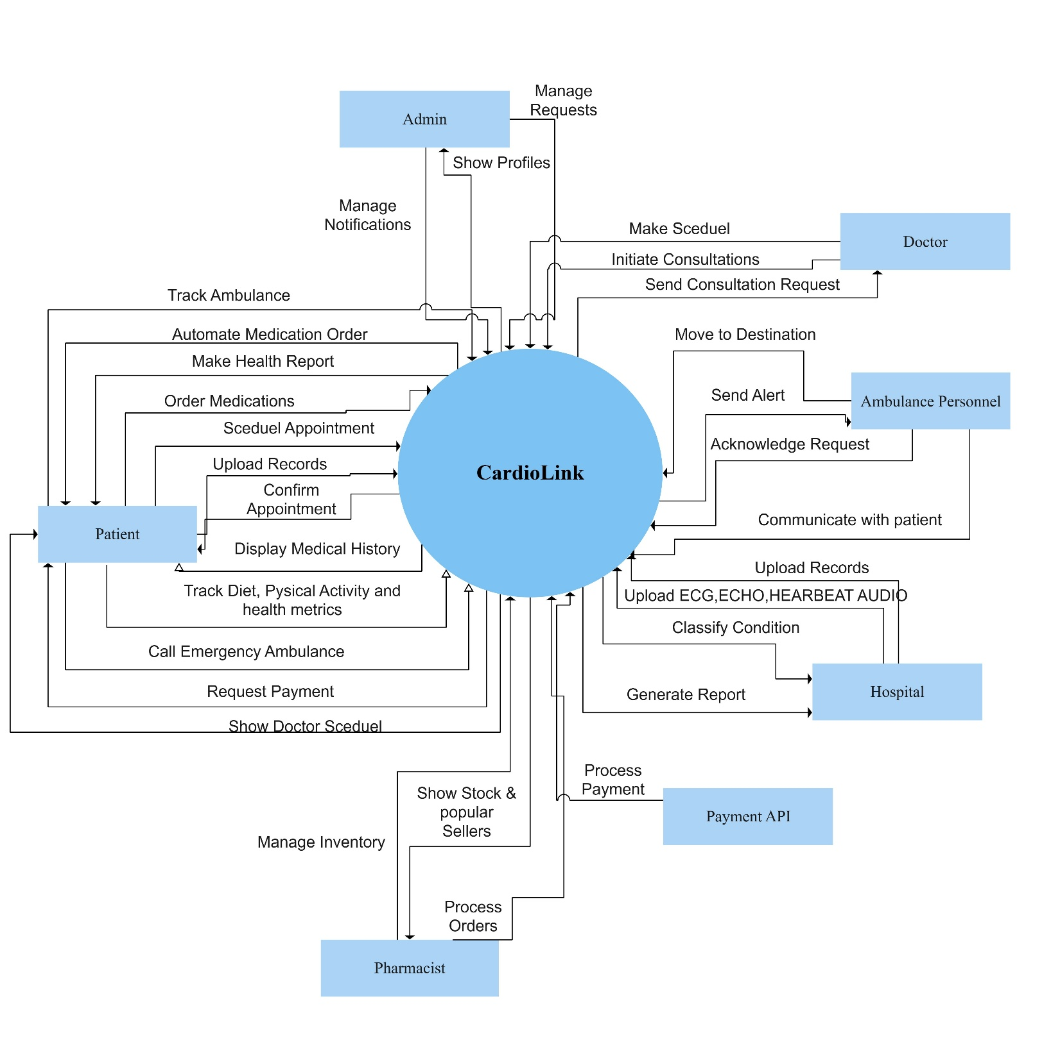

**Figure 1 Context Diagram of System**

* 1. User classes and characteristics

***Table 2.2.1 shows user classes and characteristics for CardioLink.***

|  |  |
| --- | --- |
| ***User Class*** | ***Description*** |
| *Hospital* | Hospitals use CardioLink to maintain patient records, track patient history, and provide remote consultation services. They have access to patient medical data, including ECG reports, echocardiography videos, and heartbeat audio. Hospitals can also dispatch emergency response teams via the ambulance module. Most hospitals have trained medical staff familiar with digital healthcare platforms. |
| *Patient* | Patients are the primary users of the system. They can upload ECG reports, echocardiography videos, and heartbeat audio for AI-based analysis and receive health insights. Patients can also schedule appointments with doctors, track prescriptions from pharmacists, and request an ambulance in emergencies. Since patients come from different age groups and technical backgrounds, the interface must be user-friendly and easy to navigate. |
| *Doctor* | Doctors analyze patient data, review AI-generated diagnostics, and provide remote consultations. They have access to patient reports and can prescribe medication accordingly. Doctors also provide feedback on AI-generated suggestions to improve accuracy. Most doctors are familiar with digital healthcare systems and require minimal training. |
| *Ambulance Personnel* | Ambulance personnel receive emergency alerts from hospitals or patients and use real-time GPS tracking to navigate to the patient’s location. They can update patient status during transport, providing real-time updates to hospitals. Since they operate in high-stress conditions, the system must provide quick and clear navigation and emergency response functionalities. |
| *Pharmacist* | Pharmacists receive electronic prescriptions from doctors and manage medicine availability. Patients can order prescribed medicines directly through the app, and pharmacists can update stock information. Since pharmacists handle multiple prescriptions daily, the interface must support quick data entry and retrieval. |
| *Admin* | Admins oversee the entire CardioLink platform, ensuring that user accounts, data security, and AI diagnostics function correctly. They manage user access rights, resolve technical issues, and monitor system performance. Admins require access to backend functionalities but do not interact directly with medical data. |

* 1. Operating Environment

***OPE-1:*** *CardioLink shall operate on Android (Version 7.0 and above), iOS (Version 12 and above), and desktop environments.*

***OPE-2:*** *The system shall be accessible via a web-based interface, ensuring cross-platform compatibility.*

***OPE-3:*** *CardioLink should function with a stable internet connection but offer offline access to patient records for emergency cases.*

***OPE-4:*** *The system shall use Google Maps API for real-time ambulance and hospital location tracking.*

***OPE-5:*** *CardioLink shall support secure cloud-based storage for storing patient medical history and diagnostic reports.*

* 1. Design and Implementation Constraints

***CON-1****: The user interface shall be implemented using React Native for mobile applications and Next.js for desktop applications.*

***CON-2:*** *AI-based diagnosis and medical data processing shall be implemented using Python 3.10 with TensorFlow and OpenCV for image and audio analysis.*

***CON-3****: The backend shall be developed using Node.js with Express.js, ensuring scalability and security.*

***CON-4:*** *The system shall store patient records securely using MongoDB as the primary database.*

***CON-5****: CardioLink shall comply with HIPAA (Health Insurance Portability and Accountability Act) regulations to ensure patient data privacy.*

***CON-6:*** *The system shall integrate Google Maps API for ambulance tracking and hospital navigation.*

***CON-7:*** *AI-based predictions shall improve over time through continuous model training using real-world data.*

# Requirement Identifying Technique

* 1. **Use Case**

The first technique used in identifying requirements for the system is use cases. CardioLink has a lot of user involvement, and the user requirements are identified using this technique. The use case diagram representing the requirements of each user is given below. Detailed use cases are also present in the following sections.

* + 1. **Detailed Use Cases**

# Non-Functional Requirements

* 1. Usability

***USE-1:*** *95% of users shall be able to learn how to use CardioLink within 5 minutes of orientation.*  
***USE-2:*** *The user interface shall be intuitive, allowing users to easily access patient data and medical insights.*  
***USE-3:*** *The AI-powered assistant shall correctly interpret 95% of health-related queries.*  
***USE-4:*** *Navigation through the application shall be seamless, with clear guidance on accessing different modules.*  
***USE-5:*** *Users shall be able to interact with reports, analytics, and dashboards with common mobile gestures.*  
***USE-6:*** *Patients and doctors shall be able to initiate and maintain chats with minimal latency.*  
***USE-7:*** *The system shall display clear and user-friendly error messages in case of failures or delays.*

* 1. Performance

***PER-1:*** *The system shall support up to 5000 concurrent users without performance degradation.*  
***PER-2:*** *Health record retrieval shall take no more than 3 seconds under normal load conditions.*  
***PER-3:*** *AI-based health recommendations shall be generated within 2 seconds of input submission.*  
***PER-4:*** *The response time for real-time patient monitoring updates shall not exceed 1 second.*  
***PER-5:*** *System uptime shall be maintained at 99.9% to ensure continuous availability.*

* 1. Scalability

***SCA-1:*** *The system shall be designed to scale horizontally to support increased users and data processing.*  
***SCA-2:*** *New hospitals, doctors, and patient records shall be seamlessly integrated without affecting existing users.*  
***SCA-3:*** *AI models shall dynamically scale to accommodate increased patient data analysis needs.*

* 1. Security & Privacy

**SEC-1:** All sensitive medical data shall be encrypted both in transit and at rest using industry-standard encryption protocols.

**SEC-2:** User authentication shall be performed using multi-factor authentication (MFA) for doctors and critical system users.

**SEC-3:** The system shall comply with HIPAA and GDPR regulations for data privacy and security.

**SEC-4:** Patients shall have full control over their data, including granting or revoking doctor access.

**SEC-5:** All external API requests shall be secured using OAuth 2.0 authentication.

* 1. Reliability & Availability

***REL-1:*** *CardioLink shall maintain a system uptime of 99.9%.*  
***REL-2:*** *Automatic failover mechanisms shall be implemented to recover from server failures.*  
***REL-3:*** *The system shall ensure data integrity by preventing duplicate or incomplete medical records.*

* 1. Maintainability & Extensibility

***MAI-1:*** *The system shall be built using a modular architecture, allowing easy updates and feature extensions.*  
***MAI-2:*** *API documentation shall be maintained for seamless integration with third-party health services.*  
***MAI-3:*** *System logs and monitoring shall track performance and security issues for timely maintenance.*

# External Interface Requirements

* 1. User Interfaces

***UI-1:*** *The application shall be available for both Android and iOS platforms with consistent user experience.*  
***UI-2:*** *A responsive web version shall be available for desktop users.*  
***UI-3:*** *All user interactions shall be designed for accessibility, following WCAG 2.1 guidelines.*

* 1. Hardware Interfaces

***HW-1:*** *The system shall use Google Maps to locate any registered user based on their location.*  
***HW-2:*** *The system shall detect health conditions based on echocardiography videos, ECG images, and heartbeat audio without integrating external wearable devices, relying only on mobile and web platforms.*

* 1. Software Interfaces

***SW-1****: CardioLink shall integrate with Electronic Health Record (EHR) systems for seamless data access.****SW-2****: The system shall support HL7 and FHIR standards for healthcare data exchange.****SW-3****: Third-party AI models shall be supported for advanced predictive health analytics.*

* 1. Communication Interfaces

***COM-1:*** *All communications between the mobile app and external services shall be encrypted using HTTPS and TLS 1.3.*  
***COM-2:*** *Patient-doctor chat features shall use end-to-end encryption to ensure confidentiality.*  
***COM-3:*** *Real-time alerts and notifications shall be delivered using WebSockets or Firebase Cloud Messaging (FCM).*

* 1. Data Interfaces

***DAT-1:*** *The system shall store and exchange medical data in JSON format for easy API integration.*  
***DAT-2:*** *Automated backup systems shall ensure data loss prevention with daily cloud backups.*  
***DAT-3:*** *The AI model shall process patient data without storing personally identifiable information (PII).*

* 1. Compliance & Standards

***CPL-1:*** *The system shall comply with HIPAA, GDPR, and local healthcare regulations.****CPL-2:*** *Audit logs shall be maintained for all system interactions to ensure regulatory compliance.****CPL-3:*** *The payment system (if applicable) shall comply with PCI-DSS standards for secure transactions.*

# References

1. **Aitor Goti, L. Q.-L.** (2023)*. Artificial Intelligence in Healthcare: A Literature Review on AI-Driven Medical Applications.*
2. **Beatty, K. W.** (2013). Software Requirements. Redmond, Washington: Microsoft Press.
3. **Honcharova, Y.** (2022). *The Role of Data Processing in Healthcare and Patient Monitoring.*
4. **Chung, L., & J. C.** (2009). *On Non-Functional Requirements in Software Engineering.*
5. **World Health Organization (WHO).** (2021). *Cardiovascular Diseases (CVDs) Overview & Statistics.*
6. **IEEE Xplore.** (2022). *Machine Learning in Cardiology: Algorithms & Applications.*
7. **National Institute of Health (NIH).** (2022). *Echocardiography and AI: A New Era of Heart Disease Diagnosis.*
8. **Google Health AI.** (n.d.). *How AI is Transforming Cardiac Disease Diagnosis.*
9. **Springer.** (2023). *Deep Learning Approaches for ECG Signal Processing.*
10. **Food and Drug Administration (FDA).** (2022). *Regulatory Guidelines for AI-Powered Medical Applications.*

# Plagiarism Report