Ticket Reservation System
Project Report | Muhammad Faiq Zahid | L1F23BSSE0387

1. Introduction
The Ticket Reservation System is a desktop application that helps customers and administrators manage ticket reservations. It replaces a manual paper-based process with a simple computerized system where seats can be booked, cancelled, viewed, and restored through undo operations.

2. Objectives
- Provide a user-friendly desktop interface.
- Allow users to book tickets by category.
- Prevent duplicate booking of the same seat.
- Support cancellation of booked seats.
- Support undo for booking and cancellation operations.
- Demonstrate Java Swing, exception handling, and object-oriented programming.

3. Problem Statement
Manual ticket booking is slow and can cause double-booking, missing records, and difficulty checking available seats. This project solves the problem by storing reservations in a central in-memory system and giving users clear controls for all major reservation tasks.

4. Screenshots
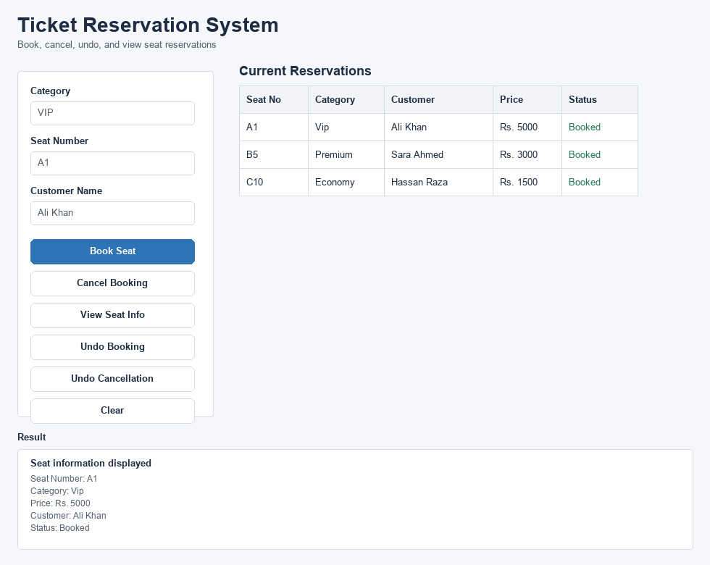
Figure 1: Main application window showing booked seats and seat information.
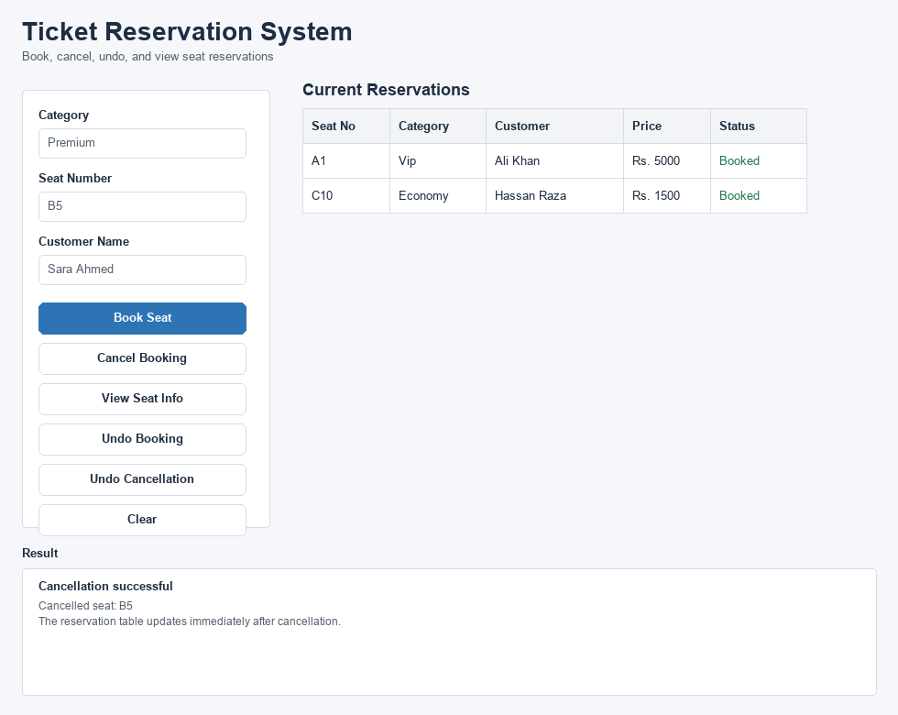
Figure 2: Cancellation result after removing a booked seat.

5. Testing
Test Case | Input | Expected Result
Book valid seat | VIP, A1, Ali | Seat A1 is booked
Book duplicate seat | VIP, A1, Ahmed | Error message appears
Empty seat number | Empty seat field | Validation error appears
Empty customer name | Empty customer field | Validation error appears
Cancel booked seat | A1 | Booking is removed
Cancel unavailable seat | Z9 | Error message appears
Undo booking | After booking A2 | Booking is removed
Undo cancellation | After cancelling A2 | Booking is restored
View booked seat | A2 | Seat details are shown

6. Conclusion
The project successfully implements a Java Swing Ticket Reservation System with booking, cancellation, undo, validation, and seat viewing features. The design uses encapsulation, inheritance, polymorphism, abstraction, constructors, method overloading, and method overriding.

7. Future Enhancements
- Add permanent database storage with JDBC.
- Add login roles for administrator and customer.
- Add printable tickets.
- Add seat maps for visual selection.
- Add reporting for total sales and reservations.

