**Mobile Computing Practice Details**

**Lecture#01**

* Just introduction

**Lecture#02**

**GitHub**

1. Creating account on <http://github.com/>

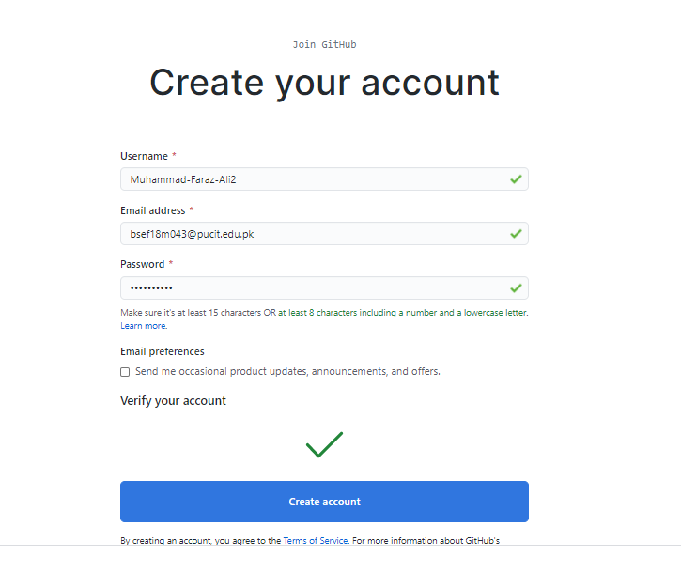

1. Creating repository on [github.com/new](https://github.com/new)

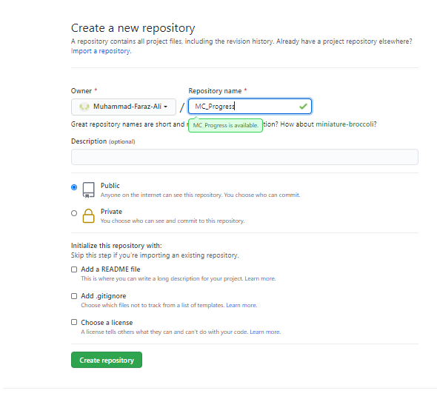

1. **Commands**

* **Create a folder in which you want to create local repo**
  1. **Clone:** It is used to clone local repo (PC) to central/main repo (server)

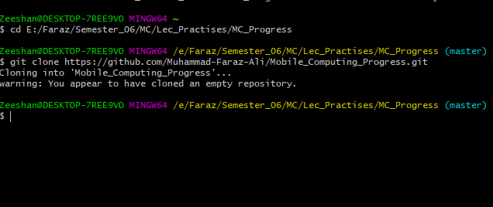

After cloning a new folder (local repo) is created with the same name as central repo.

* **Create any file within the local repo**
* **Go to the local repo (i.e. cd ……)**
* **Add the file**
  1. **Add:** It is used to add file in the local repo

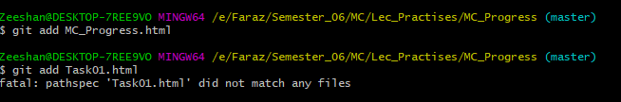

After adding the file that file is actually added in the local repo

* 1. **Commit** : It is used to show changes made on repo

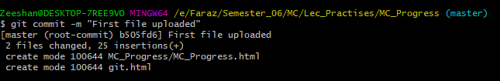

* 1. **Push:** It is used to make changes on central repo (online)

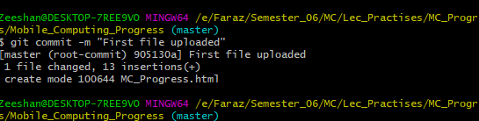

After pushing this file is also available in central repo (server/online)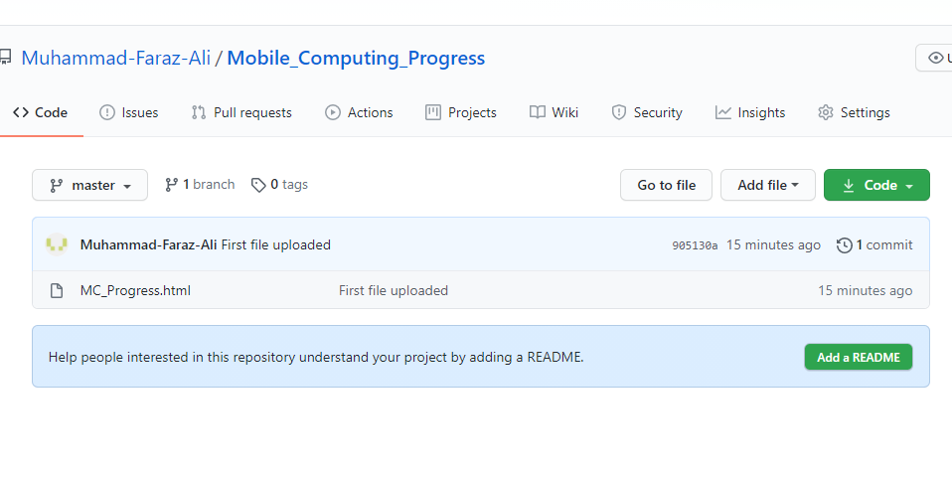

* 1. **Status**: It is used to check the status of repo

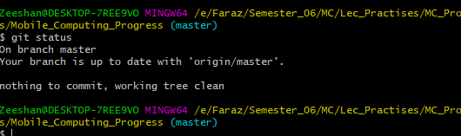

* 1. **ls**: It is used to check files in the current to directory

