ASSIGNMENT NO. 1
— ◆ —
U N I V E R S I T Y O F
GUJRAT
Gujrat, Pakistan
Arrays, Stacks & Queues
Concepts, Explanation, Operations and Functions
SUBMITTED BY
Muhammad Furqan Butt
CLASS
Data Science – Section A
COURSE
Data Structures and Algorithms
SUBMITTED TO
Sir Sabeeh

1. Array

Definition
An array is a linear data structure that stores a fixed number of elements of the same type in contiguous memory. Each element is accessed directly by its index, which starts from 0.
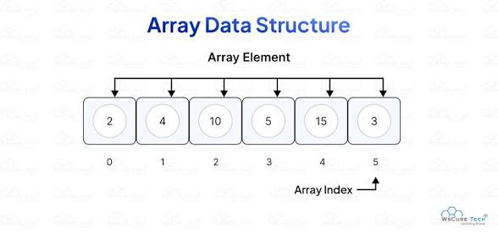
Figure 1: Array data structure
In the figure, the array holds six elements (2, 4, 10, 5, 15, 3) at indices 0 to 5. To read 15, we use arr[4].

Operations (Java)
class ArrayDemo {
// Traversal
static void traverse(int[] arr, int n) {
for (int i = 0; i < n; i++)
System.out.print(arr[i] + " ");
System.out.println();
}

// Insert value at position pos (shift right)
static int insertAt(int[] arr, int n, int pos, int value) {
if (n >= arr.length || pos < 0 || pos > n) {
System.out.println("Cannot insert!");
return n;
}
for (int i = n - 1; i >= pos; i--)
arr[i + 1] = arr[i];
arr[pos] = value;
return n + 1;
}

// Delete element at position pos (shift left)
static int deleteAt(int[] arr, int n, int pos) {
if (pos < 0 || pos >= n) {
System.out.println("Invalid position!");
return n;
}
for (int i = pos; i < n - 1; i++)
arr[i] = arr[i + 1];
return n - 1;
}

// Linear search
static int linearSearch(int[] arr, int n, int key) {
for (int i = 0; i < n; i++)
if (arr[i] == key) return i;
return -1;
}

// Binary search (array must be sorted)
static int binarySearch(int[] arr, int n, int key) {
int low = 0, high = n - 1;
while (low <= high) {
int mid = (low + high) / 2;
if (arr[mid] == key) return mid;
else if (arr[mid] < key) low = mid + 1;
else high = mid - 1;
}
return -1;
}

public static void main(String[] args) {
int[] arr = new int[10];
int[] init = {2, 4, 10, 5, 15, 3};
int n = 0;
for (int v : init) arr[n++] = v;

n = insertAt(arr, n, 2, 7); // 2 4 7 10 5 15 3
n = deleteAt(arr, n, 0); // 4 7 10 5 15 3
traverse(arr, n);
System.out.println("Index of 15: " + linearSearch(arr, n, 15));
}
}

Advantages
- Fast access to any element using its index, O(1).
- Simple to use; memory is continuous.

Disadvantages
- Size is fixed once created.
- Insertion and deletion are slow, O(n), because elements must be shifted.

Applications
- Storing lists and matrices; base for stacks, queues and hash tables.

2. Stack

Definition
A stack is a linear data structure that follows the LIFO (Last In, First Out) rule. Insertion (push) and deletion (pop) happen only at one end, called the top.
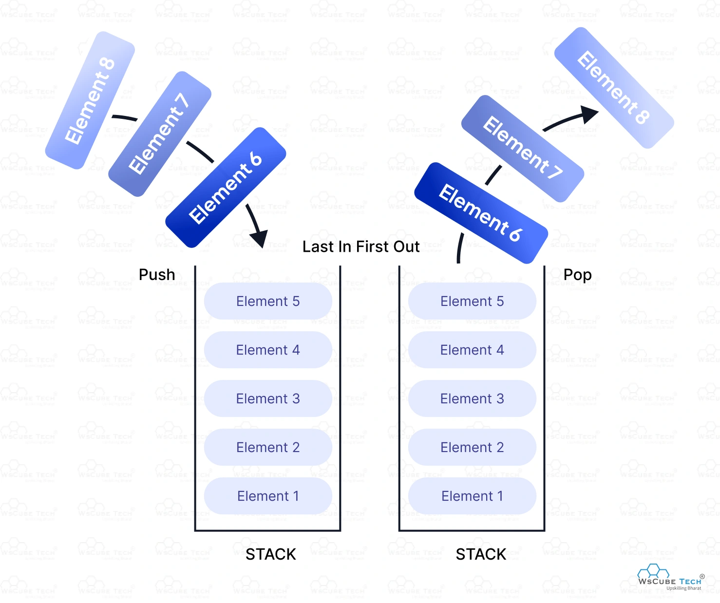
Figure 2: Stack data structure (Push and Pop)
In the figure, Elements 6, 7 and 8 are pushed on top of the stack on the left. On the right, they are popped in reverse order: Element 8 leaves first, because it was pushed last.

Operations (Java)
class Stack {
private int[] arr;
private int top;

Stack(int size) {
arr = new int[size];
top = -1;
}

boolean isEmpty() { return top == -1; }

boolean isFull() { return top == arr.length - 1; }

void push(int value) {
if (isFull()) {
System.out.println("Stack Overflow!");
return;
}
arr[++top] = value;
}

int pop() {
if (isEmpty()) {
System.out.println("Stack Underflow!");
return -1;
}
return arr[top--];
}

int peek() {
if (isEmpty()) {
System.out.println("Stack is empty!");
return -1;
}
return arr[top];
}

int size() { return top + 1; }

void display() {
for (int i = top; i >= 0; i--)
System.out.println(arr[i]);
}

public static void main(String[] args) {
Stack s = new Stack(5);
s.push(10);
s.push(20);
s.push(30);
System.out.println("Top: " + s.peek()); // 30
System.out.println("Popped: " + s.pop()); // 30
s.display(); // 20 10
}
}

Advantages
- Simple to implement; push and pop are O(1).
- Useful for reversing data and backtracking.

Disadvantages
- Only the top element can be accessed.
- Array-based stack has a fixed size.

Applications
- Function calls (recursion), undo/redo, expression evaluation, bracket matching, browser back button.

3. Queue

Definition
A queue is a linear data structure that follows the FIFO (First In, First Out) rule. Elements are inserted at the rear (enqueue) and removed from the front (dequeue).
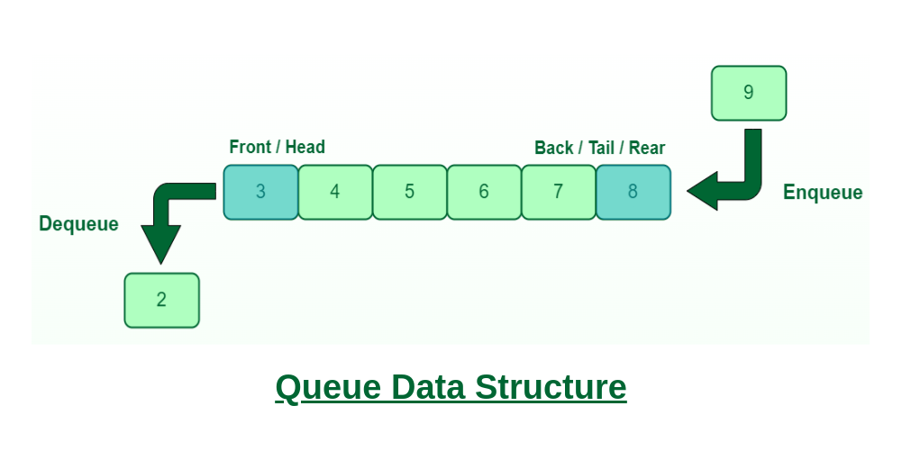
Figure 3: Queue data structure (Enqueue and Dequeue)
In the figure, the queue holds 3 to 8, with 3 at the front and 8 at the rear. The new element 9 is added at the rear, and the oldest element, 2, has been removed from the front.

Operations (Java)
class Queue {
private int[] arr;
private int front, rear;

Queue(int size) {
arr = new int[size];
front = 0;
rear = -1;
}

boolean isEmpty() { return front > rear; }

boolean isFull() { return rear == arr.length - 1; }

void enqueue(int value) {
if (isFull()) {
System.out.println("Queue Overflow!");
return;
}
arr[++rear] = value;
}

int dequeue() {
if (isEmpty()) {
System.out.println("Queue Underflow!");
return -1;
}
return arr[front++];
}

int front() {
return isEmpty() ? -1 : arr[front];
}

int rear() {
return isEmpty() ? -1 : arr[rear];
}

int size() { return isEmpty() ? 0 : rear - front + 1; }

void display() {
for (int i = front; i <= rear; i++)
System.out.print(arr[i] + " ");
System.out.println();
}

public static void main(String[] args) {
Queue q = new Queue(5);
q.enqueue(10);
q.enqueue(20);
q.enqueue(30);
System.out.println("Front: " + q.front()); // 10
System.out.println("Dequeued: " + q.dequeue()); // 10
q.display(); // 20 30
}
}

Advantages
- Serves data in the order it arrives; enqueue and dequeue are O(1).

Disadvantages
- Only front and rear are accessible.
- In a simple array queue, freed space at the front is wasted.

Applications
- CPU scheduling, printer queue, BFS, handling requests, buffers.

4. Comparison of Array, Stack and Queue
Feature | Array | Stack | Queue
Principle | Index based | LIFO | FIFO
Insertion | At any position | Push at top | Enqueue at rear
Deletion | From any position | Pop from top | Dequeue from front
Access | Random access by index | Top element only | Front and rear only
Pointers | Index | top | front and rear
Size | Fixed | Fixed (array-based) | Fixed (array-based)
Time | Access O(1), insert/delete O(n) | Push/pop O(1) | Enqueue/dequeue O(1)
Example | Row of lockers | Pile of plates | Line at ticket counter
Uses | Lists, matrices | Undo, recursion | Scheduling, BFS

