Sorting Algorithms: Insertion Sort and Merge Sort

1. Insertion Sort

Explanation
Insertion sort builds the sorted array one element at a time, much like sorting playing cards in your hand. The array is divided into a sorted part on the left and an unsorted part on the right. Each step takes the first element of the unsorted part (the "key") and inserts it into its correct position within the sorted part.
To insert the key, every element in the sorted part that is larger than the key is shifted one position to the right, which opens a gap where the key is placed.
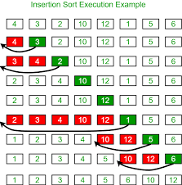
Figure 1: Insertion sort on the array 4, 3, 2, 10, 12, 1, 5, 6
How the figure works: the array is 4, 3, 2, 10, 12, 1, 5, 6. Green boxes are in their sorted position; red boxes are the elements being compared and moved.
- First, 3 is compared with 4. Since 4 is larger, they swap, giving 3, 4.
- Next, 2 moves left past 4 and 3, giving 2, 3, 4.
- 10 and 12 are already larger than everything on their left, so they stay in place.
- 1 is smaller than all sorted elements, so it moves all the way to the front.
- 5 moves left past 12 and 10, and 6 moves left past 12 and 10, giving the final sorted array 1, 2, 3, 4, 5, 6, 10, 12.

Complexity
- Best case: O(n) when the array is already sorted.
- Average and worst case: O(n²).
- Space: O(1), since it sorts in place. It is stable.

Algorithm
INSERTION-SORT(A, n)
1. for i = 1 to n - 1
2. key = A[i]
3. j = i - 1
4. while j >= 0 and A[j] > key
5. A[j + 1] = A[j] // shift element right
6. j = j - 1
7. A[j + 1] = key // insert key in its place

2. Merge Sort

Explanation
Merge sort is a divide-and-conquer algorithm. It repeatedly splits the array into two halves until every piece has only one element (a single element is already sorted), and then merges the pieces back together in sorted order.
The work has three steps: divide the array into two halves, conquer by recursively sorting each half, and combine by merging the two sorted halves into one sorted array.
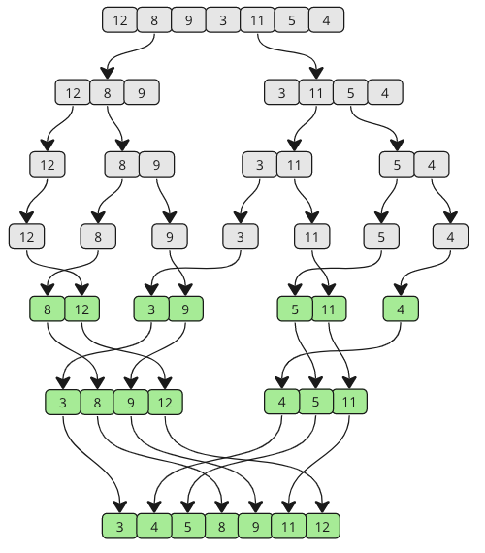
Figure 2: Merge sort on the array 12, 8, 9, 3, 11, 5, 4
How the figure works: the array 12, 8, 9, 3, 11, 5, 4 is processed in two phases.
- Dividing (grey boxes, top half): the array splits into 12, 8, 9 and 3, 11, 5, 4. These keep splitting until each box holds a single element.
- Merging (green boxes, bottom half): single elements are merged into sorted pairs such as 8, 12 and 3, 9 and 5, 11, with 4 on its own.
- The pairs are merged again into 3, 8, 9, 12 and 4, 5, 11 by repeatedly picking the smaller front element of each list.
- Finally the two sorted halves are merged into the fully sorted array 3, 4, 5, 8, 9, 11, 12.

Complexity
- Best, average and worst case: O(n log n).
- Space: O(n) for the temporary arrays used while merging. It is stable.

Algorithm
MERGE-SORT(A, left, right)
1. if left < right
2. mid = (left + right) / 2
3. MERGE-SORT(A, left, mid)
4. MERGE-SORT(A, mid + 1, right)
5. MERGE(A, left, mid, right)

MERGE(A, left, mid, right)
1. L = A[left .. mid], R = A[mid+1 .. right]
2. i = 0, j = 0, k = left
3. while i < length(L) and j < length(R)
4. if L[i] <= R[j]
5. A[k] = L[i]; i = i + 1
6. else
7. A[k] = R[j]; j = j + 1
8. k = k + 1
9. copy any remaining elements of L into A
10. copy any remaining elements of R into A

