**Exercise Questions**

**TASK # 1:** Take a number as an input from a user. Check if the number is an even number or an odd number.

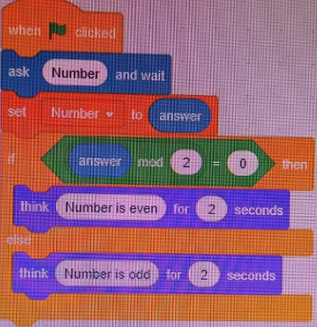

**TASK # 2:** Complete the number sequence for 20 terms total: 1, 4, 9, 16….

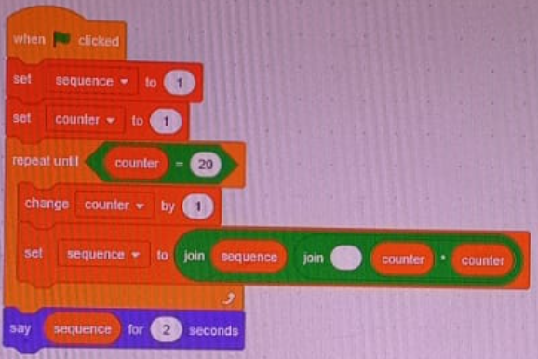

**TASK # 3:** Kolachi restaurant has started charging for wallet parking. For parking, they have announced the following rules.

Normal charges=50 Rps.

For cars which stay for 60 minutes or less than 60 minutes, owner has to pay normal charges.

For cars which stay for more 60 minutes but less than 120 minutes, owner has to pay double of normal charges

along with normal charges.

For cars which stay for more than 120 minutes, owner has to pay the triple of the normal charges along with

normal charges. You should calculate the charges of wallet parking on the basis of input hour.

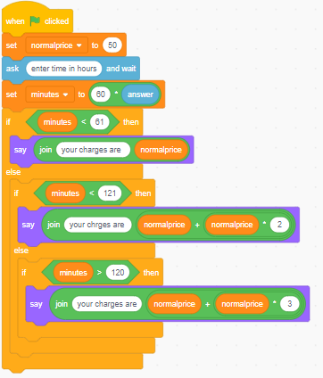

**TASK # 4:** You are supposed to create a mark sheet. There are total 4 subjects. Each subject has maximum marks 100, therefore total maximum marks are 400. Take marks of 4 subjects as an input from the user. Calculate the average percentage, and output the final overall letter grade using table below. Note: There should only be ONE grade in output (if marks are 87 then only A should be output, not A, B, C, D, and F).

| **Letter Grade** | **Percentage** |
| --- | --- |
| A | 86+ |
| B | 74+ |
| C | 62+ |
| D | 50+ |
| F | <50 |

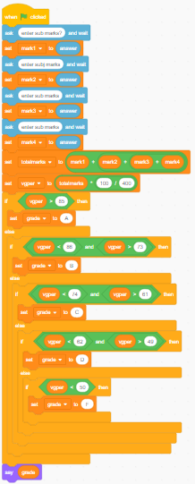

**TASK # 5:** Given below is a flow chart. Identify the decision and iterative structures in it. Convert the flow chart in to scratch diagram.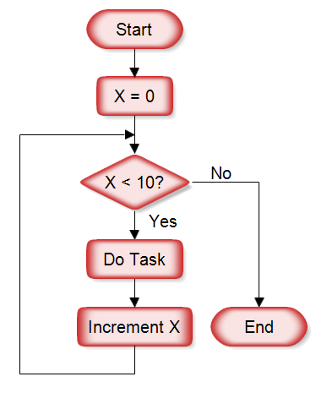

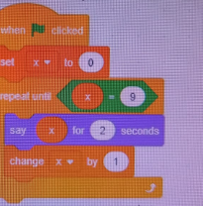

**TASK # 6:** A temperature monitoring system is used to monitor the appropriate level of the temperature. A temperature greater than 40 °C is categorized as HIGH, and below 15 °C is categorized as LOW. Anything in between is considered MEDIUM. Additionally, as soon as a temperature below 0 °C is monitored, the whole system shuts down after displaying ERROR for 5 seconds. Write a scratch program for the above case, taking continuous inputs of the temperature, and output the appropriate message regarding temperature level.

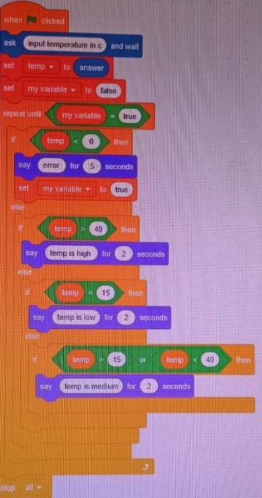

Good Luck ☺