**LAB#03 EXERCISES**

**QUESTION#1**

A car traveled for some hours. Take the number of Hours travelled as input on runtime, and then take input for the Distance Travelled during this time, Calculate Average Speed and display it on the screen.

**QUESTION#2**

Write a C program to print the following pattern using escape sequences.

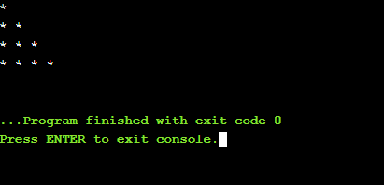

**QUESTION#3**

Write a C program that takes two integer values as input from the user. Then swap the values taken from the user and display the output of the variables. (Value of num1 should be stored in num2 and vice versa).

**QUESTION#4**

A customer asks the IT firm to develop a program in C language, which can take tax rate and salary from the user on runtime and then calculate the tax, the user has to pay and the salary he/she will have after paying the tax. Display the net income after tax deduction.

**QUESTION#5**

Calculate the volume of a cone, using FLOAT data type for all values and output the final answer up to 3 decimal places exactly.

**QUESTION#6**

Find both roots of the quadratic equation using the formula, after taking a, b, c as inputs:

