Operating Systems Lab
Lab Task # 01
Name: M. Haris
Student ID: F2024332092

Q1. Create a folder with your name and ID
Commands:
mkdir M.Haris-F2024332092
ls
Output:
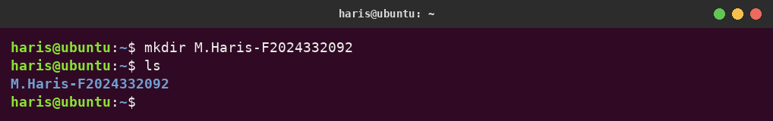
Description:
The mkdir (make directory) command creates a new folder named M.Haris-F2024332092 in the home directory. The ls command lists the contents of the current directory, confirming the folder was created (shown in blue because it is a directory).

Q2. Create 5 sub-folders inside it (folder 01 → folder 02 → … → folder 05)
Commands:
cd M.Haris-F2024332092
mkdir -p folder01/folder02/folder03/folder04/folder05
ls
Output:
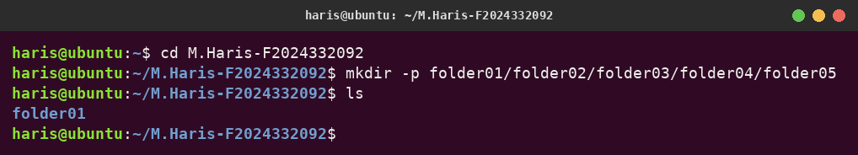
Description:
cd moves into the main folder. mkdir with the -p (parents) option creates the whole nested path in one command: folder02 is inside folder01, folder03 inside folder02, and so on up to folder05. ls shows folder01 as the top-level sub-folder.

Q3. Show the structure of the folders recursively
Commands:
cd ~
ls -R M.Haris-F2024332092
Output:
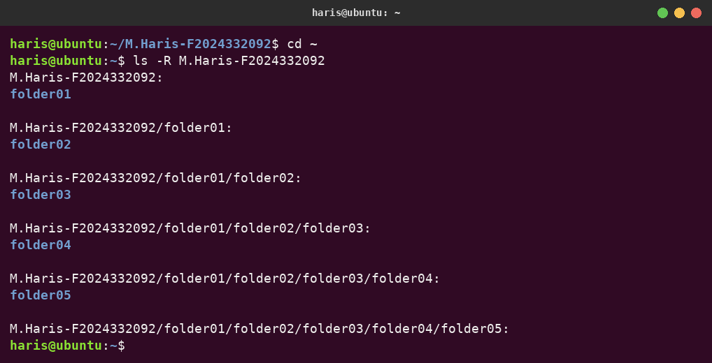
Description:
The -R (recursive) option of ls lists the given folder and then every folder inside it, level by level. The output shows the full path of each directory followed by its contents, proving that folder01 to folder05 are nested inside each other.

Q4. Create a file using nano in folder 03 and write your intro (2 lines)
Commands:
cd M.Haris-F2024332092/folder01/folder02/folder03
nano intro.txt
ls -l
Writing the intro in the nano editor:
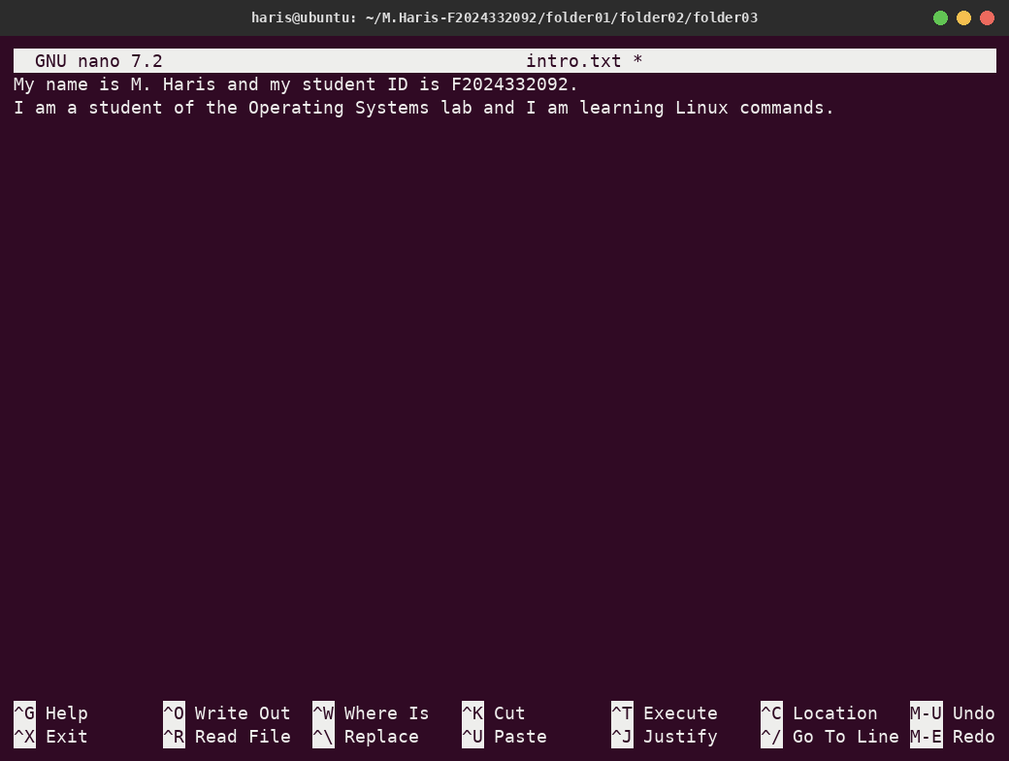
File saved in folder03:
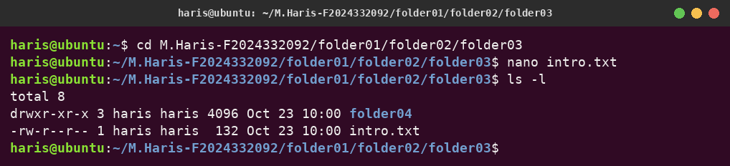
Description:
cd moves into folder03. nano intro.txt opens the nano text editor and creates the file intro.txt. Two lines of introduction were typed, then the file was saved with Ctrl + O (Write Out), Enter to confirm the file name, and nano was closed with Ctrl + X. ls -l lists folder03 in long format, showing that intro.txt now exists (132 bytes) next to folder04.

Q5. Display the content of the nano file on the console
Command:
cat intro.txt
Output:
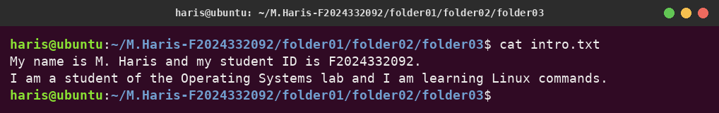
Description:
The cat (concatenate) command reads a file and prints its content to the terminal. It displays the two intro lines that were saved in intro.txt using nano.

